|  |  |  |  |
| --- | --- | --- | --- |
| logofire-standardresolution | jaune | logo_ce-en-rvb-hr | 7plogo |

|  |  |
| --- | --- |
| Project Acronym | **Fed4FIRE** |
| Project Title | **Federation for FIRE** |
| Instrument | **Large scale integrating project (IP)** |
| Call identifier | **FP7-ICT-2011-8** |
| Project number | **318389** |
| Project website | **www.fed4fire.eu** |
| Experiment | **GEO-Cloud** |

**Experiment problem statement and requirements report**

|  |  |
| --- | --- |
| Work package | WP10 |
| Task | T10.1.2 GEO-Cloud Experiment |
| Due date | 31/01/2014 |
| Submission date | 31/01/2014 |
| Report Lead | Félix Pedrera (DEIMOS) |
| Version | 1.0 |
| Authors | Félix Pedrera, Gerardo González, Jonathan Becedas (DEIMOS) |
| Reviewers | Jonathan Becedas (DEIMOS) |

|  |  |
| --- | --- |
| **Document ID** | **GEO-Cloud-DMS-TEC-DDD01-E-R** |
| Abstract | In this document the experiment problem statement and the main requirements that have to be fulfilled for its deployment in Fed4FIRE are described. |
| Keywords | Deliverable |

|  |  |  |  |
| --- | --- | --- | --- |
| Nature of the document | R | Report | X |
| P | Prototype |  |
| D | Demonstrator |  |
| O | Other |  |
| Dissemination level | PU | Public | X |
| PP | Restricted to other programme participants (including the Commission) |  |
| RE | Restricted to a group specified by the consortium (including the Commission) |  |
| CO | Confidential, only for members of the consortium (including the Commission) |  |

**Disclaimer**

*The information, documentation and figures available in this deliverable, is written by the Fed4FIRE* (Federation for FIRE) *– project consortium under EC co-financing contract FP7-ICT-318389 and does not necessarily reflect the views of the European Commission. The European Commission is not liable for any use that may be made of the information contained herein.*

**Executive Summary**

In this deliverable the GEO-Cloud experiment is described. GEO-Cloud will be deployed in the Fed4FIRE infrastructure. The works of design, implementation, execution and validation of the experiment and final reporting will be carried out by Elecnor Deimos.

This deliverable is based in the Description of Work of the experiment together with the specifications of the Fed4FIRE infrastructures.

GEO-Cloud is a close to reality industry driven experiment that will go beyond conventional services and infrastructures in the EO sector to implement and test in cloud a complete EO system (from the acquisition of geo-data with a constellation of satellites to its distribution to end users with remote access). The main objective is to value if the use of future internet technologies provides socio-economical viable solutions applicable to industry to offer highly demanding services such as crisis management in the EO sector.

The scenario is that of a constellation of satellites in Low Earth Orbits that covers the Earth’s surface in a daily basis, the geo-data is downloaded in several ground stations distributed around the world and transferred to the cloud for its treatment and distribution. We will focus in two main use cases: i) to offer basic satellite imagery services ii) to offer high added value services with real time response to manage crisis events such as natural disasters.

GEO-Cloud will emulate the remote sensing mission with the satellites, the topology network and the communications in the Virtual Wall testbed. The data acquired from the emulated satellites will be transferred to the BonFIRE cloud for storage, processing and distribution of data. End users accessing and broadcasting will be emulated in another network implemented in Virtual Wall. In order to implement realistic impairments in Virtual Wall, real networks will be tested in PlanetLab Europe. The technologies for imagery distribution and EO service delivery using cloud technologies and Internet protocols will be tested.

The document is divided into the following 8 sections: Section 1 is devoted to the introduction of the document, in Section 2 the objectives of the experiment are described, Section 3 describes the experiment, in Section 4 the experiment is designed, in Section 5 the schedule of the experiment is exposed, Section 6 describes the ethical issues, Section 7 shows the main conclusions and Section 8 the references cited throughout the text.**Acronyms and Abbreviations**

|  |  |
| --- | --- |
| BF | BonFIRE |
| GS | Ground Station |
| Sat | Satellite |
| VM | Virtual Machine |
| VW | Virtual Wall |
| PLE | PlanetLab Europe |
| EO | Earth Observation |

**Table of Contents**

[1 Introduction 7](#_Toc378868684)

[2 GEO-Cloud Objectives 9](#_Toc378868685)

[3 Experiment Description 10](#_Toc378868686)

[4 Experiment Design 14](#_Toc378868687)

[4.1 Implementation 14](#_Toc378868688)

[4.2 Procedure 16](#_Toc378868689)

[4.3 Parameters 16](#_Toc378868690)

[4.4 Requirements 17](#_Toc378868691)

[5 Experiment Schedule 19](#_Toc378868692)

[6 Ethical Issues 20](#_Toc378868693)

[7 Conclusions 21](#_Toc378868694)

[8 References 22](#_Toc378868695)

# Introduction

In this deliverable the GEO-Cloud experiment is described so as to the plan for its implementation, execution and validation. The GEO-Cloud experiment is one of the experiments that will be tested in the First Open Call of Fed4FIRE: 1st Fed4FIRE Competitive Call for Additional Project Partners.

The description of Fed4FIRE can be found in the project webpage [http://www.fed4fire.eu](http://www.fed4fire.eu/home/project-info.html). It is as follows: “*Fed4FIRE is an Integrating Project under the European Union’s Seventh Framework Programme (FP7) addressing the work programme topic Future Internet Research and Experimentation*”. The project is coordinated by iMinds and will run for 48 months until September 2016.

The GEO-Cloud experiment main objective is to provide response to one of the main challenges in the Earth Observation field: how to treat and distribute massive amounts of data recorded by optical satellites. Thus, the question to solve with the experiment is the following: *does cloud computing and, in general, future internet technology provide socio-economical viable solutions for highly demanding services in Earth Observation?*  This field is considered a key element in the European Research Road Map and an opportunity market for the next years. Nevertheless, EO still presents critical challenges that have to be overcome to cover the demand of services that are currently offered but also to advance new ones.

EO industries implement on-site conventional infrastructures to acquire, store, process and distribute the geo-information generated with the recorded data. However these solutions have the risks of over/under size the infrastructure, they are not flexible to cover sudden changes in the demand of services and the access to the information presents large latencies. These aspects limit the use of EO technology for real time use such as to manage crises, natural disasters and civil security among others (Deren, 2007).

The use of cloud computing technology can overcome the previously defined limitations that present conventional infrastructures because of its elasticity, scalability and on-demand use characteristics (Armbrust, 2010).

GEO-Cloud Experiment goes beyond conventional data infrastructures used in EO industry and beyond the implementations of applications running in cloud, to quest which parts of a complete infrastructure of EO are technologically and economically viable to be virtualized to offer basic and high added value services Figure 1.

GEO-Cloud is implemented in three Fed4FIRE testbeds: PlanetLab Europe, Virtual Wall and BonFIRE.

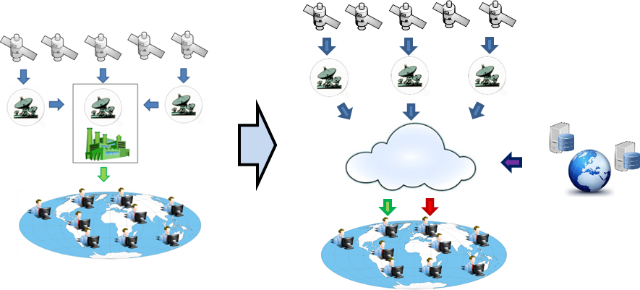

Figure The GEO-Cloud Concept. It is based on the use of cloud technology to acquire data, store it, process it, integrate it with other sources and distribute it to end users with the final objective of testing viable solutions for its real implementation.

# GEO-Cloud Objectives

The experiment objectives are summarized as follows:

1. To implement in Fed4FIRE a close to real world Earth Observation system.
2. To test and validate the following models:

* A global remote sensing model
* A cloud model for Earth Observation
* A model of end-users demand

1. To compare the different types of services offered (basic and added value services) to cover different types of demand.
2. To validate if future internet cloud computing and networks provide viable solutions for conventional Earth Observation systems to establish the basis for the implementation of EO infrastructures in cloud.
3. To verify if the Fed4FIRE infrastructure and tools are appropriate for running this complex, close to reality experiments.

# Experiment Description

The experiment consists of virtualizing a conventional EO system to offer on demand services to clients with the objective of validating its viability, find the strengths and weaknesses of using cloud computing technology and establish possible solutions for a future implementation in the market. There are three components:

1. **In-orbit mission:** this component generates the raw data. This consists of un-processed images of the Earth captured by a constellation of satellites and downloaded to different ground stations.
2. **Treatment of data:** the data has to be stored, processed at different levels based on the services offered and distributed to the clients. The data acquired by the in-orbit mission is integrated with other sources to provide higher quality services.
3. **End-users:** users of the provided services with different levels of remote access rights.

The system will be emulated at all levels for its monitoring and control. In orbit mission and end-users traffic, accesses, network topology, communications and data transfer will be emulated in Virtual Wall and PlanetLab Europe. The tools, models and architecture to treat the data will be implemented in the BonFIRE Cloud. Different parameters will be controlled (bandwidth, latencies and other impairments) to emulate a realistic system with different levels of demand.

#### Scenario

A constellation of 17 satellites covers the surface of the Earth in images in a daily basis.

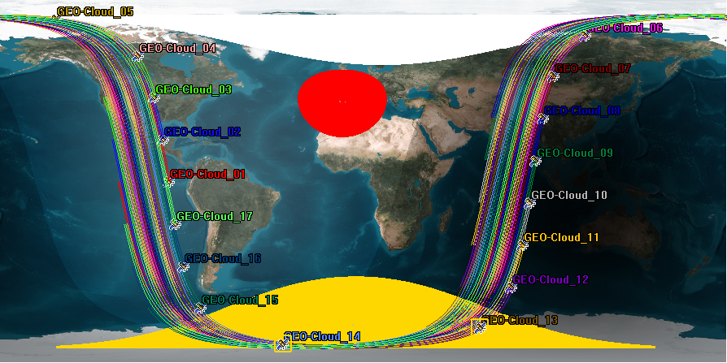

Figure Ground tracks of the 17 GEO-Cloud satellites

The images are downloaded in real time to 12 ground stations depicted in Table 1.

Table Ground stations design, number of accesses per day and duration of the passes

| Ground Station | Accesses per day | Accumulated duration (h) |
| --- | --- | --- |
| Irkutsk | 7 | 0.95 |
| Puertollano | 4 | 0.62 |
| Svalbard | 15 | 2.21 |
| Troll | 11 | 1.69 |
| Chetumal | 3 | 0.50 |
| Cordoba | 4 | 0.53 |
| Dubai | 4 | 0.57 |
| Kourou | 4 | 0.49 |
| Krugersdorp | 4 | 0.54 |
| Malaysia | 3 | 0.42 |
| Prince Albert | 6 | 0.93 |
| Sidney | 4 | 0.61 |
| TOTAL | 69 | 10.07 |

The raw data is transferred from the ground stations to a cloud computing infrastructure where the data is stored, processed on demand at different levels and integrated with information obtained from external sources to the system: sensors and other databases. All that data is processed to generate geo-information which is distributed to end-users to cover different levels of demand.

There will be different types of demand of services for both basic satellite imagery services and high added value services: constant demand, variable demand and highly variable demand. The demand can also have different types of loads associated, attending to three components: processing load, storage load and communications load. Possible combinations of them can also be presented. Types of load in the demand:

1. **Processing:** Different load levels for processing such as minimum load, medium load and high load.
2. **Storage:** Different load levels for storage such as minimum load, medium load and high load.
3. **Urgency:** Urgent responses with real time requirement and not urgent responses without real time requirement.

GEO-Cloud provides three types of services to the end-users. In those types of services, representative use cases will be implemented for testing:

1. **Basic satellite imagery services:** It includes accessing to low and automated processed satellite images from catalog. The basic service is a pull service, since the end users have to access the cloud servers and retrieve the data.
   1. Basic images: orthorectified images, images with minimum geolocation.

To carry out the experiment we will use images from our catalog, and public images from sources such as GMES, but we will not integrate them in this service (just for testing). We will test the transfer of data and accessing to the information in cloud with different loads of processing. This will be used as a control for comparing with the rest of services. We will test processing loads and timing to measure the response of the system.

1. **High added value services:** It includes instant accessing to automatically processed satellite images and data. In this case, data from other sources will be used and integrated with satellite imagery to combine the information and provide the service. Online processing will be tested with different computing loads and demands. Among the services that we will test we will focus in the following:
   1. **Pull type service:** Service under request. For example the emulation of crisis management of natural catastrophes such as the Lorca earthquake in Spain (http://en.wikipedia.org/wiki/2011\_Lorca\_earthquake).
   2. **Push type service:** The system periodically and automatically provides information to the end user without request. Tracking of specific areas or mobiles, for example the tracking of infrastructures in construction. More information about pull and push strategies can be found in (Simchi-Levi, Kaminsky, & Simchi-Levy, 1999).
2. **Hosting services:** GEO-Cloud hosting services will reserve space and access for the end-users to offer the possibility of storing their own geo-data, which can have been generated in the previous services. This solution is designed for those users that do not foresee to acquire specific storage hardware or do not want to invest on very large storage facilities.

The end users’ load will be defined by attending the following classification:

* Service Type:
* Basic
  + Basic
  + Advanced
* High added value:
  + Pull
  + Push
* Hosting
* Loads in cloud technology:
* Processing
  + Low
  + Medium
  + High
* Storage
  + Low
  + Medium
  + High
* Urgency
  + Urgent
  + Not Urgent
* Demand Variability
* Constant
* Variable
* Highly Variable

The classification will allow us to analyse the technological and economic viability of the services for their implementation in real life. It will also allow us to find the limitations of the cloud technology and establish requirements for its implementation.

# Experiment Design

## Implementation

The GEO-Cloud experiment requires emulating a complete realistic Earth Observation Mission to provide high added value services such as crisis managemen. To this complex situation, the system has to response by processing on demand massive and variable amounts of stored and on line transferred data.

GEO-Cloud makes use of the following Fed4FIRE facilities: PlanetLab Europe, Virtual Wall and BonFIRE. PlanetLab Europe allows us to measure real network characteristics geographically distributed to setup our models. Virtual Wall allows us to create any desired network topology and emulate the in-orbit mission and the web service to the users. BonFIRE provides us a real cloud infrastructure with observability in all the layers to test our cloud based services.

**A. Implementation of the cloud based services in BonFIRE**

To facilitate offering the previous services we propose to implement a multi-layered cloud model in the BonFIRE cloud infrastructure to generate on demand geo-information. The multi-layered cloud model is constituted of two layers:

1. **Layer 1:** This layer involves the basic satellite imagery services. It acquires the raw data, stores it, has the first level of processing, distributes the processed data and offers the hosting service.
2. **Layer 2:** This layer involves the high added value services. It can use historical processed, real time captured and pre-processed data from layer 1. This layer processes the information for real time generation of geo-information and offers real time access and distribution to the end-users. Typically, the implementation of high added value EO services involves the ingestion of the raster imagery from the satellites into a spatial database or storage, where it can be refined, simplified, processed or combined with other data sources in vector or raster format. The products, which can be vector or raster data, are distributed or queried using Internet technologies (OGC standards like WMS) or through Web services (tiles, caches, etcetera).

**B. Implementation of the access to the services in Virtual Wall and PlanetLab Europe**

The access to the services will be done with different levels of subscription. Thus, we can emulate that end-users can access the type of information they really need, and we can analyse the demand of the services we are offering. The access will be remote and will emulate a web service. A Virtual Wall network will emulate end-users accessing to the services.

Through the implementation of a network in PlanetLab Europe we will measure the characteristics of the real network when end users around the world remotely access the data: bandwidth, latencies, loss rate and background noise. This information will be used to upload the implemented model in Virtual Wall.

With the Virtual Wall emulation we can have complete control of the resources, compute the demand and all the factors involved in the situation to test the system and record its behaviour under the different conditions.

**C. Implementation of the acquisition of geo-data in Virtual Wall and PlanetLab Europe.**

The acquisition of geo-data will be obtained from the in-orbit mission and from external sources:

1. **In-orbit mission:** The constellation of satellites and the ground stations will be emulated in Virtual Wall. We will implement a network topology to communicate the different satellites with the ground stations. Every satellite in its orbit and every ground station models will be simulated in a node.

The satellite models will simulate the orbits and the pass of the satellites over the ground stations. The ground stations models will simulate the coverture of the antennas and the download of the data. When a satellite is inside this radius, the satellite downloads the data to the ground station that is visible. The downloaded data in the ground stations is transferred to the BonFIRE cloud.

With the Virtual Wall network we will control bandwidths, latencies, loss rates and background noise. We will also create a realistic network topology to transfer data between different nodes.

In order to determine the correct link characteristics for the connections between the ground and the cloud infrastructure we will measure appropriate values for the link impairment by measuring the current characteristics between these different geographical locations using the PlanetLab Europe testbed.

1. **External sources:** We will acquire information from other geo-data sources such as GMES database. That information will be directly transferred to the BonFIRE cloud for its use.

If available, we will have preference for integrating information that can be accessed programmatically through Web Services or APIs and with an adequate reuse license, since it allows using and requesting only the data needed by the service and reduces the needs of permanent storage. This also serves as a use case to test how the integration with other data providers and infrastructures affects the performance of the services under the Geo-Cloud scenarios.

Thus, the whole EO system will be completely implemented in Fed4FIRE, see Figure 3.

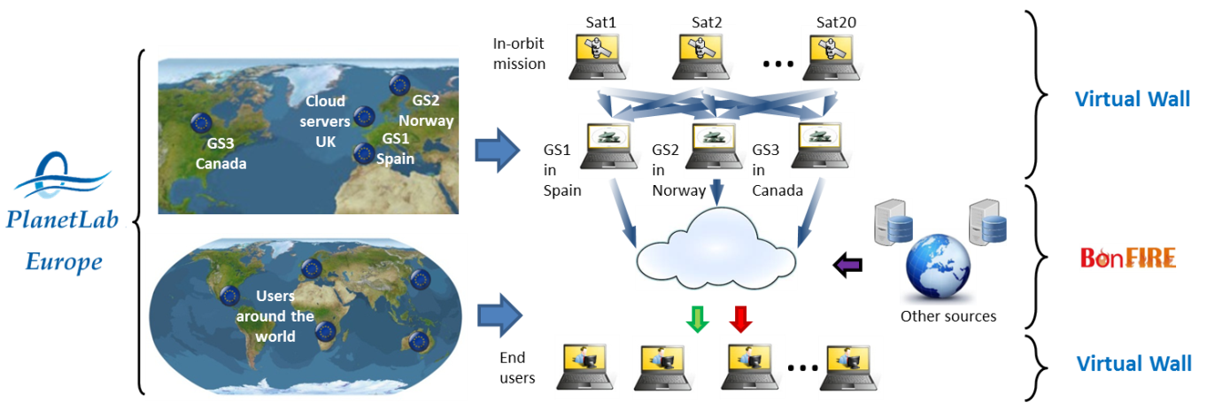

Figure 3 GEO-Cloud implementation in Fed4FIRE

## Procedure

The experiment deployment includes the computation of image processing algorithms and transfer of data from different nodes in an ad-hoc created topology network that emulates a real Earth Observation System.

The experiment starts with the preparation of the software and models that will be implemented in Fed4FIRE. Later we will start implementing the different models in VW, BF and PLE.

After the whole system is integrated in the Fed4FIRE testbeds the experiment starts its execution and validation. This stage is separated into two phases:

1. Set of trials in PlanetLab Europe to monitor and test the link characteristics between the different geographical distributed points: virtual ground stations (GSs), cloud infrastructure and end users.
2. Update of the models implemented in Virtual Wall with the parameters measured in PlanetLab Europe.
3. Set of trials in the updated EO virtualized system implemented in Virtual Wall and BonFIRE. To monitor the behavior of the system implemented in the testbeds.

## Parameters

The following parameters will be used as control and variables:

In the PlanetLab Europe tests:

* Control:
  + Bandwidth
* Variables:
  + Latencies
  + Loss rate
  + Background noise

In the integrated system in Virtual Wall and BonFIRE:

* Control:
  + - Bandwidth
    - Loss rate
    - Background noise
    - Latencies
  + Variables:
    - Processing time
    - Latency from image capture to distribution
    - Storage load
    - Processing load
    - Processing and storage strategy viability
    - Cues management
    - Performance of the system

## Requirements

The GEO-Cloud system was designed taking into account the following requirements:

**REQ\_SYS\_0001:** The geo-information generated by the satellites shall be in a daily basis.

**REQ\_SYS\_0002:** For the design of the satellite constellation, a map of the Earth surface has to be daily generated.

**REQ\_SYS\_0003:** The geo-information has to be on demand processed and distributed.

**REQ\_SYS\_0004:** The raw data acquisition from the satellites follows an almost constant pattern.

**REQ\_SYS\_0005:** The data acquired has to be stored and be accessible to provide historical records.

The following requirements are those that the Fed4FIRE testbeds shall fulfill for a correct implementation and execution of the experiment:

**REQ\_F4F\_0001:** The Fed4FIRE testbeds used in the GEO-Cloud experiment shall allow the monitoring and control of the parameters described in section 4.3.

**REQ\_F4F\_0002:** The Fed4FIRE testbeds shall allow transfer of data with size in the order of GB between nodes.

**REQ\_F4F\_0003:** Fed4FIRE shall guarantee connectivity between BonFIRE and Virtual Wall testbeds.

**REQ\_F4F\_0004:** PlanetLab Europe shall facilitate the use of at least 7 nodes of PlanetLab Central.

**REQ\_F4F\_0005:** Virtual Wall shall provide at least 30 nodes for the deployment of the GEO-Cloud experiment.

**REQ\_F4F\_0006:** BonFIRE shall allow us to script our own software in the cloud.

**REQ\_F4F\_0007:** Fed4FIRE shall guarantee the availability of the testbeds used in the GEO-Cloud experiment for its implementation and execution.

**REQ\_F4F\_0008:** Fed4FRIE shall guarantee connectivity via Internet between DEIMOS premises and the testbeds to deploy and execute the experiment.

**REQ\_F4F\_0009:** The integration of Virtual Wall, BonFIRE and PlanetLab Europe in Fed4FIRE shall be finished before the start of the experiment implementation (month 3 from GEO-Cloud kick-off).

**REQ\_F4F\_0010:** Fed4FIRE shall guarantee support to the experimenters in the design and implementation of the GEO-Cloud experiment.

**REQ\_F4F\_0011:** The Fed4FIRE support to the experimenters shall guarantee a feedback response time less than 5 working days from the establishment of the questions.

# Experiment Schedule

The experiment schedule is constituted of 6 tasks:

1. Feedback and recommendations
2. Detailed design
3. Experiment setup and implementation.
4. Experiment execution and implementation
5. Final reporting
6. Dissemination activities

The following Gantt diagram depicts the experiment schedule:

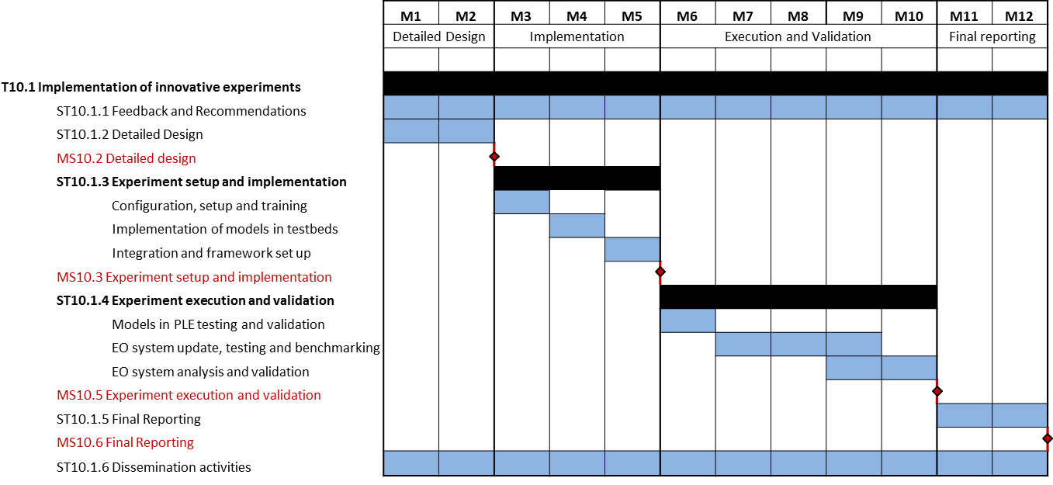

Figure Experiment Schedule

The experiment has been divided into four stages by following the Fed4FIRE timeline:

* **Stage 1: Detailed Design** involves the detailed design of the experiment.
* **Stage 2:** **Experiment Setup and Implementation** is devoted to the configuration and set up of the testbeds, adaptation of the software modules and models for their implementation in Virtual Wall, PlanetLab Europe and BonFIRE.
* **Stage 3:** **Experiment execution and validation** includes the execution of the tests, their validation and analysis.
* **Stage 4:** **Final reporting** involves the final reporting of the experiment.

# Ethical Issues

The GEO-Cloud experiment will follow the ethical guidelines already defined by the Fed4FIRE project. In addition, the experiment does not raise any sensitive ethical questions nor does it include any critical ethical aspects. The documentation generated will be objective and transparent and third parties will be disclosed to access the data collected during the experiment.

Fed4FIRE partners are invited to ethically review and monitor the experiment. Adequate actuations will be carried out for their suggestions and concerns.

# Conclusions

In this deliverable we presented the Problem Statement of the GEO-Cloud experiment and the Requirements defined to succeed on its implementation and execution in Fed4FIRE.

In the first sections of the document we exposed the importance of the Earth Observation field in European Research and the problems that currently presents. Among such problems we find the lack of flexibility and scalability of traditional data centers, characteristics that are necessary to provide on demand services. The GEO-Cloud experiment uses the future internet technologies to find viable solutions to such problems.

The scenario is that of a constellation of Earth Observation satellites that record images of the whole world in a daily basis to provide added value services such as crisis management or emergencies. Such a scenario is implemented in Fed4FIRE to emulate a real system using future internet technology and measure its response and performance when provided on demand services.

For the implementation of the experiment three Fed4FIRE testbeds will be used: PlanetLab Europe, Virtual Wall and BonFIRE. The schedule for the GEO-Cloud implementation and execution is presented in Section 5.

# Bibliography

Armbrust, M. (2010). A view of cloud computing. *Communications of the ACM, Vol. 53, N4*.

Deren, L. (2007). Remote sensing can help monitoring and predication antural disasters, Vol.25, N6.

Simchi-Levi, D., Kaminsky, P., & Simchi-Levy, E. (1999). *Designing and managing the supply chain: concepts, strategies and cases.* McGraw-Hill.