|  |  |  |  |
| --- | --- | --- | --- |
| logofire-standardresolution | jaune | logo_ce-en-rvb-hr | 7plogo |

|  |  |
| --- | --- |
| Project Acronym | **Fed4FIRE** |
| Project Title | **Federation for FIRE** |
| Instrument | **Large scale integrating project (IP)** |
| Call identifier | **FP7-ICT-2011-8** |
| Project number | **318389** |
| Project website | **www.fed4fire.eu** |
| Experiment | **GEO-Cloud** |

**Experiment Procedures**

|  |  |
| --- | --- |
| Work package | WP10 |
| Task | T10.1.2 GEO-Cloud Experiment |
| Due date | 31/01/2014 |
| Submission date | 31/01/2014 |
| Report Lead | Félix Pedrera (DEIMOS) |
| Version | 1.0 |
| Authors | Manuel José Latorre, Antonio Serrano Gómez (DEIMOS) |
| Reviewers | Jonathan Becedas (DEIMOS) |

|  |  |
| --- | --- |
| **Document ID** | **GEO-Cloud-DMS-TEC-TNO02-E** |
| Abstract | This document provides the procedures to be followed before and during implementation and experimentation. |
| Keywords | Deliverable |

|  |  |  |  |
| --- | --- | --- | --- |
| Nature of the document | R | Report | X |
| P | Prototype |  |
| D | Demonstrator |  |
| O | Other |  |
| Dissemination level | PU | Public |  |
| PP | Restricted to other programme participants (including the Commission) |  |
| RE | Restricted to a group specified by the consortium (including the Commision) |  |
| CO | Confidential, only for members of the consortium (including the Commission) | X |

**Disclaimer**

*The information, documentation and figures available in this deliverable, is written by the Fed4FIRE* (Federation for FIRE) *– project consortium under EC co-financing contract FP7-ICT-318389 and does not necessarily reflect the views of the European Commission. The European Commission is not liable for any use that may be made of the information contained herein.*

**Executive Summary**

In this document, the procedures to be followed before and during implementation and experimentation are presented. In the first section it is presented how to get a fed4FIRE account and certificate in order to get access to the testbeds. It is also explained the process to create a first experiment with the aim to test the connectivity between the user and the testbeds.

In the next section, the tools to be used with each testbed are exposed and classified by the phase in the experiment cycle they are employed.

**Acronyms and Abbreviations**

|  |  |
| --- | --- |
| F4F | Fed4FIRE |
| PLE | PlanetLab Europe |
| TBC | To Be Confirmed |
| TBD | To Be Defined |
| VW | Virtual Wall |

**Table of Contents**

[**Disclaimer** 3](#_Toc378865387)

[**Executive Summary** 4](#_Toc378865388)

[**Acronyms and Abbreviations** 5](#_Toc378865389)

[**Table of Contents** 6](#_Toc378865390)

[1 Introduction 7](#_Toc378865391)

[2 Before implementation and experimentation 8](#_Toc378865392)

[3 Implementation and experimentation in the testbeds 9](#_Toc378865393)

[3.1 In PlanetLab Europe (PLE) 9](#_Toc378865394)

[3.2 In BonFIRE 10](#_Toc378865395)

[3.3 In Virtual Wall (VW) 11](#_Toc378865396)

[4 Conclusions 13](#_Toc378865397)

[5 Bibliography 14](#_Toc378865398)

# Introduction

Before the implementation and experimentation, some other tasks shall be carried out. The first one is to get an account and a certificate in fed4FIRE to get access to the testbeds. The steps to achieve this are explained in the first section. It is also explained the process to create a first experiment with the aim to test the connectivity between the user and the testbeds.

During the experiment, the steps to be followed are exposed in the experiment cycle. In each phase of the cycle some tools have to be employed. In this document they are selected and presented. This experiment cycle is shown in Figure 1.

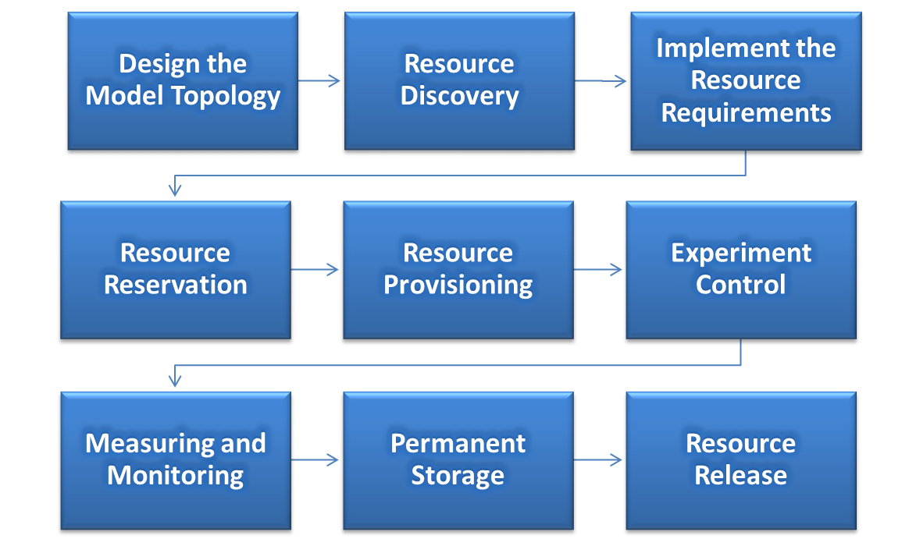

Figure . Experiment Lifecycle.

# Before implementation and experimentation

(To be done only once)

1. Get a fed4FIRE account and certificate. Follow instructions in the following link: <http://doc.fed4fire.eu/getanaccount.html#introduction>
2. Now it is necessary to register for an additional account to use BonFIRE at:

<http://doc.fed4fire.eu/testbeds.html#bonfire>

1. Create SSH key. Follow instructions at:

<http://doc.fed4fire.eu/createsshkey.html>

1. Start up jFed following these instructions:

<http://doc.fed4fire.eu/firstexperiment.html#start-up-jfed>

1. Create the first experiment in jFed to test connectivity with the testbeds (Virtual Wall and BonFIRE):

<http://doc.fed4fire.eu/firstexperiment.html#create-your-first-experiment>

# Implementation and experimentation in the testbeds

## In PlanetLab Europe (PLE)

Experiment lifecycle:

Retrieved and edited from: <http://www.fed4fire.eu/tools.html>

1. **Design the model topology:** Define the nodes, links and their requirements.
2. **Resource discovery:** Finding available resources across all facilities, and acquiring the necessary information to match required specifications.
   * NEPI will be used [link to manual](http://nepi.inria.fr/code/nepi/raw-file/652bc2e46cfe/doc/user_manual/user_manual.pdf)
3. **Implement the resource requirements:** Specification of the resources required during the experiment, including compute, network, storage and software libraries.
   * NEPI will be used [link to manual](http://nepi.inria.fr/code/nepi/raw-file/652bc2e46cfe/doc/user_manual/user_manual.pdf)
4. **Resource reservation:** Allocation of a time slot in which exclusive access and control of particular resources is granted.
   * NEPI will be used [link to manual](http://nepi.inria.fr/code/nepi/raw-file/652bc2e46cfe/doc/user_manual/user_manual.pdf)
5. **Resource provisioning:** Instantiation of resources.
   * NEPI will be used [link to manual](http://nepi.inria.fr/code/nepi/raw-file/652bc2e46cfe/doc/user_manual/user_manual.pdf)
6. **Experiment control:** Control of resource behavior during experiment execution, involving actions to query and modify resource state, and their correct sequencing.
   * NEPI will be used [link to manual](http://nepi.inria.fr/code/nepi/raw-file/652bc2e46cfe/doc/user_manual/user_manual.pdf)
7. **Measuring and monitoring:** Collection of experiment data generated and instrumentation of resources to supervise the behavior and performance of facilities.

* OML will be used [link](http://www.fed4fire.eu/tools/oml.html) (TBC)
  + NAGIOS will be used for the monitoring of the infrastructure. [link 1](http://www.fed4fire.eu/testbeds-and-tools/planetlab-europe.html), [link 2](http://www.fed4fire.eu/tools.html). (TBC)
  + For the monitoring of the network impairments, it is still to be defined if we will adapt the NEPI API, or use Sonoma ([link](http://sonoma.etomic.org))/Top-Hat ([link](http://top-hat.info)).(TBC)

1. **Permanent storage:** Storage of experiment related information beyond the experiment lifetime

* TBD

1. **Resource release:** Release of experiment resources after deletion or expiration the experiment.

* NEPI will be used [link to manual](http://nepi.inria.fr/code/nepi/raw-file/652bc2e46cfe/doc/user_manual/user_manual.pdf)

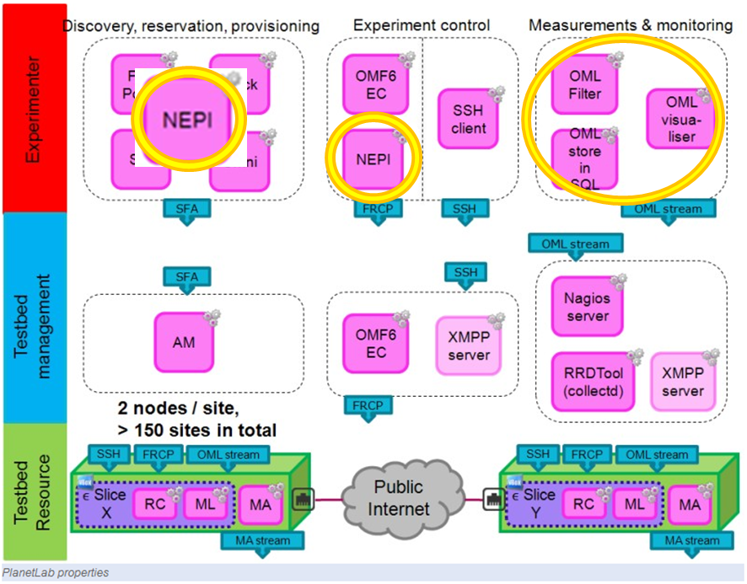

Figure . Selected tools for PlanetLab Europe.

## In BonFIRE

Experiment lifecycle:

Retrieved and edited from: <http://www.fed4fire.eu/tools.html>

1. **Design the model topology:** Define the nodes, links and their requirements.
2. **Resource discovery:** Finding available resources across all facilities, and acquiring the necessary information to match required specifications.
   * fed4FIRE Portal will be used [link](http://www.fed4fire.eu/tools/fed4fire-portal.html)
3. **Implement the resource requirements:** Specification of the resources required during the experiment, including compute, network, storage and software libraries.
   * fed4FIRE Portal will be used [link](http://www.fed4fire.eu/tools/fed4fire-portal.html)
4. **Resource reservation:** Allocation of a time slot in which exclusive access and control of particular resources is granted.
   * fed4FIRE Portal will be used [link](http://www.fed4fire.eu/tools/fed4fire-portal.html)
5. **Resource provisioning:** Instantiation of resources.
   * fed4FIRE Portal ([link](http://www.fed4fire.eu/tools/fed4fire-portal.html)) or jFed ([link](http://jfed.iminds.be/)) will be used
6. **Experiment control:** Control of resource behavior during experiment execution, involving actions to query and modify resource state, and their correct sequencing.
   * OMF ([link](http://www.fed4fire.eu/tools/omf6.html)) or NEPI ([link](http://nepi.inria.fr/code/nepi/raw-file/652bc2e46cfe/doc/user_manual/user_manual.pdf)) will be used
7. **Measuring and monitoring:** Collection of experiment data generated and instrumentation of resources to supervise the behavior and performance of facilities.

* OML ([link](http://www.fed4fire.eu/tools/oml.html)) will be used (TBC)
* Collectd ([link](http://www.fed4fire.eu/tools.html#c219)) is automatically included in each virtual machine. It is still to be defined if Zabbix ([link](http://www.fed4fire.eu/tools.html#c219)) will be used for monitoring.

1. **Permanent storage:** Storage of experiment related information beyond the experiment lifetime

* fed4FIRE Portal will be used [link](http://www.fed4fire.eu/tools/fed4fire-portal.html) (TBC)

1. **Resource release:** Release of experiment resources after deletion or expiration the experiment.

* fed4FIRE Portal will be used [link](http://www.fed4fire.eu/tools/fed4fire-portal.html) (TBC)

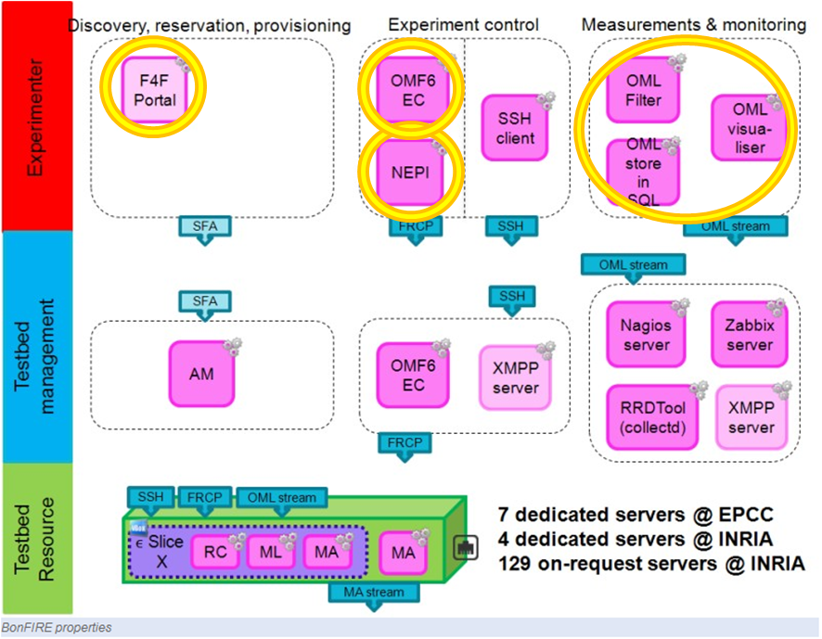

Figure . Selected tools for BonFIRE.

## In Virtual Wall (VW)

Experiment lifecycle:

Retrieved and edited from: <http://www.fed4fire.eu/tools.html>

1. **Design the model topology:** Define the nodes, links and their requirements.
2. **Resource discovery:** Finding available resources across all facilities, and acquiring the necessary information to match required specifications.
   * fed4FIRE Portal will be used [link](http://www.fed4fire.eu/tools/fed4fire-portal.html)
3. **Implement the resource requirements:** Specification of the resources required during the experiment, including compute, network, storage and software libraries.
   * fed4FIRE Portal will be used [link](http://www.fed4fire.eu/tools/fed4fire-portal.html)
4. **Resource reservation:** Allocation of a time slot in which exclusive access and control of particular resources is granted.
   * fed4FIRE Portal will be used [link](http://www.fed4fire.eu/tools/fed4fire-portal.html)
5. **Resource provisioning:** Instantiation of resources.
   * fed4FIRE Portal will be used [link](http://www.fed4fire.eu/tools/fed4fire-portal.html)
6. **Experiment control:** Control of resource behavior during experiment execution, involving actions to query and modify resource state, and their correct sequencing.
   * OMF ([link](http://www.fed4fire.eu/tools/omf6.html)) or NEPI ([link](http://nepi.inria.fr/code/nepi/raw-file/652bc2e46cfe/doc/user_manual/user_manual.pdf)) will be used
7. **Measuring and monitoring:** Collection of experiment data generated and instrumentation of resources to supervise the behavior and performance of facilities.
   * OML ([link](http://www.fed4fire.eu/tools/oml.html)) will be used (TBC)
   * It is still to be defined if Zabbix ([link](http://www.fed4fire.eu/tools.html#c219)) will be used for monitoring.
8. **Permanent storage:** Storage of experiment related information beyond the experiment lifetime

* fed4FIRE Portal will be used [link](http://www.fed4fire.eu/tools/fed4fire-portal.html) (TBC)

1. **Resource release:** Release of experiment resources after deletion or expiration the experiment.

* fed4FIRE Portal will be used [link](http://www.fed4fire.eu/tools/fed4fire-portal.html) (TBC)

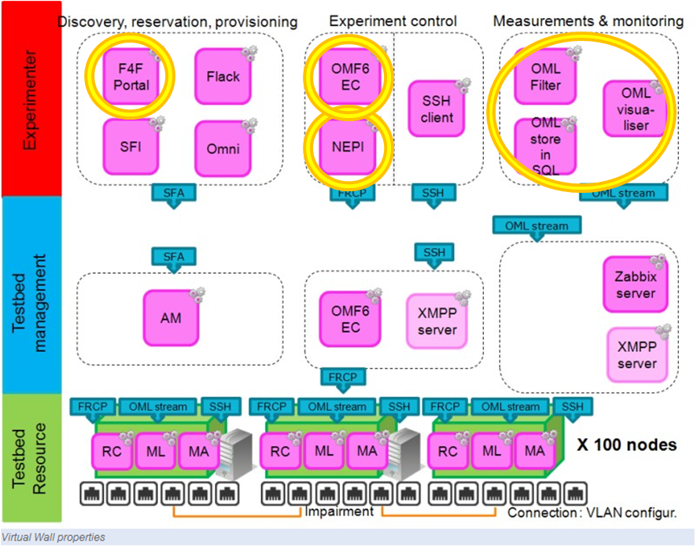

Figure . Selected tools for Virtual Wall.

# Conclusions

In this report, the first steps for the implementation and experimentation of the project have been established. This document will be used as a step by step guide when the experiment reaches these phases. Now, we are familiarized with the different tools to be used within each testbed and it will be easier to carry out the project by following these instructions.

# Bibliography

1. fed4FIRE. [Online] http://www.fed4fire.eu/tools.html.