**1 Introduction:**

Our friends in boulder want to buy a house. They have provided some information on how loans are usually handled. Our job is to investigate further the methods used to provide loans so that we may guide them in choosing the most convenient plan. The information given to us is on the most used mortgage plans.

**2 Investigation of Fixed Rate Mortgages:**

How much would I end up paying after certain amount of time?

Our friends have found a house they desire and need to take out a loan of $750,000. If we assume that the interest rate is of 3% then during the first 5 years after receiving the loan they will have to pay a certain amount of interest. These amounts of interest are found using the interest rate, yearly compounds, and loan amount. Yearly compounds are the number of times in a year in which the interest rate is applied to the previous balance so:

* For 1 yearly compound (1 every year) the balance would be: $869,455 after five years.
* For a 2 per year compound (1 every 6 months) the balance would be: $870,405 after five years.
* For a 4 per year compound the balance would be: $870,888 after five years.
* For a 12 per year compound (1 every month) the balance would be: $871,212 after five years.

There also exists a continuous compound, in which a fixed rate is compounded continuously throughout a year.

* For a continuous interest rate compound, the balance would be: $871,375.682 after five years.

(View Appendix-Section 1.1 for calculations.)

Is there a way to decrease the amount of interest?

Upon review of the differential equation (see appendix section1.2) there is. Assuming you make payments by monthly then this will affect the growth rate of your loan. This makes sense since interest is compounded to whatever the balance is. Therefore, the less the balance the less the interest compounded. In example, if your monthly payment is equal to the interest compounded then your interest compounded is essentially zero, and therefore your balance will not grow.

How much would I be paying?

The size of your payment affects both how much interest will accumulate and how long it will take to finish paying the loan. Assuming $750,000 initial loan, and a monthly payment:

* For a 10 yearlong 3% fixed rate mortgage, the monthly payment due will be: $7,234
* For a 30 yearlong 5% fixed rate mortgage, the monthly payment due will be: $4,022

While having a low payment plan is in a way convenient; low payment also comes at a cost. If we take for example the 30-year fixed rate mortgage then the total interest paid will be $6970,920.

However, if you choose to pay some quantity, say $100,000, up front then the total interest paid reduces to $604,960.

As, you can see there are some advantages to both the ten-year plan and the thirty year plan. For the ten-year plan, you do have a less amount of interest paid (see appendix section1.5) however, the monthly payment is significantly greater than the thirty year monthly payment. So, the trade-off is low monthly payment for high interest or high monthly payment for low interest. (see appendix sections 1.3 – 1.6)

**3. Numerical solutions.**

How long would it take me if I paid, let’s say…, $4,000 in an adjustable plan?

If you decide on paying approx. $4,000 as your monthly payment then the time that it will take you is 34.8 years. An adjustable rate is a rate which depends on time. So, for example, the first five years the rate might stay fixed. After the five years the rate is fixed to one of several public indexes. For the current example of $750,000 as your initial loan amount, rate of 3%, and payment of $4,500 then you would take 22.5 years to pay off the loan. If you decide on the $4,000 then the total interest paid will be $921,360. If you decide to pay the $4,500 then the interest paid will be $ 467,160. (see appendix 2.1-2.2)

**4. Conclusion.**

Dear friends,

Assuming you get a loan of $750,000 and interests are at a record low of 3% then I would recommend not getting a loan and renting. I kid of course; I recommend getting an adjustable rate mortgage. What this will do is set a constant rate of 3% interest for five years. After these five years have passed then the interest rate will be dependent on time. While the interest rate will increase, the first five years saves you from getting a fixed interest rate. And while fixed interest rates are sometimes convenient and less of a hassle, they tend to be very costly if you don’t have the money. Adjustable rates allow for a low monthly payment while reducing some overall interest. If you are willing to pay $4500 a month then by my estimate you will finish paying the loan in 22.5 years.

While having a low monthly payment might be convenient, you usually lose a lot more in the long run. Sometimes you might even pay double what you initially borrowed. Time is money: so, the longer the plan the more zeros. Therefore, I recommend the adjustable rate which in a sense is the sweet spot between length and monthly payment.

Have fun

Ruben Hinojosa Torres.

**4. Appendix**

**Section 1.1 Fixed Rate Mortgages and Continuous compound.**

$$y\left(t\right)={\left(1+\frac{r}{n}\right)}^{nt}y\left(0\right)$$

Assuming $r=0.03$ and $y_{0}=750000$ dollars.

Compute $y\left(5\right)={\left(1+\frac{r}{n}\right)}^{5n}y\left(0\right)$

For $n=1,n=2,n=4,n=12$ w/o any payment.

$$n=1 , y\left(5\right)={\left(1+\frac{0.03}{1}\right)}^{5}750000=\$869,455$$

$$n=2 , y\left(5\right)={\left(1+\frac{0.03}{2}\right)}^{10}750000=\$870,405$$

$$n=4 , y\left(5\right)={\left(1+\frac{0.03}{4}\right)}^{20}750000=\$870,888$$

$$n=12 , y\left(5\right)={\left(1+\frac{0.03}{12}\right)}^{60}750000=\$871,212$$

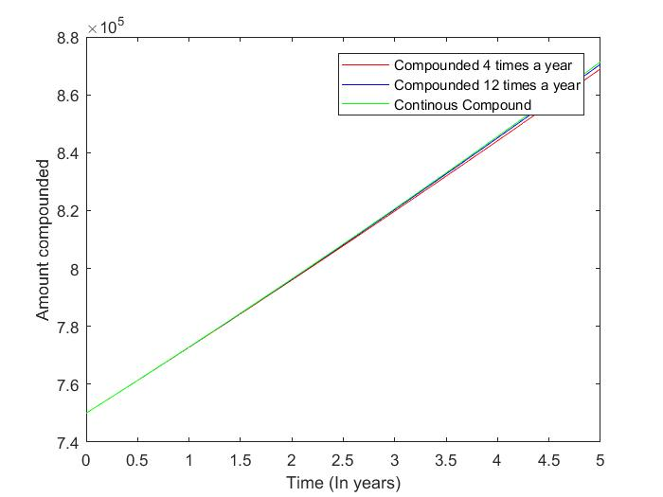Continuous Compound:

$n=∞,y\left(5\right)=750000ⅇ^{-0.03\left(5\right)}=\$871,375$

**Section 1.2 Differential Equation and function behavior.**

First, we have the differential equation.

$$y^{'}=ry-12p$$

Where $r=$ interest rate and $p=$ monthly payments, hence the 12.

$$y^{'}=ry-12p=0$$

$$ry=12p$$

$$p=\frac{ry}{12}$$

**Section 1.3 Solving Differential Equation using Separation of Variables.**

$$y^{'}=ry-12p, \int{\frac{dy}{ry-12p}= \int{dt}}$$

$$if u=ry-12p, du=rdy$$

$$\frac{1}{r}\ln\left(ry-12p\right)=t+c$$

$$\ln\left(ry-12p\right)=e^{rt+c}$$

$$ry=Ce^{rt}+12p$$

$$y=\frac{C}{r}e^{rt}+\frac{12p}{r}, for y\left(0\right)= y_{0}$$

$$y_{0}=\frac{C}{r}+\frac{12p}{r}$$

$$y_{0}r=c+12p, C= y_{0}r-12p$$

$$y\left(t\right)=\left(\frac{y_{0}r-12p}{r}\right)e^{rt}+\frac{12p}{r}$$

**Section 1.4 Monthly Payment.**

$$0=y_{0}e^{rt}-\frac{12p}{r}e^{rt}+12p$$

$$y_{0}e^{rt}-p\left(\frac{12}{r}e^{rt}-\frac{12}{r}\right)$$

$$-y_{0}e^{rt}=-p\left(\frac{12}{r}e^{rt}-\frac{12}{r}\right)$$

P = $$\frac{y_{0}e^{rt}}{\frac{12}{r}e^{rt}-\frac{12}{r}}$$

$$for t=10,r=0.03 and y_{0}=750,000 we have$$

$$p_{10}=\$7,235$$

$$for t=30, r=0.05 and y_{0}=750,000 we have$$

$$P_{30}=\$4,022$$

$$solving for t we find:$$

$$t=\frac{\ln\left(\frac{12p}{12p-ry}\right)}{r}$$

$$we see that:p>\frac{ry_{0}}{12}$$

$$therefore, the payment cannot be below \$3125 for interest rate of r=0.05.$$

**Section 1.5 Price to Pay.**

$$p_{10}≈\$7,234 \left(\frac{12months}{1year}\right)\left(\frac{10years}{1plan}\right)$$

$$interest paid =\$868,080-\$750,000=\$118,080.$$

$$P_{30}≈\left(\frac{12month}{1year}\right)\left(\frac{30year}{1plan}\right)$$

$$interest paid=\$1,447,920-\$750,000=\$697,920$$

**Section 1.6 Paying more up-front.**

$$we look at the interest given if we pay more up front.$$

$$if y_{0}=\$650,000$$

$$for r=0.03, p_{10}≈\$6,270 \left(12\right)\left(10\right)=\$752,400-\$650,000=\$102,400$$

$$for r=0.05, p_{30}≈\$3,486 \left(12\right)\left(30\right)=\$1,254,960-\$650,000=\$604,960$$

$$if we look at the interest difference between both initial values we get interest saved:$$

$$for 10 year plan:\$1180,080-\$102,400=\$15,680$$

$$for 30 year plan:\$697,920-\$604,960=\$92,960$$

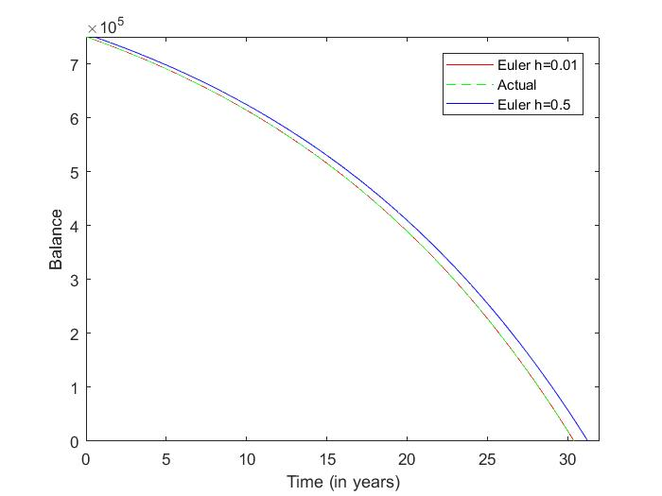**Section 2.1 Numerical solutions.**

(see euler_method.m)

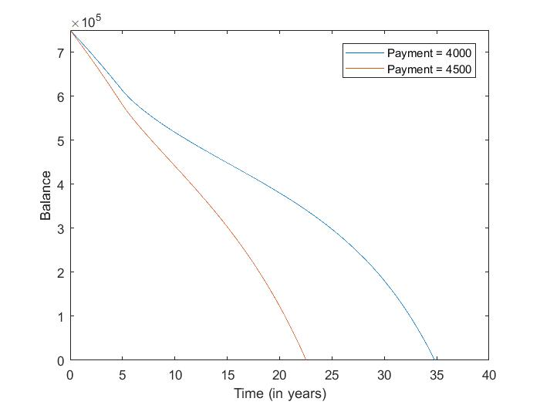 **Section 2.2 Adjustable rate mortgage**

(see euler_method2)

You see that for the first 5 years the interest rate is low or rather constant, but as it moves past t = 5, the interest begins to grow.

**Euler_method.m :**

%Constants

%Initial Loan

yo = 750000;

%Steps per unit time (1/100 of a year)

h = .01; %tn+1 - tn

%Interest rate

r = .05;

%Monthly payments

p = 4000;

%Initial step (just to visualize)

yn = yo + h*(r*yo - 12*p);

%Preparing while Loop \/

n = 1;

%Concatenating.

tn = 0:n;

yt = zeros(1,length(tn));

% Loop

while yn>0

yn = yn + h*(r*yn - 12*p);

yt(n) = yn;

n = n+1;

end

%Plotting.

t = (1:length(yt)+2)*h;

yt = [750000 (yo + h*(r*yo-12*p)) yt];

plot(t,yt,'color','red');

hold on

%Actual line.

yt2 = ((-210000)*exp(0.05*t)+960000);

yt2 = [750000 yt2];

plot(h*(1:length(yt2)),yt2,'linestyle','--','color','green');

axis([0 h*(length(t)+1) 0 750000])

%Time Period.

fprintf('It takes approx %.3f years to pay the loan. \n',(length(yt)+2)*h)

%%

%Constants

%Initial Loan

yo = 750000;

%Steps per unit time (1/2 of a year)

h = .5; %tn+1 - tn

%Interest rate

r = .05;

%Monthly payments

p = 4000;

%Initial step (just to visualize)

yn = yo + h*(r*yo - 12*p);

%Preparing while Loop \/

n = 1;

%Concatenating.

tn = 0:n;

yt = zeros(1,length(tn));

% Loop

while yn>0

yn = yn + h*(r*yn - 12*p);

yt(n) = yn;

n = n+1;

end

%Plotting.

t = (1:length(yt)+2)*h;

yt = [750000 (yo + h*(r*yo-12*p)) yt];

plot(t,yt,'color','blue');

hold on

axis([0 h*(length(t)+1) 0 750000])

legend('Euler h=0.01','Actual','Euler h=0.5');

xlabel('Time (in years)');

ylabel('Balance');

%Time Period.

fprintf('It takes approx %.3f years to pay the loan. \n',(length(yt)+2)*h)

**euler_method2.m :**

%%

%Constants

%Initial Loan

yo = 750000;

%Steps per unit time (1/100 of a year)

h = .01; %100 steps per year.

%Interest rate

r = .03;

%Monthly payments

p = 4000;

%Initial step (just to visualize)

yn = yo + h*(r*yo - 12*p);

%Preparing while Loop \/

n = 1;

%Concatenating.

tn = 0:n;

xt = zeros(1,length(tn));

yt = zeros(1,length(tn));

% Loop

while yn>0

if xt<=(5)

yn = yn + h*(r*yn - 12*p); % -- h = .01 = 1/100

yt(n) = yn;

xt(n) = n*h;

else

r = (.03+.015*sqrt(xt(n-1)-5));

yn = yn + h*(r*yn - 12*p);

yt(n) = yn;

xt(n) = n*h;

end

n = n+1;

end

for_4000 = max(xt)

fprintf('For p=$4000 then interest is %.2f \n',for_4000*12*4000-750000);

plot(xt,yt);

hold on

%%

% yn+1 = yo + h(f(tn,yn))

%%

%Constants

%Initial Loan

yo = 750000;

%Steps per unit time (1/100 of a year)

h = .01; %100 steps per year.

%Interest rate

r = .03;

%Monthly payments

p = 4500;

%Initial step (just to visualize)

yn = yo + h*(r*yo - 12*p);

%Preparing while Loop \/

n = 1;

%Concatenating.

tn = 0:n;

xt = zeros(1,length(tn));

yt = zeros(1,length(tn));

% Loop

while yn>0

if xt<=(5)

yn = yn + h*(r*yn - 12*p); % -- h = .01 = 1/100

yt(n) = yn;

xt(n) = n*h;

else

r = (.03+.015*sqrt(xt(n-1)-5));

yn = yn + h*(r*yn - 12*p);

yt(n) = yn;

xt(n) = n*h;

end

n = n+1;

end

for_4500 = max(xt)

fprintf('For p=$4500 then interest is %.2f \n',for_4500*12*4500-750000);

plot(xt,yt);

hold on

legend('Payment = 4000','Payment = 4500');

axis([0 40 0 750001]);

xlabel('Time (in years)');

ylabel('Balance');

**projectPart1.m**

%Analysis of fixed rate mortgages.

%constant r (fixed rate)

r = 0.03;

%function of t (max 5 years).

t5 = 0:.25:5;

%%

%compounding factor for 4 loan compounds a year:

n = 4;

%compounding function for 4 loan compounds a year:

y4 = ((1+r*t5/n).^n)*750000;

y4(t5==5)

plot(t5,y4,'color','red')

hold on

%%

%compunding factor for 12 loan compounds a year:

n = 12;

%compounding function for 12 loan compounds a year:

y12 = ((1+r*t5/n).^n)*750000;

y12(t5==5)

plot(t5,y12,'color','blue')

hold on

%%

%Interest is compounded continously.

%Compunding function

yC = (750000)*exp(r*t5);

yC(t5==5)

plot(t5,yC,'color','green')

hold on

legend('Compounded 4 times a year','Compounded 12 times a year','Continous Compound')

xlabel('Time (In years)')

ylabel('Amount compounded')