|  |  |  |  |
| --- | --- | --- | --- |
| IST_logo | ***Industrial Processes Automation***  *MSc in Electrical and Computer Engineering*  *Scientific Area of Systems, Decision, and Control*  *Winter Semester 2018/2019* |  | *Group: 6*  ***70547*** *– João Ferreira* ***75268*** *– Rúben Tadeia* ***75987*** *– João Ribafeita* ***80978*** *– Gonçalo Pedro* |

***1st Training Laboratory Work [[1]](#footnote-1)***

***PLC Inputs and Outputs***

*Note: Despite not being graded, it is important to fill this guide. The filling of this guide provides self-assessment of the acquaintance obtained in the lab with the hardware.*

The main objective of the 1st training laboratory is to allow the participants to get familiar with the Programmable Logic Controllers (PLCs) Schneider **Premium**, **TSX P57 1634M** or **2634M**, available in the laboratory. The PLCs have digital input and output modules with the following references: **DEY16D2**, **DSY16T2**, **DMY28FK**. In particular are relevant: a) Using the software development system, *Unity Pro*, b) Setting the PLC initial configuration, c) Using the user manuals from Schneider, d) *Uploading / downloading* programs to/from the PLC, e) Editing and debugging solutions, f) *Interfacing* with external devices.

Hardware to be used in the laboratory: **VCC TROCADO COM O GND**

- PLC P57 with digital **inputs and outputs** made available through a 40-conductors flat cable

- One **40-conductors flat cable** with one side free to strip and screw the wires to a terminal block

- One **terminal block**, 10-way screw down (to help connecting the flat cable wires to a breadboard)

- One **breadboard**, one **7-segments** digit, one **capacitor**, two resistors and/or **potentiometers**

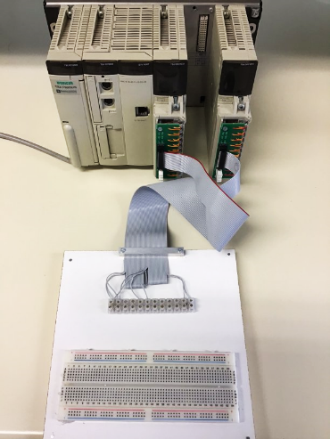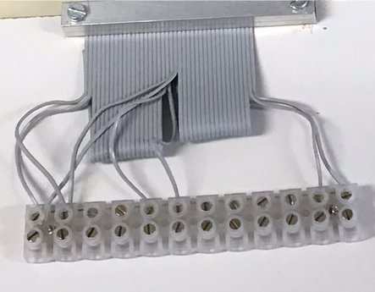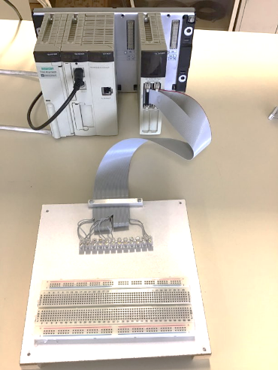

pin1

pin1

pin1

%i0.2.1

%i0.2.0

%q0.4.1

%q0.4.0

Vcc

GND

Fig.1: Two hardware setups, same pinout on the flat cable. For the left setup change names: %i0.2.0→**%i0.3.0**, %i0.2.1→**%i0.3.1**, %q0.4.0→**%q0.3.16**, %q0.4.1→**%q0.3.17**

**Q1. *(****24 VDC external power deliver to the input/output PLC modules)* Using a 2-wires cable, connect the external DC power supply to the breadboard and from there connect to the terminal block (which is already connected to the flat cable). Using the hardware reference manuals (see the course webpage) fill the data in the next tables.

|  |  |  |
| --- | --- | --- |
| Input module name | Point to plug in +24VDC | Point to plug ground |
| DEY 16D2 |  |  |
| DMY28FK |  |  |

|  |  |  |
| --- | --- | --- |
| Output module name | Point to plug in +24VDC | Point to plug ground |
| DSY 16T2 |  |  |
|  |  |  |

**Q2.** *(Connect one digital output to a LED)* Connect one digital output to one of the LEDs of the 7-segments digit. Please choose the right resistor given that the output of the PLC is 24VDC. Use the PLC graphical user interface (Unity Pro) to turn the LED on or off. Discuss how to use the PLC outputs to write the digits 0..9 in the 7-segments display. Discuss how a 74LS47 integrated circuit may help, namely to save PLC digital outputs.

Passa a ser 8-segment.

**Q3.** *(Use PLC inputs)* Use one wire to input +24VDC or ground (GND) to one digital input of the PLC input module. More precisely, the flat cable conducts the signal from the wire to the PLC input module. How does the PLC display indicate an input pin has +24VDC or has GND? How many digital inputs does your PLC have, and what are their physical names?

**Q4.** *(Output and input; time delay)* Mount a resistor and capacitor (RC) series circuit powered by a PLC digital output. More precisely, connect one PLC output bit to a potentiometer (variable resistor) and then connect the potentiometer to a capacitor. Note: it is an electrolytic capacitor, so polarity must be respected by putting the minus terminal connected to the ground. Connect also the capacitor positive terminal to a PLC input. Draw a diagram of the RC series circuit powered (and observed) by the PLC. Charge and discharge the capacitor using the Unity Pro. Indicate the time delay observed from turning on or off the PLC output bit till that on or off is observed in the PLC input bit. How do you set the time delay by configuring the circuit?

Tau = Resistência \* Capacidade

1. *This training problem has no direct contribution to the final grade.* [↑](#footnote-ref-1)