Alma Mater Studiorum - University of Bologna


CYBERSECURITY

Attacker Behavioral Profiling in SSH honeypots

STUDENTS
Rubén Gil Martínez
Jorge Mejías Donoso
Guillermo López Pérez

INDEX
1. INTRODUCTION 3
1.1 BACKGROUND 4
1.2 PROBLEM STATEMENT 4
1.3 RESEARCH QUESTION 4
1.4 OBJECTIVES OF THE STUDY 4
1.5 CONTRIBUTION AND RELEVANCE 5
2. DATASET DESCRIPTION 5
2.1 COWRIE HONEYPOT OVERVIEW 6
2.2 DATASET SOURCES 6
2.3 EVENT SRUCTURE AND LOG FORMAT 6
2.4 DATA LIMITATIONS 7
3. SYSTEM ARCHITECTURE & METHODOLOGY OVERVIEW 8
3.1 END-TO-END WORKFLOW 9
3.2 RATIONALE FOR AN UNSUPERVISED BEHAVIORAL APPROACH 9
3.3 OVERVIEW OF THE FEATURE ENGINEERING STRATEGY 10
3.4 OVERVIEW OF THE MULTI-DENSITY CLUSTERING STRATEGY 10
4. DATA PREPROCESSING PIPELINE 11
4.1 LARGE-SCALE LOG LOADING (DASK PROCESSING) 11
4.2 EVENT NORMALIZATION AND FIELD FLATTENING 11
4.3 CHRONOLOGICAL ORDEING AND SESSION RECONSTRUCTION 12
4.4 CLEANING OPERATIONS (MISSING VALUES, FILTERING, VALIDATION) 13
4.5 FINAL CLEAN EVENT-LEVEL DATASET 13
5 BEHAVIORAL FEATURE ENGINEERING 14
5.1 TEMPORAL FEATURES 15
5.2 COMMAND-BASED FEATURE 15
5.3 Behavioral Indicators (Reconnaissance, Exploitation, Errors) 16
5.4 Feature Scaling and Normalization 18
5.5 Final Feature Matrix (Session-Level Dataset) 18
6. Baseline Unsupervised Approaches 19
6.1 K-Means Exploratory Clustering (Initial Baseline) 19
6.2 Seed-Based Heuristic Labeling profiling 21
6.3 Limitations of Baseline Clustering Approaches 22
7. Advanced Multi-Density Clustering Algorithm 23
7.1 Motivation for Iterative DBSCAN (Density Variation Problem) 23
7.2 Level 1: High-Density Cluster Extraction (Bots) 24
7.3 Level 2: Medium-Density Behaviors (IoT Bots / Semi-Automated Attackers) 25
7.4 Level 3: Low-Density Sessions (Human and Skilled Operators) 26
8. Behavioral Interpretation of Clusters 29
8.1 Profiling Methodology 29
8.2 Cluster Characteristics Overview 30
8.3 Identification of Bots 31
8.4 Identification of Script Kiddies 31
8.5 Identification of Skilled Operators 32
8.6 Outliers and Rare Attack Behaviors 33
9. Evaluation and Discussion 34
9.1 Discriminative Power of the Features and Baseline Comparison 34
9.2 Insights from the Multi-Density Clustering Results 34
9.3 Security Implications and Study Limitations 34
10. Conclusion 34

Introduction
SSH honeypots are widely used in cybersecurity research as controlled environments for monitoring malicious activity on exposed SSH services. These systems capture detailed logs of attacker interactions, including login attempts, command executions, and file transfers. While traditional analyses often focus on aggregated metrics, such as the number of attacks per day or the distribution of attempted passwords, much less attention has been given to understanding attacker behavior at the individual session level.
Understanding how attackers behave once inside a session provides valuable insights into their intent, sophistication, and operational capabilities. Automated bots, inexperienced users (“script kiddies”), and skilled human operators exhibit distinct interaction patterns, including differences in command diversity, timing behavior, reconnaissance depth, and error rates. Profiling these behaviors can significantly support security operations by enabling faster triage, adaptive defensive measures, and prioritization of high-risk adversaries.
This project investigates whether machine learning techniques can be applied to SSH honeypot logs to automatically classify attackers into behavioral profiles based solely on their interaction patterns. By shifting the focus from aggregate attack statistics to per-session behavioral modeling, the study aims to uncover meaningful differences between attacker types and highlight their operational signatures.

1.1 Background
Modern cyberattacks increasingly rely on automation, large-scale credential stuffing, and rapid scanning performed by botnets. Honeypot systems such as Cowrie provide invaluable telemetry to study these activities, as they capture detailed interaction logs from a wide range of adversaries. Previous research has shown that most SSH attacks originate from automated tools; however, although skilled human attackers are significantly less common, they represent a much higher operational threat.
Machine learning has been used extensively to classify network anomalies and detect intrusions, yet its application to behavioral profiling within SSH honeypots remains relatively unexplored. By transforming raw honeypot logs into structured behavioral features, unsupervised learning techniques can uncover latent behavioral patterns that distinguish automated bots, inexperienced users, and skilled operators.

1.2 Problem statement
Existing honeypot analyses focus primarily on high-level statistics rather than on understanding how attackers behave during an individual session. Without a mechanism to distinguish automated activity from human-driven intrusions, defenders may overreact to harmless scanning activity or, conversely, underestimate high-risk adversaries whose actions require escalation.
A further challenge is that honeypot datasets contain no ground-truth labels, making it difficult to characterize attacker types through traditional supervised methods. There is therefore a need for a systematic, data-driven approach capable of extracting behavioral characteristics from SSH honeypot logs and grouping attacker sessions in an automated and meaningful way.

1.3 Research questions
Can machine learning models accurately classify attackers into distinct behavioral profiles (bots, script kiddies, skilled operators) based on their command sequences and interaction patterns within SSH honeypots?

1.4 Objectives of the study
The main objectives of this project are:
- To extract and engineer meaningful behavioral features from raw Cowrie honeypot logs.
- To develop an unsupervised ML pipeline capable of grouping attacker sessions based on their interaction patterns.
- To identify clusters that correspond to different attacker types, such as automated bots, script kiddies, and skilled operators.
- To analyze the discriminative power of temporal, behavioral, and command-based features in distinguishing attacker behaviors.
- To evaluate the security relevance of the resulting attacker profiles and assess their applicability to real-world defensive operations.

1.5 Contribution and relevance
This study contributes to the field of honeypot analysis by shifting the focus from aggregated attack statistics to per-session behavioral modeling. The resulting attacker profiles offer practical value for a wide range of cybersecurity operations:
- Security Operations Centers (SOCs) - prioritizing high-skill intrusions and reducing noise from large-scale automated activity.
- Incident Response teams - identifying sessions that require escalation based on behavioral indicators rather than simple event counts.
- Threat Intelligence analysts - gaining insight into attacker tooling, reconnaissance strategies, and exploitation patterns.
- Honeypot administrators - automating the classification of malicious activity through a reproducible behavioral pipeline.
By providing an end-to-end methodology, from raw logs to unsupervised attacker profiling, this project demonstrates how machine learning, and particularly multi-density clustering techniques, can enhance defensive capabilities in real-world environments.

Dataset description
This project relies on SSH honeypot logs generated by the Cowrie honeypot framework, a widely used medium-interaction honeypot designed to emulate SSH and Telnet services and capture attacker behavior in a controlled environment. The dataset provides detailed, event-level telemetry that enables the reconstruction of complete attacker sessions and the extraction of behavioral patterns.
This section describes the dataset sources, the structure of the logged events, and the inherent limitations that influence the task of attacker behavioral profiling.

2.1 Cowrie honeypot overview
Cowrie is an SSH/Telnet honeypot that records a wide range of attacker interactions, including:
- Login attempts (successful and failed)
- Command inputs and their arguments
- File upload and download events
- Terminal interaction patterns
- Client fingerprint information (e.g., SSH client version, key exchange algorithms)
Unlike low-interaction honeypots, Cowrie produces detailed, session-level logs that allow a fine-grained reconstruction of attacker behavior. Each attacker connection is assigned a unique session_id, enabling the grouping of raw events into meaningful behavioral sequences.
Cowrie is intentionally designed to simulate a vulnerable system, encouraging attackers to freely interact with the environment and reveal their tools, techniques, and procedures (TTPs). This high level of detail makes Cowrie particularly suitable for behavioral profiling and machine learning–based analysis.

2.2 Dataset sources
Two public datasets were considered for this project, as suggested by the assignment:
- CyberLab Honeynet Dataset (Zenodo)
  - 9 months of SSH honeypot activity collected across 50 distributed nodes
  - Contains diverse attacker interactions, including botnet activity and human-driven intrusions
  - JSON logs with timestamps, event types, command inputs, and metadata
- SIHD Smart Industrial Honeypot Dataset (IEEE DataPort)
  - Multi-region honeypot deployment across six geographic locations
  - Log files containing full session details
  - Suitable for cross-geographic behavioral comparisons
Although both datasets were reviewed, the analysis in this project is based on logs following the Cowrie JSON format, as this structure provides the granularity required for detailed behavioral feature extraction and aligns directly with the preprocessing and feature engineering pipeline developed for this study.

2.3 Event structure and log format
Each event in the dataset is represented as a JSON object containing several key fields:
- timestamp → precise time at which the event occurred
- session_id → identifier linking all events belonging to the same attacker interaction
- eventid → event type (e.g., cowrie.command.input, cowrie.login.failed, cowrie.session.file_download)
- message → raw content of the command or event
- additional metadata → protocol details, client information, or file-transfer attributes depending on the event type
Typical event categories recorded by Cowrie include:
- Authentication events
(cowrie.login.failed, cowrie.login.success)
- Command execution events
(cowrie.command.input)
- File transfer events
(cowrie.session.file_download, cowrie.session.file_upload)
- Protocol and reconnaissance indicators
(cowrie.client.version, cowrie.client.kex, cowrie.client.fingerprint)
This event-level granularity enables the reconstruction of complete attacker sessions and supports the extraction of temporal, behavioral, and command-based features required for machine learning–based profiling.

2.4 Data limitations
Despite its usefulness, the dataset exhibits several limitations that must be acknowledged:
- Noise and Incomplete Sessions
Many sessions contain only failed logins or very few commands. These may represent:
  - automated scanning tools
  - aborted connections
  - network noise
Such sessions offer little behavioral value and must be filtered out.
- Variability in Attacker Intent
Cowrie is an emulated environment. Some attackers may:
  - detect the honeypot
  - terminate the connection prematurely
  - behave differently compared to a real system
This can introduce deviations from typical attacker behavior.
- Imbalanced Behavioral Profiles
Most SSH attacks originate from automated bots, meaning that:
  - human operators are rare
  - script kiddies constitute a small fraction
  - clustering algorithms may form dominant “bot clusters”
Interpretation must therefore consider the natural skew of the threat landscape.
- Lack of Ground Truth Labels
The dataset is inherently unlabeled. Attacker categories (bot, script kiddie, skilled operator) must be inferred from behavioral patterns rather than verified labels, making unsupervised learning the appropriate approach.
These limitations guided the design of the preprocessing pipeline and clustering methodology used in this project.

System architecture & methodology overview
The analytical workflow developed in this project follows a modular, end-to-end architecture designed to transform raw Cowrie honeypot logs into meaningful behavioral attacker profiles. The methodology combines large-scale data preprocessing, session reconstruction, behavioral feature engineering, and unsupervised machine learning techniques capable of identifying attacker types without prior labels.
The system is structured into four main stages:
- Data Ingestion and Normalization → Large volumes of JSON event logs are processed using scalable pipelines to ensure correct parsing, flattening of nested structures, chronological ordering, and cleaning of inconsistent records.
- Session Reconstruction and Feature Engineering → Individual events are grouped into coherent attacker sessions, from which temporal, behavioral, and command-based features are extracted. These features capture the rhythm, intent, and sophistication of each attacker interaction.
- Unsupervised Behavioral Modeling – Both exploratory clustering techniques (e.g., K-Means and heuristic seed-based profiling) and an advanced multi-density DBSCAN-based algorithm are applied to uncover natural behavioral patterns across sessions.
- Cluster Interpretation and Attacker Profiling – The resulting clusters are analyzed in terms of their behavioral characteristics to identify groups corresponding to automated bots, script kiddies, and skilled human operators. Dimensionality-reduction techniques (e.g., PCA) support visual examination of cluster separability.
This methodology ensures that each stage builds upon the previous one in a reproducible and scalable manner. The resulting architecture enables the discovery of meaningful attacker profiles grounded in observable behavioral patterns rather than predefined signatures.

3.1 End-to-end workflow
The system follows a structured end-to-end workflow that transforms raw honeypot logs into meaningful behavioral attacker profiles. Each stage of the pipeline contributes a distinct layer of processing, allowing the final clustering results to be grounded in well-defined behavioral signals. The workflow proceeds through the following steps:
- Raw Log Ingestion
Large volumes of Cowrie JSON event logs are collected and loaded using scalable data-processing tools. Nested fields are flattened, malformed records are removed, and timestamps are standardized to ensure consistency.
- Event Ordering and Grouping
All events are chronologically sorted and grouped by their session_id. This step reconstructs each attacker interaction as a coherent sequence, enabling the extraction of timing-related and behavioral metrics.
- Behavioral Feature Engineering
For each reconstructed session, a rich set of temporal, command-based, and behavioral features is computed. These features quantify the attacker's rhythm (e.g., inter-command timing), intent (e.g., reconnaissance vs. exploitation), and sophistication (e.g., command diversity, error rates).
- Feature Scaling and Dimensionality Reduction
The resulting feature matrix is normalized using standard scaling techniques to ensure that clustering algorithms treat all dimensions consistently. Dimensionality-reduction methods such as PCA are applied when necessary to support visualization and cluster interpretability.
- Unsupervised Clustering
Both baseline methods (e.g., K-Means, heuristic seed-based profiling) and an advanced multi-density DBSCAN approach are used to identify groups of sessions exhibiting distinct behavioral patterns. This combination captures both dense bot activity and more irregular human-driven interactions.
- Cluster Characterization and Attacker Profiling
Each cluster is analyzed by examining its feature distributions and typical interaction patterns. Clusters are subsequently mapped to meaningful profiles such as automated bots, script kiddies, or skilled operators. Outliers and rare behaviors are also examined to provide additional insight.
This workflow ensures that every step, from log ingestion to behavioral interpretation, contributes to a coherent and reproducible pipeline capable of capturing the diversity of attacker behaviors present in SSH honeypot environments.

3.2 Rationale for an unsupervised behavioral approach
The dataset contains no ground-truth labels indicating whether a session was generated by a bot, a script kiddie, or a skilled human operator. This absence of verified annotations makes supervised learning unsuitable. An unsupervised approach is therefore required to discover behavioral patterns directly from the data without predefined categories.
In addition, attacker behavior in SSH honeypots is highly heterogeneous: automated bots produce dense and repetitive interactions, while human-driven sessions are sparse and irregular. Unsupervised clustering methods are well suited to capturing this variability by grouping sessions based on similarity in their temporal, behavioral, and command-level features.
This approach enables the identification of meaningful attacker profiles grounded in observable behavior rather than static signatures, supporting a more adaptive and data-driven understanding of adversarial activity.

3.3 Overview of the feature engineering strategy
The feature engineering process focuses on transforming raw event logs into session-level representations that capture meaningful behavioral patterns. Instead of relying on raw commands or log messages, the strategy centers on extracting numerical indicators that reflect timing regularity, interaction complexity, exploration depth, and error tendencies.
The features are grouped into three complementary dimensions:
- Temporal characteristics, describing how quickly and consistently an attacker interacts with the system.
- Command-based indicators, summarizing the diversity and structure of issued commands.
- Behavioral signals, such as error rates or reconnaissance versus exploitation tendencies.
This structured representation enables clustering algorithms to compare attacker sessions using standardized, quantifiable metrics. By condensing each session into a compact feature vector, the approach provides the foundation for identifying distinct behavioral profiles in later stages of the pipeline.

3.4 Overview of the multi-density clustering strategy
Attacker sessions in SSH honeypots exhibit highly uneven density distributions: automated bots generate large volumes of highly repetitive interactions, while human-driven sessions are fewer, irregular, and sparsely distributed in feature space. A single clustering model with fixed density parameters cannot capture this variability.
To address this, the project employs a multi-density clustering strategy based on iterative DBSCAN. The approach extracts the densest behavioral patterns first, typically representing large botnets, and progressively reclusters the remaining, less dense sessions at increasingly relaxed density thresholds. This “peeling” process reveals distinct behavioral groups that would otherwise be overshadowed by dominant automated activity.
By applying DBSCAN in multiple stages, the method separates high-density bot clusters, medium-density semi-automated behaviors, and low-density human sessions in a structured and interpretable manner, forming the basis for meaningful attacker profiling.

Data preprocessing pipeline
The preprocessing pipeline transforms raw Cowrie event logs into a clean, organized, and analysis-ready dataset. Given the volume and heterogeneity of the logs, the process prioritizes scalability, consistency, and the preservation of behavioral information essential for feature extraction. The pipeline operates through sequential steps that prepare event-level records for session reconstruction and subsequent clustering.

The core components of the preprocessing stage include large-scale log ingestion, normalization of event structures, chronological ordering, and filtering of incomplete or irrelevant sessions. These steps ensure that only coherent and meaningful attacker interactions progress to the feature engineering phase, allowing the later modeling stages to operate on reliable and well-structured input data.

4.1 Large-scale log loading (dask processing)
Processing several months of Cowrie logs requires a scalable approach capable of handling large JSON files efficiently. To achieve this, the pipeline uses Dask, which enables parallelized loading and transformation of log batches without exceeding memory limits.
During ingestion, each JSON event is parsed, nested fields are flattened, and inconsistent records are discarded. The use of Dask ensures that the dataset can be processed incrementally, allowing thousands of event files to be combined into a unified structure suitable for downstream normalization and session reconstruction.
This step establishes a reliable foundation for the rest of the pipeline, enabling fast, distributed processing while preserving the integrity of the original log data.

4.2 Event normalization and field flattening
Once the raw logs are loaded, the dataset undergoes a normalization process to ensure structural consistency across all events. The key operations include:
Timestamp Standardization
- Convert all timestamps to a unified format
- Ensure correct parsing for chronological ordering
Schema Alignment
- Enforce consistent field names and types
- Remove malformed or incomplete records
Flattening of Nested Fields
Cowrie stores several fields as lists or nested objects (e.g., encCS, kexAlgs, macCS, client.fingerprint).
These are transformed into flattened string representations to support tabular processing.
Removal of Unnecessary Structural Variability
- Simplifies grouping by session_id
- Ensures feature extraction operates on clean, uniform event rows
This step produces a normalized event-level dataset suitable for accurate ordering and session reconstruction.

4.3 Chronological ordering and session reconstruction
Once events are normalized, they are organized into coherent attacker sessions. This step ensures that every session reflects the true sequence of interactions performed by a single source.
Chronological ordering
Events are sorted by:
- session_id
- timestamp
This guarantees that timing-related features (e.g., inter-command intervals, session duration) are computed accurately.
Session grouping
All events sharing the same session_id are combined into a single session.
A session may contain:
- login attempts
- command inputs
- file transfer actions
- protocol negotiation events
Formation of session timelines
For each session, the event stream is converted into an ordered interaction timeline.
This timeline forms the basis for:
- temporal feature extraction
- behavioral pattern identification
- command-level analysis

4.4 Cleaning operation (missing values, filtering, validation)
After reconstructing sessions, additional cleaning steps ensure that only meaningful and valid interactions are retained for analysis.
Handling missing of invalid values
- Remove events or fields with corrupted timestamps or unparsable content.
- Drop columns with extremely high proportions of missing values (e.g., >90%), which provide no behavioral insight.
Filtering non-informative sessions
Many sessions contain no real interaction (e.g., only failed logins or a single event).
These are excluded because they do not contribute meaningful behavioral features.
Filtering criteria typically include:
- num_commands = 0
- extremely short or empty sessions
- protocol-only handshakes with no activity
Structure validation
- Ensure each session has a consistent chronological order.
- Check that fields required for feature extraction are present and correctly typed.

4.5 Final clean event-level dataset
After all preprocessing steps, the dataset is consolidated into a clean and uniform event-level table that serves as the foundation for behavioral feature extraction.
Key characteristics of the final dataset
- Consistent schema across all events
- Flattened fields with no nested structures
- Chronologically ordered sequences per session
- Filtered records containing only meaningful attacker interactions
- Validated timestamps and metadata suitable for temporal calculations
Structure
Each row represents a single event, containing:
- session_id
- standardized timestamp
- eventid
- normalized message content
- additional cleaned metadata fields
Purpose
This event-level dataset enables:
- accurate reconstruction of session timelines
- computation of temporal, behavioral, and command-based metrics
- reliable input for the feature engineering pipeline in Section 5

5 Behavioral feature engineering
Once the dataset has been cleaned and sessions reconstructed, the next step is to convert each session into a structured set of behavioral indicators. Instead of relying on raw commands or event logs, the feature engineering process extracts numerical metrics that capture how attackers behave while interacting with the honeypot.
The features are designed to reflect three complementary aspects:
- Temporal behavior → how quickly and consistently the attacker issues commands.
- Command-related patterns → the variety and structure of the commands used.
- Operational behavior → tendencies such as reconnaissance, exploitation, or repeated errors.
Each session is ultimately represented as a feature vector summarizing its behavioral footprint. This structured representation enables clustering algorithms to compare sessions objectively and identify groups exhibiting similar interaction patterns.

5.1 Temporal features
Temporal features capture the rhythm and pacing of an attacker’s interaction with the honeypot. These metrics help distinguish automated tools, typically fast, regular, and uniform, from humans, who show slower and more variable timing.
Core temporal indicators
- Session Duration
Time between the first and last event of the session.
→ Long durations often indicate exploration; extremely short ones suggest automated activity.
- Number of Commands
Total commands issued during the session.
→ Bots tend to produce repetitive streams; humans issue fewer but more meaningful commands.
- Inter-Command Timing
Calculated from differences between consecutive command timestamps:
  - mean inter-command time
  - standard deviation
  - maximum interval
→ Bots show very low variance; humans present irregular timing gaps.
- Event Count Per Session
Includes all events (commands, logins, file actions).
→ High counts with uniform pacing are typical of scripted automation.
Command-based features capture the structure, variety, and complexity of the commands issued by an attacker. These indicators reflect the attacker's technical intentions and skill level, helping differentiate between automated tools and human-driven activity.
Purpose:
These temporal metrics form a key foundation for distinguishing automated, semi-automated, and human-driven behaviors during clustering.

5.2 Command-based feature
Command-based features capture the structure, variety, and complexity of the commands issued by an attacker. These indicators reflect the attacker's technical intentions and skill level, helping differentiate between automated tools and human-driven activity.
Normalized command extraction
Before computing features, each command is normalized by:
- removing Cowrie-specific prefixes (e.g., "CMD: "),
- converting to lowercase,
- isolating the base command (e.g., ls, wget, cat, chmod),
- splitting compound commands when needed (pipes, semicolons).
This ensures consistent comparisons across sessions.
Key command-base indicators
- Unique Commands Ratio
unique_commands / num_commands
→ Low ratios indicate repetition (typical of bots); higher values reflect exploratory or interactive behavior.
- Command Diversity
Count of distinct base commands used.
→ Skilled users tend to employ a wider variety of commands.
- Command Frequency Patterns
Detects repetition loops or cycles often produced by automated scripts.
→ Bots show high-frequency repetition of the same command sequence.
- Presence of High-Skill Commands (optional indicator)
Commands such as chmod, scp, wget, or file-system traversal may indicate higher attacker capability.
(No classification is made solely from command presence, but it contributes to behavioral context.)
Purpose
These features quantify how an attacker interacts with the system at the command level, enabling clustering algorithms to recognize differences between scripted automation, low-skill trial behavior, and expert-driven sessions.

5.3 Behavioral Indicators (Reconnaissance, Exploitation, Errors)
Behavioral indicators capture what the attacker attempts to do inside the honeypot, complementing the temporal and command-based metrics. These features help distinguish between reconnaissance-driven automation, trial-and-error behavior, and more purposeful, human-guided actions.
Reconnaissance ratio
Measures how much of the session is spent probing the system.
Typical recon events include:
- directory listings (ls, pwd)
- file inspection (cat, head)
- environment checks (uname, whoami)
A high ratio often corresponds to bots probing system characteristics or humans exploring the environment before acting.
Exploitation ratio
Represents the proportion of actions that attempt to modify the system or retrieve/execute files.
Examples:
- downloading payloads (wget, curl)
- changing permissions (chmod)
- writing or modifying files
Higher values may indicate skilled attackers or malware deployment attempts.
Command error rate
Percentage of commands that result in syntax errors, invalid paths, or unsupported operations.
Interpretation:
- high error rate → associated with script kiddies or poorly configured tools
- low error rate → typical of bots (repetitive and precise) or skilled operators
Login error rate
Ratio of failed logins over total login attempts.
Indicates:
- brute-force or credential-stuffing activity
- automated scanning tools performing wide credential sweeps
Purpose
These indicators summarize the attacker’s operational intent, distinguishing between exploration, exploitation, and ineffective or noisy behavior. Combined with temporal and command-based features, they provide a comprehensive behavioral fingerprint for clustering.

5.4 Feature Scaling and Normalization
Before applying clustering algorithms, all session-level features must be placed on a comparable numerical scale. Without this step, features with larger numeric ranges (e.g., event counts or durations) would dominate distance-based models.
Why scaling is needed?
- Clustering methods such as DBSCAN rely on distance calculations.
- Features like command diversity and timing intervals operate on different scales.
- Standardization ensures that no single feature biases the clustering process.
Scaling method used
The pipeline applies StandardScaler, which transforms each feature as:
$$z= \frac{x- μ​}{σ}$$
This results in:
- mean = 0
- standard deviation = 1
Across all features, making the dataset numerically uniform and suitable for density-based clustering.
Outcome
- All temporal, command-based, and behavioral indicators are expressed in comparable units.
- Clustering algorithms can evaluate similarities based on behavior rather than magnitude differences.
- PCA visualizations become more stable and interpretable.

5.5 Final Feature Matrix (Session-Level Dataset)
After all preprocessing and feature engineering steps, each reconstructed session is transformed into a numerical vector summarizing its behavioral characteristics. This session-level representation serves as the direct input for clustering models.
Structure of the feature matrix
Each row corresponds to one attacker session, and each column represents a behavioral indicator, grouped into:
- Temporal features
(session duration, inter-command timing, event counts)
- Command-based features
(unique commands ratio, command diversity)
- Behavioral indicators
(error rates, reconnaissance vs. exploitation ratios)
Format
- Stored as a clean, tabular dataframe
- Index: session_id
- All features scaled and standardized
- No empty or non-interactive sessions included
Purpose
This matrix provides a compact, comparable behavioral profile for every session, enabling unsupervised algorithms to detect natural groupings and distinguish between automated bots, semi-automated tools, and human-driven activity.

6. Baseline Unsupervised Approaches
Before designing the advanced multi-density clustering algorithm, several baseline unsupervised approaches were explored to obtain an initial view of the attacker landscape and to validate the usefulness of the engineered features.
Two complementary strategies were considered:
- K-Means clustering, to identify compact behavioral groups and obtain interpretable centroids.
- Seed-based heuristic profiling, using a small set of manually inspected sessions as behavioral prototypes for bots, script kiddies, and skilled operators.
These baselines serve two main purposes:
- provide a simple reference against which to compare the advanced method, and
- verify that temporal, command-based, and behavioral features capture meaningful differences between attacker sessions.

6.1 K-Means Exploratory Clustering (Initial Baseline)
K-Means was used as an initial exploratory method to assess whether the engineered features naturally separate attacker sessions into meaningful behavioral groups. Although the algorithm assumes spherical clusters and equal variance, conditions that do not fully hold in this dataset, it provides a fast, interpretable baseline.
Process overview
- Features were scaled using StandardScaler.
- A small range of k values was tested to observe cluster stability.
- Clustering results were projected onto a PCA-reduced space for visualization.
Observations
- K-Means tended to form one large dominant cluster, primarily containing highly automated bot sessions with repetitive behavior.
- Smaller clusters emerged around more irregular or diverse behavior patterns, suggesting the presence of low-skill or semi-interactive attackers.
- The method struggled to capture low-density human activity, confirming the need for more flexible clustering algorithms.
Role as a baseline
While not suitable for final profiling due to density imbalance and irregular cluster shapes, K-Means provides an important reference point:
it confirms that the feature set captures behavioral variation and highlights where simple models fail.
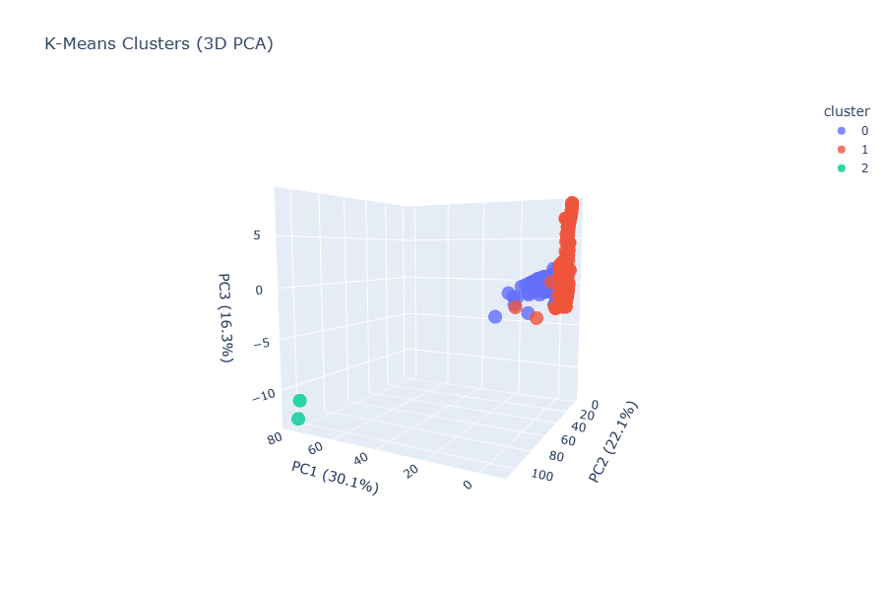
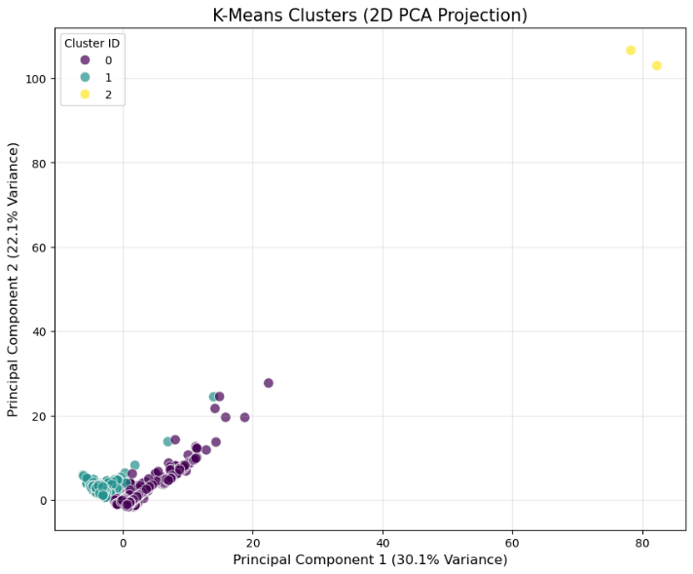

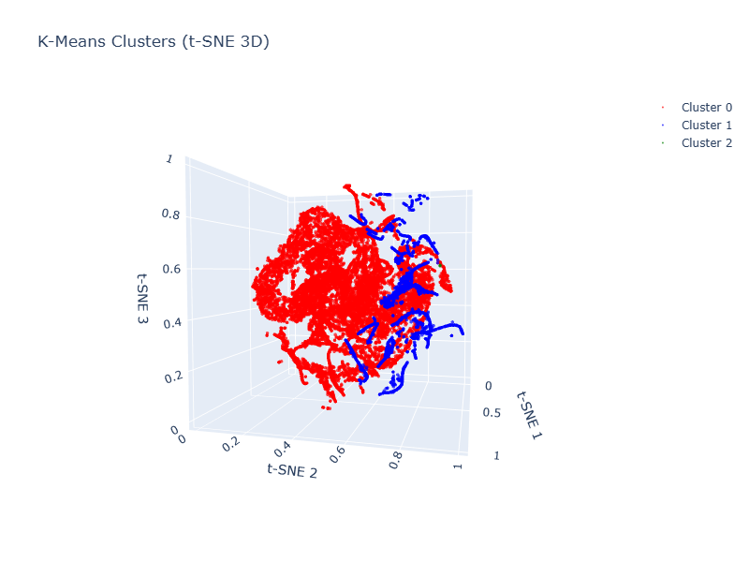

6.2 Seed-Based Heuristic Labeling profiling
To complement the K-Means baseline, a heuristic labeling approach was implemented using a small set of manually inspected sessions as behavioral prototypes. These “seed sessions” serve as reference points for three categories commonly observed in SSH honeypots:
- Automated Bots
Highly repetitive command sequences, minimal diversity, near-zero timing variability.
- Script Kiddies
Short, inconsistent sessions, frequent errors, irregular pacing, and limited command knowledge.
- Skilled Operators
Longer sessions with structured reconnaissance, diverse commands, and purposeful interaction.
Method
- A few representative sessions for each profile were selected from the dataset after manual inspection.
- All features were scaled, and the Euclidean distance from every session to each seed was computed.
- Each session was assigned the label of the closest seed, producing a coarse behavioral categorization.
Purpose and outcome
- The approach provides a lightweight, interpretable baseline to confirm that the feature set captures real behavioral differences.
- It highlights clear distinctions between high-density automated activity and more irregular human-driven sessions.
- These coarse labels are not used as final classifications, but they guide intuition and help validate the need for more advanced clustering.
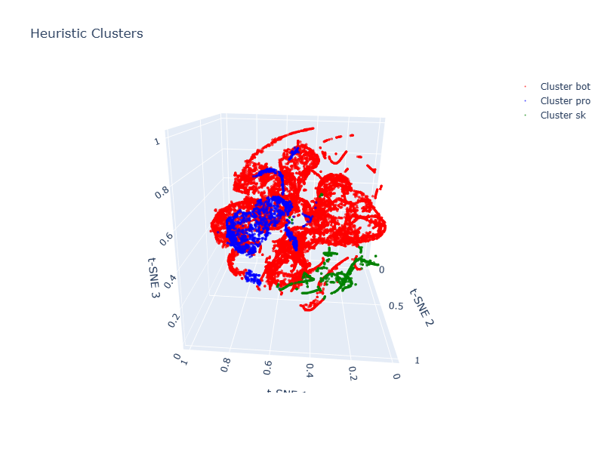

6.3 Limitations of Baseline Clustering Approaches
Although the baseline methods provide useful initial insights, they are not sufficient for producing reliable attacker profiles. Their key limitations include:
Sensitivity to dominant automated activity
The dataset is heavily imbalanced, with automated bots representing the majority of sessions.
Both K-Means and seed-based labeling tend to group most sessions into a single cluster, overshadowing minority behaviors such as human-driven activity.
Inability to capture irregular cluster shapes
Attacker behavior is highly heterogeneous.
- K-Means assumes spherical, evenly sized clusters → unrealistic for this dataset.
- Script kiddie and expert sessions form sparse, irregular patterns that K-Means cannot model.
Dependence on initial assumptions
Seed-based labeling relies on manually chosen prototypes.
- While useful for intuition, it cannot guarantee that these seeds represent the full behavioral diversity of the dataset.
Lack of multi-density handling
Neither approach adapts to varying densities in feature space.
- Dense botnets and sparse human sessions require different density thresholds.
- A single clustering model cannot capture both simultaneously.
Conclusion
Baseline methods help validate that the feature set captures behavioral differences, but their structural limitations justify the transition to a more robust approach, specifically, the multi-density DBSCAN framework introduced in Section 7.

7. Advanced Multi-Density Clustering Algorithm
Given the strong imbalance and heterogeneous structure of attacker behaviors, a more flexible clustering approach is required than traditional single-density models. To address this challenge, the project employs an iterative multi-density clustering algorithm based on DBSCAN, designed to uncover meaningful behavioral groups across varying density levels.
Unlike K-Means or single-stage DBSCAN, this strategy progressively isolates dense clusters, typically representing large-scale automated bot activity, before reapplying clustering on the remaining sessions under progressively relaxed parameters. This “peeling” process enables the discovery of medium-density and low-density behaviors that would otherwise remain overshadowed.
The multi-density algorithm provides a structured way to differentiate:
- High-density automated botnets
- Medium-density semi-automated or tool-assisted attackers
- Low-density human-driven or skilled operator sessions
This approach forms the core of the final attacker profiling methodology, ensuring that clusters reflect genuine behavioral variation rather than artifacts of dataset imbalance.

7.1 Motivation for Iterative DBSCAN (Density Variation Problem)
Attacker behavior in SSH honeypots does not form a uniform or balanced distribution in feature space. Instead, the dataset exhibits strong density variation:
- Large, extremely dense regions generated by automated bots issuing repetitive commands at high speed.
- Medium-density regions corresponding to semi-automated or poorly configured tools.
- Sparse regions containing the irregular and exploratory behavior typical of human attackers.
A single run of DBSCAN with fixed parameters cannot capture this diversity:
- If epsilon is too small, DBSCAN only detects the densest bot clusters and labels most other sessions as noise.
- If epsilon is too large, sparse human-driven sessions merge incorrectly with automated activity, losing behavioral meaning.
- If min_samples is too high, only botnets appear as clusters;
if too low, noise becomes fragmented into artificial micro-clusters.
Because attacker behaviors inhabit multiple density scales simultaneously, a single-density clustering approach inevitably fails to separate meaningful groups.
Why iterative DBSCAN?
The solution is to apply DBSCAN iteratively, peeling off clusters level by level:
- First iteration → captures only the densest structures (large botnets).
- Second iteration → applied to the leftover points, with relaxed parameters, exposing semi-automated behavior.
- Third iteration → isolates low-density human activity.
This approach resolves the density variation problem by adapting the clustering sensitivity to each layer of behavior, enabling the discovery of attacker profiles that would otherwise remain hidden.

7.2 Level 1: High-Density Cluster Extraction (Bots)
The first iteration of the multi-density clustering algorithm focuses on identifying the densest behavioral structures in the dataset. These correspond almost exclusively to automated bot activity, which produces large volumes of highly repetitive commands with minimal timing variation.
Clustering configuration
To isolate only the densest regions, DBSCAN is applied with small epsilon values and high min_samples thresholds.
This configuration ensures that only sessions exhibiting extremely consistent behavior, typical of botnets, form clusters.
Observed characteristics of Level 1 cluster
Sessions captured at this stage share several traits:
- Very low inter-command timing variance
- High command repetition and minimal diversity
- Long sequences of nearly identical events
- Predictable execution patterns consistent with scripted tools
- Large cluster sizes, reflecting widespread automated scanning campaigns
Human-driven or semi-automated sessions do not meet the density requirements and therefore remain unclustered at this stage.
Output of Level 1
- One or more large bot clusters are extracted.
- All remaining sessions are labeled as noise for this iteration and passed on to Level 2.
- This effectively “peels off” the bulk of automated traffic, reducing noise for subsequent clustering steps.

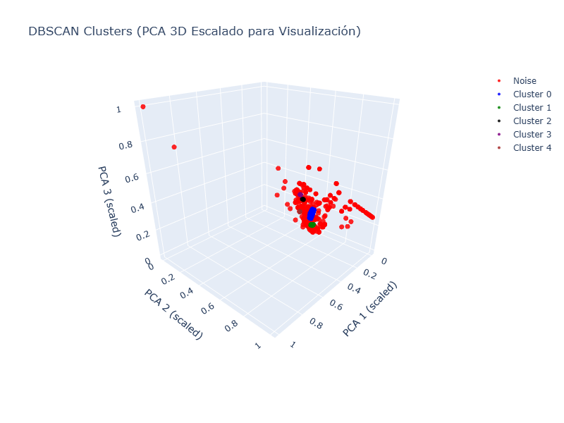

7.3 Level 2: Medium-Density Behaviors (IoT Bots / Semi-Automated Attackers)
After removing the densest automated activity in Level 1, the remaining sessions form a space with lower but still coherent density patterns. These sessions typically correspond to IoT malware, semi-automated tools, or low-sophistication attackers who interact with the system using simple command sequences.
Clustering configuration
DBSCAN is applied again, this time with:
- a larger epsilon,
- a lower min_samples threshold,
reflecting the reduced density of the remaining points.
These relaxed parameters allow the algorithm to detect behavioral groups that are too sparse to form clusters in Level 1, but still consistent enough to represent a distinct attacker profile.
Characteristics of Level 2 Clusters
Typical behaviors observed at this level include:
- Short repetitive sequences characteristic of IoT botnets
- Simple reconnaissance followed by immediate exploitation attempts
- Low to moderate command diversity
- Irregular but still partially automated timing patterns
- Small and medium-sized clusters, indicating distributed malware campaigns or repeated attempts by the same tool family
These sessions reflect automation, but with less precision and uniformity than the large botnets isolated in the first iteration.
Output of Level 2
- Detection of secondary bot families and semi-automated behaviors.
- Reduced noise: only sparsely distributed or highly irregular sessions remain unclustered.
- A clearer separation between low-skill automation and genuinely human-driven behavior, which is addressed in Level 3.


7.4 Level 3: Low-Density Sessions (Human and Skilled Operators)
Once high- and medium-density automated behaviors have been removed in the first two iterations, the remaining sessions are characterized by very low density and high variability. These interactions typically belong to human attackers, script kiddies, or skilled operators, whose behavior is sparse, irregular, and difficult to model with fixed-density parameters.

Clustering configuration
At this final stage, DBSCAN is applied with:
- a lower min_samples value to avoid discarding human sessions as noise
These settings allow the algorithm to detect loose behavioral groupings that reflect genuine human-driven exploration patterns.
Characteristics of Level 3 behaviors
Sessions clustered at this level exhibit traits such as:
- High variability in inter-command timing
(reflecting thinking time, trial-and-error, or manual exploration)
- Greater command diversity
including inspection commands (cat, ls, pwd), tool usage (wget, chmod), and navigation
- Irregular session length
some short and chaotic (script kiddie), others long and structured (skilled operator)
- Higher error rates
often associated with low-skilled users experimenting with commands
- Purposeful, multi-stage interaction
typical of experienced attackers performing reconnaissance before attempting exploitation
Output of Level 3
- Identification of behavioral groups corresponding to low-density, human-oriented activity
- Isolation of skilled operator signatures, often represented as small clusters or even single-session outliers
- Final separation between chaotic, low-skill behavior and deliberate, methodical intrusion attempts
This stage completes the multi-density clustering pipeline by revealing the attacker categories that are normally overshadowed by large-scale automated behavior.

The sessions detected as noise in the final Level 3 iteration are treated as genuine outliers, reflecting behaviors that are markedly distinct from all other clustered patterns. Their irregularity and uniqueness prevent them from forming coherent groups within the feature space.


8. Behavioral Interpretation of Clusters
The multi-density clustering process produces groups of sessions that exhibit distinct interaction patterns within the honeypot. To transform these clusters into meaningful attacker profiles, each group is examined through its characteristic temporal, command-based, and behavioral features.
Rather than relying on predefined categories, the interpretation focuses on identifying consistent behavioral signatures across clusters, such as repetition patterns, command diversity, timing irregularity, and operational intent. This analysis enables the mapping of clusters to common attacker types observed in real SSH intrusion scenarios.
The following subsections describe how each major behavioral category, automated bots, script kiddies, and skilled operators, emerges naturally from the clustered data and how their profiles differ in terms of interaction depth and sophistication.

8.1 Profiling Methodology
To assign meaningful behavioral interpretations to the clusters identified by the multi-density algorithm, each group is analyzed using a structured profiling methodology. The goal is not to force labels onto the data, but to understand how different attacker types manifest through measurable session characteristics.
Steps in the profiling process
- Feature Distribution Analysis
For each cluster, temporal, command-based, and behavioral indicators are examined to detect patterns such as:
  - timing regularity
  - command repetition
  - error frequency
  - exploration vs. exploitation tendencies
- Comparison Across Density Levels
The origin of each cluster (Level 1, Level 2, Level 3) provides context:
  - Level 1 → dense, automated behavior
  - Level 2 → semi-automated or IoT activity
  - Level 3 → human-driven or irregular sessions
- Behavioral Signature Identification
Clusters are evaluated for traits consistent with known attacker archetypes, such as:
  - repetitive automation
  - trial-and-error usage
  - structured reconnaissance
- Cross-Checking With Representative Sessions
A small sample of sessions is inspected within each cluster to verify that:
  - commands align with expected behavior
  - timing patterns match the quantitative features
  - anomalies or outliers are understood in context
Outcome
Using this methodology, each cluster can be linked to a recognizable pattern, automated bot, script kiddie, or skilled operator, grounded in observable and reproducible behavioral evidence rather than subjective interpretation.

8.2 Cluster Characteristics Overview
The clusters obtained through the multi-density DBSCAN algorithm exhibit distinct behavioral patterns that reflect different attacker capabilities and intentions. By examining their shared characteristics, clear distinctions emerge across the clusters identified in Levels 1, 2, and 3.
Level 1 clusters – high density automated bots
- Extremely low variance in inter-command timing
- Long sequences of repetitive commands
- Minimal command diversity
- Large cluster sizes representing widespread automated campaigns
Level 2 clusters – medium density semi-automated behaviors
- Short, partially repetitive command sequences
- Simple reconnaissance combined with quick exploitation attempts
- Moderate timing variability
- Cluster sizes smaller than Level 1, often representing IoT malware or scripted tools
Level 3 clusters – low-density human or mixed interaction
- High variability in timing and session duration
- Increased command diversity, including inspection and navigation
- Presence of errors and trial-and-error behavior
- Very small clusters or isolated sessions, typical of human-driven intrusions
General observations
As density decreases across levels, clusters transition from rigid, automated patterns to flexible, exploratory, and inconsistent behaviors, mirroring the spectrum from bot activity to skilled human operators.

8.3 Identification of Bots
Clusters corresponding to automated bots emerge clearly during the first level of the multi-density process. Their behavior is highly consistent and reflects large-scale scripted activity commonly observed in SSH-targeting malware and scanning frameworks.
Key behavioral traits
- Extremely repetitive command sequences
Bots often loop simple commands or credential attempts with minimal variation.
- Very low timing variance
Inter-command intervals are short and nearly identical, indicating automated execution without human delay.
- Minimal command diversity
Sessions typically rely on a narrow set of commands, such as repeated authentication attempts or basic reconnaissance.
- High event volume
Long streams of commands and login attempts reflect automated brute-forcing or scanning campaigns.
- Large cluster sizes
High-density grouping indicates widespread, uniform behavior coming from many similar malware sources.
Interpretations
These characteristics align with typical SSH botnet activity, where malicious software performs credential stuffing, rapid probing, or scripted exploitation at scale. The consistency and density of these sessions make them straightforward to isolate in Level 1.

8.4 Identification of Script Kiddies
Script kiddie activity appears predominantly in the lower-density regions of the clustering process, particularly within Level 3 and some borderline Level 2 clusters. These sessions exhibit inconsistent, trial-and-error behavior typical of inexperienced users experimenting with commands or attempting simple exploits without a deep understanding of the system.
Key behavioral traits

- High error rates
Frequent invalid commands, mistyped inputs, or unsupported operations.
- Irregular timing patterns
Noticeable pauses or inconsistent spacing between commands, reflecting manual interaction or uncertainty.
- Limited command repertoire
Use of a small set of familiar commands, often focused on basic exploration (ls, pwd, cat) or imitation of known exploit snippets.
- Short and inconsistent session length
Many sessions terminate abruptly after one or two failed attempts.
- Low to moderate command diversity
More varied than bots, but far less structured than skilled operators.
Interpretations
These characteristics align with low-skill attackers who rely on guesswork, copied exploit commands, or shallow understanding of Unix environments. Their behavior is neither fully automated nor strategically organized, resulting in scattered, low-density clusters within the feature space.

8.5 Identification of Skilled Operators
Skilled operators represent the most sophisticated category of attacker behavior identified in the clustering process. Their sessions typically appear within the sparsest regions of Level 3, often forming very small clusters or even isolated outliers due to the uniqueness of their interaction patterns.
Key behavioral traits
- Structured and purposeful command sequences
Skilled attackers perform systematic reconnaissance (uname, whoami, cat /etc/*, directory traversal) followed by logical next steps such as privilege probing or environment inspection.
- High command diversity
Their command set is wider and more versatile, reflecting deeper system knowledge and familiarity with Unix-based environments.
- Longer and more sustained sessions
They spend more time exploring the system, testing capabilities, or preparing exploitation attempts.
- Low error rates
Commands are executed correctly and rarely repeated unnecessarily, indicating technical competence rather than trial-and-error behavior.
- Irregular but intentional timing
Inter-command intervals vary, but in a way consistent with human reasoning, analysis, and decision-making, not randomness.
- Use of higher-level operations
Examples include downloading payloads, inspecting network interfaces, modifying permissions, or navigating the filesystem with precision.
Interpretations
These sessions reflect manual intrusion attempts carried out by attackers who understand their objectives and interact strategically with the honeypot. Their sparse distribution in the feature space indicates that such behavior is rare compared to automated attacks, but highly relevant from a security perspective due to the greater threat posed by skilled human adversaries.

8.6 Outliers and Rare Attack Behaviors
Not all sessions fit neatly into the main behavioral categories identified by the clustering process. A subset of interactions appears as true outliers, typically emerging during the final iteration of the multi-density algorithm or remaining unclustered even after parameter relaxation.
Characteristics of outliers sessions
- Highly unique command sequences
Commands or patterns not seen elsewhere in the dataset, often reflecting custom scripts or manual experimentation.
- Extreme timing irregularities
Long pauses, bursts of activity, or unusual temporal structures that do not resemble either automation or common human behavior.
- Unexpected interaction goals
Attempts to access uncommon directories, use atypical tools, or generate system responses not triggered elsewhere.
- Very short or very long sessions
Some outliers reflect accidental connections; others show lengthy but incoherent exploration.
Possible interpretations
Outliers may represent:
- Skilled attackers using custom tooling
- Misconfigured automated agents behaving differently from mainstream botnets
- Researchers or scanners probing honeypots intentionally
- Noise artifacts, such as partial connections or anomalous log generation
Relevance
Although isolated, these sessions can offer valuable insight into edge-case attacker behavior. Their rarity and unpredictability make them particularly important from a defensive perspective, as they may correspond to emerging malware variants or sophisticated adversaries operating outside typical patterns.

9. Evaluation and Discussion

9.1 Discriminative Power of the Features and Baseline Comparison
The engineered temporal, command-based, and behavioral features proved effective in separating attacker behaviors. Baseline methods (K-Means and seed-based labeling) confirmed that automated bots dominate the feature space and cluster tightly, while more irregular or human-driven interactions scatter across low-density regions.
However, these baseline models struggled with density imbalance and could not capture sparse human behaviors, reinforcing the need for the multi-density DBSCAN approach.

9.2 Insights from the Multi-Density Clustering Results
The advanced clustering framework revealed three consistent behavioral layers:
- High-density automation (large botnets)
- Medium-density semi-automated tools (IoT malware, simple scripts)
- Low-density human-driven activity (script kiddies and skilled operators)
Representative sessions from each group confirmed these interpretations, showing clear differences in timing variability, command diversity, and operational intent.

9.3 Security Implications and Study Limitations
The profiling results highlight which sessions merit prioritization in operational environments, particularly those associated with skilled attackers or rare behavioral patterns.
Key limitations include the lack of ground-truth labels, dataset imbalance, and the inherent constraints of honeypot environments.
Despite these challenges, the clustering pipeline provides a reproducible and scalable method for extracting actionable intelligence from SSH honeypot logs.

10. Conclusion
The multi-density clustering approach developed in this study successfully reveals distinct attacker behaviors within SSH honeypot logs. By combining temporal, command-based, and operational features, the analysis differentiates large-scale automated botnets from semi-automated tools and human-driven intrusions. These findings demonstrate that behavioral profiling offers a more nuanced understanding of malicious activity than traditional aggregate statistics.
From an operational standpoint, the resulting attacker profiles can assist cybersecurity teams in prioritizing responses, focusing attention on sessions that exhibit signs of manual exploration or advanced skill. The methodology’s scalability and reliance on unlabeled data make it practical for real-world environments where attacks are continuous and diverse.

