Alma Mater Studiorum - University of Bologna


CYBERSECURITY

Attacker Behavioral Profiling in SSH honeypots

STUDENTS
Rubén Gil Martínez
Jorge Mejías Donoso
Guillermo López Pérez

INDEX
1. Introduction 4
1.1 Background 4
1.2 Problem statement 4
1.3 Research questions 4
1.4 Objectives of the study 4
1.5 Contribution and relevance 4
2. Dataset description 4
2.1 Cowrie honeypot overview 4
2.2 Dataset sources 4
2.3 Event structure and log format 4
2.4 Data limitations 4
3. System architecture & methodology overview 5
3.1 End-to-end workflow 5
3.2 Rationale for an unsupervised behavioral approach 5
3.3 Overview of the feature engineering strategy 5
3.4 Overview of the multi-density clustering strategy 5
4. Data preprocessing pipeline 5
4.1 Large-scale log loading (dask processing) 5
4.2 Event normalization and field flattening 5
4.3 Chronological ordering and session reconstruction 5
4.4 Cleaning operation (missing values, filtering, validation) 5
4.5 Final clean event-level dataset 5
5. Behavioral feature engineering 5
5.1 Temporal features 5
5.2 Command-based feature 5
5.3 Behavioral Indicators (Reconnaissance, Exploitation, Errors) 5
5.4 Feature Scaling and Normalization 5
5.5 Final Feature Matrix (Session-Level Dataset) 5
6. Baseline Unsupervised Approaches 5
6.1 K-Means Exploratory Clustering (Initial Baseline) 5
6.2 Seed-Based Heuristic Labeling profiling 5
6.3 Limitations of Baseline Clustering Approaches 5
7. Multi-Density Clustering with DBSCAN 5
7.1 Motivation for the Iterative Density-Based Approach 5
7.2 Level 1: High-Density Behavioral Clusters 6
7.2.1 Cluster L1-C0: Behavioral Analysis 6
7.2.2 Cluster L1-C1: Behavioral Analysis 8
7.2.3 Cluster L1-C2: Behavioral Analysis 9
7.2.4 Cluster L1-C3: Behavioral Analysis 10
7.2.5 Cluster L1-C4: Behavioral Analysis 11
7.2.6 Summary of Level 1 Behavioral Groups 12
7.3 Level 2: Medium-Density Behaviors Clusters 12
7.3.1 Cluster L2-C0: Behavioral Analysis 13
7.3.2 Cluster L2-C1: Behavioral Analysis 14
7.3.3 Cluster L2-C2: Behavioral Analysis 15
7.3.4 Summary of Level 2 Behavioral Groups 16
7.4 Level 3: Low-Density Sessions (Human and Skilled Operators) 17
7.4.1 Cluster L3-C0: Behavioral Analysis 17
7.4.2 Cluster L3-C1: Behavioral Analysis 19
7.4.3 Cluster L3-C2: Behavioral Analysis 20
7.4.4 Summary of Level 3 Behavioral Groups 21
7.5 Outliers and Rare Anomalous Sessions 22
7.5.1 Behavioral Characteristics of Outliers 22
7.5.2 Samples of Expert Hackers 23
7.5.3 Samples of Script Kiddies 24
7.5.4 Outlier Bots 25
8. Discussion and Interpretation of Results 26
8.1 Behavioural Insights from Level 1 (High-Density Layer) 26
8.2 Behavioural Insights from Level 2 (Medium-Density Layer) 26
8.3 Behavioural Insights from Level 3 (Low-Density Layer) 27
8.4 Outliers and Rare Behaviors 27
8.5 What the Results Reveal About SSH Attacker Ecosystems 27
8.6 Limitations and Considerations 28
9. Evaluation and Discussion 28
9.1 Discriminative Power of Behavioral Features 28
9.2 Comparison Between Baseline and Multi-Density Clustering 29
9.3 Case Studies of Representative Sessions 30
9.4 Security Implications of Behavioral Profiling 30
9.5 Limitations of the Study 31
10. Conclusion and Future Work 31
10.1 Summary of Findings 31
10.2 Practical Impact for Cybersecurity Operations 32
Overall Conclusion 32

Introduction
SSH honeypots are widely used in cybersecurity research as controlled environments for monitoring malicious activity on exposed SSH services. These systems capture detailed logs of attacker interactions, including login attempts, command executions, and file transfers. While traditional analyses often focus on aggregated metrics, such as the number of attacks per day or the distribution of attempted passwords, much less attention has been given to understanding attacker behavior at the individual session level.
Understanding how attackers behave once inside a session provides valuable insights into their intent, sophistication, and operational capabilities. Automated bots, inexperienced users (“script kiddies”), and skilled human operators exhibit distinct interaction patterns, including differences in command diversity, timing behavior, reconnaissance depth, and error rates. Profiling these behaviors can significantly support security operations by enabling faster triage, adaptive defensive measures, and prioritization of high-risk adversaries.
This project investigates whether machine learning techniques can be applied to SSH honeypot logs to automatically classify attackers into behavioral profiles based solely on their interaction patterns. By shifting the focus from aggregate attack statistics to per-session behavioral modeling, the study aims to uncover meaningful differences between attacker types and highlight their operational signatures.

1.1 Background
Modern cyberattacks increasingly rely on automation, large-scale credential stuffing, and rapid scanning performed by botnets. Honeypot systems such as Cowrie provide invaluable telemetry to study these activities, as they capture detailed interaction logs from a wide range of adversaries. Previous research has shown that most SSH attacks originate from automated tools; however, although skilled human attackers are significantly less common, they represent a much higher operational threat.
Machine learning has been used extensively to classify network anomalies and detect intrusions, yet its application to behavioral profiling within SSH honeypots remains relatively unexplored. By transforming raw honeypot logs into structured behavioral features, unsupervised learning techniques can uncover latent behavioral patterns that distinguish automated bots, inexperienced users, and skilled operators.

1.2 Problem statement
Existing honeypot analyses focus primarily on high-level statistics rather than on understanding how attackers behave during an individual session. Without a mechanism to distinguish automated activity from human-driven intrusions, defenders may overreact to harmless scanning activity or, conversely, underestimate high-risk adversaries whose actions require escalation.
A further challenge is that honeypot datasets contain no ground-truth labels, making it difficult to characterize attacker types through traditional supervised methods. There is therefore a need for a systematic, data-driven approach capable of extracting behavioral characteristics from SSH honeypot logs and grouping attacker sessions in an automated and meaningful way.

1.3 Research questions
Can machine learning models accurately classify attackers into distinct behavioral profiles (bots, script kiddies, skilled operators) based on their command sequences and interaction patterns within SSH honeypots?

1.4 Objectives of the study
The main objectives of this project are:
- To extract and engineer meaningful behavioral features from raw Cowrie honeypot logs.
- To develop an unsupervised ML pipeline capable of grouping attacker sessions based on their interaction patterns.
- To identify clusters that correspond to different attacker types, such as automated bots, script kiddies, and skilled operators.
- To analyze the discriminative power of temporal, behavioral, and command-based features in distinguishing attacker behaviors.
- To evaluate the security relevance of the resulting attacker profiles and assess their applicability to real-world defensive operations.

1.5 Contribution and relevance
This study contributes to the field of honeypot analysis by shifting the focus from aggregated attack statistics to per-session behavioral modeling. The resulting attacker profiles offer practical value for a wide range of cybersecurity operations:
- Security Operations Centers (SOCs) - prioritizing high-skill intrusions and reducing noise from large-scale automated activity.
- Incident Response teams - identifying sessions that require escalation based on behavioral indicators rather than simple event counts.
- Threat Intelligence analysts - gaining insight into attacker tooling, reconnaissance strategies, and exploitation patterns.
- Honeypot administrators - automating the classification of malicious activity through a reproducible behavioral pipeline.
By providing an end-to-end methodology, from raw logs to unsupervised attacker profiling, this project demonstrates how machine learning, and particularly multi-density clustering techniques, can enhance defensive capabilities in real-world environments.
It is important to note that these attacker profiles are not ground-truth identities but behavioral categories inferred from observable interaction patterns.

Dataset description
This project relies on SSH honeypot logs generated by the Cowrie honeypot framework, a widely used medium-interaction honeypot designed to emulate SSH and Telnet services and capture attacker behavior in a controlled environment. The dataset provides detailed, event-level telemetry that enables the reconstruction of complete attacker sessions and the extraction of behavioral patterns.
This section describes the dataset sources, the structure of the logged events, and the inherent limitations that influence the task of attacker behavioral profiling.

2.1 Cowrie honeypot overview
Cowrie is an SSH/Telnet honeypot that records a wide range of attacker interactions, including:
- Login attempts (successful and failed)
- Command inputs and their arguments
- File upload and download events
- Terminal interaction patterns
- Client fingerprint information (e.g., SSH client version, key exchange algorithms)
Unlike low-interaction honeypots, Cowrie produces detailed, session-level logs that allow a fine-grained reconstruction of attacker behavior. Each attacker connection is assigned a unique session_id, enabling the grouping of raw events into meaningful behavioral sequences.
Cowrie is intentionally designed to simulate a vulnerable system, encouraging attackers to freely interact with the environment and reveal their tools, techniques, and procedures (TTPs). This high level of detail makes Cowrie particularly suitable for behavioral profiling and machine learning–based analysis.

2.2 Dataset sources
Two public datasets were considered for this project, as suggested by the assignment:
- CyberLab Honeynet Dataset (Zenodo)
  - 9 months of SSH honeypot activity collected across 50 distributed nodes
  - Contains diverse attacker interactions, including botnet activity and human-driven intrusions
  - JSON logs with timestamps, event types, command inputs, and metadata

- SIHD Smart Industrial Honeypot Dataset (IEEE DataPort)
  - Multi-region honeypot deployment across six geographic locations
  - Log files containing full session details
  - Suitable for cross-geographic behavioral comparisons
Although both datasets were reviewed, the analysis in this project is based on logs following the Cowrie JSON format from CyberLab Dataset, as this structure provides the granularity required for detailed behavioral feature extraction and aligns directly with the preprocessing and feature engineering pipeline developed for this study.

2.3 Event structure and log format
Each event in the dataset is represented as a JSON object containing several key fields:
- timestamp → precise time at which the event occurred
- session_id → identifier linking all events belonging to the same attacker interaction
- eventid → event type (e.g., cowrie.command.input, cowrie.login.failed, cowrie.session.file_download)
- message → raw content of the command or event
- additional metadata → protocol details, client information, or file-transfer attributes depending on the event type
Typical event categories recorded by Cowrie include:
- Authentication events
(cowrie.login.failed, cowrie.login.success)
- Command execution events
(cowrie.command.input)
- File transfer events
(cowrie.session.file_download, cowrie.session.file_upload)
- Protocol and reconnaissance indicators
(cowrie.client.version, cowrie.client.kex, cowrie.client.fingerprint)
This event-level granularity enables the reconstruction of complete attacker sessions and supports the extraction of temporal, behavioral, and command-based features required for machine learning–based profiling.

2.4 Data limitations
Despite its usefulness, the dataset exhibits several limitations that must be acknowledged:
- Noise and Incomplete Sessions
Many sessions contain only failed logins or very few commands. These may represent:
  - automated scanning tools
  - aborted connections
  - network noise
Such sessions offer little behavioral value and must be filtered out.
- Variability in Attacker Intent
Cowrie is an emulated environment. Some attackers may:
  - detect the honeypot
  - terminate the connection prematurely
  - behave differently compared to a real system
This can introduce deviations from typical attacker behavior.
- Imbalanced Behavioral Profiles
Most SSH attacks originate from automated bots, meaning that:
  - human operators are rare
  - script kiddies constitute a small fraction
  - clustering algorithms may form dominant “bot clusters”
Interpretation must therefore consider the natural skew of the threat landscape.
- Lack of Ground Truth Labels
The dataset is inherently unlabeled. Attacker categories (bot, script kiddie, skilled operator) must be inferred from behavioral patterns rather than verified labels, making unsupervised learning the appropriate approach.
These limitations guided the design of the preprocessing pipeline and clustering methodology used in this project.

System architecture & methodology overview
The analytical workflow developed in this project follows a modular, end-to-end architecture designed to transform raw Cowrie honeypot logs into meaningful behavioral attacker profiles. The methodology combines large-scale data preprocessing, session reconstruction, behavioral feature engineering, and unsupervised machine learning techniques capable of identifying attacker types without prior labels.
The system is structured into four main stages:
- Data Ingestion and Normalization → Large volumes of JSON event logs are processed using scalable pipelines to ensure correct parsing, flattening of nested structures, chronological ordering, and cleaning of inconsistent records.

- Session Reconstruction and Feature Engineering → Individual events are grouped into coherent attacker sessions, from which temporal, behavioral, and command-based features are extracted. These features capture the rhythm, intent, and sophistication of each attacker’s interaction.

- Unsupervised Behavioral Modeling – Both exploratory clustering techniques (e.g., K-Means and heuristic seed-based profiling) and an advanced multi-density DBSCAN-based algorithm are applied to uncover natural behavioral patterns across sessions.

- Cluster Interpretation and Attacker Profiling – The resulting clusters are analyzed in terms of their behavioral characteristics to identify groups corresponding to automated bots, script kiddies, and skilled human operators. Dimensionality-reduction techniques (e.g., PCA) support visual examination of cluster separability.
This methodology ensures that each stage builds upon the previous one in a reproducible and scalable manner. The resulting architecture enables the discovery of meaningful attacker profiles grounded in observable behavioral patterns rather than predefined signatures.

3.1 End-to-end workflow
The system follows a structured end-to-end workflow that transforms raw honeypot logs into meaningful behavioral attacker profiles. Each stage of the pipeline contributes a distinct layer of processing, allowing the final clustering results to be grounded in well-defined behavioral signals. The workflow proceeds through the following steps:
- Raw Log Ingestion: Large volumes of Cowrie JSON event logs are collected and loaded using scalable data-processing tools. Nested fields are flattened, malformed records are removed, and timestamps are standardized to ensure consistency.

- Event Ordering and Grouping: All events are chronologically sorted and grouped by their session_id. This step reconstructs each attacker interaction as a coherent sequence, enabling the extraction of timing-related and behavioral metrics.

- Behavioral Feature Engineering: For each reconstructed session, a rich set of temporal, command-based, and behavioral features is computed. These features quantify the attacker's rhythm (e.g., inter-command timing), intent (e.g., reconnaissance vs. exploitation), and sophistication (e.g., command diversity, error rates).

- Feature Scaling and Dimensionality Reduction: The resulting feature matrix is normalized using standard scaling techniques to ensure that clustering algorithms treat all fields consistently. Dimensionality-reduction methods such as PCA and t-SNE are applied when necessary to support visualization and cluster interpretability.

- Unsupervised Clustering: Both baseline methods (e.g., K-Means, heuristic seed-based profiling) and an advanced multi-density DBSCAN approach are used to identify groups of sessions exhibiting distinct behavioral patterns. This combination captures both dense bot activity and more irregular human-driven interactions.

- Cluster Characterization and Attacker Profiling: Each cluster is analyzed by examining its feature distributions and typical interaction patterns. Clusters are subsequently mapped to meaningful profiles such as automated bots, script kiddies, or skilled operators. Outliers and rare behaviors are also examined to provide additional insight. These mappings are interpretative and based solely on behavioral patterns, rather than ground-truth attacker identities.

This workflow ensures that every step, from log ingestion to behavioral interpretation, contributes to a coherent and reproducible pipeline capable of capturing the diversity of attacker behaviors present in SSH honeypot environments.

3.2 Rationale for an unsupervised behavioral approach
The dataset contains no ground-truth labels indicating whether a session was generated by a bot, a script kiddie, or a skilled human operator. This absence of verified annotations makes supervised learning unsuitable. An unsupervised approach is therefore required to discover behavioral patterns directly from the data without predefined categories.
In addition, attacker behavior in SSH honeypots is highly heterogeneous: automated bots produce dense and repetitive interactions, while human-driven sessions are sparse and irregular. Unsupervised clustering methods are well suited to capturing this variability by grouping sessions based on similarity in their temporal, behavioral, and command-level features.
This approach enables the identification of meaningful attacker profiles grounded in observable behavior rather than static signatures, supporting a more adaptive and data-driven understanding of adversarial activity.

3.3 Overview of the feature engineering strategy
The feature engineering process focuses on transforming raw event logs into session-level representations that capture meaningful behavioral patterns. Instead of relying on raw commands or log messages, the strategy centers on extracting numerical indicators that reflect timing regularity, interaction complexity, exploration depth, and error tendencies.
The features are grouped into three complementary dimensions:
- Temporal characteristics, describing how quickly and consistently an attacker interacts with the system.
- Command-based indicators, summarizing the diversity and structure of issued commands.
- Behavioral signals, such as error rates or reconnaissance versus exploitation tendencies.
This structured representation enables clustering algorithms to compare attacker sessions using standardized, quantifiable metrics. By condensing each session into a compact feature vector, the approach provides the foundation for identifying distinct behavioral profiles in later stages of the pipeline.

3.4 Overview of the multi-density clustering strategy
Attacker sessions in SSH honeypots exhibit highly uneven density distributions: automated bots generate large volumes of highly repetitive interactions, while human-driven sessions are fewer, irregular, and sparsely distributed in feature space. A single clustering model with fixed density parameters cannot capture this variability.
To address this, the project employs a multi-density clustering strategy based on iterative DBSCAN. The approach extracts the densest behavioral patterns first, typically representing large botnets, and progressively reclusters the remaining, less dense sessions at increasingly relaxed density thresholds. This “peeling” process reveals distinct behavioral groups that would otherwise be overshadowed by dominant automated activity.
By applying DBSCAN in multiple stages, the method separates into different cluster, and looking at those cluster we were able to obtain different behaviors. This iterative strategy reveals distinct behavioral groups that later analysis can characterize based on command usage, timing regularity, and operational intent.
The goal of the multi-density strategy is not to assign fixed attacker types to each level, but to uncover behavioral groups at different density scales, which can later be interpreted through cybersecurity analysis.

Data preprocessing pipeline
The preprocessing pipeline transforms raw Cowrie event logs into a clean, organized, and analysis-ready dataset. Given the volume and heterogeneity of the logs, the process prioritizes scalability, consistency, and the preservation of behavioral information essential for feature extraction. The pipeline operates through sequential steps that prepare event-level records for session reconstruction and subsequent clustering.
The core components of the preprocessing stage include large-scale log ingestion, normalization of event structures, chronological ordering, and filtering of incomplete or irrelevant sessions. These steps ensure that only coherent and meaningful attacker interactions progress to the feature engineering phase, allowing the later modeling stages to operate on reliable and well-structured input data.

4.1 Large-scale log loading (dask processing)
Processing several months of Cowrie logs requires a scalable approach capable of handling large JSON files efficiently. To achieve this, the pipeline uses Dask, which enables parallelized loading and transformation of log batches without exceeding memory limits.
During ingestion, each JSON event is parsed, nested fields are flattened, and inconsistent records are discarded. The use of Dask ensures that the dataset can be processed incrementally, allowing thousands of event files to be combined into a unified structure suitable for downstream normalization and session reconstruction.
This step establishes a reliable foundation for the rest of the pipeline, enabling fast, distributed processing while preserving the integrity of the original log data.

4.2 Event normalization and field flattening
Once the raw logs are loaded, the dataset undergoes a normalization process to ensure structural consistency across all events. The key operations include:
Timestamp Standardization
- Convert all timestamps to a unified format
- Ensure correct parsing for chronological ordering
Schema Alignment
- Enforce consistent field names and types
- Remove malformed or incomplete records

Flattening of Nested Fields
Cowrie stores several fields as lists or nested objects (e.g., encCS, kexAlgs, macCS, client.fingerprint). These are transformed into flattened string representations to support tabular processing.
Removal of Unnecessary Structural Variability
- Simplifies grouping by session_id
- Ensures feature extraction operates on clean, uniform event rows
This step produces a normalized event-level dataset suitable for accurate ordering and session reconstruction.

4.3 Chronological ordering and session reconstruction
Once events are normalized, they are organized into coherent attacker sessions. This step ensures that every session reflects the true sequence of interactions performed by a single source.
Chronological ordering
Events are sorted by:
- session_id
- timestamp
This guarantees that timing-related features (e.g., inter-command intervals, session duration) are computed accurately.
Session grouping
All events sharing the same session_id are combined into a single session.
A session may contain:
- login attempts
- command inputs
- file transfer actions
- protocol negotiation events

Formation of session timelines
For each session, the event stream is converted into an ordered interaction timeline.
This timeline forms the basis for:
- temporal feature extraction
- behavioral pattern identification
- command-level analysis

4.4 Cleaning operation (missing values, filtering, validation)
After reconstructing sessions, additional cleaning steps ensure that only meaningful and valid interactions are retained for analysis.
Handling missing of invalid values
- Remove events or fields with corrupted timestamps or unparsable content.
- Drop columns with extremely high proportions of missing values (e.g., >90%), which provide no behavioral insight.
Filtering non-informative sessions
Many sessions contain no real interaction (e.g., only failed logins or a single event).
These are excluded because they do not contribute meaningful behavioral features.
Extremely important filtering criteria:
- num_commands = 0
- extremely short or empty sessions
- protocol-only handshakes with no activity
Structure validation
- Ensure each session has a consistent chronological order.
- Check that fields required for feature extraction are present and correctly typed.
These filters remove sessions that are structurally unusable for behavior analysis, without excluding any meaningful behavioral categories.

4.5 Final clean event-level dataset
After all preprocessing steps, the dataset is consolidated into a clean and uniform event-level table that serves as the foundation for behavioral feature extraction.

Key characteristics of the final dataset
- Consistent schema across all events
- Flattened fields with no nested structures
- Chronologically ordered sequences per session
- Filtered records containing only meaningful attacker interactions
- Validated timestamps and metadata suitable for temporal calculations

Structure
Each row represents a single event, containing:
- session_id
- standardized timestamp
- eventid
- normalized message content
- additional cleaned metadata fields
Purpose
This event-level dataset enables:
- accurate reconstruction of session timelines
- computation of temporal, behavioral, and command-based metrics
- reliable input for the feature engineering pipeline in Section 5

5. Behavioral feature engineering
Once the dataset has been cleaned and sessions reconstructed, the next step is to convert each session into a structured set of behavioral indicators. Instead of relying on raw commands or event logs, the feature engineering process extracts numerical metrics that capture how attackers behave while interacting with the honeypot.
The features are designed to reflect three complementary aspects:
- Temporal behavior → how quickly and consistently the attacker issues commands.
- Command-related patterns → the variety and structure of the commands used.
- Operational behavior → tendencies such as reconnaissance, exploitation, or repeated errors.
Each session is ultimately represented as a feature vector summarizing its behavioral footprint. This structured representation enables clustering algorithms to compare sessions objectively and identify groups exhibiting similar interaction patterns.

5.1 Temporal features
Temporal features capture the rhythm and pacing of an attacker’s interaction with the honeypot. These metrics help distinguish automated tools, typically fast, regular, and uniform, from humans, who show slower and more variable timing.
Core temporal indicators
- Session Duration
Time between the first and last event of the session.
→ Long durations often indicate exploration; extremely short ones suggest automated activity.
- Number of Commands
Total commands issued during the session.
→ Bots tend to produce repetitive streams; humans issue fewer but more meaningful commands.
- Inter-Command Timing
Calculated from differences between consecutive command timestamps:
  - mean inter-command time
  - standard deviation
  - maximum interval
→ Bots show very low variance; humans present irregular timing gaps.
- Event Count Per Session
Includes all events (commands, logins, file actions).
→ High counts with uniform pacing are typical of scripted automation.
Command-based features capture the structure, variety, and complexity of the commands issued by an attacker. These indicators reflect the attacker's technical intentions and skill level, helping differentiate between automated tools and human-driven activity.
Purpose:
These temporal metrics form a key foundation for distinguishing automated, semi-automated, and human-driven behaviors during clustering.

5.2 Command-based feature
Command-based features capture the structure, variety, and complexity of the commands issued by an attacker. These indicators reflect the attacker's technical intentions and skill level, helping differentiate between automated tools and human-driven activity.
Normalized command extraction
Before computing features, each command is normalized by:
- removing Cowrie-specific prefixes (e.g., "CMD: "),
- converting to lowercase,
- isolating the base command (e.g., ls, wget, cat, chmod),
- splitting compound commands when needed (pipes, semicolons).
This ensures consistent comparisons across sessions.
Key command-base indicators
- Unique Commands Ratio
unique_commands / num_commands
→ Low ratios indicate repetition (typical of bots); higher values reflect exploratory or interactive behavior.
- Command Diversity
Count of distinct base commands used.
→ Skilled users tend to employ a wider variety of commands.

- Command Frequency Patterns
Detects repetition loops or cycles often produced by automated scripts.
→ Bots show high-frequency repetition of the same command sequence.

- Presence of High-Skill Commands (optional indicator)
Commands such as chmod, scp, wget, or file-system traversal may indicate higher attacker capability.
(No classification is made solely from command presence, but it contributes to behavioral context.)
Purpose
These features quantify how an attacker interacts with the system at the command level, enabling clustering algorithms to recognize differences between scripted automation, low-skill trial behavior, and expert-driven sessions.

5.3 Behavioral Indicators (Reconnaissance, Exploitation, Errors)
Behavioral indicators capture what the attacker attempts to do inside the honeypot, complementing the temporal and command-based metrics. These features help distinguish between reconnaissance-driven automation, trial-and-error behavior, and more purposeful, human-guided actions.
Reconnaissance ratio
Measures how much of the session is spent probing the system.
Typical recon events include:
- directory listings (ls, pwd)
- file inspection (cat, head)
- environment checks (uname, whoami)
A high ratio often corresponds to bots probing system characteristics or humans exploring the environment before acting.

Exploitation ratio
Represents the proportion of actions that attempt to modify the system or retrieve/execute files.
Examples:
- downloading payloads (wget, curl)
- changing permissions (chmod)
- writing or modifying files
Higher values may indicate skilled attackers or malware deployment attempts.

Command error rate
Percentage of commands that result in syntax errors, invalid paths, or unsupported operations.
Interpretation:
- high error rate → associated with script kiddies or poorly configured tools
- low error rate → typical of bots (repetitive and precise) or skilled operators

Login error rate
Ratio of failed logins over total login attempts.
Indicates:
- brute-force or credential-stuffing activity
- automated scanning tools performing wide credential sweeps
Purpose
These indicators summarize the attacker’s operational intent, distinguishing between exploration, exploitation, and ineffective or noisy behavior. Combined with temporal and command-based features, they provide a comprehensive behavioral fingerprint for clustering.

5.4 Feature Scaling and Normalization
Before applying clustering algorithms, all session-level features must be placed on a comparable numerical scale. Without this step, features with larger numeric ranges (e.g., event counts or durations) would dominate distance-based models.
Why scaling is needed?
- Clustering methods such as DBSCAN rely on distance calculations.
- Features like command diversity and timing intervals operate on different scales.
- Standardization ensures that no single feature biases the clustering process.
Scaling method used
The pipeline applies StandardScaler, which transforms each feature as:
$$z= \frac{x- μ​}{σ}$$
Across all features, making the dataset numerically uniform and suitable for density-based clustering.

Outcome
- All temporal, command-based, and behavioral indicators are expressed in comparable units.
- Clustering algorithms can evaluate similarities based on behavior rather than magnitude differences.
- Visualizations become more stable and interpretable.

5.5 Final Feature Matrix (Session-Level Dataset)
After all preprocessing and feature engineering steps, each reconstructed session is transformed into a numerical vector summarizing its behavioral characteristics. This session-level representation serves as the direct input for clustering models.
Structure of the feature matrix
Each row corresponds to one attacker session, and each column represents a behavioral indicator, grouped into:
- Temporal features
(session duration, inter-command timing, event counts)
- Command-based features
(unique commands ratio, command diversity)
- Behavioral indicators
(error rates, reconnaissance vs. exploitation ratios, file transfer rates)
Format
- Stored as a clean, tabular dataframe
- Index: session_id
- All features scaled and standardized
- No empty or non-interactive sessions included
Purpose
The feature matrix does not imply attacker identity by itself; instead, it provides a behavioral representation that enables cluster-level interpretation.

6. Baseline Unsupervised Approaches
Before designing the advanced multi-density clustering algorithm, several baseline unsupervised approaches were explored to obtain an initial view of the attacker landscape and to validate the usefulness of the engineered features.
Two complementary strategies were considered:
- K-Means clustering, to identify compact behavioral groups and obtain interpretable centroids.
- Seed-based heuristic profiling, using a small set of manually inspected sessions as behavioral prototypes for bots, script kiddies, and skilled operators.
These baselines serve two main purposes:
- provide a simple reference against which to compare the advanced method, and
- verify that temporal, command-based, and behavioral features capture meaningful differences between attacker sessions.

6.1 K-Means Exploratory Clustering
K-Means was used as an initial exploratory method to assess whether the engineered features naturally separate attacker sessions into meaningful behavioral groups. Although the algorithm assumes spherical clusters and equal variance, conditions that do not fully hold in this dataset, it provides a fast, interpretable baseline.
Process overview
- Features were scaled using StandardScaler.
- A small range of K values was tested to observe cluster stability.
- Clustering results were projected onto a PCA-reduced and t-SNE-reduced space for visualization.
Observations
- K-Means tended to form one large dominant cluster, primarily containing highly automated bot sessions with repetitive behavior.
- Smaller clusters emerged around more irregular or diverse behavior patterns, suggesting the presence of low-skill or semi-interactive attackers.
- The method struggled to capture low-density human activity, confirming the need for more flexible clustering algorithms.
Role as a first approach
While not suitable for final profiling due to density imbalance and irregular cluster shapes, K-Means provides an important reference point: it confirms that the feature set captures behavioral variation and highlights where simple models fail.
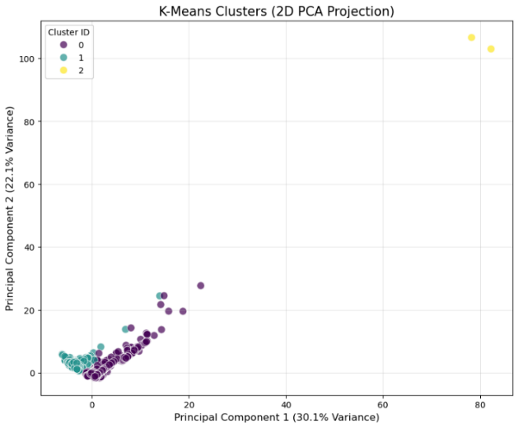
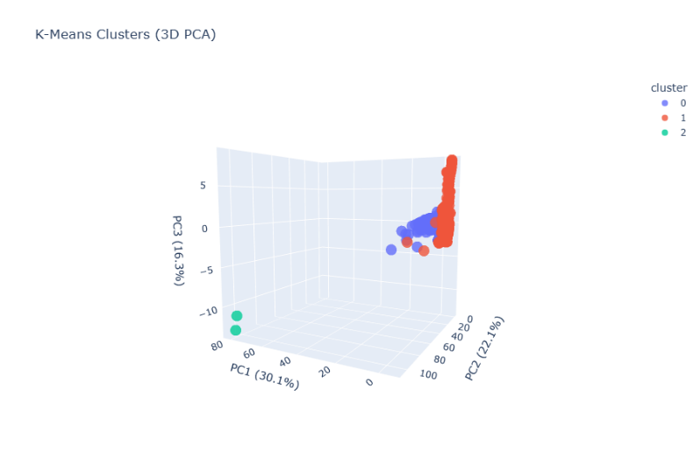

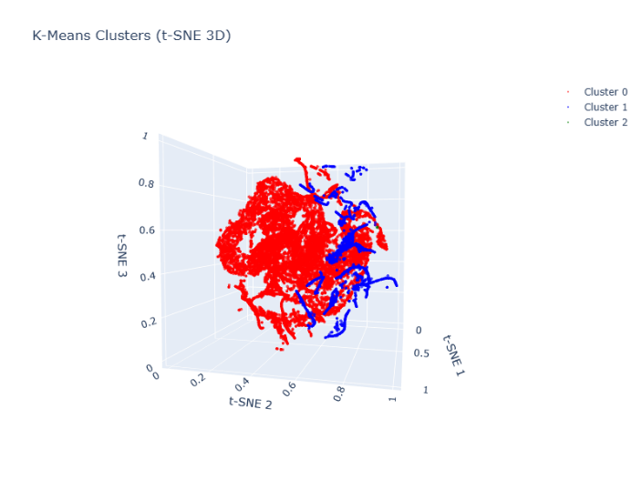

6.2 Seed-Based Heuristic Labeling profiling (Baseline)
To complement the K-Means first approach, a heuristic labeling approach was implemented using a small set of manually inspected sessions as behavioral prototypes. These “seed sessions” serve as reference points for three categories commonly observed in SSH honeypots:
- Automated Bots
Highly repetitive command sequences, minimal diversity, near-zero timing variability.

- Script Kiddies
Short, inconsistent sessions, frequent errors, irregular pacing, and limited command knowledge.

- Skilled Operators
Longer sessions with structured reconnaissance, diverse commands, and purposeful interaction.
Method
- A few representative sessions for each profile were selected from the dataset after manual inspection.
- All features were scaled, and the Euclidean distance from every session to each seed was computed.
- Each session was temporarily labeled with the closest seed profile, producing a coarse behavioral approximation used only for exploratory analysis.
Purpose and outcome
- The approach provides a lightweight, interpretable baseline to confirm that the feature set captures real behavioral differences.
- It highlights clear distinctions between high-density automated activity and more irregular human-driven sessions.
- These coarse labels are not used as final classifications, but they guide intuition and help validate the need for more advanced clustering.
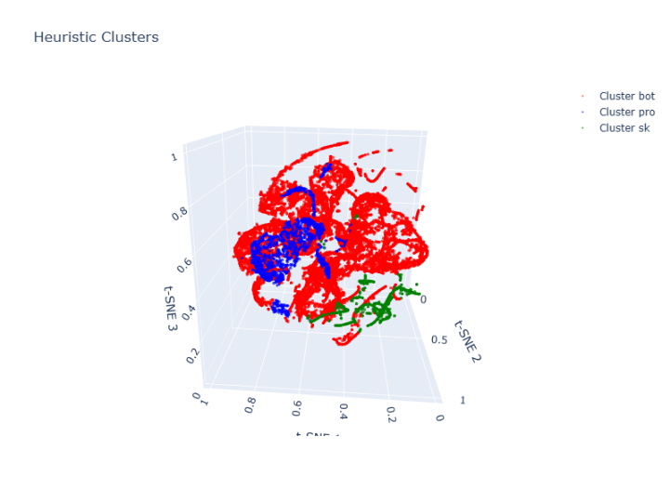

6.3 Limitations of Baseline Clustering Approaches
Although the baseline methods provide useful initial insights, they are not sufficient for producing reliable attacker profiles. Their key limitations include:
Sensitivity to dominant automated activity
The dataset is heavily imbalanced, with automated bots representing the majority of sessions.
Both K-Means and seed-based labeling tend to group most sessions into a single cluster, overshadowing minority behaviors such as human-driven activity.
Inability to capture irregular cluster shapes
Attacker behavior is highly heterogeneous.
- K-Means assumes spherical, evenly sized clusters → unrealistic for this dataset.
- Script kiddie and expert sessions form sparse, irregular patterns that K-Means cannot model.
Dependence on initial assumptions
Seed-based labeling relies on manually chosen prototypes.
- While useful for intuition, it cannot guarantee that these seeds represent the full behavioral diversity of the dataset.
Lack of multi-density handling
Neither approach adapts to varying densities in feature space.
- Dense botnets and sparse human sessions require different density thresholds.
- A single clustering model cannot capture both simultaneously.
Conclusion
Baseline methods help validate that the feature set captures behavioral differences, but their structural limitations justify the transition to a more robust approach, specifically, the multi-density DBSCAN framework introduced in Section 7.

7. Multi-Density Clustering with DBSCAN
DBSCAN was used as the main clustering method because it can detect behavioral groups of different densities and naturally isolate noise. SSH honeypot data contains highly uneven patterns: some behaviors appear in thousands of sessions, while others are rare or irregular. A single clustering pass cannot capture this variability.
To handle this, an iterative multi-density procedure was applied:
- Level 1: extracts the most frequent and highly consistent behaviors.
- Level 2: re-clusters the noise from Level 1 using relaxed parameters to reveal medium-density patterns.
- Level 3: analyzes the remaining noise to expose rare or low-density behaviors.
This step-by-step approach separates dominant, moderate, and rare behaviors, making each group easier to analyze.
The following sections examine each cluster from each level, describing its main characteristics and command patterns before moving to higher-level interpretation.

7.1 Motivation for the Iterative Density-Based Approach
SSH honeypot sessions do not form a single homogeneous behavioral space. Some behaviors are extremely common and repetitive, while others occur only a handful of times, making the dataset highly variable in density. Traditional methods such as K-Means assume uniform cluster structure and force all data into groups of similar size, causing dominant behaviors to overshadow less frequent ones.
DBSCAN overcomes this limitation by identifying clusters of different densities and labeling inconsistent sessions as noise. However, a single run still tends to capture only the densest structures. For this reason, an iterative pipeline was used: after extracting high-density clusters, the remaining noise is re-clustered with relaxed parameters, progressively revealing medium- and low-density behavioral groups.
This multi-level strategy ensures that both widespread automated patterns and rare, irregular behaviors are captured and analyzed separately.

7.2 Level 1: High-Density Behavioral Clusters
Level 1 applies DBSCAN with strict parameters to isolate the most frequent and internally consistent behaviors in the dataset. These clusters represent interaction patterns that repeat across many sessions and display low variance in timing, command usage, and sequence structure.
The PCA visualization of Level 1 shows several compact and well-defined clusters surrounded by a wide noise region. The dense clusters correspond to highly stable behaviors, while the noise consists of heterogeneous sessions that lack sufficient similarity to be grouped at this stage.
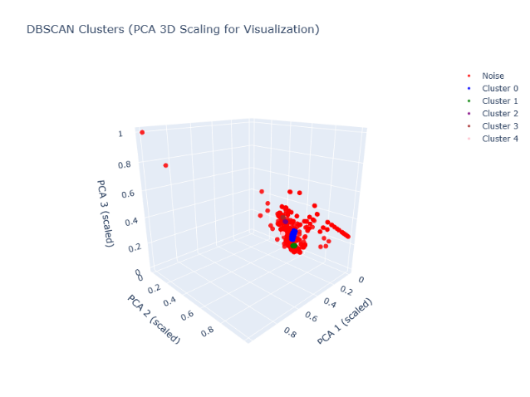
Each Level 1 cluster is analyzed individually in the following subsections, examining:
- quantitative characteristics (size, variance, timing metrics)
- dominant command patterns
- internal behavioral consistency

7.2.1 Cluster L1-C0: Behavioral Analysis
Cluster L1-C0 is the largest and most coherent high-density group identified in Level 1.
Its sessions show very low variance in timing and command order, indicating a highly automated and stable interaction pattern.
Cluster Characteristics
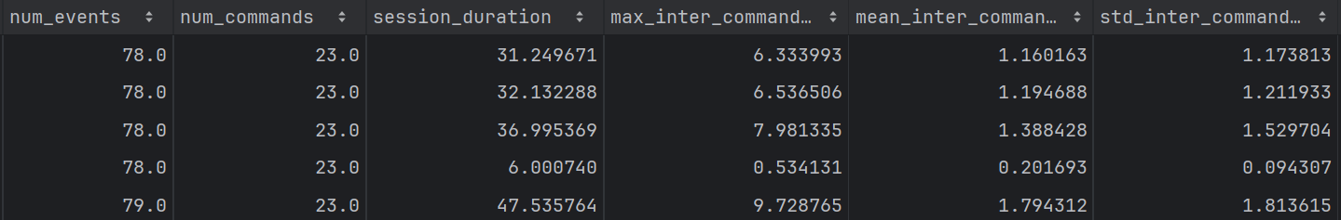
Sessions in this cluster:
- execute commands with regular timing,
- follow nearly identical sequences,
- perform consistent system-modification actions.
Command and Behavior Analysis
A representative session reveals a structured sequence of actions:
System inspection:
- cat /proc/cpuinfo, lscpu. Used to profile CPU architecture and environment characteristics.
Privilege modification:
- echo "root:gm8fN4LptkJH" | chpasswd. Direct password-change attempt.
Temporary staging:
- Creation of /var/tmp/.varXXXXX. Typical location for automated script staging.
Persistence checks:
- crontab -l
Reconnaissance:
- w, top, uname, uname -a
Payload execution:
- Base64-encoded command ("IyEvYmluL..."). Indicates execution of an obfuscated or downloaded payload.
Summary
Cluster L1-C0 displays a complete compromise sequence, reconnaissance, privilege changes, staging, and payload execution, performed with high consistency across sessions.
Its behavior is strongly aligned with automated attack scripts, though no ground-truth identity is assumed.

7.2.2 Cluster L1-C1: Behavioral Analysis
Cluster L1-C1 displays a behavioral structure highly similar to Cluster L1-C0, forming another dense and internally consistent group. Timing regularity and command ordering again indicate a fully automated sequence with minimal variability across sessions.
Cluster Characteristics
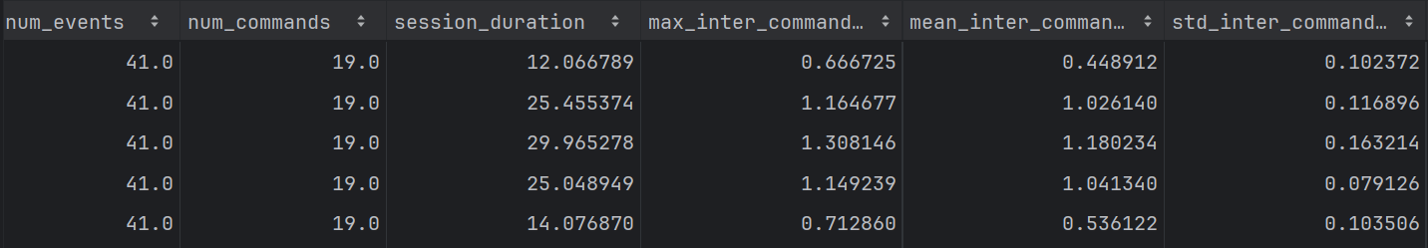
Sessions in this cluster:
- follow nearly identical execution flows,
- repeat the same reconnaissance and staging procedures,
- differ mainly in how credentials or commands are issued.
Command and Behavior Analysis
Inspection of representative sessions shows a workflow closely mirroring L1-C0:
System fingerprinting:
- cat /proc/cpuinfo, lscpu. Environmental checks identical to those in L1-C0.
Staging and temporary workspace:
- Activity in /var/tmp. Used for transient files and script preparation.
Persistence checks:
- crontab -l
Reconnaissance:
- w, top, uname -a. Collects system and user information.
Credential testing instead of direct password change
Instead of executing a chpasswd command, sessions send credential-like strings (e.g., via echo or file creation), possibly probing a vulnerable script or external authentication component.
Summary
Cluster L1-C1 represents a behavioral variant of the same automated attack pattern observed in Cluster L1-C0. The intrusion flow is nearly identical, with minor differences in how credential actions are performed. These variations suggest different stages, modules, or configurations of the same automated tooling, without implying any ground-truth identity.

7.2.3 Cluster L1-C2: Behavioral Analysis
Cluster L1-C2 contains short and highly consistent sessions characterized by rapid environment probing. Unlike previous clusters, these interactions are brief but structured, suggesting a lightweight automated routine focused on capability detection rather than full compromise.
Cluster Characteristics
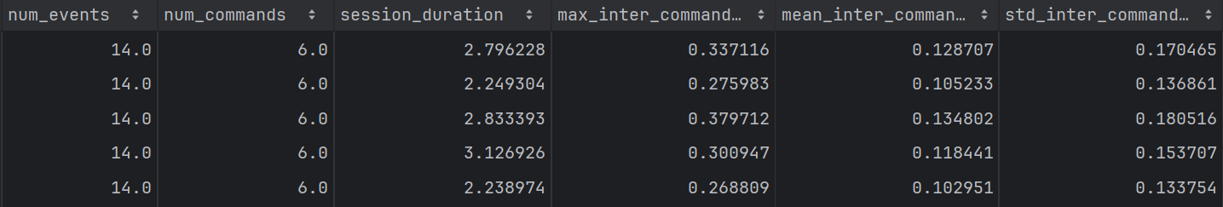
Sessions in this cluster exhibit:
- minimal command diversity,
- extremely short execution time,
- compact and repetitive interaction structure.
Command and Behavior Analysis
Interactive shell probing:
Attempts to initialize a shell or test whether the environment accepts interactive input.
Command availability checks:
Typical sequences such as:
- enable
- system
- sh
Used to determine available tools.
BusyBox verification:
- /bin/busybox SATORI
BusyBox checks are common preprocessing steps in IoT-targeting malware to adapt payloads to constrained systems.
Architecture identification:
Commands used to infer CPU type or OS variant, helping automated scripts select the correct binary.
Summary
Cluster L1-C2 reflects a quick capability-assessment workflow, focused on determining what tools are present and what architecture the device uses. This pattern aligns with behaviors commonly observed in lightweight IoT-targeting malware families, including Mirai/Satori-style routines, although no specific attribution is assumed.

7.2.4 Cluster L1-C3: Behavioral Analysis
Cluster L1-C3 forms another compact high-density group whose sessions closely match the interaction structure observed in Cluster L1-C2. These sessions are short, highly repetitive, and dominated by capability checks rather than full compromise attempts.
Cluster Characteristics
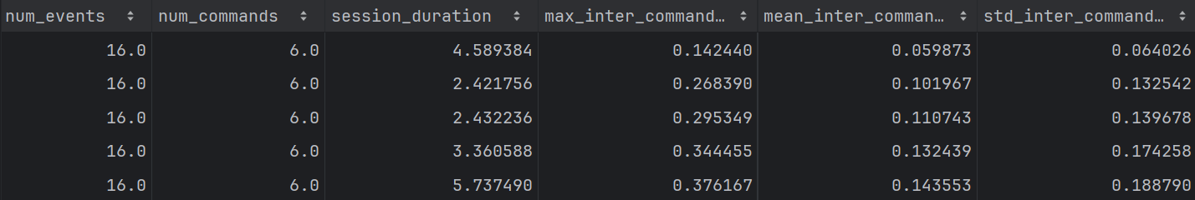
Sessions in this cluster show:
- low variability across executions,
- minimal command diversity,
- a consistent short probing sequence.
Command and Behavior Analysis
Representative sessions reveal virtually the same workflow identified in L1-C2
Capability probing:
- checks for available tools (which wget, which sh, etc.)
BusyBox verification:
Repeated BusyBox detection, a common preprocessing step in IoT-oriented malware.
Architecture fingerprinting:
Commands gathering minimal system details to choose the appropriate payload.
Short, direct execution:
The sequence ends after probing, without showing extended exploitation or lateral movement attempts.

Summary
Cluster L1-C3 appears to be a behavioral variant of the same lightweight IoT probing routine found in Cluster L1-C2. While feature values differ slightly, the overall pattern, short sessions, BusyBox checks, capability probing, and minimal interaction, is nearly identical. These behaviors are consistent with Mirai/Satori-style probing logic, though no definitive attribution is assumed.

7.2.5 Cluster L1-C4: Behavioral Analysis
Cluster L1-C4 represents a distinct high-density pattern focused on filesystem probing and environment preparation. Sessions are longer and slightly more diverse than the lighter probing routines seen in L1-C2 and L1-C3, but still exhibit a consistent, automated structure.
Cluster Characteristics
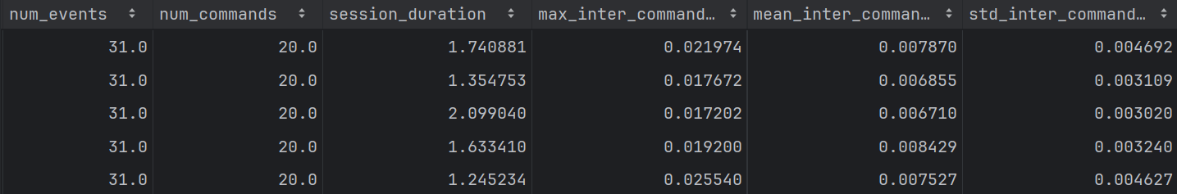
Typical properties of this cluster include:
- repeated directory traversal,
- systematic testing of writable paths,
- limited variation across sessions.
Command and Behavior Analysis
Representative sessions display a structured staging workflow.
Shell initialization attempts:
- sh, system, ping ; sh. Used to force a usable command environment.
Write-permission testing across directories:
Targets multiple system paths:
- /tmp, /var, /dev, /etc, /usr, /boot, /sys, / Automated scripts often probe these locations to determine where files can be created or modified.
Creation of dummy files:
- t, .t, retrieve Used to detect writable directories and confirm file operation capabilities.
BusyBox deployment attempts: Copies BusyBox binaries into accessible locations to embed a multi-purpose toolset for later actions.
Filesystem scanning for persistence: The session repeatedly inspects directories where malware is commonly installed or executed.

Summary
Cluster L1-C4 reflects a structured filesystem-probing routine, aimed at identifying writable paths and suitable persistence locations before deploying additional components.
Its consistent probing pattern is characteristic of automated staging scripts, although no specific malware identity is assumed.

7.2.6 Summary of Level 1 Behavioral Groups
Level 1 reveals a set of dense and highly consistent behavioral clusters, each representing recurring automated interaction patterns:
- L1-C0 and L1-C1: Both clusters follow a complete and structured compromise workflow, including system inspection, privilege modification, staging in /var/tmp, reconnaissance, and payload execution. L1-C1 differs only in minor credential-handling variations, suggesting a closely related automation routine.
- L1-C2 and L1-C3: These clusters exhibit very short probing sequences focused on capability detection, BusyBox checks, command availability, and basic architecture fingerprinting. Their lightweight and repetitive structure aligns with typical IoT-oriented automated routines.
- L1-C4: This cluster conducts systematic filesystem probing across multiple directories, creating test files and preparing the environment for potential persistence or payload deployment. The behavior is more elaborate but still highly regular across sessions.
Overall, Level 1 captures the most frequent and internally stable automated behaviors in the dataset, providing a foundation for analyzing less common and more irregular patterns in subsequent levels.

7.3 Level 2: Medium-Density Behaviors Clusters
Level 2 applies DBSCAN a second time to the sessions labeled as noise in Level 1. These sessions were not dense enough to form high-consistency behavioral groups but still contain structure once examined under more relaxed clustering parameters.
A new DBSCAN configuration with a larger eps and smaller min_samples reveals several medium-density clusters. These patterns generally correspond to behaviors that are less frequent, more diverse, or slightly more irregular than those observed in Level 1.
The procedure consists of:
- isolating Level 1 noise,
- rescaling the features,
- running DBSCAN with relaxed parameters,
- assigning new cluster labels within this reduced subset.
The resulting Level 2 clusters capture behavioral routines that fall between high-density automation and low-density irregular activity. Each of these clusters is analyzed individually in the following sections.


7.3.1 Cluster L2-C0: Behavioral Analysis
Cluster L2-C0 represents a medium-density group characterized by short, repetitive probing attempts with limited command diversity. Sessions in this cluster are less structured than those observed in Level 1 but still display consistent automated behavior across executions.
Cluster Characteristics
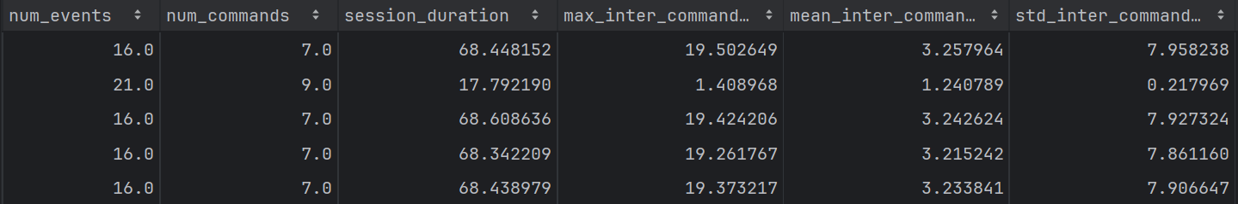

Typical properties include:
- brief interaction sequences,
- repeated attempts to initialize an execution environment,
- minimal variation between sessions.
Command and Behavior Analysis
Inspection of representative sessions reveals probing routines similar to those found in L1-C2 and L1-C3
Shell initialization attempts:
Commands such as:
- enable, development, shell, sh, linuxshell. Used to test or invoke an interactive environment.
BusyBox-related execution:
- /bin/busybox TSUNAMI. Indicates reliance on BusyBox utilities and may reflect testing or invocation of DDoS-related modules.
BusyBox availability checks:
- /bin/busybox cat /bin/busybox. A common method for verifying the presence and integrity of BusyBox before running further commands.
Summary
Cluster L2-C0 exhibits lightweight automated probing behavior centered around environment detection and BusyBox-based execution. Its structure closely resembles the IoT-style routines observed in L1-C2 and L1-C3, though with less consistency and quality, suggesting early-stage, experimental, or lower-quality automated tooling rather than fully developed malware behavior.

7.3.2 Cluster L2-C1: Behavioral Analysis
Cluster L2-C1 groups together sessions that share a medium-density pattern but display two distinct automated routines. Although both workflows indicate malicious intent, they differ in purpose: one is focused on downloading external payloads, while the other gathers system information before deciding further action.
Cluster Characteristics
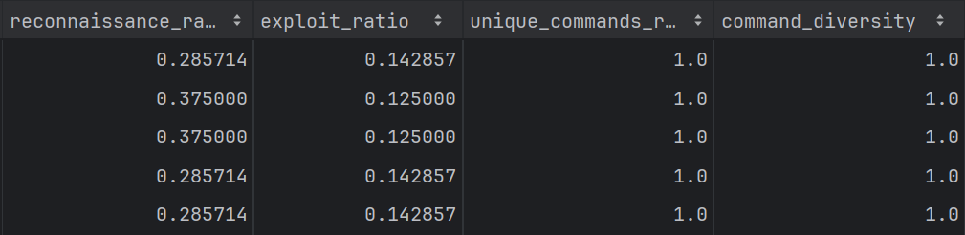
Sessions in this cluster show:
- moderate consistency,
- clear compromise-oriented actions,
- short and direct execution flows with minimal user-like variability.
Command and Behavior Analysis
Representative sessions reveal two behavioral sub-patterns within the cluster
Pattern A – Download-based infection workflow:
- Navigates to /tmp, a common writable directory for staging malicious binaries.
- Downloads an external file:
  - wget http://187.113.34.8/read.txt. Used to retrieve scripts or payloads that initiate a broader infection process.
This reflects a typical early-stage compromise where the attacker prepares the environment and pulls remote resources.
Pattern B – System resource inspection:
- Executes:
  - top -bn1. This retrieves CPU and memory usage statistics.
Such checks are often used by automated malware to determine whether the device is suitable for resource-intensive actions such as DDoS modules, cryptocurrency mining, or sustained remote execution.
Summary
Cluster L2-C1 consolidates two related but distinct automated workflows:
one oriented toward payload retrieval, and the other toward environment assessment before deploying further actions. Both reflect structured, compromise-focused routines that are less frequent than the high-density behaviors in Level 1 but exhibit enough internal consistency to form a coherent medium-density group.

7.3.3 Cluster L2-C2: Behavioral Analysis
Cluster L2-C2 contains sessions characterized by short but deliberate reconnaissance activity combined with actions intended to minimize traceability. Although less frequent than the probing routines seen in Level 1, the internal structure of this cluster is consistent and clearly automated.
Cluster Characteristics
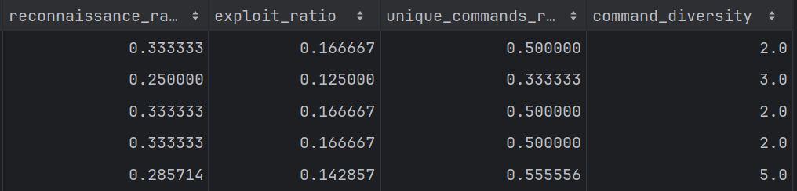
Sessions in this cluster typically:
- execute a very small number of well-chosen commands,
- focus on collecting system details,
- attempt to reduce or eliminate logging artifacts.
Command and Behavior Analysis
Representative sessions reveal a clear reconnaissance-and-evasion workflow
System fingerprinting:
- uname -a. Retrieves kernel version, OS, architecture, and system metadata.
This helps automated routines select compatible binaries or identify vulnerable kernels.

History suppression, commands such as:
- unset HISTORY,
- unset HISTFILE,
- unset HISTSAVE,
- and related variables
These actions disable shell history logging and are commonly used to reduce forensic visibility.
Summary
Cluster L2-C2 shows a focused, low-noise reconnaissance pattern with explicit attempts to avoid leaving traces. Its behavior is aligned with stealth-oriented automated routines that gather system information before deciding whether further exploitation is appropriate.
As with previous clusters, no ground-truth identity is assumed, but the behavioral consistency is notable.

7.3.4 Summary of Level 2 Behavioral Groups
Level 2 reveals several medium-density behavioral patterns that were not frequent or consistent enough to appear in Level 1 but still exhibit clear structure:
- L2-C0 - Lightweight probing routines: Short sequences focused on shell initialization and BusyBox capability checks. These behaviors resemble simplified or lower-quality variants of the IoT-style probing seen in L1-C2 and L1-C3.
- L2-C1 - Early-stage compromise workflows: Sessions fall into two sub-patterns:
(A) payload retrieval via wget in /tmp, and (B) system resource inspection using top.
Both reflect preparatory steps for later exploitation.
- L2-C2 - Stealth-oriented reconnaissance: Minimal but deliberate activity involving system fingerprinting (uname -a) and explicit attempts to disable shell history logging.
This indicates automated routines that prioritize reconnaissance and evasion.
Overall, Level 2 captures less frequent but still internally consistent automated behaviors, bridging the gap between the dense, repetitive routines of Level 1 and the irregular or low-density patterns examined in Level 3.

7.4 Level 3: Low-Density Sessions (Human and Skilled Operators)
Level 3 applies DBSCAN once more, this time to the sessions that remained as noise after Level 2. At this point, only the sparsest, most irregular, or highly distinctive behaviors remain in the dataset. To detect meaningful structure in these infrequent patterns, the algorithm is run with a further reduced min_samples value, allowing clusters to form even when only a small number of sessions share similar characteristics.
This final clustering stage captures behaviors that fall outside the automated routines seen in previous levels, including:
- partially automated scripts with inconsistent execution flow,
- low-skill or exploratory interactions,
- rare automated routines that appear too infrequently to form medium-density clusters.
After isolating the Level 2 noise, the features are rescaled, DBSCAN is executed with relaxed parameters, and the resulting clusters are examined individually. These Level 3 clusters represent irregular yet still interpretable behavioral structures, positioned between coherent automation and fully unstructured noise.

7.4.1 Cluster L3-C0: Behavioral Analysis
Cluster L3-C0 contains a small number of sessions but displays a remarkably consistent and intrusive workflow. Unlike the lightweight probing seen in earlier layers, this cluster executes an extended compromise sequence involving persistence, account modification, binary deployment, and trace removal. The length and structure of these sessions distinguish them from the simpler automated routines identified in Levels 1 and 2.
Cluster Characteristics
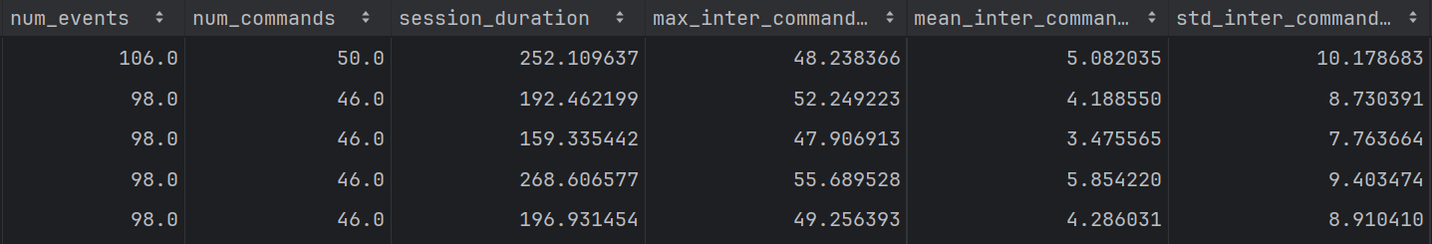
These sessions:
- are longer and more complex than typical automated probes,
- include multiple phases of a compromise,
- show coordinated use of persistence, execution, and cleanup steps.

Command and Behavior Analysis
Inspection of representative sessions shows a multi-stage compromise workflow.
Persistence and startup checks:
- /etc/rc.local, crontab -l. Used to inspect or prepare persistence mechanisms.
Binary upload and execution:
- scp -t, /tmp/knrm, /tmp/r. Indicates transfer and execution of attacker-controlled binaries.
Hidden file modification:
- rm -f ~/.dhpcd, chattr -i -a. Used to delete artifacts or modify file attributes to evade removal.
Account takeover attempts:
- passwd test, passwd oracle. Suggests credential modification or creation of new access points.
SSH key installation:
- Writes to ~/.ssh/authorized_keys. A common method for persistent remote access.
Network inspection:
- netstat, ss. Used to assess open ports and potential communication channels.
System load checks:
- top -bn1. Evaluates system resource availability before deploying heavier components.
Cleanup actions:
- removing temporary files or artifacts created earlier in the session.
Summary
Cluster L3-C0 represents a comprehensive multi-stage compromise workflow, including persistence checks, binary deployment, account manipulation, system inspection, and trace removal.
Although rare in frequency, its structure is highly consistent across sessions and aligns with advanced automated malware routines designed for full system takeover. No ground-truth attribution is assumed, but the behavioral completeness makes this one of the most intrusive patterns in the dataset.

7.4.2 Cluster L3-C1: Behavioral Analysis
Cluster L3-C1 consists of short, focused sessions centered on reconnaissance and evasion. These interactions are sparse compared to previous levels but remain consistent enough to form a low-density cluster. The workflow is deliberate, information-oriented, and explicitly attempts to minimize traceability.
Cluster Characteristics
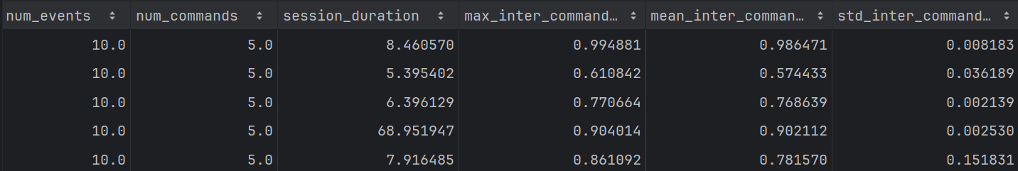
Sessions in this cluster:
- execute a small but well-selected set of commands,
- prioritize environment understanding over active exploitation,
- include explicit anti-forensic steps.
Command and Behavior Analysis
Representative sessions show a stealthy reconnaissance sequence
History suppression:
- unset HISTORY, unset HISTFILE, unset HISTSAVE, etc. These commands disable shell logging and reduce the forensic footprint.
System information gathering:
Commands include:
- uname / uname -a → OS and kernel details
- free -m → memory availability
- ps -x → running processes
- cat /proc/cpuinfo → hardware information
The combination suggests an intent to understand system capabilities before any further action.
Summary
Cluster L3-C1 exhibits stealth-oriented reconnaissance behavior, combining system fingerprinting with explicit efforts to avoid command logging. Its workflow resembles the reconnaissance-and-evasion pattern observed in Level 2 (Cluster L2-C2), but appears less frequent and more irregular, which explains its emergence at the low-density stage. No ground-truth identity is assumed, but the behavioral consistency points to an automated tool designed for information gathering with minimal visibility.

7.4.3 Cluster L3-C2: Behavioral Analysis
Cluster L3-C2 contains extremely short sessions with almost no interaction beyond explicit attempts to avoid forensic visibility. Despite the minimal number of commands, the behavior is consistent across sessions, forming a distinct low-density cluster.
Cluster Characteristics
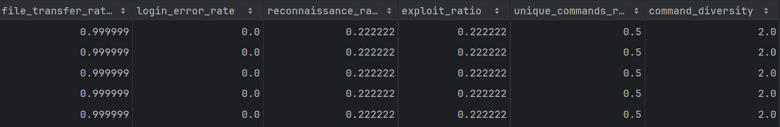
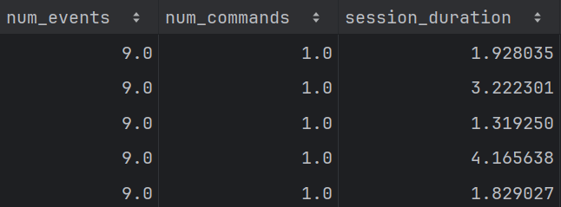
Sessions in this cluster are characterized by:
- very limited activity,
- nearly identical command sequences,
- a sole focus on reducing traceability.
Command and Behavior Analysis
Representative sessions consist almost entirely of
History suppression:
- unset HISTORY,
- unset HISTFILE,
- unset HISTSAVE,
- and related variables.
This is a standard anti-forensic technique used to prevent executed commands from being recorded in shell history files.
No further reconnaissance, exploitation, or environmental probing is observed.
Summary
Cluster L3-C2 represents a minimal yet deliberate evasion-only workflow, where the session’s primary purpose is disabling history logging. Its behavior is closely related to the stealth-focused routine seen in L3-C1 and resembles the reconnaissance evasion pattern observed earlier in Level 2 (Cluster L2-C2), but with even fewer actions. Although highly limited in scope, its consistency is sufficient to form a coherent low-density behavioral group.

7.4.4 Summary of Level 3 Behavioral Groups
Level 3 captures the least frequent and most irregular behaviors in the dataset, sessions that were too sparse or distinctive to form clusters in earlier stages. Despite their low density, these groups still display recognizable automated patterns:
- L3-C0 - Multi-stage compromise workflow: Extended sessions involving persistence checks, binary uploads, account manipulation, SSH key installation, network inspection, and cleanup. This is one of the most intrusive and complete behavioral sequences observed.
- L3-C1 - Stealth-focused reconnaissance: Short but deliberate interactions combining system fingerprinting with explicit history suppression to reduce traceability.
- L3-C2 - Minimal evasion-only behavior: Sessions almost exclusively dedicated to disabling shell history variables, with no additional reconnaissance or exploitation.
Across all clusters, Level 3 behaviors appear less consistent and less widespread than those in Levels 1 and 2, but remain structured enough to form meaningful groups. These patterns represent rare automated workflows or partially developed tools positioned between coherent automation and fully unstructured noise.

7.5 Outliers and Rare Anomalous Sessions
After the third clustering stage, a residual set of sessions remains labeled as noise. These interactions are too heterogeneous or infrequent to form stable clusters, even under the most relaxed density parameters. Their dispersion reflects the presence of diverse and irregular behaviors that do not align with any of the automated patterns captured in previous levels.
These outliers typically fall into two broad categories:
- Irregular or incomplete automated routines: Sessions that contain only fragments of automated workflows, partial command sequences, or malformed interactions that lack sufficient structure for clustering.
- Potentially benign or user-driven activity: Interactions that do not follow recognizable attack patterns, often exhibiting human-like pauses, inconsistent commands, or minimal engagement with the system.
The combination of low frequency, high variability, and absence of repeated structure explains why these sessions remain unclustered across all three density levels. While individually they may still provide useful forensic insights, they do not form coherent behavioral groups suitable for unsupervised modeling.


7.5.1 Behavioral Characteristics of Outliers
After the third clustering stage, a small set of sessions remains unclustered. These outliers represent behaviors that are either too irregular, too sparse, or too unique to be grouped by density. Although they do not form coherent clusters, many display clear behavioral patterns that warrant individual examination.
The following subsections present representative examples of three distinct categories found among the outliers:
- skilled human operators,
- inexperienced human users (script kiddies),
- edge-case automated bots.

7.5.2 Samples of Expert Attackers
Some outlier sessions exhibit clear signs of skilled human interaction. These examples show irregular timing, high command diversity, purposeful exploration, and execution patterns that do not match automated workflows.
Session: 051da2977a31
- std_inter_command_time = 11.83 s → Irregular pacing typical of manual decision-making.
- command_diversity = 16, unique_commands_ratio ≈ 0.56 → Broad and varied command usage.
- command_error_rate = 0.0 → High precision and familiarity with the environment.
- session_duration = 135.8 s, num_events = 41 → Steady, thoughtful interaction rhythm.
Interpretation:
Consistent with a knowledgeable operator exploring the system manually.
Session: 27983da3ac55
- std_inter_command_time = 26.86 s → Long pauses suggesting evaluation of output.
- command_diversity = 17, unique_commands_ratio ≈ 0.56 → Extensive use of different tools.
- command_error_rate ≈ 9% → Occasional errors, common in manual probing.
- Mix of exploration, process inspection, and light exploitation.
Interpretation:
Behavior aligns with an experienced user conducting targeted, manual investigation.
Overall Interpretation
These sessions demonstrate traits typical of skilled human attackers:
- irregular timing,
- diverse and purposeful command usage,
- minimal repetition,
- and clear intent behind each action.
Such characteristics distinguish them from both automated bots and low-skill users.

7.5.3 Samples of Script Kiddies
Some outlier sessions display behaviors typical of inexperienced human users, characterized by limited command knowledge, high error rates, and hesitant interaction patterns.
Session: 60a1c78f32a4
- std_inter_command_time ≈ 36 s → Long pauses suggesting uncertainty.
- command_diversity = 3, unique_commands_ratio ≈ 0.33 → Very limited set of commands.
- command_error_rate ≈ 66% → Frequent mistakes, consistent with low familiarity.
- Minimal activity: num_commands = 3, num_events = 16.
Interpretation:
Behavior consistent with a novice experimenting without understanding the system.
Session: 227750191cbc
- std_inter_command_time ≈ 6.85 s → Hesitant but somewhat steady pacing.
- command_diversity = 11, unique_commands_ratio ≈ 0.29 → Some exploration but still limited.
- command_error_rate ≈ 21% → Repeated mistakes typical of inexperienced usage.
- Moderate activity: num_commands = 14, but little command variety.
Interpretation:
Shows typical script-kiddie behavior: basic commands, errors, and limited system understanding.
Overall Interpretation
These sessions exhibit hallmark characteristics of script kiddies:
- low command diversity,
- high error frequency,
- hesitant pacing,
- limited exploration.
Their behavior contrasts with both structured bot activity and the intentional, high-diversity patterns of skilled human operators.

7.5.4 Outlier Bots
Some noise sessions correspond to automated routines whose behavior is too extreme, either too regular, too minimal, or too inconsistent, to cluster with standard bot families. These cases illustrate edge-case automation rather than human-driven activity.
Session: 890cb40f9e53
- std_inter_command_time ≈ 0.75 s → Very regular timing, strongly indicative of mechanized execution.
- command_error_rate = 0% → Perfect precision typical of automated scripts.
- num_commands = 19, num_events = 41 → Moderate activity with machine-like consistency.
- session_duration ≈ 5049 s (~1.4 hours) → Extremely long session, contributing to it remaining unclustered.
Interpretation:
A highly regular automated routine that does not match the behavior patterns of known bot groups.
Session: a1e66dd17777
- num_commands = 1, num_events = 7 → Almost no interaction.
- session_duration ≈ 2.07 s → Extremely short session.
- command_error_rate ≈ 100% → Single failed action with no retries.
Interpretation:
Likely a misconfigured or malfunctioning bot executing an incomplete or broken routine.
Overall Interpretation
These examples represent outlier bots, automated behaviors that are either too sparse, too uniform, or too anomalous to form clusters. Their divergence highlights the diversity of automated activity present in SSH honeypot data.

8. Discussion and Interpretation of Results
The iterative clustering analysis reveals the underlying behavioral landscape of SSH attackers interacting with the honeypot. Instead of assuming a priori categories (e.g., bots vs. humans), the methodology extracts behavioral structure directly from the data and uses those patterns to infer plausible attacker types.
Because no ground truth exists, these interpretations reflect observable behavior, not guaranteed identities.

8.1 Behavioral Insights from Level 1 (High-Density Layer)
Level 1 isolates extremely dense regions of the behavioral space. All resulting clusters exhibit:
- Very low timing variance
- Near-identical command sequences across thousands of sessions
- Highly structured execution flows
These characteristics are consistent with large-scale fully automated botnets.
Within this layer, the clusters represent different families or variants of automated malware:
- L1-C0 & L1-C1: Complete automated compromise attempts (recon → privilege escalation → payload deployment).
- L1-C2 & L1-C3: Short IoT-style probes verifying BusyBox presence and system architecture.
- L1-C4: Advanced filesystem-probing bot focused on identifying writable paths and persistence opportunities.
These differences show that even within automated activity, distinct intrusion strategies and toolchains emerge naturally from the clustering.

8.2 Behavioral Insights from Level 2 (Medium-Density Layer)
After removing dense bots, Level 2 reveals clusters that were too sparse for Level 1 but still show meaningful structure. These clusters represent less consistent or more specialized automated behaviors:
- L2-C0: Early-stage or low-quality bots testing BusyBox capabilities.
- L2-C1: Mixed infection workflows (file downloaders and resource-inspection bots).
- L2-C2: Stealth-oriented reconnaissance with explicit history wiping.
These clusters highlight automated malware that is less uniform, more exploratory, or still under development, which is characteristic of IoT botnet variants or probing tools.

8.3 Behavioral Insights from Level 3 (Low-Density Layer)
Level 3 focuses on the sparsest and most irregular sessions. These behaviors cannot be captured by stricter parameters due to:
- Highly variable timing
- Irregular command diversity
- Non-repetitive interaction patterns
Some clusters still reflect malware, especially full-compromise attempts or stealth reconnaissance, but the remaining sessions reveal:
- Highly deliberate command flow
- High diversity with low repetition
- Human-like pauses and decision-making
These traits indicate the presence of manual operators or semi-automated tools under human supervision.
Importantly, Level 3 demonstrates that human or human-guided sessions exist but are rare, overshadowed by large-scale automated traffic.

8.4 Outliers and Rare Behaviors
Even after three iterations, some sessions remain as noise. These outliers include:
- Expert operators (high diversity, irregular timing, intentional system exploration).
- Script kiddies (basic commands, high error rates, trial-and-error behavior).
- Edge-case bots (extremely regular or minimal interactions that fall outside cluster density thresholds).
This residual category emphasizes that not all behaviors fit neatly into clusters, and noise itself contains meaningful security-relevant insights.

8.5 What the Results Reveal About SSH Attacker Ecosystems
Across all levels, a clear pattern emerges:
- Automated activity dominates the landscape, both in volume and density.
- IoT malware families produce distinct, consistent fingerprints, making them cluster cleanly.
- More sophisticated malware appears at lower densities, often blending reconnaissance, evasion, and selective exploitation.
- Human activity exists but is rare, detectable mainly through irregular timing and high command diversity.
- The layered DBSCAN approach is essential, as no single density parameter can capture all behavioral scales simultaneously.
Overall, the clustering framework provides a taxonomy of behaviors, not rigid identities. It shows how different attacker types, automated, semi-automated, novice, and skilled, manifest behaviorally within SSH honeypots.
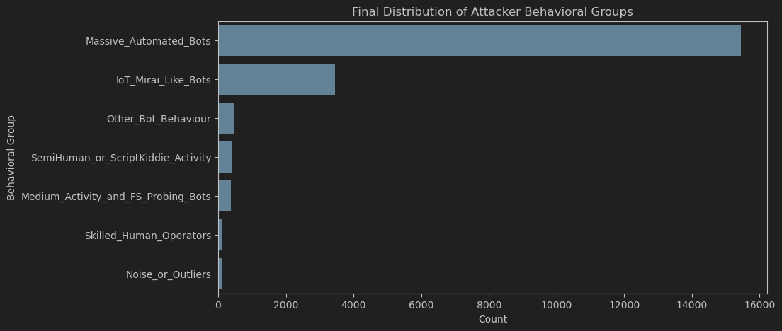

8.6 Limitations and Considerations
While insightful, the approach has inherent limitations:
- Honeypot environments may influence behavior (e.g., bots detecting virtualization).
- Behavior-based clustering cannot guarantee attacker identity, only likelihood based on observable traits.
- Parameter choices impact cluster boundaries, though the multi-density approach mitigates this.
- Different datasets may reveal different attacker ecosystems.
Despite these limitations, the methodology provides a robust, interpretable, and scalable way to analyze attacker behavior at large scale.

9. Evaluation and Discussion
This section evaluates the effectiveness of the proposed behavioral profiling pipeline by examining the discriminative power of the engineered features, comparing baseline clustering methods with the multi-density approach, and discussing the practical implications and limitations of the results.

9.1 Discriminative Power of Behavioral Features
The feature set, composed of temporal metrics, command diversity ratios, error rates, file-transfer indicators, and reconnaissance/exploitation proportions, proved effective in separating attacker behaviors across density levels.

Key observations:
- Temporal variance (e.g., standard deviation of inter-command time) strongly differentiates automated sessions from human-driven ones. Automated bots show near-constant timing, while human or semi-human interactions exhibit irregular pacing.
- Command diversity and uniqueness ratios help separate simple probing bots from more complex malware and human operators. Dense clusters consistently align with low-diversity automated routines, whereas human-driven sessions appear in sparse regions of the feature space.
- Error rates provide a reliable signal of operator skill. Automated routines rarely commit syntactic errors, while low-skill users often do.
- File-transfer and exploitation ratios highlight multi-stage malware workflows, allowing them to be distinguished from lightweight IoT probes or reconnaissance-focused routines.
Overall, the feature space achieves meaningful behavioral separation, enabling unsupervised clustering to structure the dataset into interpretable attacker types.

9.2 Comparison Between Baseline and Multi-Density Clustering
Two baselines were evaluated prior to applying the multi-density DBSCAN workflow:
K-Means (Baseline 1)
K-Means fails to capture behavioral structure due to:
- its assumption of spherical, equally sized clusters,
- inability to model density variation,
- sensitivity to outliers,
- and lack of robustness when the majority of points exhibit repetitive, bot-like behavior.
Clusters produced by K-Means mixed unrelated behaviors and separated similar ones, providing limited interpretability.
Seed-Based Heuristic (Baseline 2)
A heuristic based on manually selected "prototype sessions" (bot-like, semi-human, human) was tested.
However:
- behavioral boundaries were blurred,
- prototypes did not generalize across the dataset,
- and the method risked imposing preconceived labels onto unlabeled data.
This approach helped conceptualize the space but failed as a scalable clustering method.

Iterative DBSCAN (Final Method)
The multi-density DBSCAN pipeline overcomes baseline limitations by:
- identifying high-density automation clusters without hyperparameter tuning,
- progressively revealing medium- and low-density rare behaviors,
- isolating outliers without forcing them into clusters,
- adapting naturally to the non-uniform distribution of attacker sessions.
This method provided clean, interpretable behavioral groups that aligned with command-level inspection and operational intuition.
The comparison confirms that density-based iterative clustering is substantially more effective than classical alternatives for behavioral attacker profiling.

9.3 Case Studies of Representative Sessions
To validate the interpretability of the clustering results, several representative sessions were inspected:
- A Level 1 bot cluster demonstrated a complete automated infection flow (reconnaissance → privilege modification → payload execution → cleanup), showing perfect alignment between cluster density and behavioral regularity.
- A Level 2 cluster displayed early-stage malware behavior mixing download attempts with resource-inspection routines—patterns too irregular for Level 1 but still clearly automated and malicious.
- A Level 3 outlier session demonstrated high command diversity, irregular pacing, and deliberate system exploration, consistent with skilled manual interaction rather than automation.
These case studies show that cluster assignments reflect real behavioral differences, validating the ability of the multi-density pipeline to organize attacker activity meaningfully.

9.4 Security Implications of Behavioral Profiling
The behavioral grouping produced by the pipeline provides several actionable benefits:
- Improved triage and prioritization: SOC teams can quickly distinguish between large-scale automated noise and rare high-risk sessions requiring closer examination.

- Identification of malware families and variants: Similar command sequences and workflow structures naturally group together, enabling threat intelligence teams to track evolving bot behaviors.

- Detection of human-driven intrusions: Sparse, irregular clusters and outliers highlight sessions potentially associated with skilled operators, often the most critical to investigate.

- Strengthened honeypot value: Behavioral analysis enriches the telemetry extracted from honeypots, transforming raw logs into actionable insights on attacker ecosystems.

9.5 Limitations of the Study
Despite the robustness of the methodology, several limitations must be acknowledged:
- No ground-truth labels: Behaviors are interpreted, not verified. Assignments such as “bot-like” or “human-like” are based solely on observed interaction patterns.

- Honeypot bias: Some attackers may detect the emulated environment, altering their behavior or terminating sessions prematurely.

- Parameter sensitivity: Although the iterative approach mitigates this, cluster boundaries still depend on DBSCAN parameters and feature scaling.

- Dataset variability: Results may differ across regions, time periods, or honeypot configurations.

These limitations do not undermine the findings but contextualize them, emphasizing the importance of combining automated clustering with expert behavioral inspection.

10. Conclusion and Future Work

10.1 Summary of Findings
This study developed a complete pipeline for profiling attacker behavior in SSH honeypots using an unsupervised, multi-density clustering approach. By engineering behavioral features from Cowrie logs and applying iterative DBSCAN, the system successfully uncovered the underlying structure of attacker interactions without relying on ground-truth labels.
Three major observations emerged:
- Automated activity overwhelmingly dominates SSH honeypot traffic: High-density clusters consistently aligned with repetitive, low-diversity workflows characteristic of large-scale botnets.

- Medium-density behaviors revealed more specialized or partially developed malware routines: These included downloaders, reconnaissance-focused tools, and probing bots with limited consistency.

- Low-density and outlier sessions captured rare behaviors, including stealthy malware, misconfigured automated tools, script kiddies, and skilled human operators.
The iterative multi-density framework proved essential for capturing this behavioral hierarchy, as no single clustering configuration could reveal all levels simultaneously.
Overall, the results demonstrate that behavioral signatures extracted from raw honeypot logs are sufficient to meaningfully distinguish different categories of attacker behavior, even in the absence of labels.

10.2 Practical Impact for Cybersecurity Operations
The findings have direct implications for defensive and analytical workflows:
- Enhanced triage: Clustering separates high-volume bot activity from rare, high-risk behaviors, enabling incident responders to allocate resources more efficiently.
- Threat intelligence enrichment: Distinct malware families and behavioral variants naturally emerge through clustering, supporting botnet tracking and behavior-based signatures.
- Detection of human-driven intrusions: Sparse, irregular patterns highlight sessions likely associated with skilled operators, which often warrant deeper forensic analysis.
- Improved honeypot value: Translating raw logs into behavioral groups transforms honeypots into high-quality sources of attacker telemetry and behavioral insights.
This demonstrates that behavioral clustering can complement traditional signature-based or anomaly-based detection methods by contextualizing attacker intent and sophistication.

Overall Conclusion
This work demonstrates that unsupervised, behavior-based profiling is a powerful and scalable method for understanding attacker ecosystems in SSH honeypots. By revealing structure where none is labeled, the approach offers actionable insights for security operations and lays a foundation for more advanced behavioral analytics.

