# Model 1

## Arquitectura y configuración de hiperparámetros

Model: "sequential"

_________________________________________________________________

Layer (type) Output Shape Param #

=================================================================

conv2d (Conv2D) (None, 62, 62, 32) 896

_________________________________________________________________

max_pooling2d (MaxPooling2D) (None, 31, 31, 32) 0

_________________________________________________________________

flatten (Flatten) (None, 30752) 0

_________________________________________________________________

dense (Dense) (None, 128) 3936384

_________________________________________________________________

dense_1 (Dense) (None, 6) 774

=================================================================

Total params: 3,938,054

Trainable params: 3,938,054

Non-trainable params: 0

|  |  |  |  |  |  |  |  |  |  |  |  |  |  |  |  |  |  |  |  |  |
| --- | --- | --- | --- | --- | --- | --- | --- | --- | --- | --- | --- | --- | --- | --- | --- | --- | --- | --- | --- | --- |
| **Model-1** | 0.2 | 0.05 | [0.95, 1.2] | TRUE | 64x64 | 32 | 64x64 | 32 | 1 | 32 | 3x3 | 64x64x3 | relu | 2x2 | 1 | 128 | relu |  | adam | 25 |
| 2 |  |  |  |  |  | 2 | 6 | softmax |  |
| 3 |  |  |  |  |  | 3 |  |  |  |
| 4 |  |  |  |  |  | 4 |  |  |  |

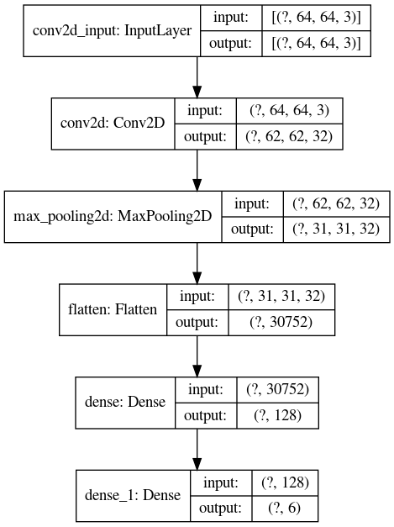

## Proceso de Training

Epoch 1/25

2020-07-11 17:55:04.743545: I tensorflow/stream_executor/platform/default/dso_loader.cc:44] Successfully opened dynamic library libcublas.so.10

2020-07-11 17:55:05.123259: I tensorflow/stream_executor/platform/default/dso_loader.cc:44] Successfully opened dynamic library libcudnn.so.7

593/593 [==============================] - 44s 75ms/step - loss: 1.2056 - accuracy: 0.5042 - val_loss: 0.9864 - val_accuracy: 0.5778

Epoch 2/25

593/593 [==============================] - 43s 72ms/step - loss: 0.9622 - accuracy: 0.5911 - val_loss: 0.9372 - val_accuracy: 0.5922

Epoch 3/25

593/593 [==============================] - 42s 72ms/step - loss: 0.9072 - accuracy: 0.6125 - val_loss: 0.9597 - val_accuracy: 0.5793

Epoch 4/25

593/593 [==============================] - 43s 73ms/step - loss: 0.8781 - accuracy: 0.6241 - val_loss: 0.9186 - val_accuracy: 0.6107

Epoch 5/25

593/593 [==============================] - 45s 75ms/step - loss: 0.8432 - accuracy: 0.6360 - val_loss: 0.8958 - val_accuracy: 0.6147

Epoch 6/25

593/593 [==============================] - 45s 76ms/step - loss: 0.8274 - accuracy: 0.6408 - val_loss: 0.8822 - val_accuracy: 0.6105

Epoch 7/25

593/593 [==============================] - 45s 75ms/step - loss: 0.8046 - accuracy: 0.6524 - val_loss: 0.9203 - val_accuracy: 0.6147

Epoch 8/25

593/593 [==============================] - 44s 74ms/step - loss: 0.7901 - accuracy: 0.6614 - val_loss: 0.9339 - val_accuracy: 0.6023

Epoch 9/25

593/593 [==============================] - 46s 77ms/step - loss: 0.7748 - accuracy: 0.6617 - val_loss: 0.8680 - val_accuracy: 0.6284

Epoch 10/25

593/593 [==============================] - 45s 76ms/step - loss: 0.7600 - accuracy: 0.6691 - val_loss: 0.8710 - val_accuracy: 0.6295

Epoch 11/25

593/593 [==============================] - 47s 79ms/step - loss: 0.7413 - accuracy: 0.6800 - val_loss: 0.8426 - val_accuracy: 0.6276

Epoch 12/25

593/593 [==============================] - 45s 76ms/step - loss: 0.7337 - accuracy: 0.6818 - val_loss: 0.8648 - val_accuracy: 0.6238

Epoch 13/25

593/593 [==============================] - 47s 79ms/step - loss: 0.7199 - accuracy: 0.6900 - val_loss: 0.8605 - val_accuracy: 0.6307

Epoch 14/25

593/593 [==============================] - 46s 77ms/step - loss: 0.7075 - accuracy: 0.6947 - val_loss: 0.9179 - val_accuracy: 0.6350

Epoch 15/25

593/593 [==============================] - 47s 78ms/step - loss: 0.7056 - accuracy: 0.6939 - val_loss: 0.8654 - val_accuracy: 0.6255

Epoch 16/25

593/593 [==============================] - 46s 77ms/step - loss: 0.6910 - accuracy: 0.7007 - val_loss: 0.8689 - val_accuracy: 0.6320

Epoch 17/25

593/593 [==============================] - 48s 80ms/step - loss: 0.6745 - accuracy: 0.7100 - val_loss: 0.8808 - val_accuracy: 0.6255

Epoch 18/25

593/593 [==============================] - 47s 79ms/step - loss: 0.6693 - accuracy: 0.7103 - val_loss: 0.9015 - val_accuracy: 0.6090

Epoch 19/25

593/593 [==============================] - 47s 79ms/step - loss: 0.6549 - accuracy: 0.7182 - val_loss: 0.8883 - val_accuracy: 0.6295

Epoch 20/25

593/593 [==============================] - 46s 77ms/step - loss: 0.6409 - accuracy: 0.7232 - val_loss: 0.9100 - val_accuracy: 0.6432

Epoch 21/25

593/593 [==============================] - 46s 78ms/step - loss: 0.6460 - accuracy: 0.7232 - val_loss: 0.9141 - val_accuracy: 0.6364

Epoch 22/25

593/593 [==============================] - 46s 77ms/step - loss: 0.6329 - accuracy: 0.7304 - val_loss: 0.8914 - val_accuracy: 0.6358

Epoch 23/25

593/593 [==============================] - 49s 83ms/step - loss: 0.6229 - accuracy: 0.7346 - val_loss: 0.9150 - val_accuracy: 0.6274

Epoch 24/25

593/593 [==============================] - 48s 80ms/step - loss: 0.6076 - accuracy: 0.7392 - val_loss: 0.9001 - val_accuracy: 0.6409

Epoch 25/25

593/593 [==============================] - 46s 78ms/step - loss: 0.6015 - accuracy: 0.7428 - val_loss: 0.9370 - val_accuracy: 0.6217

## Matriz de Confusión

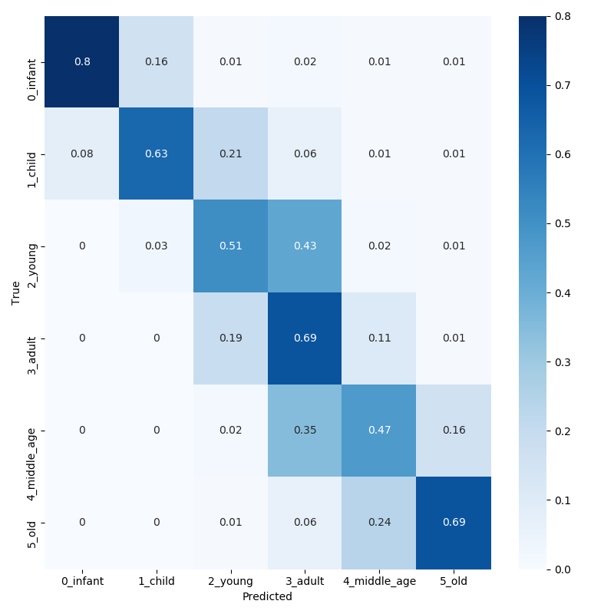

## Classification Report

|  |  |  |  |  |
| --- | --- | --- | --- | --- |
|  | **precision** | **recall** | **f1-score** | **support** |
| **0_infant** | 0.91 | 0.80 | 0.85 | 379 |
| **1_child** | 0.68 | 0.63 | 0.66 | 304 |
| **2_young** | 0.50 | 0.51 | 0.50 | 845 |
| **3_adult** | 0.64 | 0.69 | 0.66 | 1873 |
| **4_middle_age** | 0.54 | 0.47 | 0.50 | 862 |
| **5_old** | 0.65 | 0.69 | 0.67 | 479 |
|  |  |  |  |  |
| **accuracy** | -- | -- | 0.62 | 4742 |
| **macro_avg** | 0.65 | 0.63 | 0.64 | 4742 |
| **weighted_avg** | 0.62 | 0.62 | 0.62 | 4742 |

## Observaciones

Precisión training: 0.74

Pérdida training: 0.6

Precisión validación/test: 0.62

Pérdida test: 0.94

- Overfitting

- Baja tasa de acierto

# Model 2

## Arquitectura y configuración de hiperparámetros

|  |  |  |  |  |  |  |  |  |  |  |  |  |  |  |  |  |  |  |  |  |
| --- | --- | --- | --- | --- | --- | --- | --- | --- | --- | --- | --- | --- | --- | --- | --- | --- | --- | --- | --- | --- |
| **Model-2** | 0.2 | 0.05 | [0.95, 1.2] | TRUE | 64x64 | 32 | 64x64 | 32 | 1 | 32 | 3x3 | 64x64x3 | relu | 2x2 | 1 | 128 | relu |  | adam | 25 |
| 2 | **32** | **3x3** | **--** | **relu** | **2x2** | 2 | 6 | softmax |  |
| 3 |  |  |  |  |  | 3 |  |  |  |
| 4 |  |  |  |  |  | 4 |  |  |  |

* 1. 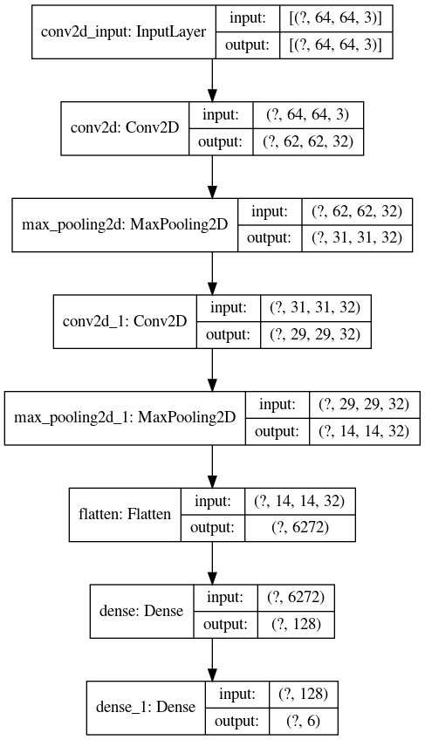

## Proceso de Training

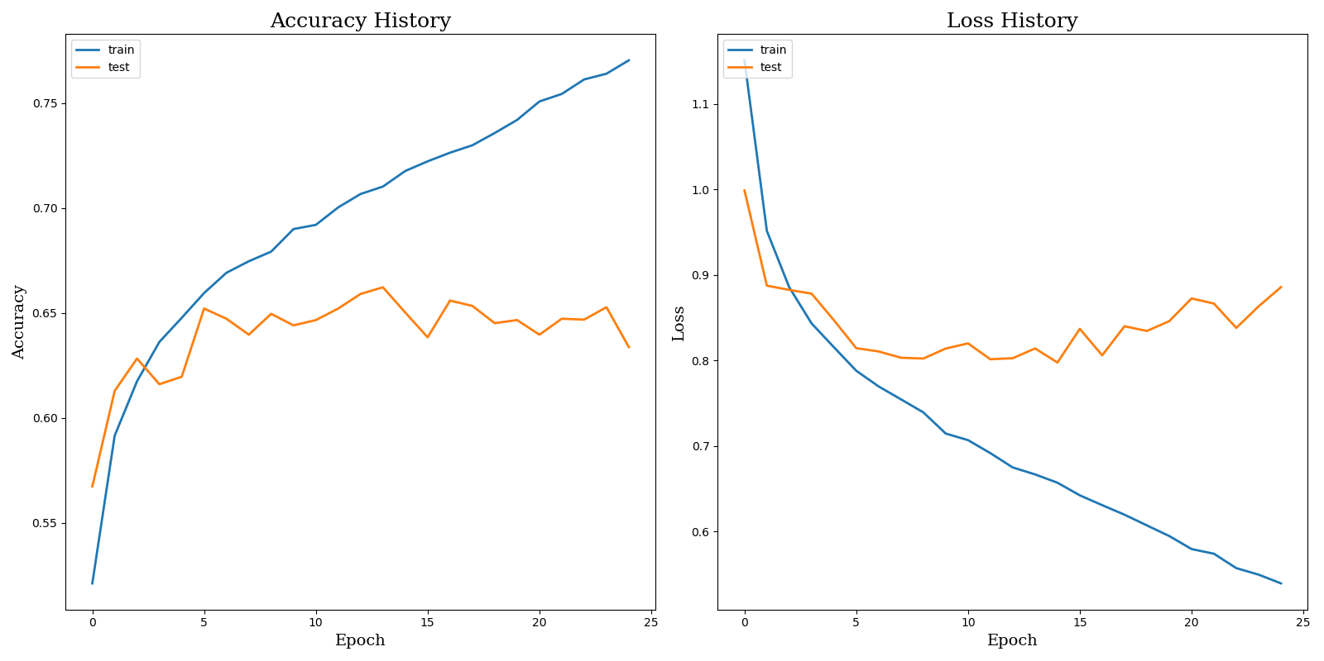

## Matriz de Confusión

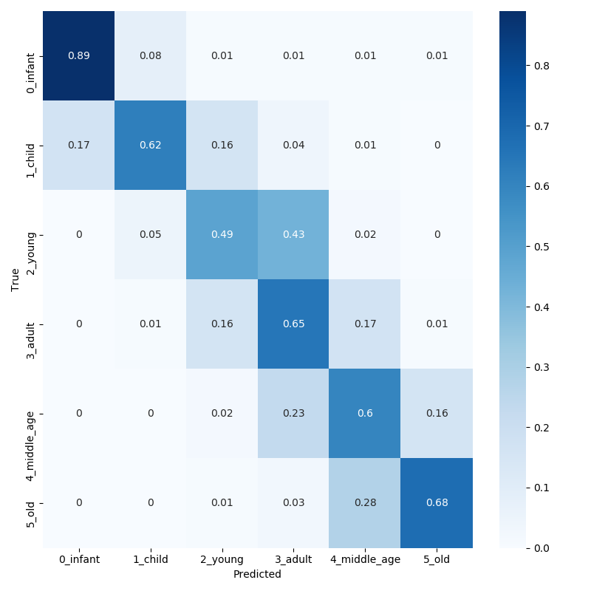

## Classification Report

|  |  |  |  |  |
| --- | --- | --- | --- | --- |
|  | **precision** | **recall** | **f1-score** | **support** |
| **0_infant** | 0.86 | 0.89 | 0.87 | 379 |
| **1_child** | 0.70 | 0.62 | 0.66 | 304 |
| **2_young** | 0.52 | 0.49 | 0.51 | 845 |
| **3_adult** | 0.67 | 0.65 | 0.66 | 1873 |
| **4_middle_age** | 0.52 | 0.60 | 0.56 | 862 |
| **5_old** | 0.67 | 0.68 | 0.68 | 479 |
|  |  |  |  |  |
| **accuracy** | -- | -- | 0.63 | 4742 |
| **macro_avg** | 0.66 | 0.66 | 0.66 | 4742 |
| **weighted_avg** | 0.64 | 0.63 | 0.63 | 4742 |

## Observaciones

Precisión training: 0.77

Pérdida training: 0.52

Precisión validación/test: 0.63

Pérdida test: 0.89

- Overfitting

- Accuracy mejorable

# Model 3

## Arquitectura y configuración de hiperparámetros

Model: "sequential"

_________________________________________________________________

Layer (type) Output Shape Param #

=================================================================

conv2d (Conv2D) (None, 62, 62, 32) 896

_________________________________________________________________

max_pooling2d (MaxPooling2D) (None, 31, 31, 32) 0

_________________________________________________________________

conv2d_1 (Conv2D) (None, 29, 29, 32) 9248

_________________________________________________________________

max_pooling2d_1 (MaxPooling2 (None, 14, 14, 32) 0

_________________________________________________________________

flatten (Flatten) (None, 6272) 0

_________________________________________________________________

dense (Dense) (None, 128) 802944

_________________________________________________________________

dropout (Dropout) (None, 128) 0

_________________________________________________________________

dense_1 (Dense) (None, 6) 774

=================================================================

Total params: 813,862

Trainable params: 813,862

Non-trainable params: 0

|  |  |  |  |  |  |  |  |  |  |  |  |  |  |  |  |  |  |  |  |  |
| --- | --- | --- | --- | --- | --- | --- | --- | --- | --- | --- | --- | --- | --- | --- | --- | --- | --- | --- | --- | --- |
| **Model-3** | 0.2 | 0.05 | [0.95, 1.2] | TRUE | 64x64 | 32 | 64x64 | 32 | 1 | 32 | 3x3 | 64x64x3 | relu | 2x2 | 1 | 128 | relu | **0.3** | adam | 25 |
| 2 | 32 | 3x3 | -- | relu | 2x2 | 2 | 6 | softmax |  |
| 3 |  |  |  |  |  | 3 |  |  |  |
| 4 |  |  |  |  |  | 4 |  |  |  |

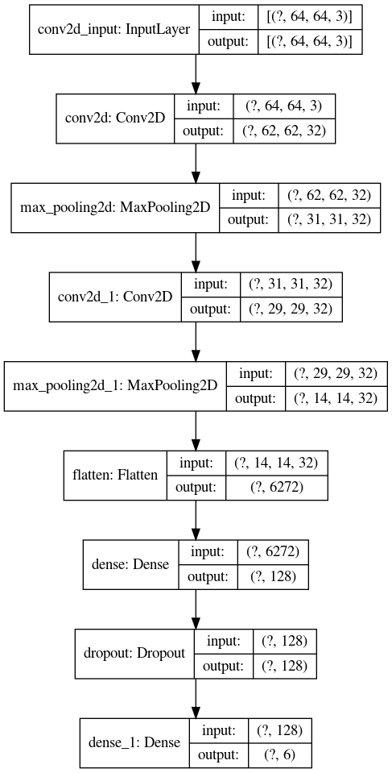

## Proceso de Training

Epoch 1/25

2020-07-12 18:52:13.253582: I tensorflow/stream_executor/platform/default/dso_loader.cc:44] Successfully opened dynamic library libcublas.so.10

2020-07-12 18:52:13.651463: I tensorflow/stream_executor/platform/default/dso_loader.cc:44] Successfully opened dynamic library libcudnn.so.7

593/593 [==============================] - 42s 71ms/step - loss: 1.2725 - accuracy: 0.4812 - val_loss: 1.0947 - val_accuracy: 0.5261

Epoch 2/25

593/593 [==============================] - 38s 65ms/step - loss: 1.0339 - accuracy: 0.5546 - val_loss: 0.9540 - val_accuracy: 0.5768

Epoch 3/25

593/593 [==============================] - 39s 66ms/step - loss: 0.9678 - accuracy: 0.5811 - val_loss: 0.8973 - val_accuracy: 0.6025

Epoch 4/25

593/593 [==============================] - 38s 65ms/step - loss: 0.9166 - accuracy: 0.6023 - val_loss: 0.8710 - val_accuracy: 0.6179

Epoch 5/25

593/593 [==============================] - 40s 67ms/step - loss: 0.8903 - accuracy: 0.6154 - val_loss: 0.8606 - val_accuracy: 0.6158

Epoch 6/25

593/593 [==============================] - 50s 84ms/step - loss: 0.8638 - accuracy: 0.6254 - val_loss: 0.8370 - val_accuracy: 0.6341

Epoch 7/25

593/593 [==============================] - 39s 66ms/step - loss: 0.8483 - accuracy: 0.6351 - val_loss: 0.8336 - val_accuracy: 0.6326

Epoch 8/25

593/593 [==============================] - 39s 66ms/step - loss: 0.8333 - accuracy: 0.6345 - val_loss: 0.8230 - val_accuracy: 0.6286

Epoch 9/25

593/593 [==============================] - 39s 65ms/step - loss: 0.8160 - accuracy: 0.6402 - val_loss: 0.8043 - val_accuracy: 0.6480

Epoch 10/25

593/593 [==============================] - 40s 68ms/step - loss: 0.8054 - accuracy: 0.6443 - val_loss: 0.7996 - val_accuracy: 0.6470

Epoch 11/25

593/593 [==============================] - 41s 69ms/step - loss: 0.7904 - accuracy: 0.6537 - val_loss: 0.8034 - val_accuracy: 0.6504

Epoch 12/25

593/593 [==============================] - 42s 70ms/step - loss: 0.7829 - accuracy: 0.6543 - val_loss: 0.8024 - val_accuracy: 0.6474

Epoch 13/25

593/593 [==============================] - 44s 74ms/step - loss: 0.7693 - accuracy: 0.6650 - val_loss: 0.7913 - val_accuracy: 0.6520

Epoch 14/25

593/593 [==============================] - 43s 73ms/step - loss: 0.7607 - accuracy: 0.6665 - val_loss: 0.8178 - val_accuracy: 0.6423

Epoch 15/25

593/593 [==============================] - 42s 71ms/step - loss: 0.7505 - accuracy: 0.6684 - val_loss: 0.7836 - val_accuracy: 0.6577

Epoch 16/25

593/593 [==============================] - 43s 72ms/step - loss: 0.7497 - accuracy: 0.6655 - val_loss: 0.8064 - val_accuracy: 0.6476

Epoch 17/25

593/593 [==============================] - 40s 68ms/step - loss: 0.7399 - accuracy: 0.6740 - val_loss: 0.7806 - val_accuracy: 0.6531

Epoch 18/25

593/593 [==============================] - 40s 67ms/step - loss: 0.7350 - accuracy: 0.6773 - val_loss: 0.7878 - val_accuracy: 0.6419

Epoch 19/25

593/593 [==============================] - 42s 71ms/step - loss: 0.7305 - accuracy: 0.6758 - val_loss: 0.7856 - val_accuracy: 0.6563

Epoch 20/25

593/593 [==============================] - 42s 71ms/step - loss: 0.7168 - accuracy: 0.6845 - val_loss: 0.7818 - val_accuracy: 0.6489

Epoch 21/25

593/593 [==============================] - 40s 68ms/step - loss: 0.7081 - accuracy: 0.6888 - val_loss: 0.7885 - val_accuracy: 0.6558

Epoch 22/25

593/593 [==============================] - 44s 74ms/step - loss: 0.7117 - accuracy: 0.6858 - val_loss: 0.7905 - val_accuracy: 0.6653

Epoch 23/25

593/593 [==============================] - 43s 72ms/step - loss: 0.6992 - accuracy: 0.6947 - val_loss: 0.7924 - val_accuracy: 0.6563

Epoch 24/25

593/593 [==============================] - 41s 70ms/step - loss: 0.6988 - accuracy: 0.6901 - val_loss: 0.7879 - val_accuracy: 0.6594

Epoch 25/25

593/593 [==============================] - 41s 69ms/step - loss: 0.6911 - accuracy: 0.6964 - val_loss: 0.7968 - val_accuracy: 0.6607

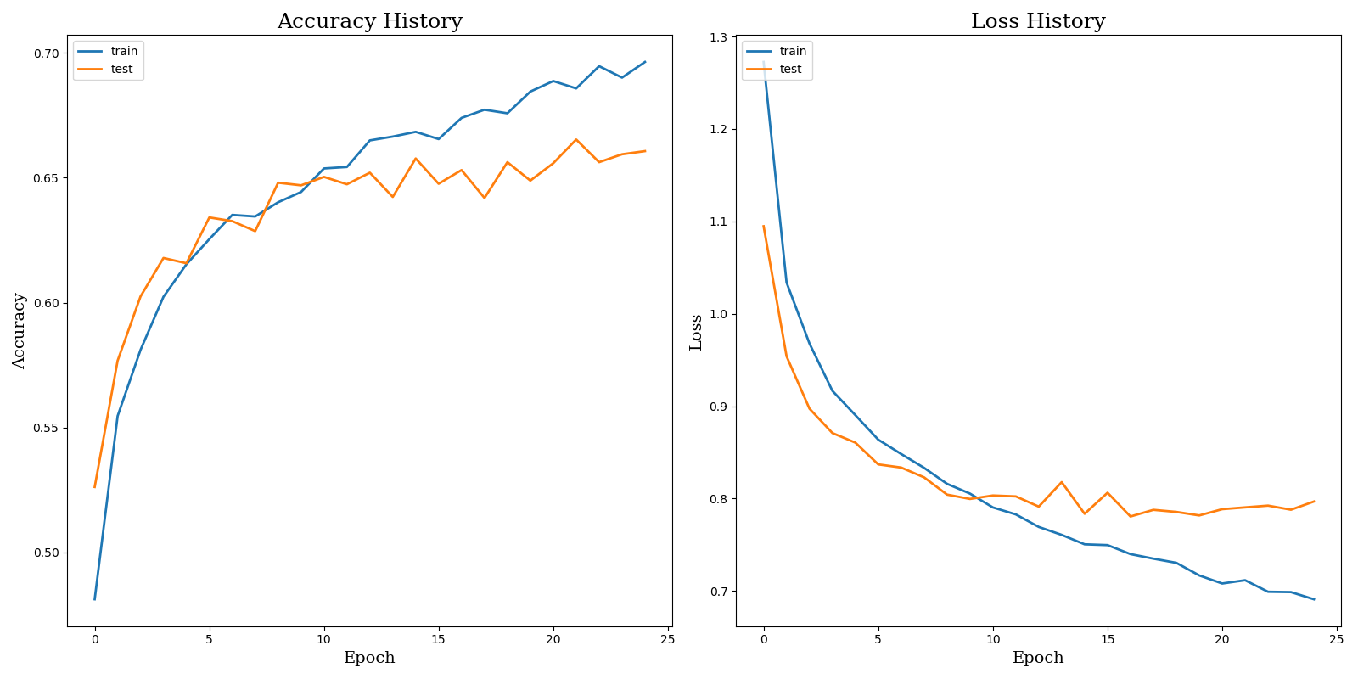

## Matriz de Confusión

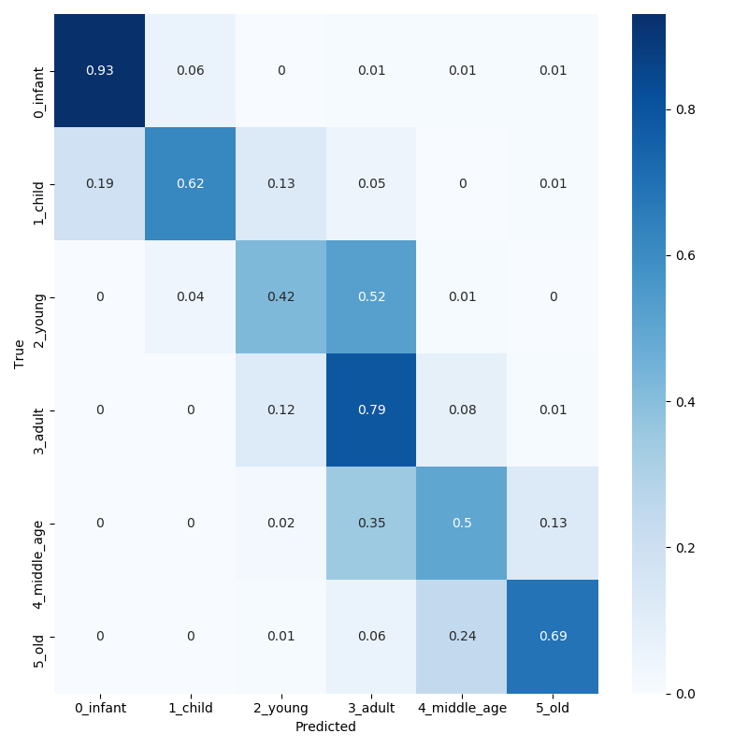

## Classification Report

|  |  |  |  |  |
| --- | --- | --- | --- | --- |
|  | **precision** | **recall** | **f1-score** | **support** |
| **0_infant** | 0.85 | 0.93 | 0.89 | 379 |
| **1_child** | 0.75 | 0.62 | 0.68 | 304 |
| **2_young** | 055 | 0.42 | 0.48 | 845 |
| **3_adult** | 0.65 | 0.79 | 0.71 | 1873 |
| **4_middle_age** | 0.61 | 0.50 | 0.55 | 862 |
| **5_old** | 0.71 | 0.69 | 0.70 | 479 |
|  |  |  |  |  |
| **accuracy** | -- | -- | 0.66 | 4742 |
| **macro_avg** | 0.69 | 0.66 | 0.67 | 4742 |
| **weighted_avg** | 0.66 | 0.66 | 0.65 | 4742 |

## Observaciones

Precisión training: 0.6964

Pérdida training: 0.6911

Precisión validación/test: 0.6607

Pérdida test: 0.7968

# Model 4

## Arquitectura y configuración de hiperparámetros

Model: "sequential"

_________________________________________________________________

Layer (type) Output Shape Param #

=================================================================

conv2d (Conv2D) (None, 62, 62, 32) 896

_________________________________________________________________

max_pooling2d (MaxPooling2D) (None, 31, 31, 32) 0

_________________________________________________________________

conv2d_1 (Conv2D) (None, 29, 29, 32) 9248

_________________________________________________________________

max_pooling2d_1 (MaxPooling2 (None, 14, 14, 32) 0

_________________________________________________________________

flatten (Flatten) (None, 6272) 0

_________________________________________________________________

dense (Dense) (None, 128) 802944

_________________________________________________________________

dropout (Dropout) (None, 128) 0

_________________________________________________________________

dense_1 (Dense) (None, 64) 8256

_________________________________________________________________

dropout_1 (Dropout) (None, 64) 0

_________________________________________________________________

dense_2 (Dense) (None, 6) 390

=================================================================

Total params: 821,734

Trainable params: 821,734

Non-trainable params: 0

|  |  |  |  |  |  |  |  |  |  |  |  |  |  |  |  |  |  |  |  |  |
| --- | --- | --- | --- | --- | --- | --- | --- | --- | --- | --- | --- | --- | --- | --- | --- | --- | --- | --- | --- | --- |
| **Model-4** | 0.2 | 0.05 | [0.95, 1.2] | TRUE | 64x64 | 32 | 64x64 | 32 | 1 | 32 | 3x3 | 64x64x3 | relu | 2x2 | 1 | 128 | relu | 0.3 | adam | 25 |
| 2 | 32 | 3x3 | -- | relu | 2x2 | 2 | **64** | **relu** | **0.3** |
| 3 |  |  |  |  |  | 3 | 6 | softmax |  |
| 4 |  |  |  |  |  | 4 |  |  |  |

* 1. 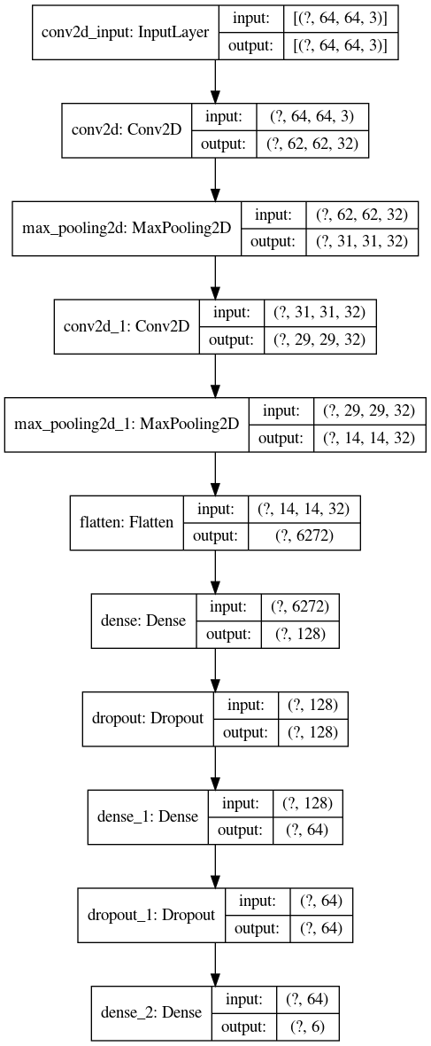

## Proceso de Training

Epoch 1/25

2020-07-12 20:02:10.049413: I tensorflow/stream_executor/platform/default/dso_loader.cc:44] Successfully opened dynamic library libcublas.so.10

2020-07-12 20:02:10.229117: I tensorflow/stream_executor/platform/default/dso_loader.cc:44] Successfully opened dynamic library libcudnn.so.7

593/593 [==============================] - 37s 63ms/step - loss: 1.2997 - accuracy: 0.4654 - val_loss: 1.0309 - val_accuracy: 0.5506

Epoch 2/25

593/593 [==============================] - 39s 65ms/step - loss: 1.0516 - accuracy: 0.5510 - val_loss: 0.9480 - val_accuracy: 0.5909

Epoch 3/25

593/593 [==============================] - 39s 65ms/step - loss: 0.9776 - accuracy: 0.5792 - val_loss: 0.8851 - val_accuracy: 0.6107

Epoch 4/25

593/593 [==============================] - 39s 65ms/step - loss: 0.9353 - accuracy: 0.5945 - val_loss: 0.9230 - val_accuracy: 0.5936

Epoch 5/25

593/593 [==============================] - 39s 65ms/step - loss: 0.9046 - accuracy: 0.6030 - val_loss: 0.8818 - val_accuracy: 0.6229

Epoch 6/25

593/593 [==============================] - 39s 65ms/step - loss: 0.8846 - accuracy: 0.6139 - val_loss: 0.8494 - val_accuracy: 0.6240

Epoch 7/25

593/593 [==============================] - 39s 66ms/step - loss: 0.8651 - accuracy: 0.6246 - val_loss: 0.8326 - val_accuracy: 0.6369

Epoch 8/25

593/593 [==============================] - 43s 72ms/step - loss: 0.8430 - accuracy: 0.6346 - val_loss: 0.8420 - val_accuracy: 0.6276

Epoch 9/25

593/593 [==============================] - 42s 71ms/step - loss: 0.8310 - accuracy: 0.6366 - val_loss: 0.8320 - val_accuracy: 0.6383

Epoch 10/25

593/593 [==============================] - 40s 68ms/step - loss: 0.8136 - accuracy: 0.6476 - val_loss: 0.8404 - val_accuracy: 0.6388

Epoch 11/25

593/593 [==============================] - 40s 68ms/step - loss: 0.8142 - accuracy: 0.6456 - val_loss: 0.8023 - val_accuracy: 0.6508

Epoch 12/25

593/593 [==============================] - 39s 65ms/step - loss: 0.7973 - accuracy: 0.6513 - val_loss: 0.8340 - val_accuracy: 0.6445

Epoch 13/25

593/593 [==============================] - 39s 67ms/step - loss: 0.7865 - accuracy: 0.6572 - val_loss: 0.7984 - val_accuracy: 0.6525

Epoch 14/25

593/593 [==============================] - 40s 68ms/step - loss: 0.7822 - accuracy: 0.6575 - val_loss: 0.7989 - val_accuracy: 0.6542

Epoch 15/25

593/593 [==============================] - 39s 67ms/step - loss: 0.7669 - accuracy: 0.6606 - val_loss: 0.8129 - val_accuracy: 0.6504

Epoch 16/25

593/593 [==============================] - 40s 67ms/step - loss: 0.7651 - accuracy: 0.6645 - val_loss: 0.8062 - val_accuracy: 0.6470

Epoch 17/25

593/593 [==============================] - 41s 69ms/step - loss: 0.7511 - accuracy: 0.6687 - val_loss: 0.8010 - val_accuracy: 0.6472

Epoch 18/25

593/593 [==============================] - 42s 70ms/step - loss: 0.7489 - accuracy: 0.6735 - val_loss: 0.8085 - val_accuracy: 0.6482

Epoch 19/25

593/593 [==============================] - 41s 70ms/step - loss: 0.7399 - accuracy: 0.6776 - val_loss: 0.7960 - val_accuracy: 0.6552

Epoch 20/25

593/593 [==============================] - 43s 73ms/step - loss: 0.7380 - accuracy: 0.6780 - val_loss: 0.7990 - val_accuracy: 0.6563

Epoch 21/25

593/593 [==============================] - 41s 69ms/step - loss: 0.7278 - accuracy: 0.6805 - val_loss: 0.8028 - val_accuracy: 0.6464

Epoch 22/25

593/593 [==============================] - 40s 67ms/step - loss: 0.7243 - accuracy: 0.6794 - val_loss: 0.8270 - val_accuracy: 0.6453

Epoch 23/25

593/593 [==============================] - 39s 66ms/step - loss: 0.7179 - accuracy: 0.6813 - val_loss: 0.7981 - val_accuracy: 0.6451

Epoch 24/25

593/593 [==============================] - 40s 68ms/step - loss: 0.7117 - accuracy: 0.6874 - val_loss: 0.7992 - val_accuracy: 0.6546

Epoch 25/25

593/593 [==============================] - 39s 66ms/step - loss: 0.7064 - accuracy: 0.6900 - val_loss: 0.8097 - val_accuracy: 0.6512

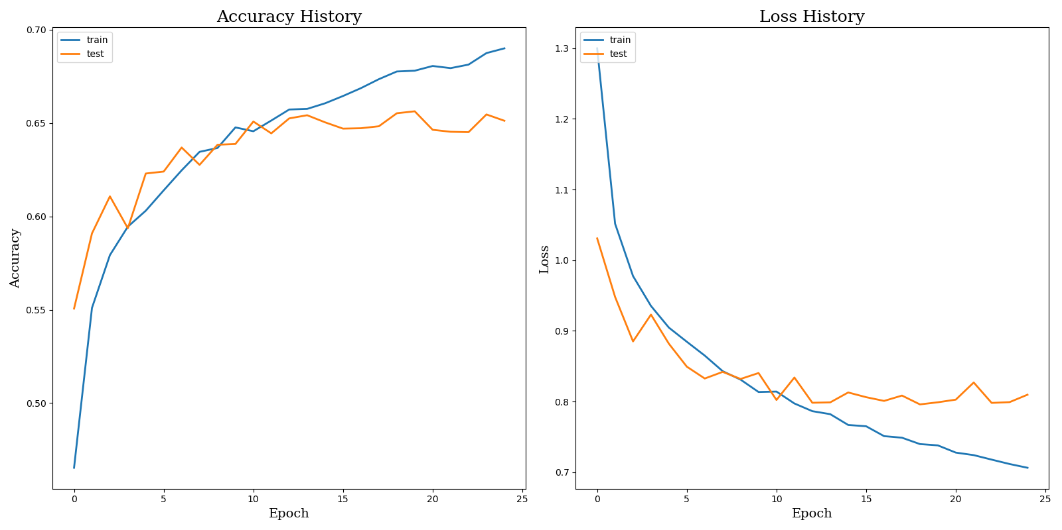

## Matriz de Confusión

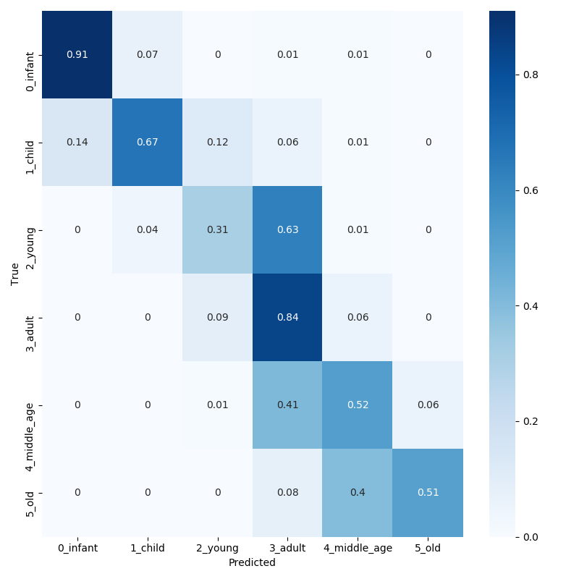

## Classification Report

|  |  |  |  |  |
| --- | --- | --- | --- | --- |
|  | **precision** | **recall** | **f1-score** | **support** |
| **0_infant** | 0.88 | 0.91 | 0.90 | 379 |
| **1_child** | 0.74 | 0.67 | 0.70 | 304 |
| **2_young** | 0.56 | 0.31 | 0.40 | 845 |
| **3_adult** | 0.63 | 0.84 | 0.72 | 1873 |
| **4_middle_age** | 0.58 | 0.52 | 0.55 | 862 |
| **5_old** | 0.81 | 0.51 | 0.63 | 479 |
|  |  |  |  |  |
| **accuracy** | -- | -- | 0.65 | 4742 |
| **macro_avg** | 0.70 | 0.63 | 0.65 | 4742 |
| **weighted_avg** | 0.65 | 0.65 | 0.64 | 4742 |

## Observaciones

Precisión training: 0.6900

Pérdida training: 0.7064

Precisión validación/test: 0.6512

Pérdida test: 0.8097

-

-

# Model 5

## Arquitectura y configuración de hiperparámetros

Model: "sequential"

_________________________________________________________________

Layer (type) Output Shape Param #

=================================================================

conv2d (Conv2D) (None, 62, 62, 32) 896

_________________________________________________________________

max_pooling2d (MaxPooling2D) (None, 31, 31, 32) 0

_________________________________________________________________

conv2d_1 (Conv2D) (None, 29, 29, 32) 9248

_________________________________________________________________

max_pooling2d_1 (MaxPooling2 (None, 14, 14, 32) 0

_________________________________________________________________

conv2d_2 (Conv2D) (None, 12, 12, 64) 18496

_________________________________________________________________

max_pooling2d_2 (MaxPooling2 (None, 6, 6, 64) 0

_________________________________________________________________

flatten (Flatten) (None, 2304) 0

_________________________________________________________________

dense (Dense) (None, 128) 295040

_________________________________________________________________

dropout (Dropout) (None, 128) 0

_________________________________________________________________

dense_1 (Dense) (None, 64) 8256

_________________________________________________________________

dropout_1 (Dropout) (None, 64) 0

_________________________________________________________________

dense_2 (Dense) (None, 6) 390

=================================================================

Total params: 332,326

Trainable params: 332,326

Non-trainable params: 0

|  |  |  |  |  |  |  |  |  |  |  |  |  |  |  |  |  |  |  |  |  |
| --- | --- | --- | --- | --- | --- | --- | --- | --- | --- | --- | --- | --- | --- | --- | --- | --- | --- | --- | --- | --- |
| **Model-5** | 0.2 | 0.05 | [0.95, 1.2] | TRUE | 64x64 | 32 | 64x64 | 32 | 1 | 32 | 3x3 | 64x64x3 | relu | 2x2 | 1 | 128 | relu | 0.3 | adam | 25 |
| 2 | 32 | 3x3 | -- | relu | 2x2 | 2 | 64 | relu | 0.3 |
| 3 | **64** | **3x3** | **--** | **relu** | **2x2** | 3 | 6 | softmax |  |
| 4 |  |  |  |  |  | 4 |  |  |  |

## Proceso de Training

Epoch 1/25

2020-07-12 20:31:05.631457: I tensorflow/stream_executor/platform/default/dso_loader.cc:44] Successfully opened dynamic library libcublas.so.10

2020-07-12 20:31:05.801441: I tensorflow/stream_executor/platform/default/dso_loader.cc:44] Successfully opened dynamic library libcudnn.so.7

593/593 [==============================] - 38s 65ms/step - loss: 1.3431 - accuracy: 0.4529 - val_loss: 1.0670 - val_accuracy: 0.5342

Epoch 2/25

593/593 [==============================] - 41s 69ms/step - loss: 1.0918 - accuracy: 0.5333 - val_loss: 0.9984 - val_accuracy: 0.5704

Epoch 3/25

593/593 [==============================] - 40s 67ms/step - loss: 1.0161 - accuracy: 0.5595 - val_loss: 0.9453 - val_accuracy: 0.5856

Epoch 4/25

593/593 [==============================] - 40s 67ms/step - loss: 0.9774 - accuracy: 0.5734 - val_loss: 0.9338 - val_accuracy: 0.5841

Epoch 5/25

593/593 [==============================] - 43s 73ms/step - loss: 0.9364 - accuracy: 0.5958 - val_loss: 0.9025 - val_accuracy: 0.5995

Epoch 6/25

593/593 [==============================] - 43s 72ms/step - loss: 0.9130 - accuracy: 0.6011 - val_loss: 0.9174 - val_accuracy: 0.6027

Epoch 7/25

593/593 [==============================] - 43s 73ms/step - loss: 0.8935 - accuracy: 0.6065 - val_loss: 0.8818 - val_accuracy: 0.6067

Epoch 8/25

593/593 [==============================] - 43s 72ms/step - loss: 0.8790 - accuracy: 0.6150 - val_loss: 0.8662 - val_accuracy: 0.6208

Epoch 9/25

593/593 [==============================] - 43s 72ms/step - loss: 0.8642 - accuracy: 0.6194 - val_loss: 0.8756 - val_accuracy: 0.6202

Epoch 10/25

593/593 [==============================] - 45s 75ms/step - loss: 0.8474 - accuracy: 0.6260 - val_loss: 0.8478 - val_accuracy: 0.6331

Epoch 11/25

593/593 [==============================] - 43s 73ms/step - loss: 0.8373 - accuracy: 0.6291 - val_loss: 0.8330 - val_accuracy: 0.6350

Epoch 12/25

593/593 [==============================] - 41s 69ms/step - loss: 0.8253 - accuracy: 0.6338 - val_loss: 0.8112 - val_accuracy: 0.6388

Epoch 13/25

593/593 [==============================] - 42s 70ms/step - loss: 0.8195 - accuracy: 0.6409 - val_loss: 0.8560 - val_accuracy: 0.6314

Epoch 14/25

593/593 [==============================] - 43s 73ms/step - loss: 0.8108 - accuracy: 0.6443 - val_loss: 0.8144 - val_accuracy: 0.6411

Epoch 15/25

593/593 [==============================] - 45s 76ms/step - loss: 0.8061 - accuracy: 0.6474 - val_loss: 0.8143 - val_accuracy: 0.6358

Epoch 16/25

593/593 [==============================] - 46s 78ms/step - loss: 0.7920 - accuracy: 0.6502 - val_loss: 0.8189 - val_accuracy: 0.6381

Epoch 17/25

593/593 [==============================] - 45s 76ms/step - loss: 0.7884 - accuracy: 0.6498 - val_loss: 0.8183 - val_accuracy: 0.6432

Epoch 18/25

593/593 [==============================] - 44s 74ms/step - loss: 0.7925 - accuracy: 0.6522 - val_loss: 0.8007 - val_accuracy: 0.6457

Epoch 19/25

593/593 [==============================] - 45s 76ms/step - loss: 0.7765 - accuracy: 0.6574 - val_loss: 0.8006 - val_accuracy: 0.6539

Epoch 20/25

593/593 [==============================] - 46s 78ms/step - loss: 0.7756 - accuracy: 0.6606 - val_loss: 0.8108 - val_accuracy: 0.6430

Epoch 21/25

593/593 [==============================] - 46s 77ms/step - loss: 0.7781 - accuracy: 0.6549 - val_loss: 0.7929 - val_accuracy: 0.6423

Epoch 22/25

593/593 [==============================] - 48s 82ms/step - loss: 0.7573 - accuracy: 0.6719 - val_loss: 0.7975 - val_accuracy: 0.6516

Epoch 23/25

593/593 [==============================] - 47s 80ms/step - loss: 0.7660 - accuracy: 0.6572 - val_loss: 0.8032 - val_accuracy: 0.6472

Epoch 24/25

593/593 [==============================] - 47s 80ms/step - loss: 0.7563 - accuracy: 0.6656 - val_loss: 0.7906 - val_accuracy: 0.6464

Epoch 25/25

593/593 [==============================] - 47s 80ms/step - loss: 0.7490 - accuracy: 0.6685 - val_loss: 0.7856 - val_accuracy: 0.6554

## Matriz de Confusión

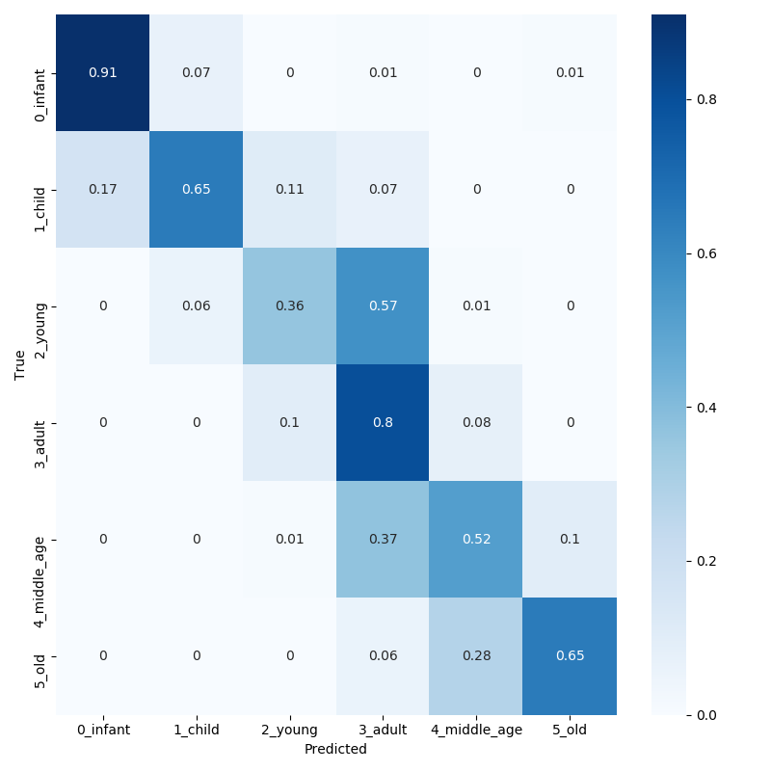

## Classification Report

|  |  |  |  |  |
| --- | --- | --- | --- | --- |
|  | **precision** | **recall** | **f1-score** | **support** |
| **0_infant** | 0.85 | 0.91 | 0.88 | 379 |
| **1_child** | 0.70 | 0.65 | 0.67 | 304 |
| **2_young** | 0.56 | 0.36 | 0.44 | 845 |
| **3_adult** | 0.64 | 0.80 | 0.71 | 1873 |
| **4_middle_age** | 0.60 | 0.52 | 0.55 | 862 |
| **5_old** | 0.76 | 0.65 | 0.70 | 479 |
|  |  |  |  |  |
| **accuracy** | -- | -- | 0.66 | 4742 |
| **macro_avg** | 0.68 | 0.65 | 0.66 | 4742 |
| **weighted_avg** | 0.65 | 0.66 | 0.64 | 4742 |

## Observaciones

Precisión training: 0.6685

Pérdida training: 0.7490

Precisión validación/test: 0.6554

Pérdida test: 0.7856

# Model 6

## Arquitectura y configuración de hiperparámetros

Model: "sequential"

_________________________________________________________________

Layer (type) Output Shape Param #

=================================================================

conv2d (Conv2D) (None, 62, 62, 32) 896

_________________________________________________________________

max_pooling2d (MaxPooling2D) (None, 31, 31, 32) 0

_________________________________________________________________

conv2d_1 (Conv2D) (None, 29, 29, 32) 9248

_________________________________________________________________

max_pooling2d_1 (MaxPooling2 (None, 14, 14, 32) 0

_________________________________________________________________

conv2d_2 (Conv2D) (None, 12, 12, 64) 18496

_________________________________________________________________

max_pooling2d_2 (MaxPooling2 (None, 6, 6, 64) 0

_________________________________________________________________

flatten (Flatten) (None, 2304) 0

_________________________________________________________________

dense (Dense) (None, 128) 295040

_________________________________________________________________

dropout (Dropout) (None, 128) 0

_________________________________________________________________

dense_1 (Dense) (None, 64) 8256

_________________________________________________________________

dropout_1 (Dropout) (None, 64) 0

_________________________________________________________________

dense_2 (Dense) (None, 32) 2080

_________________________________________________________________

dropout_2 (Dropout) (None, 32) 0

_________________________________________________________________

dense_3 (Dense) (None, 6) 198

=================================================================

Total params: 334,214

Trainable params: 334,214

Non-trainable params: 0

|  |  |  |  |  |  |  |  |  |  |  |  |  |  |  |  |  |  |  |  |  |
| --- | --- | --- | --- | --- | --- | --- | --- | --- | --- | --- | --- | --- | --- | --- | --- | --- | --- | --- | --- | --- |
| **Model-6** | 0.2 | 0.05 | [0.95, 1.2] | TRUE | 64x64 | 32 | 64x64 | 32 | 1 | 32 | 3x3 | 64x64x3 | relu | 2x2 | 1 | 128 | relu | 0.3 | adam | 25 |
| 2 | 32 | 3x3 | -- | relu | 2x2 | 2 | 64 | relu | 0.3 |
| 3 | 64 | 3x3 | -- | relu | 2x2 | 3 | **32** | **relu** | **0.3** |
| 4 |  |  |  |  |  | 4 | 6 | softmax |  |

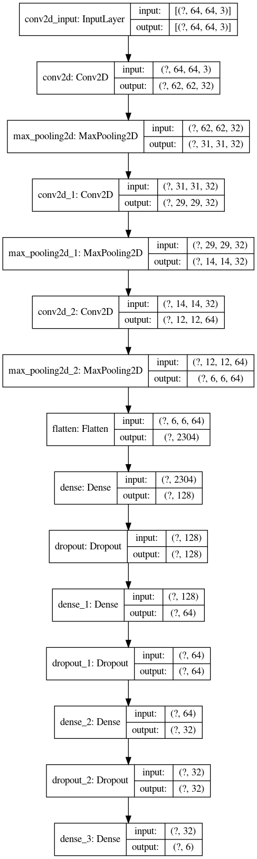

## Proceso de Training

Epoch 1/25

2020-07-12 21:10:08.088763: I tensorflow/stream_executor/platform/default/dso_loader.cc:44] Successfully opened dynamic library libcublas.so.10

2020-07-12 21:10:08.297802: I tensorflow/stream_executor/platform/default/dso_loader.cc:44] Successfully opened dynamic library libcudnn.so.7

593/593 [==============================] - 40s 67ms/step - loss: 1.4532 - accuracy: 0.4152 - val_loss: 1.1551 - val_accuracy: 0.4987

Epoch 2/25

593/593 [==============================] - 39s 66ms/step - loss: 1.1613 - accuracy: 0.5096 - val_loss: 1.0480 - val_accuracy: 0.5415

Epoch 3/25

593/593 [==============================] - 42s 71ms/step - loss: 1.0720 - accuracy: 0.5420 - val_loss: 1.0090 - val_accuracy: 0.5662

Epoch 4/25

593/593 [==============================] - 43s 72ms/step - loss: 1.0221 - accuracy: 0.5636 - val_loss: 0.9341 - val_accuracy: 0.5924

Epoch 5/25

593/593 [==============================] - 42s 70ms/step - loss: 0.9831 - accuracy: 0.5778 - val_loss: 0.9484 - val_accuracy: 0.5974

Epoch 6/25

593/593 [==============================] - 40s 68ms/step - loss: 0.9541 - accuracy: 0.5891 - val_loss: 0.9195 - val_accuracy: 0.6027

Epoch 7/25

593/593 [==============================] - 40s 68ms/step - loss: 0.9379 - accuracy: 0.5959 - val_loss: 0.8715 - val_accuracy: 0.6145

Epoch 8/25

593/593 [==============================] - 40s 68ms/step - loss: 0.9139 - accuracy: 0.6015 - val_loss: 0.8731 - val_accuracy: 0.6170

Epoch 9/25

593/593 [==============================] - 41s 69ms/step - loss: 0.8912 - accuracy: 0.6080 - val_loss: 0.8693 - val_accuracy: 0.6208

Epoch 10/25

593/593 [==============================] - 40s 68ms/step - loss: 0.8872 - accuracy: 0.6106 - val_loss: 0.8493 - val_accuracy: 0.6288

Epoch 11/25

593/593 [==============================] - 41s 69ms/step - loss: 0.8798 - accuracy: 0.6178 - val_loss: 0.8424 - val_accuracy: 0.6208

Epoch 12/25

593/593 [==============================] - 43s 72ms/step - loss: 0.8725 - accuracy: 0.6173 - val_loss: 0.8359 - val_accuracy: 0.6343

Epoch 13/25

593/593 [==============================] - 41s 70ms/step - loss: 0.8606 - accuracy: 0.6216 - val_loss: 0.8486 - val_accuracy: 0.6236

Epoch 14/25

593/593 [==============================] - 41s 69ms/step - loss: 0.8462 - accuracy: 0.6243 - val_loss: 0.8202 - val_accuracy: 0.6442

Epoch 15/25

593/593 [==============================] - 42s 71ms/step - loss: 0.8382 - accuracy: 0.6309 - val_loss: 0.8326 - val_accuracy: 0.6263

Epoch 16/25

593/593 [==============================] - 42s 70ms/step - loss: 0.8417 - accuracy: 0.6305 - val_loss: 0.8282 - val_accuracy: 0.6316

Epoch 17/25

593/593 [==============================] - 43s 73ms/step - loss: 0.8307 - accuracy: 0.6349 - val_loss: 0.8160 - val_accuracy: 0.6419

Epoch 18/25

593/593 [==============================] - 43s 72ms/step - loss: 0.8247 - accuracy: 0.6422 - val_loss: 0.8336 - val_accuracy: 0.6278

Epoch 19/25

593/593 [==============================] - 42s 71ms/step - loss: 0.8184 - accuracy: 0.6395 - val_loss: 0.7973 - val_accuracy: 0.6455

Epoch 20/25

593/593 [==============================] - 41s 70ms/step - loss: 0.8109 - accuracy: 0.6481 - val_loss: 0.8202 - val_accuracy: 0.6464

Epoch 21/25

593/593 [==============================] - 42s 70ms/step - loss: 0.8133 - accuracy: 0.6474 - val_loss: 0.8244 - val_accuracy: 0.6455

Epoch 22/25

593/593 [==============================] - 41s 68ms/step - loss: 0.8059 - accuracy: 0.6458 - val_loss: 0.8186 - val_accuracy: 0.6415

Epoch 23/25

593/593 [==============================] - 42s 70ms/step - loss: 0.8003 - accuracy: 0.6474 - val_loss: 0.8000 - val_accuracy: 0.6504

Epoch 24/25

593/593 [==============================] - 43s 73ms/step - loss: 0.7971 - accuracy: 0.6502 - val_loss: 0.8019 - val_accuracy: 0.6491

Epoch 25/25

593/593 [==============================] - 43s 73ms/step - loss: 0.7977 - accuracy: 0.6540 - val_loss: 0.8015 - val_accuracy: 0.6575

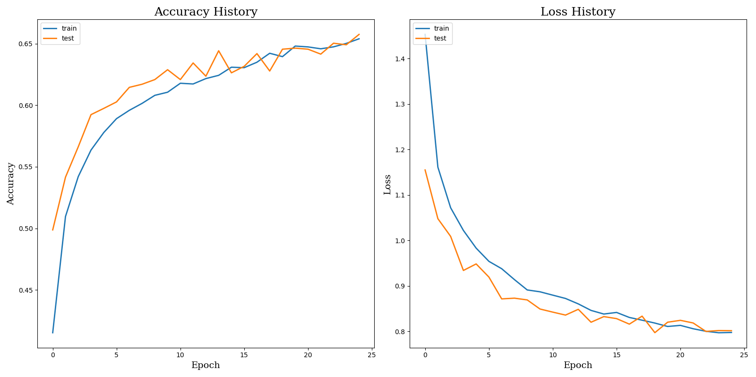

## Matriz de Confusión

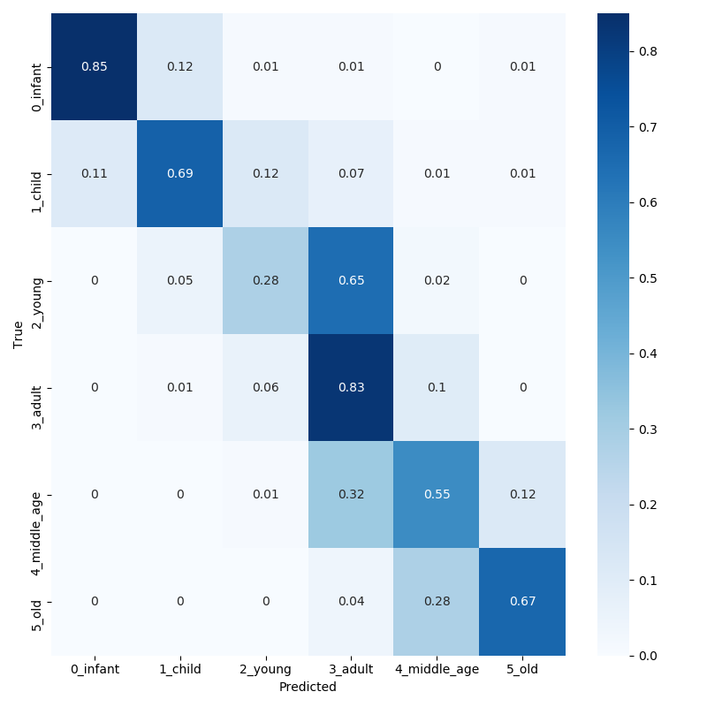

## Classification Report

|  |  |  |  |  |
| --- | --- | --- | --- | --- |
|  | **precision** | **recall** | **f1-score** | **support** |
| **0_infant** | 0.90 | 0.85 | 0.88 | 379 |
| **1_child** | 0.68 | 0.69 | 0.69 | 304 |
| **2_young** | 0.59 | 0.28 | 0.38 | 845 |
| **3_adult** | 0.64 | 0.83 | 0.72 | 1873 |
| **4_middle_age** | 0.58 | 0.55 | 0.57 | 862 |
| **5_old** | 0.74 | 0.67 | 0.70 | 479 |
|  |  |  |  |  |
| **accuracy** | -- | -- | 0.66 | 4742 |
| **macro_avg** | 0.69 | 0.65 | 0.66 | 4742 |
| **weighted_avg** | 0.65 | 0.66 | 0.64 | 4742 |

## Observaciones

Precisión training: 0.6540

Pérdida training: 0.7977

Precisión validación/test: 0.6575

Pérdida test: 0.8015

- Precisión se mantiene en línea con la precisión de los modelos anteriores, en torno al 65% - 66%

- No se aprecia overfitting en el modelo, lo que podría considerarse bueno.

- Tanto las gráficas de Accuracy como Loss para el proceso de entrenamiento muestran unas tendencias similares en train como en test.

- El ratio de acierto en la clase Young es extremadamente bajo (28%), siendo el 65% de los ejemplos clasificados como Adult. Consultar matriz de confusión.

# Model 7

## Arquitectura y configuración de hiperparámetros

Model: "sequential"

_________________________________________________________________

Layer (type) Output Shape Param #

=================================================================

conv2d (Conv2D) (None, 62, 62, 32) 896

_________________________________________________________________

max_pooling2d (MaxPooling2D) (None, 31, 31, 32) 0

_________________________________________________________________

conv2d_1 (Conv2D) (None, 29, 29, 64) 18496

_________________________________________________________________

max_pooling2d_1 (MaxPooling2 (None, 14, 14, 64) 0

_________________________________________________________________

conv2d_2 (Conv2D) (None, 12, 12, 128) 73856

_________________________________________________________________

max_pooling2d_2 (MaxPooling2 (None, 6, 6, 128) 0

_________________________________________________________________

flatten (Flatten) (None, 4608) 0

_________________________________________________________________

dense (Dense) (None, 128) 589952

_________________________________________________________________

dropout (Dropout) (None, 128) 0

_________________________________________________________________

dense_1 (Dense) (None, 64) 8256

_________________________________________________________________

dropout_1 (Dropout) (None, 64) 0

_________________________________________________________________

dense_2 (Dense) (None, 32) 2080

_________________________________________________________________

dropout_2 (Dropout) (None, 32) 0

_________________________________________________________________

dense_3 (Dense) (None, 6) 198

=================================================================

Total params: 693,734

Trainable params: 693,734

Non-trainable params: 0

|  |  |  |  |  |  |  |  |  |  |  |  |  |  |  |  |  |  |  |  |  |
| --- | --- | --- | --- | --- | --- | --- | --- | --- | --- | --- | --- | --- | --- | --- | --- | --- | --- | --- | --- | --- |
| **Model-7** | 0.2 | 0.05 | [0.95, 1.2] | TRUE | 64x64 | 32 | 64x64 | 32 | 1 | 32 | 3x3 | 64x64x3 | relu | 2x2 | 1 | 128 | relu | 0.3 | adam | 25 |
| 2 | **64** | **3x3** | **--** | **relu** | **2x2** | 2 | 64 | relu | 0.3 |
| 3 | **128** | **3x3** | **--** | **relu** | **2x2** | 3 | 32 | relu | 0.3 |
| 4 |  |  |  |  |  | 4 | 6 | softmax |  |

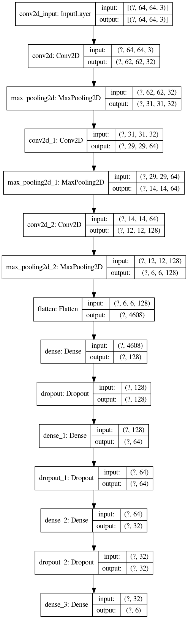

## Proceso de Training

* 1. Epoch 1/25
  2. 2020-07-12 21:55:37.389972: I tensorflow/stream_executor/platform/default/dso_loader.cc:44] Successfully opened dynamic library libcublas.so.10
  3. 2020-07-12 21:55:37.554525: I tensorflow/stream_executor/platform/default/dso_loader.cc:44] Successfully opened dynamic library libcudnn.so.7
  4. 593/593 [==============================] - 40s 68ms/step - loss: 1.4744 - accuracy: 0.4102 - val_loss: 1.1734 - val_accuracy: 0.4833
  5. Epoch 2/25
  6. 593/593 [==============================] - 44s 74ms/step - loss: 1.1730 - accuracy: 0.5091 - val_loss: 1.1125 - val_accuracy: 0.5261
  7. Epoch 3/25
  8. 593/593 [==============================] - 43s 72ms/step - loss: 1.0749 - accuracy: 0.5412 - val_loss: 0.9918 - val_accuracy: 0.5656
  9. Epoch 4/25
  10. 593/593 [==============================] - 45s 76ms/step - loss: 1.0199 - accuracy: 0.5648 - val_loss: 0.9255 - val_accuracy: 0.5865
  11. Epoch 5/25
  12. 593/593 [==============================] - 41s 70ms/step - loss: 0.9878 - accuracy: 0.5707 - val_loss: 0.9123 - val_accuracy: 0.5949
  13. Epoch 6/25
  14. 593/593 [==============================] - 41s 70ms/step - loss: 0.9590 - accuracy: 0.5883 - val_loss: 0.9042 - val_accuracy: 0.6107
  15. Epoch 7/25
  16. 593/593 [==============================] - 41s 70ms/step - loss: 0.9381 - accuracy: 0.5934 - val_loss: 0.8911 - val_accuracy: 0.6086
  17. Epoch 8/25
  18. 593/593 [==============================] - 41s 69ms/step - loss: 0.9255 - accuracy: 0.5956 - val_loss: 0.8722 - val_accuracy: 0.6179
  19. Epoch 9/25
  20. 593/593 [==============================] - 41s 70ms/step - loss: 0.9092 - accuracy: 0.6046 - val_loss: 0.8582 - val_accuracy: 0.6272
  21. Epoch 10/25
  22. 593/593 [==============================] - 41s 69ms/step - loss: 0.9020 - accuracy: 0.6097 - val_loss: 0.8796 - val_accuracy: 0.6162
  23. Epoch 11/25
  24. 593/593 [==============================] - 42s 71ms/step - loss: 0.8837 - accuracy: 0.6119 - val_loss: 0.8589 - val_accuracy: 0.6213
  25. Epoch 12/25
  26. 593/593 [==============================] - 43s 72ms/step - loss: 0.8735 - accuracy: 0.6136 - val_loss: 0.8433 - val_accuracy: 0.6331
  27. Epoch 13/25
  28. 593/593 [==============================] - 43s 73ms/step - loss: 0.8620 - accuracy: 0.6209 - val_loss: 0.8756 - val_accuracy: 0.6217
  29. Epoch 14/25
  30. 593/593 [==============================] - 42s 71ms/step - loss: 0.8566 - accuracy: 0.6230 - val_loss: 0.8384 - val_accuracy: 0.6352
  31. Epoch 15/25
  32. 593/593 [==============================] - 42s 70ms/step - loss: 0.8461 - accuracy: 0.6283 - val_loss: 0.8334 - val_accuracy: 0.6413
  33. Epoch 16/25
  34. 593/593 [==============================] - 42s 70ms/step - loss: 0.8385 - accuracy: 0.6333 - val_loss: 0.8375 - val_accuracy: 0.6282
  35. Epoch 17/25
  36. 593/593 [==============================] - 41s 69ms/step - loss: 0.8379 - accuracy: 0.6331 - val_loss: 0.8256 - val_accuracy: 0.6394
  37. Epoch 18/25
  38. 593/593 [==============================] - 41s 70ms/step - loss: 0.8277 - accuracy: 0.6369 - val_loss: 0.8540 - val_accuracy: 0.6204
  39. Epoch 19/25
  40. 593/593 [==============================] - 42s 70ms/step - loss: 0.8180 - accuracy: 0.6382 - val_loss: 0.8108 - val_accuracy: 0.6426
  41. Epoch 20/25
  42. 593/593 [==============================] - 42s 70ms/step - loss: 0.8106 - accuracy: 0.6432 - val_loss: 0.8171 - val_accuracy: 0.6476
  43. Epoch 21/25
  44. 593/593 [==============================] - 42s 71ms/step - loss: 0.8114 - accuracy: 0.6449 - val_loss: 0.7927 - val_accuracy: 0.6510
  45. Epoch 22/25
  46. 593/593 [==============================] - 42s 70ms/step - loss: 0.8068 - accuracy: 0.6481 - val_loss: 0.8111 - val_accuracy: 0.6464
  47. Epoch 23/25
  48. 593/593 [==============================] - 41s 70ms/step - loss: 0.8010 - accuracy: 0.6482 - val_loss: 0.8084 - val_accuracy: 0.6495
  49. Epoch 24/25
  50. 593/593 [==============================] - 43s 72ms/step - loss: 0.8020 - accuracy: 0.6452 - val_loss: 0.8028 - val_accuracy: 0.6455
  51. Epoch 25/25
  52. 593/593 [==============================] - 42s 70ms/step - loss: 0.7992 - accuracy: 0.6445 - val_loss: 0.8468 - val_accuracy: 0.6423

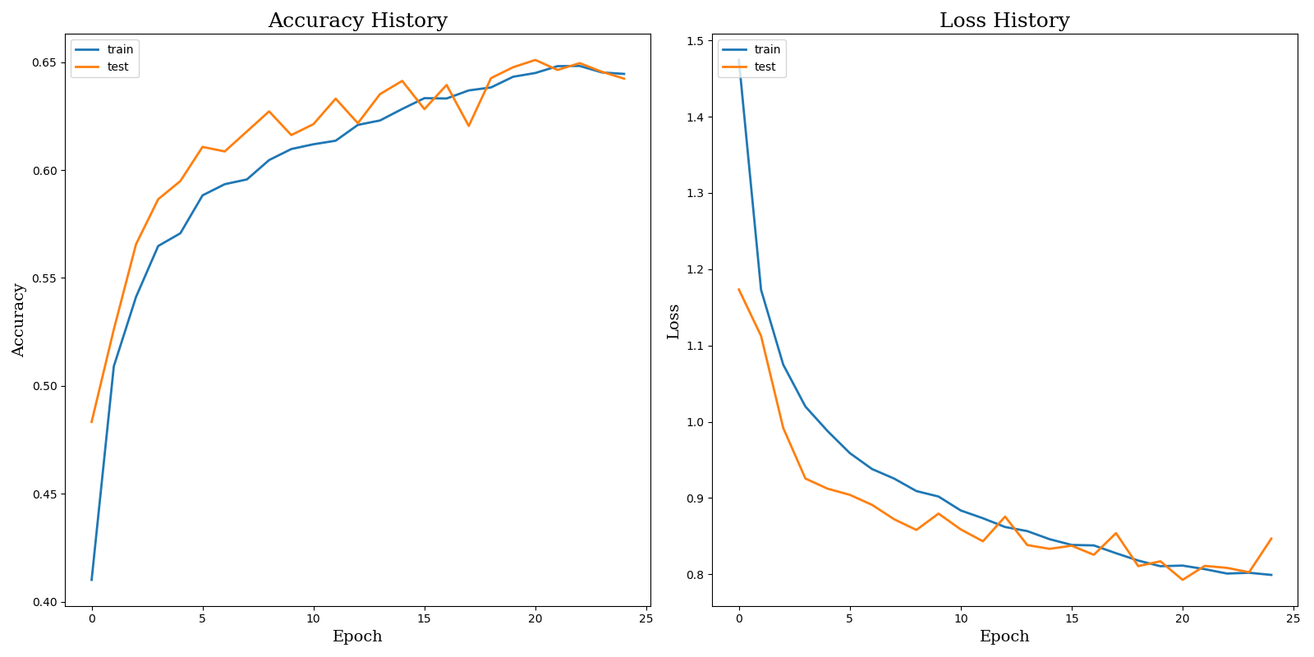

## Matriz de Confusión

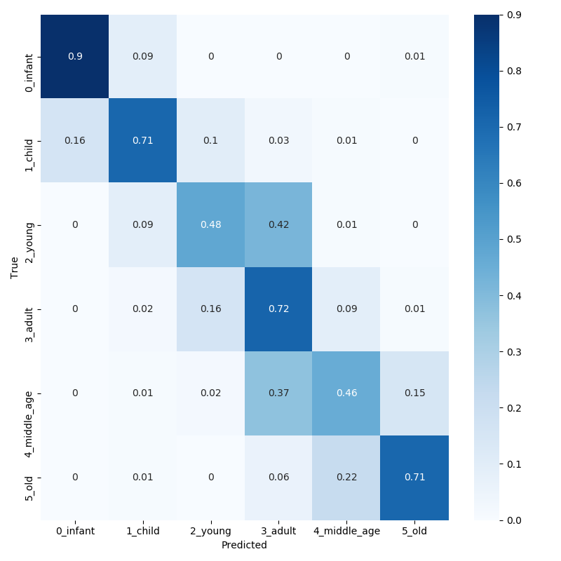

## Classification Report

|  |  |  |  |  |
| --- | --- | --- | --- | --- |
|  | **precision** | **recall** | **f1-score** | **support** |
| **0_infant** | 0.86 | 0.90 | 0.88 | 379 |
| **1_child** | 0.59 | 0.71 | 0.65 | 304 |
| **2_young** | 0.53 | 0.48 | 0.50 | 845 |
| **3_adult** | 0.66 | 0.72 | 0.69 | 1873 |
| **4_middle_age** | 0.58 | 0.46 | 0.51 | 862 |
| **5_old** | 0.70 | 0.71 | 0.71 | 479 |
|  |  |  |  |  |
| **accuracy** | -- | -- | 0.64 | 4742 |
| **macro_avg** | 0.65 | 0.66 | 0.66 | 4742 |
| **weighted_avg** | 0.64 | 0.64 | 0.64 | 4742 |

## Observaciones

Precisión training: 0.6445

Pérdida training: 0.7992

Precisión validación/test: 0.6423

Pérdida test: 0.8468

- Precisión más baja que en modelo anterior

- No overfitting

- Tasa acierto en Young algo más alta, pero continúa la alta confusión con la clase Adult.

- Aumentar duración del training (epochs), aparentemente la tendencia de Loss sigue a la baja y la de aprendizaje en incremento.

# Model 8

## Arquitectura y configuración de hiperparámetros

## Proceso de Training

## Matriz de Confusión

## Classification Report

|  |  |  |  |  |
| --- | --- | --- | --- | --- |
|  | **precision** | **recall** | **f1-score** | **support** |
| **0_infant** |  |  |  | 379 |
| **1_child** |  |  |  | 304 |
| **2_young** |  |  |  | 845 |
| **3_adult** |  |  |  | 1873 |
| **4_middle_age** |  |  |  | 862 |
| **5_old** |  |  |  | 479 |
|  |  |  |  |  |
| **accuracy** | -- | -- |  | 4742 |
| **macro_avg** |  |  |  | 4742 |
| **weighted_avg** |  |  |  | 4742 |

## Observaciones

Precisión training:

Pérdida training:

Precisión validación/test:

Pérdida test:

# Model 9

## Arquitectura y configuración de hiperparámetros

## Proceso de Training

## Matriz de Confusión

## Classification Report

|  |  |  |  |  |
| --- | --- | --- | --- | --- |
|  | **precision** | **recall** | **f1-score** | **support** |
| **0_infant** |  |  |  | 379 |
| **1_child** |  |  |  | 304 |
| **2_young** |  |  |  | 845 |
| **3_adult** |  |  |  | 1873 |
| **4_middle_age** |  |  |  | 862 |
| **5_old** |  |  |  | 479 |
|  |  |  |  |  |
| **accuracy** | -- | -- |  | 4742 |
| **macro_avg** |  |  |  | 4742 |
| **weighted_avg** |  |  |  | 4742 |

## Observaciones

Precisión training:

Pérdida training:

Precisión validación/test:

Pérdida test:

# Model 10

## Arquitectura y configuración de hiperparámetros

## Proceso de Training

## Matriz de Confusión

## Classification Report

|  |  |  |  |  |
| --- | --- | --- | --- | --- |
|  | **precision** | **recall** | **f1-score** | **support** |
| **0_infant** |  |  |  | 379 |
| **1_child** |  |  |  | 304 |
| **2_young** |  |  |  | 845 |
| **3_adult** |  |  |  | 1873 |
| **4_middle_age** |  |  |  | 862 |
| **5_old** |  |  |  | 479 |
|  |  |  |  |  |
| **accuracy** | -- | -- |  | 4742 |
| **macro_avg** |  |  |  | 4742 |
| **weighted_avg** |  |  |  | 4742 |

## Observaciones

Precisión training:

Pérdida training:

Precisión validación/test:

Pérdida test:

# Model 11

## Arquitectura y configuración de hiperparámetros

## Proceso de Training

## Matriz de Confusión

## Classification Report

|  |  |  |  |  |
| --- | --- | --- | --- | --- |
|  | **precision** | **recall** | **f1-score** | **support** |
| **0_infant** |  |  |  | 379 |
| **1_child** |  |  |  | 304 |
| **2_young** |  |  |  | 845 |
| **3_adult** |  |  |  | 1873 |
| **4_middle_age** |  |  |  | 862 |
| **5_old** |  |  |  | 479 |
|  |  |  |  |  |
| **accuracy** | -- | -- |  | 4742 |
| **macro_avg** |  |  |  | 4742 |
| **weighted_avg** |  |  |  | 4742 |

## Observaciones

Precisión training:

Pérdida training:

Precisión validación/test:

Pérdida test:

# Model 12

## Arquitectura y configuración de hiperparámetros

## Proceso de Training

## Matriz de Confusión

## Classification Report

|  |  |  |  |  |
| --- | --- | --- | --- | --- |
|  | **precision** | **recall** | **f1-score** | **support** |
| **0_infant** |  |  |  | 379 |
| **1_child** |  |  |  | 304 |
| **2_young** |  |  |  | 845 |
| **3_adult** |  |  |  | 1873 |
| **4_middle_age** |  |  |  | 862 |
| **5_old** |  |  |  | 479 |
|  |  |  |  |  |
| **accuracy** | -- | -- |  | 4742 |
| **macro_avg** |  |  |  | 4742 |
| **weighted_avg** |  |  |  | 4742 |

## Observaciones

Precisión training:

Pérdida training:

Precisión validación/test:

Pérdida test:

# Model 13

## Arquitectura y configuración de hiperparámetros

## Proceso de Training

## Matriz de Confusión

## Classification Report

|  |  |  |  |  |
| --- | --- | --- | --- | --- |
|  | **precision** | **recall** | **f1-score** | **support** |
| **0_infant** |  |  |  |  |
| **1_child** |  |  |  |  |
| **2_young** |  |  |  |  |
| **3_adult** |  |  |  |  |
| **4_middle_age** |  |  |  |  |
| **5_old** |  |  |  |  |
|  |  |  |  |  |
| **accuracy** | -- | -- |  |  |
| **macro_avg** |  |  |  |  |
| **weighted_avg** |  |  |  |  |

## Observaciones

Precisión training:

Pérdida training:

Precisión validación/test:

Pérdida test:

# Model 14

## Arquitectura y configuración de hiperparámetros

## Proceso de Training

## Matriz de Confusión

## Classification Report

|  |  |  |  |  |
| --- | --- | --- | --- | --- |
|  | **precision** | **recall** | **f1-score** | **support** |
| **0_infant** |  |  |  |  |
| **1_child** |  |  |  |  |
| **2_young** |  |  |  |  |
| **3_adult** |  |  |  |  |
| **4_middle_age** |  |  |  |  |
| **5_old** |  |  |  |  |
|  |  |  |  |  |
| **accuracy** | -- | -- |  |  |
| **macro_avg** |  |  |  |  |
| **weighted_avg** |  |  |  |  |

## Observaciones

Precisión training:

Pérdida training:

Precisión validación/test:

Pérdida test:

# Model 15

## Arquitectura y configuración de hiperparámetros

## Proceso de Training

## Matriz de Confusión

## Classification Report

|  |  |  |  |  |
| --- | --- | --- | --- | --- |
|  | **precision** | **recall** | **f1-score** | **support** |
| **0_infant** |  |  |  |  |
| **1_child** |  |  |  |  |
| **2_young** |  |  |  |  |
| **3_adult** |  |  |  |  |
| **4_middle_age** |  |  |  |  |
| **5_old** |  |  |  |  |
|  |  |  |  |  |
| **accuracy** |  |  |  |  |
| **macro_avg** |  |  |  |  |
| **weighted_avg** |  |  |  |  |

## Observaciones

Precisión training:

Pérdida training:

Precisión validación/test:

Pérdida test:

# Model 16

## Arquitectura y configuración de hiperparámetros

## Proceso de Training

## Matriz de Confusión

## Classification Report

|  |  |  |  |  |
| --- | --- | --- | --- | --- |
|  | **precision** | **recall** | **f1-score** | **support** |
| **0_infant** |  |  |  |  |
| **1_child** |  |  |  |  |
| **2_young** |  |  |  |  |
| **3_adult** |  |  |  |  |
| **4_middle_age** |  |  |  |  |
| **5_old** |  |  |  |  |
|  |  |  |  |  |
| **accuracy** |  |  |  |  |
| **macro_avg** |  |  |  |  |
| **weighted_avg** |  |  |  |  |

## Observaciones

Precisión training:

Pérdida training:

Precisión validación/test:

Pérdida test:

# Model 17

## Arquitectura y configuración de hiperparámetros

## Proceso de Training

## Matriz de Confusión

## Classification Report

|  |  |  |  |  |
| --- | --- | --- | --- | --- |
|  | **precision** | **recall** | **f1-score** | **support** |
| **0_infant** |  |  |  |  |
| **1_child** |  |  |  |  |
| **2_young** |  |  |  |  |
| **3_adult** |  |  |  |  |
| **4_middle_age** |  |  |  |  |
| **5_old** |  |  |  |  |
|  |  |  |  |  |
| **accuracy** |  |  |  |  |
| **macro_avg** |  |  |  |  |
| **weighted_avg** |  |  |  |  |

## Observaciones

Precisión training:

Pérdida training:

Precisión validación/test:

Pérdida test:

# Model 18

## Arquitectura y configuración de hiperparámetros

## Proceso de Training

## Matriz de Confusión

## Classification Report

|  |  |  |  |  |
| --- | --- | --- | --- | --- |
|  | **precision** | **recall** | **f1-score** | **support** |
| **0_infant** |  |  |  |  |
| **1_child** |  |  |  |  |
| **2_young** |  |  |  |  |
| **3_adult** |  |  |  |  |
| **4_middle_age** |  |  |  |  |
| **5_old** |  |  |  |  |
|  |  |  |  |  |
| **accuracy** |  |  |  |  |
| **macro_avg** |  |  |  |  |
| **weighted_avg** |  |  |  |  |

## Observaciones

Precisión training:

Pérdida training:

Precisión validación/test:

Pérdida test:

# Model 19

## Arquitectura y configuración de hiperparámetros

## Proceso de Training

## Matriz de Confusión

## Classification Report

|  |  |  |  |  |
| --- | --- | --- | --- | --- |
|  | **precision** | **recall** | **f1-score** | **support** |
| **0_infant** |  |  |  |  |
| **1_child** |  |  |  |  |
| **2_young** |  |  |  |  |
| **3_adult** |  |  |  |  |
| **4_middle_age** |  |  |  |  |
| **5_old** |  |  |  |  |
|  |  |  |  |  |
| **accuracy** |  |  |  |  |
| **macro_avg** |  |  |  |  |
| **weighted_avg** |  |  |  |  |

## Observaciones

Precisión training:

Pérdida training:

Precisión validación/test:

Pérdida test:

# Model 20

## Arquitectura y configuración de hiperparámetros

## Proceso de Training

## Matriz de Confusión

## Classification Report

|  |  |  |  |  |
| --- | --- | --- | --- | --- |
|  | **precision** | **recall** | **f1-score** | **support** |
| **0_infant** |  |  |  |  |
| **1_child** |  |  |  |  |
| **2_young** |  |  |  |  |
| **3_adult** |  |  |  |  |
| **4_middle_age** |  |  |  |  |
| **5_old** |  |  |  |  |
|  |  |  |  |  |
| **accuracy** |  |  |  |  |
| **macro_avg** |  |  |  |  |
| **weighted_avg** |  |  |  |  |

## Observaciones

Precisión training:

Pérdida training:

Precisión validación/test:

Pérdida test: