Instituto Superior Técnico

Mestrado Integrado em Engenharia Electrotécnica e de Computadores

SIBD
2nd Project Assignment

Group number: 12

Number: 84106 Name: John Daniel Fidalgo Mendonça
Number: 84180 Name: Rúben dos Santos Gomes
Number: 91410 Name: Renato Fraga Trevizan

Database Schema Creation

drop table if exists produced_indicator;
drop table if exists test_procedure;
drop table if exists radiography;
drop table if exists indicator;
drop table if exists performed;
drop table if exists procedure_;

drop table if exists prescription;
drop table if exists medication;
drop table if exists consult_diagnosis;
drop table if exists diagnosis_code;

drop table if exists participation;
drop table if exists consult;
drop table if exists animal;

drop table if exists generalization_species;
drop table if exists species;
drop table if exists assistant;
drop table if exists veterinary;
drop table if exists phone_number;
drop table if exists client;
drop table if exists person;

create table person (
VAT varchar(255),
name varchar(255),
address_street varchar(255),
address_city varchar(255),
address_zip varchar(255),
primary key (VAT)
);

create table phone_number (
VAT varchar(255),
phone varchar(255),
primary key(phone),
foreign key(VAT) references person(VAT) on delete cascade
);

create table client (
VAT varchar(255),
foreign key(VAT) references person(VAT) on delete cascade
);

create table veterinary (
VAT varchar(255),
specialization varchar(255),
bio varchar(255),
foreign key(VAT) references person(VAT) on delete cascade
);

create table assistant (
VAT varchar(255),
foreign key(VAT) references person(VAT) on delete cascade);

create table species (
name varchar(255),
descc varchar(255),
primary key (name)
);

create table generalization_species (
name1 varchar(255),
name2 varchar(255),
primary key(name1),
foreign key (name1) references species(name),
foreign key (name2) references species(name)
);

create table animal (
name varchar(255),
VAT varchar(255),
species_name varchar(255),
colour varchar(255),
gender varchar(255),
birth_year year,
age int,
primary key(name, VAT),
foreign key (VAT) references client(VAT) on delete cascade,
foreign key(species_name) references species(name) on delete cascade
);

create table consult (
name varchar(255),
VAT_owner varchar(255),
date_timestamp timestamp,
s varchar(255),
o varchar(255),
aa varchar(255),
p varchar(255),
VAT_client varchar(255),
VAT_vet varchar(255),
weight numeric(5,2),
primary key(name, VAT_owner, date_timestamp),
foreign key(name, VAT_owner) references animal(name,VAT) on delete cascade,
foreign key(VAT_client) references client(VAT) on delete cascade,
foreign key(VAT_vet) references veterinary(VAT) on delete cascade
);

create table participation (
name varchar(255),
VAT_owner varchar(255),
date_timestamp timestamp,
VAT_assistant varchar(255),
primary key(name, VAT_owner, date_timestamp, VAT_assistant),
foreign key(name, VAT_owner, date_timestamp) references consult(name,VAT_owner,date_timestamp) on delete cascade,
foreign key(VAT_assistant) references assistant(VAT) on delete cascade
);

create table diagnosis_code (
code varchar(255),
name varchar(255),
primary key(code)
);

create table consult_diagnosis (
code varchar(255),
name varchar(255),
VAT_owner varchar(255),
date_timestamp timestamp,
primary key(code, name, VAT_owner, date_timestamp),
foreign key(name, VAT_owner, date_timestamp) references consult(name,VAT_owner,date_timestamp) on delete cascade,
foreign key(code) references diagnosis_code(code) on delete cascade
);

create table medication (
name varchar(255),
lab varchar(255),
dosage varchar(255),
primary key(name, lab, dosage)
);

create table prescription (
code varchar(255),
name varchar(255),
VAT_owner varchar(255),
date_timestamp timestamp,
name_med varchar(255),
lab varchar(255),
dosage varchar(255),
regime varchar(255),
primary key(code, name, VAT_owner, date_timestamp, name_med,lab,dosage),
foreign key(name, VAT_owner, date_timestamp) references consult(name,VAT_owner,date_timestamp) on delete cascade,
foreign key(name_med, lab, dosage) references medication(name,lab,dosage) on delete cascade,
foreign key(code) references diagnosis_code(code) on delete cascade
);

create table indicator (
name varchar(255),
reference_value numeric(10,2),
units varchar(255),
description varchar(255),
primary key(name)
);

create table procedure_ (
name varchar(255),
VAT_owner varchar(255),
date_timestamp timestamp,
num int,
description varchar(255),
primary key(name, VAT_owner, date_timestamp, num),
foreign key(name, VAT_owner, date_timestamp) references consult(name,VAT_owner,date_timestamp) on delete cascade
);

create table performed (
name varchar(255),
VAT_owner varchar(255),
date_timestamp timestamp,
num int,
VAT_assistant varchar(255),
primary key(name, VAT_owner, date_timestamp,num,VAT_assistant),
foreign key(name, VAT_owner, date_timestamp,num) references procedure_(name,VAT_owner,date_timestamp,num) on delete cascade,
foreign key(VAT_assistant) references assistant(VAT) on delete cascade
);

create table radiography (
name varchar(255),
VAT_owner varchar(255),
date_timestamp timestamp,
num int,
file varchar(255),
primary key(name, VAT_owner, date_timestamp, num),
foreign key(name, VAT_owner, date_timestamp, num) references procedure_(name, VAT_owner, date_timestamp, num) on delete cascade
);

create table test_procedure (
name varchar(255),
VAT_owner varchar(255),
date_timestamp timestamp,
num int,
type varchar(255),
primary key(name, VAT_owner, date_timestamp, num),
foreign key(name, VAT_owner, date_timestamp, num) references procedure_(name, VAT_owner, date_timestamp, num) on delete cascade
);

create table produced_indicator (
name varchar(255),
VAT_owner varchar(255),
date_timestamp timestamp,
num int,
indicator_name varchar(255),
value float,
primary key(name, VAT_owner, date_timestamp, num, indicator_name),
foreign key(name, VAT_owner, date_timestamp, num) references procedure_(name, VAT_owner, date_timestamp, num) on delete cascade,
foreign key(indicator_name) references indicator(name) on delete cascade
);

Database population

Queries

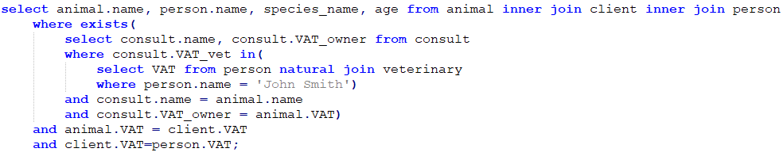
- List the name, owner name, species, and age, for all animals that participated in consults with a veterinary doctor named John Smith.
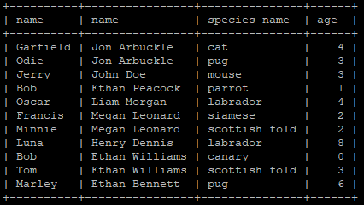
Figure 1 - Query 1 result

- List the name of all indicators measured in milligrams and with a reference value above 100. The names should be presented together with the corresponding reference value, and sorted according to the reference value, in descending order
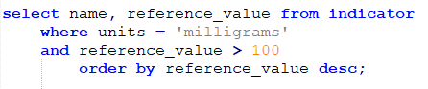

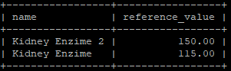
Figure 2 - Query 2 result
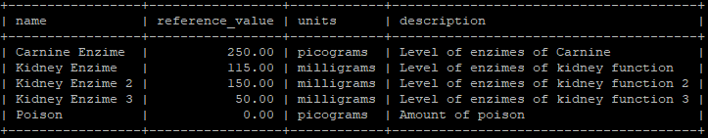
Figure 3- List of all indicators
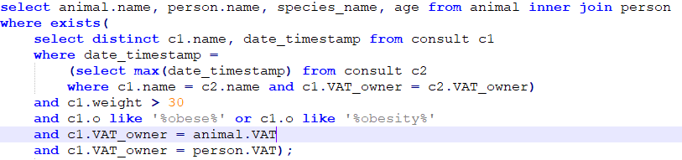
- List the name, owner name, species and age for all animals with the most recent weight above 30 kilograms, and where the objective part of any SOAP note, associated to consults of that animal, mentions terms like obesity or obese.
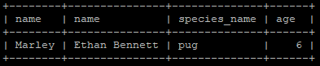

Figure 4- Query 3 result

In the next figure, we show the query result of listing all consults recorded in the database. The 1st marked row represents the most recent consult of Luna, where weight is above 30 kg but the objective part does not mention terms like obesity or obese. The 2nd marked row represents a consult of Oscar, where weight is above 30 kg and the objective part mentions terms like obesity or obese, but it is not the most recent consult of Oscar. The 3rd marked row represents the most recent consult of Marley where weight is above 30 kg and the objective part mentions obesity so this was the only row that was chosen.

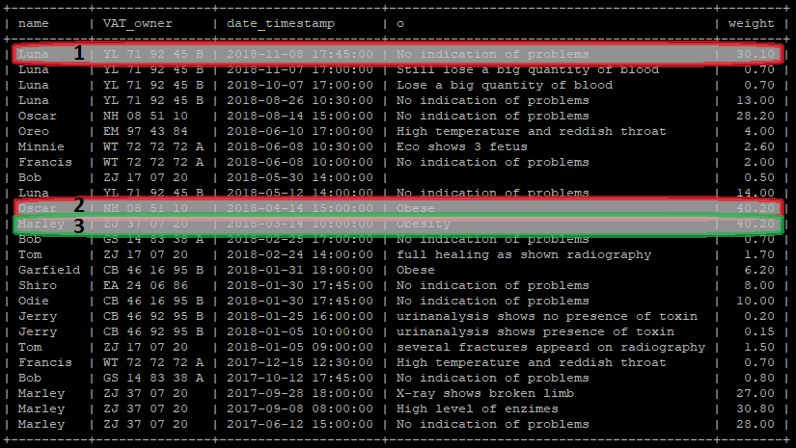

Figure 5- List of all consults recorded in the database

- List the name, VAT and address of all clients of the hospital that are not owners of animals.

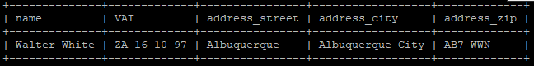
Figure 6- Query 4 result

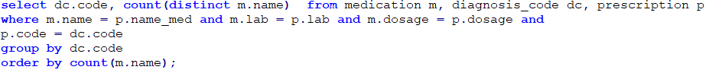
- For each possible diagnosis, list the number of distinct medication names that have been prescribed to treat that condition. Sort the results according to the number of distinct medication names, in ascending order.
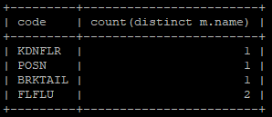
Figure 7- Query 5 result

By listing all the prescriptions, selecting the code of the diagnosis and the corresponding medication name we confirm the results.
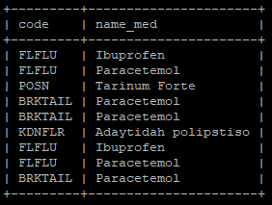
Figure 8- List of all prescriptions

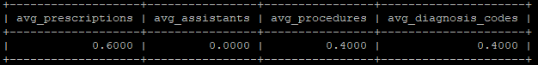
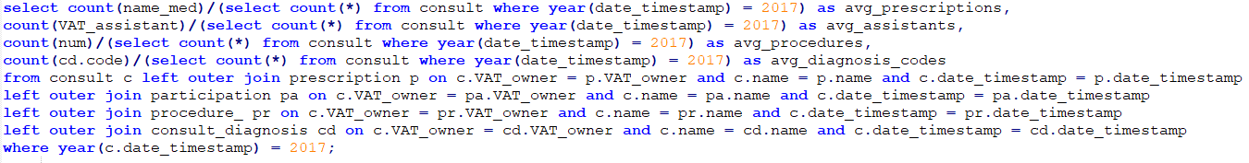
- Present the average number of assistants, procedures, diagnostic codes, and prescriptions involved in consults from the year of 2017.
Figure 9- Query 6 result
From 2017 there were 3 prescriptions, 0 assistants, 2 procedures and 2 diagnosis in a list of 5 consults.

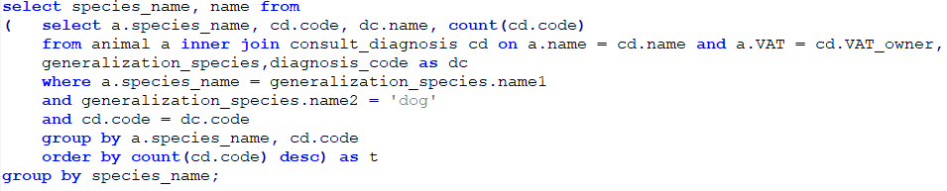
- For each animal sub-species of dog, present the name of the most common disease (i.e., the name associated to the most frequent diagnostic code for consults involving animals of that species).

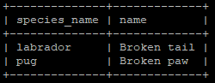
Figure 10 - Query 7 result

- List the names of individuals that are simultaneously clients of the hospital (i.e., owners of animals or clients that have brought animals to consults) and employees of the hospital (i.e., veterinary doctors or assistants).
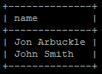
Figure 11 - Query 8 result

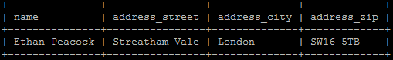
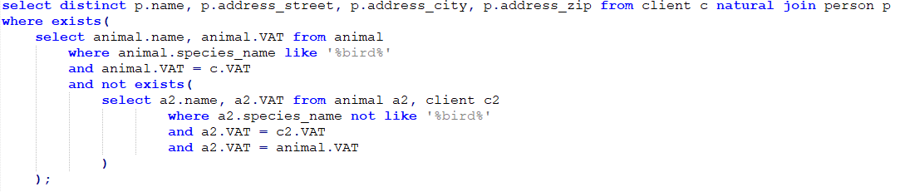
- List the names and addresses of clients that only own birds as their pets (i.e., the clients for whom all the owned animals contain the word bird as part of the species name).
Figura 12 - Query 9 result

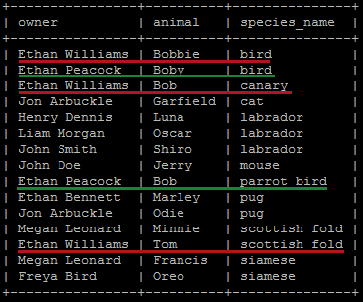
Figura 13 - List of animals and corresponding owners

In the figure above, that represents the list of all animals and corresponding owners, we mark the 2 clients that have birds. We can see that Ethan Williams has two animals that have not the word bird in the species_name. Ethan Peacock have 2 pets and both have the word bird in the species_name as we can see in query 9 result.

Database population

Indexes

Updates

Views

