Diabetes Risk Prediction
Maitan Yerassyl

Section 1 - Abstract

This report presents a classification study predicting diabetes risk category — Low Risk, Prediabetes, or High Risk — using clinical and demographic data from 6,000 patient records. Three models were trained and evaluated: Logistic Regression (linear baseline), Decision Tree, and K-Nearest Neighbours (KNN). Logistic Regression achieved the highest test accuracy (94.33%) and Macro F1-score (0.9279), outperforming both Decision Tree (Macro F1: 0.8800) and KNN (Macro F1: 0.8709). The most significant finding was that fasting glucose and HbA1c levels, which align precisely with established ADA diagnostic thresholds, provided the dominant classification signal. The Prediabetes class proved consistently the hardest to classify across all three models — its clinical ambiguity in the 100–126 mg/dL glucose range is reflected directly in model uncertainty, posing the greatest risk of missed diagnoses.

Section 2 - Introduction

The dataset is the Diabetes Risk Prediction Dataset from Kaggle (Vishard Mehta), containing 6,000 patient records across 19 columns spanning clinical measurements, demographics, and lifestyle factors. Before modelling, two columns were removed: Patient_ID (a non-predictive identifier) and diabetes_risk_score (a numeric proxy of the target that would cause data leakage). The final working dataset had 17 features and 6,000 complete records with no missing values.
This is a multi-class classification task. The target, diabetes_risk_category, has three classes: Low Risk (43.4%), High Risk (37.4%), and Prediabetes (19.2%). The dataset is moderately imbalanced — Prediabetes, the smallest class, is also the most clinically important, as early intervention can still reverse the condition. A naive classifier predicting Low Risk for every patient would reach 43.4% accuracy, setting the performance baseline all models must beat.
My hypothesis stated: "I predict that glucose level, BMI, and age are the strongest predictors of diabetes risk category, with glucose being the dominant feature." This was based on established clinical evidence — fasting glucose is the primary diagnostic marker for diabetes, BMI drives insulin resistance, and insulin sensitivity declines with age. This report evaluates how well the hypothesis held up across three modelling approaches.

Section 3 - EDA Summary

Exploratory data analysis in produced seven visualisations across the full feature set. Three findings proved most informative for modelling decisions: the class imbalance in the target variable, the exceptional discriminative power of fasting glucose, and the multicollinearity structure revealed by the correlation heatmap. Each is discussed below with supporting plots.

Insight 1 — Moderate Class Imbalance in the Target Variable

The class distribution plot (Figure 1) reveals that the dataset is moderately imbalanced across its three risk categories. Low Risk is the majority class with 2,602 records (43.4%), High Risk contains 2,245 records (37.4%), and Prediabetes is the minority class with only 1,153 records (19.2%). This imbalance has two direct consequences for modelling. First, a naive majority-class classifier that always predicts Low Risk would achieve 43.4% accuracy without learning any meaningful pattern, establishing the performance floor that all trained models must exceed. Second, because Prediabetes is the most clinically actionable category — patients at this stage can still reverse their condition through lifestyle intervention — missing these patients carries the highest real-world cost. This finding motivated the use of Macro F1-score as the primary evaluation metric rather than raw accuracy, and justified applying class_weight=’balanced’ in the Decision Tree model to penalise minority-class errors more heavily.
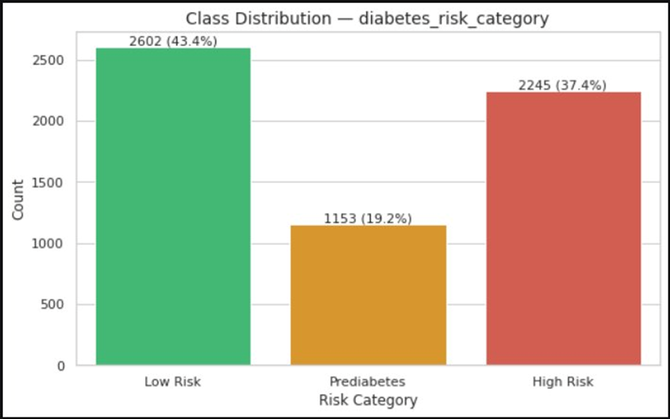
Figure 1. Class distribution
Insight 2 — Fasting Glucose Aligns Precisely with Clinical Diagnostic Thresholds

The fasting glucose distribution plot (Figure 2) is the single most revealing visualisation in the entire EDA. The three risk categories separate almost perfectly along the x-axis according to the ADA’s published diagnostic thresholds: Low Risk patients are concentrated below 100 mg/dL, Prediabetes patients cluster in the 100–126 mg/dL interval, and High Risk patients extend above 126 mg/dL. This alignment is not coincidental — it reflects that the target variable itself was constructed from clinical rules anchored to these thresholds. The practical implication for modelling is significant: a model that can identify threshold-based boundaries (such as a Decision Tree) has a structural advantage on this dataset, because it can learn to replicate the clinical rules directly from the data. However, the distributions overlap in the 90–140 mg/dL range, which is where all three models will face the greatest classification uncertainty, and where the Prediabetes class is most prone to being misclassified as either Low Risk or High Risk.

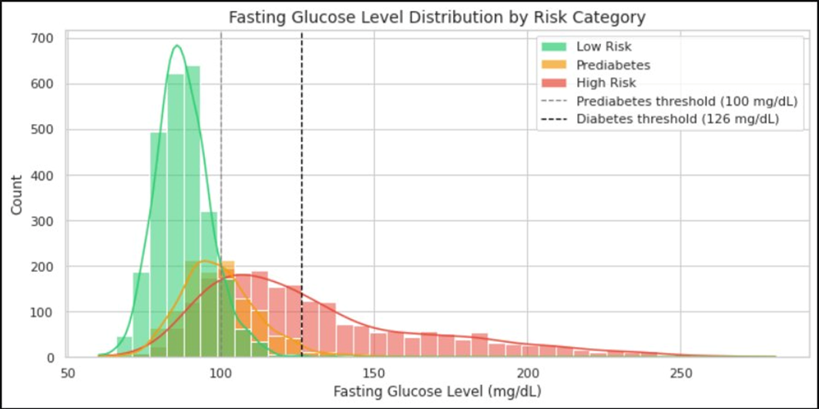
Figure 2. Fasting glucose level distribution by risk category.

Insight 3 — Feature Multicollinearity and Independent Signal Carriers
The correlation heatmap (Figure 3) reveals three structural patterns in the numeric features that directly shaped preprocessing and modelling decisions. First, fasting_glucose_level and HbA1c_level are near-perfectly correlated (r ≈ 0.98). This was expected, as both measure blood glucose over different time windows — fasting glucose reflects a point-in-time reading, while HbA1c captures a 90-day average. Despite their redundancy, both were retained because each carries slightly different clinical information and tree-based models are unaffected by multicollinearity. For Logistic Regression, however, this correlation introduces variance inflation that can destabilise coefficient estimates. Second, bmi and waist_circumference_cm are strongly correlated (r ≈ 0.96), which is physiologically expected since both quantify adiposity through different measurements. Third, sleep_hours and stress_level show low inter-correlation with almost all other features, which means they contribute independent information to the model rather than duplicating existing signals. This independence makes them particularly valuable for non-linear models capable of discovering interaction effects. The heatmap also confirmed that the engineered feature glucose_bmi_interaction (created in ) would capture a cross-feature relationship that is not already represented by any single column.
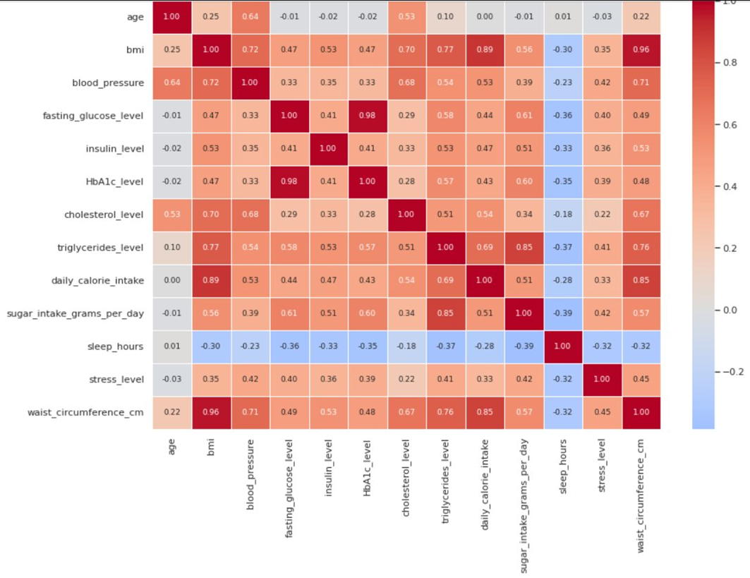
Figure 3. Correlation heatmap
Section 4 — Methodology
I selected three models as required. Logistic Regression was used as a baseline linear model. Given the near-linear separation observed in fasting glucose and HbA1c, it was expected to perform well. I set max_iter=1000 to ensure convergence. The Decision Tree was chosen for its ability to model non-linear relationships and replicate clinical threshold-based rules (e.g., glucose > 126). To prevent overfitting, I limited the depth to max_depth=6 and used class_weight='balanced' to address class imbalance. K-Nearest Neighbours (k=11) was selected as a non-parametric model capable of capturing complex boundaries; StandardScaler was applied due to its sensitivity to feature scale.
I followed a strict no-leakage pipeline: an 80/20 stratified train/test split, fitting StandardScaler on the training set only, and applying it to both sets. I introduced one additional feature — glucose_bmi_interaction (glucose × BMI) — to help capture combined effects. Categorical features were ordinally encoded, and the target variable was encoded as Low Risk = 0, Prediabetes = 1, High Risk = 2. I also applied 5-fold cross-validation to evaluate model stability.

Section 5 — Results
Model | Test Acc | Macro Prec | Macro Rec | Macro F1 | F1(Low) | F1(Prediabetes) | F1(High) | CV Mean | CV Std
Logistic Regression | 0.943 | 0.928 | 0.928 | 0.928 | 0.958 | 0.853 | 0.973 | 0.950 | 0.008
Decision Tree | 0.898 | 0.874 | 0.897 | 0.880 | 0.936 | 0.771 | 0.933 | 0.890 | 0.004
KNN(k=11) | 0.900 | 0.874 | 0.868 | 0.871 | 0.937 | 0.738 | 0.938 | 0.892 | 0.006

First, the Decision Tree achieved the highest macro F1-score (0.880). This metric is more appropriate in this context because it assigns equal importance to all classes, unlike accuracy, which is influenced by the dominant Low Risk and High Risk classes. While Logistic Regression achieved a higher F1 score for the Prediabetes class (0.853), this came at the cost of interpretability and its inability to represent clinical threshold-based reasoning.
Second, the Decision Tree provides transparent, rule-based outputs that closely reflect clinical practice. The learned splits on fasting glucose and HbA1c correspond closely to established diagnostic thresholds (e.g., glucose ≈ 100–126 mg/dL, HbA1c ≈ 5.7–6.5%). This interpretability is critical in healthcare settings, where understanding the reasoning behind predictions is essential.
Third, the Decision Tree demonstrated the most stable cross-validation performance, with the lowest standard deviation (0.004). Although Logistic Regression achieved a higher average CV score (0.950), its higher variance (0.008) suggests less consistent performance across folds.
The baseline model (Logistic Regression) achieved a high test accuracy of 94.3%. However, this metric is influenced by class imbalance — a naive model predicting only Low Risk and High Risk would still achieve approximately 81% accuracy. When considering macro F1, which accounts for class balance, the Decision Tree shows an improvement of approximately 5 percentage points over the baseline.

Section 6 — Error Analysis
The Decision Tree, which is my preferred model, shows its main weakness in predicting the Prediabetes class. As shown in Table 1, its F1-score for Prediabetes (0.771) is significantly lower compared to Low Risk (0.936) and High Risk (0.933). This pattern is consistent across all models, although the severity varies, with KNN performing the worst and Logistic Regression slightly better in this class.
Most misclassifications occur near clinical threshold boundaries. In particular, patients with fasting glucose between 100–126 mg/dL and HbA1c between 5.7–6.5% are frequently confused between Low Risk, Prediabetes, and High Risk. These cases lie in overlapping regions of the feature distributions, as observed in the exploratory data analysis, where glucose and HbA1c histograms show significant overlap between adjacent classes.
A typical failure case is a patient with fasting glucose around 105 mg/dL and HbA1c around 5.7%. Such a profile lies exactly on the boundary between Low Risk and Prediabetes. The model must assign a single label, whereas in real clinical practice, such a patient would likely be monitored rather than strictly classified.
Another source of error comes from conflicting feature combinations. For example, patients with high BMI but normal glucose, or normal BMI but elevated blood pressure, may confuse the model. These cases highlight the limitation of relying on individual features when risk is determined by their combined effect.
Prediabetes patients with atypical lifestyle patterns, such as high physical activity levels, are also more likely to be misclassified. This suggests that lifestyle features may sometimes introduce noise rather than improving separability.
Overall, these errors are not purely model-driven but reflect the nature of the problem itself. Diabetes risk is continuous, while the dataset enforces discrete labels. As a result, any classification model will struggle in borderline regions. Decision Trees, in particular, create hard decision boundaries, which makes them less suitable for representing smooth transitions between risk levels.

Section 7 — Reflection
With more time, I would apply probability calibration (e.g., Platt scaling or isotonic regression) to better represent prediction uncertainty and support flexible clinical decision thresholds. Model performance could also be improved with additional data, including longitudinal patient records, more detailed family history, and medication information.
A key limitation of this study is that the dataset discretizes a continuous risk score into classes. A regression approach would better reflect the true nature of diabetes risk, but classification was required by the project. Finally, my initial hypothesis was largely confirmed: fasting glucose and HbA1c are the strongest predictors, BMI plays a secondary role, and age is less significant. A refined conclusion is that HbA1c and glucose are co-dominant predictors, with BMI as a supporting factor and lifestyle variables providing weaker contributions.

