- Problem Definition: The first stage involves defining the business problem that needs to be solved using machine learning. This stage involves working with stakeholders to understand their requirements, goals, and constraints. It is essential to define the problem clearly, as it will determine the data to be collected, the models to be trained, and the evaluation metrics to be used.
- Data Collection and Preparation: The next stage involves collecting and preparing the data required for model training. This stage involves cleaning and transforming the data, handling missing values, and creating features that will be used in model training. It is important to ensure that the data is of high quality and that it represents the problem being solved.
- Model Training and Selection: The third stage involves selecting an appropriate machine learning algorithm and training it on the prepared data. This stage involves testing different models and selecting the one that performs best on the evaluation metrics defined in the problem definition stage. It is essential to ensure that the selected model is interpretable, robust, and scalable.
- Model Deployment: The fourth stage involves deploying the trained model into production. This stage involves creating an API that can be used to make predictions using the trained model. It is essential to ensure that the deployed model is monitored regularly for performance and that it is updated as required.
- Monitoring and Maintenance: The final stage involves monitoring the deployed model's performance and maintaining it over time. This stage involves monitoring the model for errors and making updates to the model as required. It is essential to ensure that the model remains accurate and reliable over time.

Data Collection and Preparation:
- Data Collection: This sub-module involves identifying and acquiring relevant data sources for the problem at hand. The sources can be internal or external, structured or unstructured, and can be obtained through various means such as web scraping, API calls, or manual data entry.
- Data Preprocessing: This sub-module involves cleaning and transforming the raw data into a format that is suitable for machine learning. This process includes data cleaning, data transformation, and data integration. Data cleaning involves removing noise and errors from the data, while data transformation involves converting the data into a format that is suitable for the machine learning algorithms. Data integration involves combining data from multiple sources to create a single, unified dataset.
- Feature Engineering: This sub-module involves selecting and creating features from the preprocessed data that will be used to train the machine learning model. Feature selection involves choosing the most relevant features that will improve the model's performance, while feature creation involves generating new features from the existing ones.
- Data Splitting: This sub-module involves dividing the dataset into two or more subsets - a training set, a validation set, and a testing set. The training set is used to train the model, while the validation set is used to tune the hyperparameters of the model. The testing set is used to evaluate the performance of the model.

Data Science Lifecycle
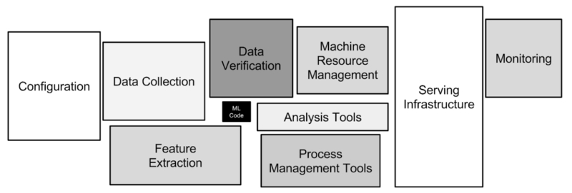

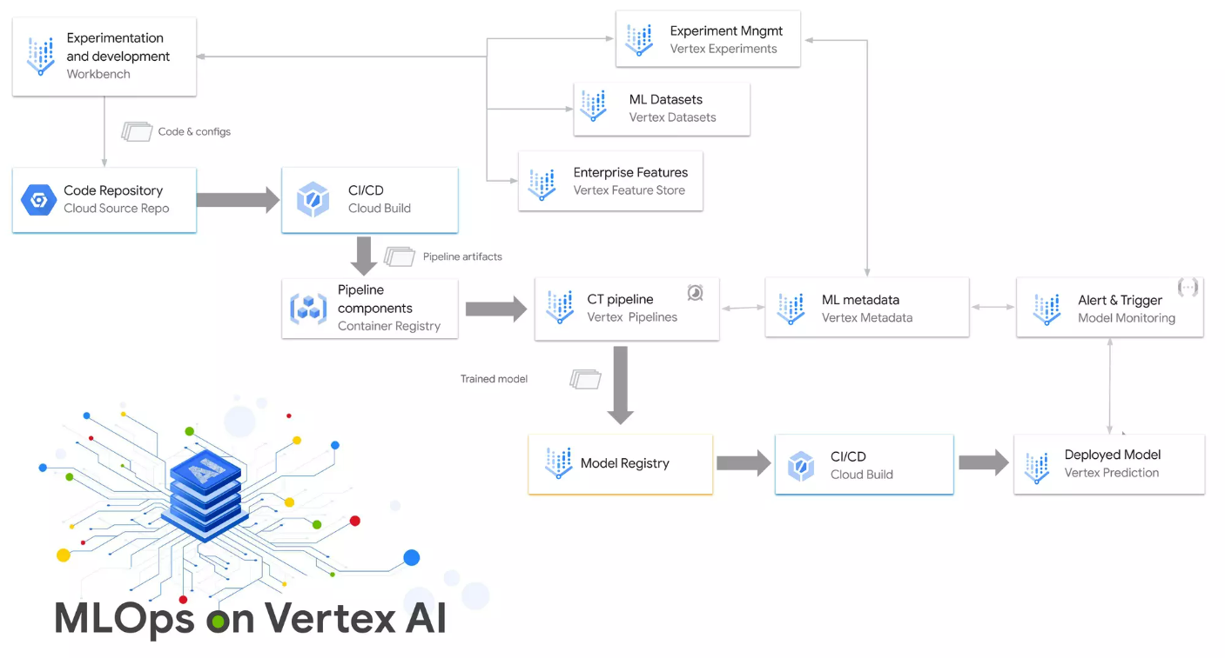

Data Science Lifecycle
Set up of experimentation and tracking process with visualization
TensorBoard can be used to track and visualize the performance of TensorFlow models, while Vertex TensorBoard can be used to track and visualize the performance of Vertex AI models. Additionally, Vertex AI provides built-in integrations with popular experiment tracking tools such as MLflow and Kubeflow. This makes it easy to set up an experimentation and tracking process with visualization in a typical MLOps framework using Vertex AI
Build a centralized model registry

Model Industrialization Approach
Set up alert mechanism for model and data drift detection

Monitoring (model & data)
• Set up vertex-based model & data monitoring
Set up standard cloud logging and monitoring for services (with visualization)

Software Engineering
Establish branching strategy and code promotion with proper release management

Architecture
Create modularized / microservices-based framework for seamless customizations at later stages

Data read and pre-processing

To develop a feature called "Data read and pre-processing" using Kubeflow and connecting to a BigQuery data source, you can follow the below steps:
- Create a Kubeflow Pipeline: Create a Kubeflow pipeline that will handle the data read and pre-processing tasks. You can use the Kubeflow Pipelines SDK to define the pipeline and its components.
- Add a BigQuery Component: Add a BigQuery component to the pipeline that will allow you to connect to the BigQuery data source and retrieve the data. You can use the BigQuery component provided by the Kubeflow Pipelines SDK.
- Define the Pre-Processing Steps: Define the pre-processing steps that will be performed on the data. This may include data cleaning, feature engineering, normalization, or any other pre-processing steps that are required.
- Add Pre-Processing Components: Add the pre-processing components to the pipeline, using the Kubeflow Pipelines SDK to define each component. These components can be written in Python, and may use libraries such as Pandas, NumPy, or Scikit-learn.
- Connect Components: Connect the BigQuery component to the pre-processing components in the pipeline, using the Kubeflow Pipelines SDK to define the input and output connections.
- Define Parameters: Define any parameters that are required for the pipeline, such as the BigQuery query to retrieve the data, or the pre-processing parameters.
- Run the Pipeline: Run the pipeline on Kubeflow, specifying the input parameters and any other required configuration options. The pipeline will connect to the BigQuery data source, retrieve the data, perform the pre-processing steps, and produce the pre-processed data as output.
By following these steps, you can develop a feature called "Data read and pre-processing" using Kubeflow and connecting to a BigQuery data source. This feature can be integrated into a larger MLOps platform or pipeline, allowing for efficient and scalable data pre-processing as part of the overall data science workflow.

To create a feature called "Statistical Analysis on Data" using Kubeflow and perform the tasks mentioned, you can follow the below steps:
- Create a Kubeflow Pipeline: Create a Kubeflow pipeline that will handle the statistical analysis tasks. You can use the Kubeflow Pipelines SDK to define the pipeline and its components.
- Split Data: Split the data into training and testing datasets using the Kubeflow Pipelines SDK.
- Generate Statistics: Generate statistics on the data using the Kubeflow Pipelines SDK. You can use the TensorFlow Data Validation library to generate statistics such as mean, median, and standard deviation for each feature.
- Plot Statistics: Plot the statistics using TensorBoard or other visualization tools. You can use the Kubeflow Pipelines SDK to define the visualization component and connect it to the statistics component.
- Custom Threshold Check: Define custom threshold checks for the statistics to be used for monitoring and alerts. You can use the Kubeflow Pipelines SDK to define the threshold check component and connect it to the statistics component. For example, you may define a threshold for the standard deviation of a feature and set up an alert if it exceeds a certain value.
- Connect Components: Connect the data split component, statistics component, visualization component, and threshold check component in the pipeline using the Kubeflow Pipelines SDK.
- Run the Pipeline: Run the pipeline on Kubeflow to split the data, generate statistics, plot the statistics, perform threshold checks, and generate alerts as necessary.
By following these steps, you can create a feature called "Statistical Analysis on Data" using Kubeflow and perform tasks such as data splitting, statistics generation, visualization, and threshold checking as part of your data science workflow.

To create a feature for defining model parameters using Kubeflow, you can follow these steps:
- Define a component: Use the Kubeflow Pipelines SDK to define a component for defining model parameters. The component should include inputs for specifying the model parameters such as learning rate, batch size, and number of epochs.
- Configure the component: Configure the component to allow for customization of the model parameters. This can be done using the Kubeflow Pipelines SDK by defining inputs for the model parameters and using environment variables to set default values.
- Connect the component: Connect the component to the rest of the pipeline by specifying its inputs and outputs using the Kubeflow Pipelines SDK. The output of this component will be the set of model parameters.
- Test the component: Test the component to ensure that it is properly configured and working as expected. You can use the Kubeflow Pipelines SDK to run the component locally before integrating it into the pipeline.
- Integrate the component: Integrate the model parameters component into the rest of the Kubeflow pipeline. This can be done by connecting it to the data processing, model training, and evaluation components using the Kubeflow Pipelines SDK.
- Run the pipeline: Run the pipeline on Kubeflow to define the model parameters and train the model using the specified parameters.

To create a feature for model experimentation and tuning using Kubeflow, you can follow these steps:
- Define a component: Define a component that sets up configurations for the model parameters and trails run. This component should include inputs for defining the hyperparameters for the model and the number of trials to be run.
- Configure the component: Configure the component to allow for customization of the hyperparameters and number of trials. This can be done using the Kubeflow Pipelines SDK by defining inputs for the hyperparameters and number of trials.
- Connect the component: Connect the component to the rest of the pipeline by specifying its inputs and outputs using the Kubeflow Pipelines SDK. The output of this component will be the set of hyperparameters and number of trials.
- Use Kubeflow's TFX Tuner: Use Kubeflow's TFX Tuner to tune the hyperparameters and run the trials for the model. The TFX Tuner is an open-source library that provides an easy way to tune hyperparameters and can be integrated into the pipeline using the Kubeflow Pipelines SDK.
- Analyze results: Analyze the results of the model experimentation and tuning using Kubeflow's TensorBoard, which provides a dashboard for visualizing the metrics and hyperparameters of the model.
- Integrate the component: Integrate the model experimentation and tuning component into the rest of the Kubeflow pipeline. This can be done by connecting it to the data processing, model training, and evaluation components using the Kubeflow Pipelines SDK.
- Run the pipeline: Run the pipeline on Kubeflow to experiment and tune the model using the specified hyperparameters and number of trials.

