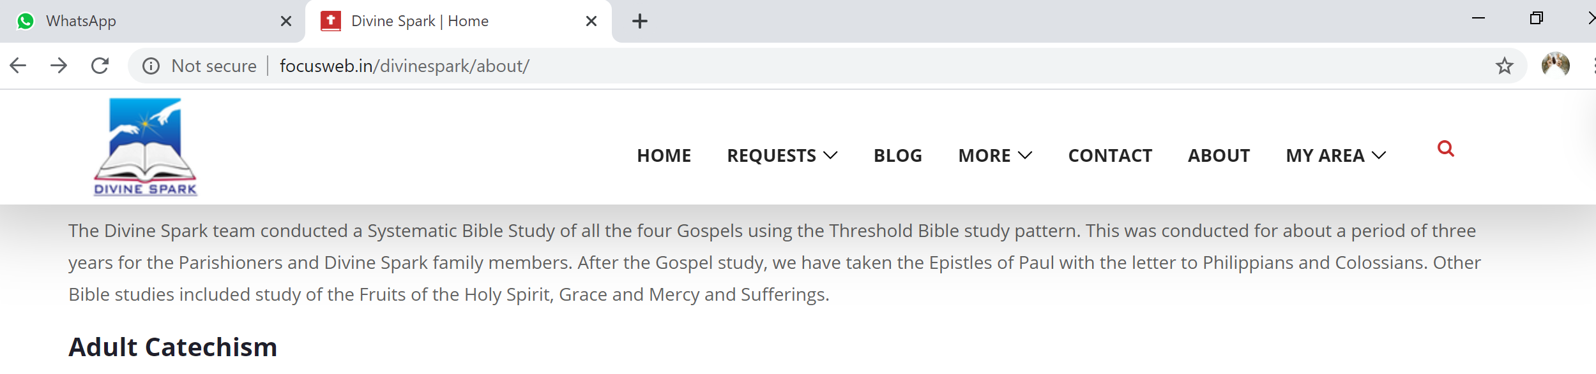

When I have entered “**blog**”in the search button



I have got below error, when I entered “**blog”** in the search button.

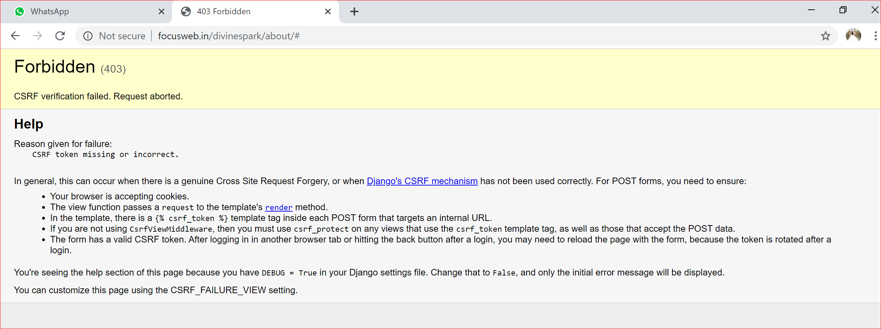

Clicked on “Contact” Menu and filled only mandatory fields.Under Email id field ,I gave only two letters and clicked on submit now .The message is successfully submitted.

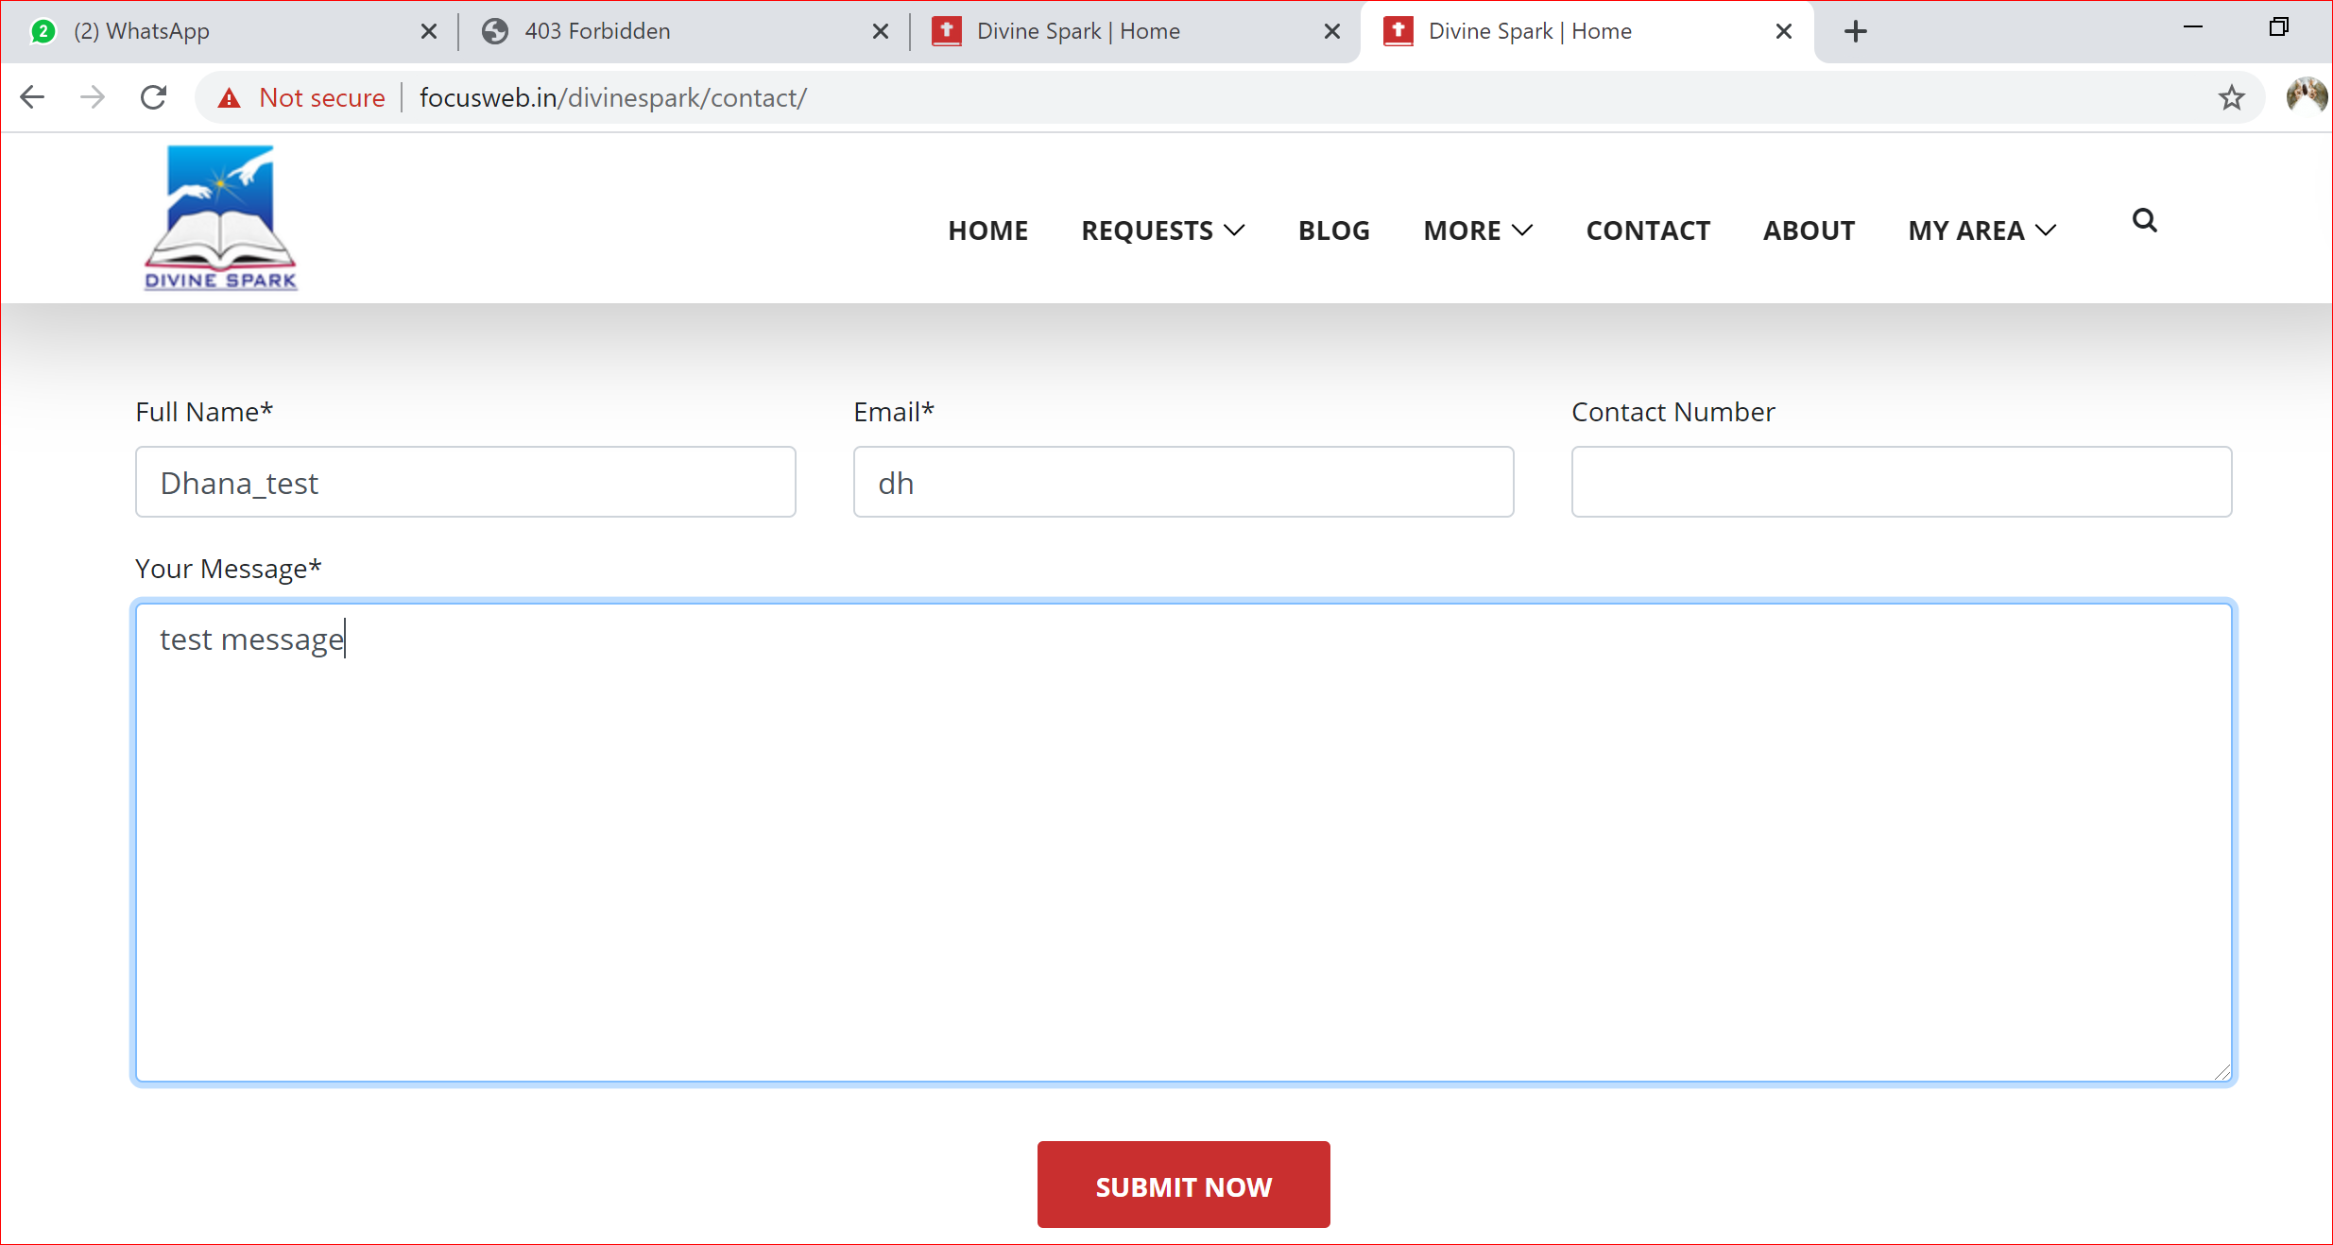

Under Sermons, when I have clicked on particular video icon, in the same page only the YouTube video is opening. Shall we provide in the different page because, if we want to view the Focus webpage again, we have to click on back arrow.

