3. Select a node on the Explorer Cluster and report the following  
information about that node:

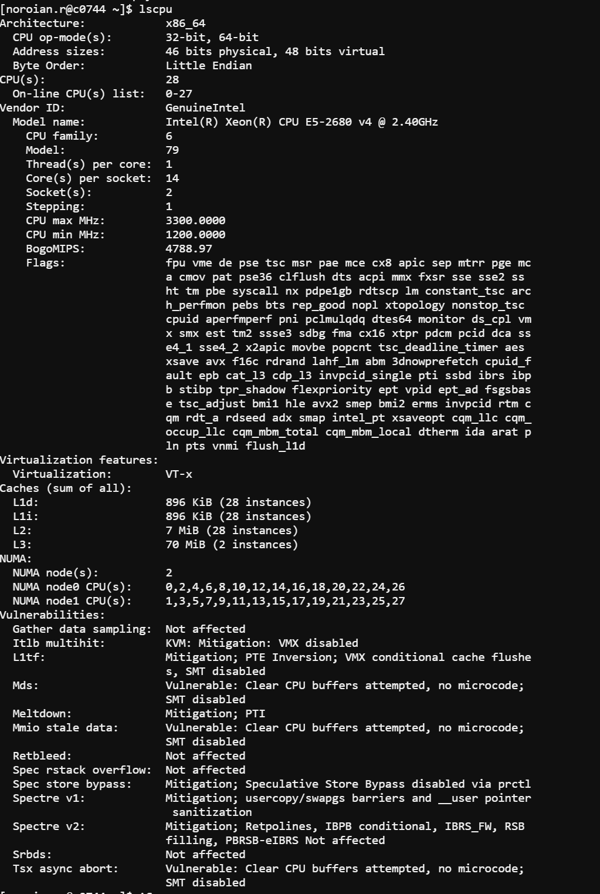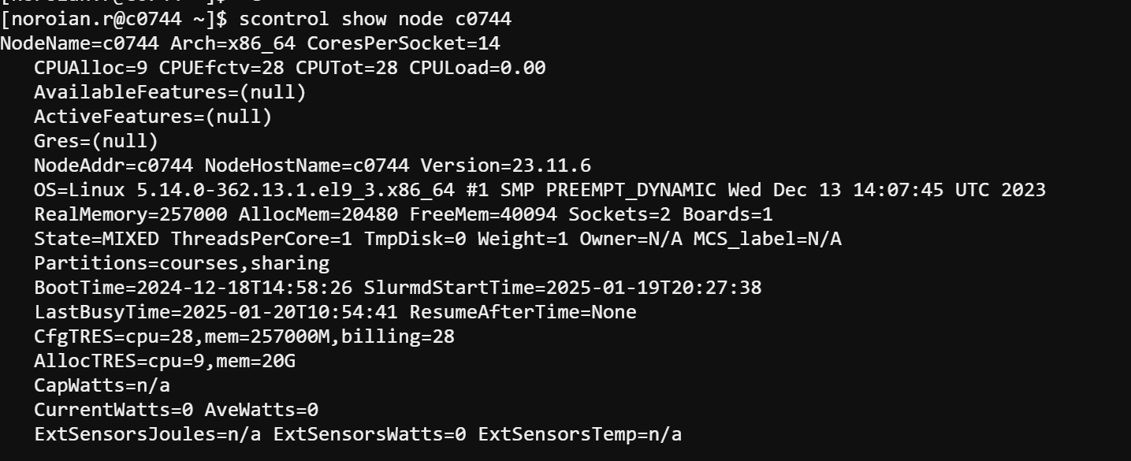

I selected node c0744, with details shown above.

a) CPU Model

The CPU model of this node is the Intel Xeon CPU ES-2680 v4 @ 2.40GHz. There are 28 CPU cores on this node.

b) Cache Memory Hierarchy

The L1 data, L1 instruction, L2, and L3 cache sizes are shown in the image for the sum of the cores. The L1 data cache and instruction cache both have sizes of 896 KiB, the L2 has a 7 MiB cache, and the L3 has a 70 MiB cache. Since there are 28 instances of the L1 and L2 caches, the L1 caches have 32 KiB per core, L2 caches have 256 KiB per core, and the L3 cache, which is split by 2 sockets and shares information amongst 14 cores, is 35 MiB per socket.

c) Main Memory Size

The node has a main memory of 257,000 MiB, which rounds to about 251 GiB.

d) Version of Linux

The node c0744 uses Rocky Linux, based on the Red Hat Enterprise Linux. It is Rocky Linux 9.3, titled Blue Onyx.