4. Summary of Trends + My Design

Several trends were apparent in the architecture of the top 10 best performing supercomputers. The performance of the first three supercomputers is significantly greater than the other seven. First, different CPU/GPU combinations were prevalent for the nodes of each supercomputer. El Capitan and Tuolumne, first and tenth, both used AMD MI300A, and accelerator unit combined AMD CPU and GPUs. Each node of El Capitan has 4 of these accelerator units.

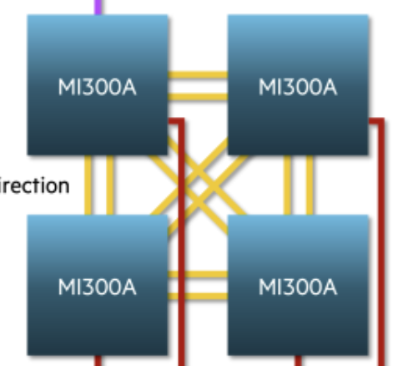

Fig: El Capitan’s node configuration for 4 MI300A’s.

Their CPU is an AMD Zen 4 EPYC Architecture, with 3 chiplets each with 8 cores, and this die architecture:

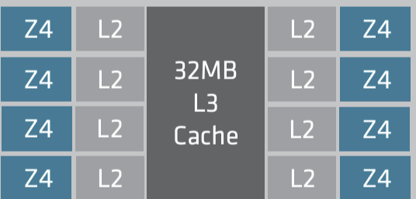

L1 cache is not pictured, but is 64KB per core, split evenly for instruction and data. Each L2 cache is 1MB and the 32 MB L3 cache is shared between all cores.

Though this architecture is utilized by number 1, El Capitan, there are others in the top ten with more frequency.

Specifically, the Frontier, HPCG, and Lumi use **AMD Instinct MI250x**, which is a GPU rather than an AU that combines GPU/CPU. I believe the MI250x is better for performance than Nvidia’s H100 as well, which is featured in the Eagle. To compare performance, the MI250x offers 128 GB of high memory bandwidth (HBM2), and has a FP64 performance of 95.7 TFLOPS compared to the H100’s 94 GB and 34 TFLOPS. HBM2

The Froniter, HPCG, and Lumi, all implement AMD’s 3rd Gen EPYC 64C 2 GHz CPU to combine with the MI250x GPU. This, in a broader sense, is a pattern between most of the top ten, as most use CPUs and GPUs from the same HPC company, as their custom architectures are tailored to their own products. The combination of this CPU and GPU is enhanced by AMD’s infinity fabric interconnect, which makes it advantageous for HPC applications.

AMD’s 3rd Gen EPYC 64C 2 GHz CPU, with 64 cores, and 2 threads per core, is optimized for multi-threading involving massive parallel workloads. It supports DDR memory, improves bandwidth as DDR4 handles 8 memory channels per processor. These memory modules can support up to 4TB of memory, which is optimal for workloads requiring lots of memory.

Its top comparisons on the list include Aurora’s Intel Xeon CPU Max 9470 with 52 cores, which is less than AMD’s 64 for parallel processing. This is like the Eagle with 48 cores on an Intel Xeon Platinum 8480C.

For interconnect, the majority of the top 10 use Slingshot-11 for high-speed data transfer. The different network topologies included in the list are, first, the dragonfly topology, where groups serve as sets of nodes, which are connected by links. This minimizes communication steps between two nodes. My architecture is shown below:

