Why AI Agents Need Bi-Temporal Memory Architecture
Distinguishing valid time from transaction time to prevent hallucinated facts and outdated agent state.
ARCHITECTURE · DEEP DIVE | Author: Chitresh Parihar (Founder & CEO) | Sep 4, 2026 (14 min read)
Tags: Bi-Temporal, Postgres, Memory Layer, Agent Architecture
―――――――――――――――――――――――――――――――――――――――――――――

Overview & Thesis
When building autonomous LLM agents designed to interact with users over months or years, memory is fundamentally a temporal domain modeling problem, not just a vector similarity problem. Most teams start by indexing conversation turns into Pinecone or pgvector alongside a single created_at timestamp. This works fine for static documentation QA, but breaks down catastrophically when an agent must reason over changing entity state, retroactive user corrections, or historical facts. Without bi-temporal temporal boundaries, agents inevitably conflate past states with present realities, resulting in subtle, persistent hallucinations that standard RAG evals miss entirely.

The Single-Timestamp Trap: Conflating Valid Time and Transaction Time
In relational temporal database theory-pioneered by Richard Snodgrass in the late 1980s-data modeling distinguishes between two orthogonal axes of time: Valid Time (when a fact was true in the real world) and Transaction Time (when the database recorded or asserted that fact). Standard agent memory platforms collapse both timelines into a single created_at column representing when the embedding vector hit disk.
Consider a concrete customer support agent scenario. On September 15th, a user mentions in chat: "I moved from Chicago to Seattle back on July 1st, but my billing address was still my old Chicago home until August 15th." If the memory layer only stores created_at = 2026-09-15, any future query asking "Where was the user residing in July 2026?" relies purely on semantic cosine distance. Because both the Chicago and Seattle address embeddings contain high semantic overlap with "user address residence", standard vector search returns both facts with near-identical similarity scores.
The LLM receives a context prompt containing two contradictory residence claims marked with the same timestamp. It has no deterministic way to evaluate temporal precedence, forcing it to guess or synthesize a false hybrid answer (e.g., claiming the user lived in both cities simultaneously). As session count scales into the thousands, single-timestamp vector stores accumulate layers of stale, superseded entity state that corrupt prompt context.
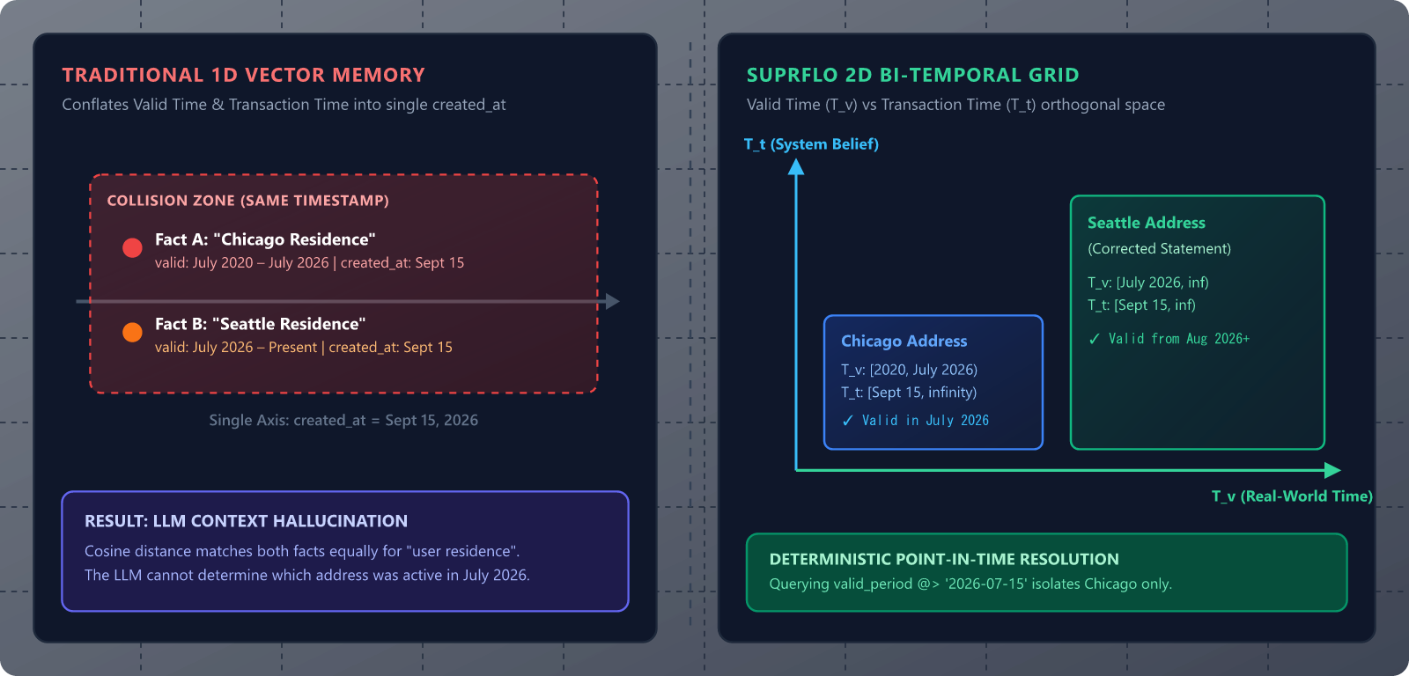
Figure 1: Single-timestamp memory collapses Valid Time and Transaction Time into a 1D vector line, causing prompt state collisions. Suprflo separates them into an orthogonal 2D coordinate space.

Bi-Temporal Schema Design in PostgreSQL
To eliminate temporal ambiguity, Suprflo models every memory atom as a bi-temporal record in PostgreSQL using native range types (tstzrange). Valid Time (valid_period) represents the inclusive/exclusive time bracket [start, end) during which the real-world state existed. Transaction Time (transaction_period) represents the system assertion interval during which the agent believed this record to be an active, un-superseded truth.
By leveraging Postgres native range types alongside pgvector, we can apply hard spatio-temporal boundary filtering before or during HNSW vector index traversal. Below is the production table definition we use for enterprise agent deployments.
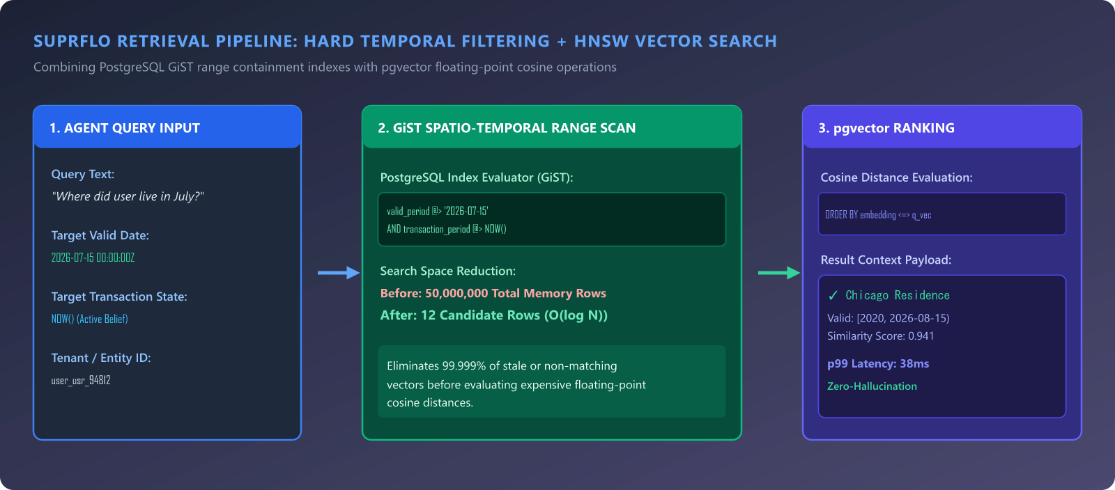
Figure 2: Suprflo dual-stage retrieval pipeline - GiST range containment filter reduces 50M rows to 12 candidates in O(log N) before HNSW cosine ranking.
-- schema_bitemporal_memories.sql
-- Schema for bi-temporal agent memory atoms in PostgreSQL 17 + pgvector
CREATE TABLE agent_memories (
id UUID PRIMARY KEY DEFAULT gen_random_uuid(),
tenant_id UUID NOT NULL,
entity_id TEXT NOT NULL, -- e.g., 'user_usr_94812' or 'account_acc_3021'
fact_key TEXT NOT NULL, -- e.g., 'residence_address'
fact_value JSONB NOT NULL, -- Structured payload: {"city": "Seattle", "state": "WA"}
-- Bi-temporal dimension ranges
valid_period TSTZRANGE NOT NULL, -- Real-world validity timeline [V_start, V_end)
transaction_period TSTZRANGE NOT NULL,-- System assertion timeline [T_start, T_end)
embedding vector(1536), -- Dense semantic embedding of the fact statement
confidence FLOAT DEFAULT 1.0, -- Extraction confidence score (0.0 to 1.0)
created_at TIMESTAMPTZ DEFAULT NOW()
);
-- Generalized Search Tree (GiST) indexes for fast temporal interval overlap & containment queries
CREATE INDEX idx_memories_valid_gist ON agent_memories USING GIST (valid_period);
CREATE INDEX idx_memories_tx_gist ON agent_memories USING GIST (transaction_period);
-- HNSW vector index for cosine similarity ranking within filtered temporal sets
CREATE INDEX idx_memories_embedding_hnsw ON agent_memories
USING hnsw (embedding vector_cosine_ops)
WITH (m = 16, ef_construction = 64);

Key Takeaways:
- Valid Time range (valid_period) tracks when the fact held true in the physical or domain universe.
- Transaction Time range (transaction_period) records the system assertion window, enabling point-in-time state reconstruction.
- Postgres GiST indexes allow O(log N) temporal boundary filtering before vector similarity calculations.

Time-Travel Queries: Disentangling Reality from Perception
Bi-temporal modeling unlocks two distinct types of temporal queries that single-timestamp architectures cannot execute: "World State As-Of" and "Agent Perception As-Of".
A "World State As-Of" query answers: "Given everything the agent knows today, what was the user's valid state on July 20th?" To answer this, we query records where valid_period contains '2026-07-20' and transaction_period is currently open (meaning upper_inf(transaction_period) IS TRUE).
An "Agent Perception As-Of" query answers an audit question: "What did the agent think the user's address was when it generated response #4021 last Tuesday at 14:00 UTC?" Here, we pin transaction_period to contain '2026-09-01 14:00:00+00'. This guarantees exact audit reproducibility for compliance, debugging, and regulatory safety.
-- query_bitemporal_point_in_time.sql
-- Fetch the user's active residence as of July 20th, 2026 (based on current system knowledge)
SELECT
entity_id,
fact_key,
fact_value,
valid_period,
transaction_period,
1 - (embedding <=> $1) AS similarity
FROM agent_memories
WHERE tenant_id = $2
AND entity_id = $3
AND fact_key = 'residence_address'
-- 1. Valid Time containment: Was the fact true on July 20th, 2026?
AND valid_period @> '2026-07-20 00:00:00+00'::timestamptz
-- 2. Transaction Time state: Is this assertion currently active in system belief?
AND transaction_period @> NOW()
ORDER BY embedding <=> $1
LIMIT 5;

Executing Non-Destructive Mutations & Retroactive Revisions
In a traditional database, correcting a past entry means executing an UPDATE statement that overwrites the existing row. In agent memory, overwriting rows destroys historical audit trails and prevents the agent from understanding why its reasoning changed over time.
In Suprflo's bi-temporal model, we treat transaction history as strictly append-only. When a user retroactively corrects a past statement ("Actually, I moved on June 15th, not July 1st"), the agent executes a two-step non-destructive transaction:
First, it closes the transaction window of the superseded fact by setting upper(transaction_period) = NOW(). Second, it inserts a new row with the corrected valid_period [2026-06-15, infinity) and a fresh transaction_period [NOW(), infinity). The old row remains intact for historical audit, but drops out of active point-in-time context retrieval.
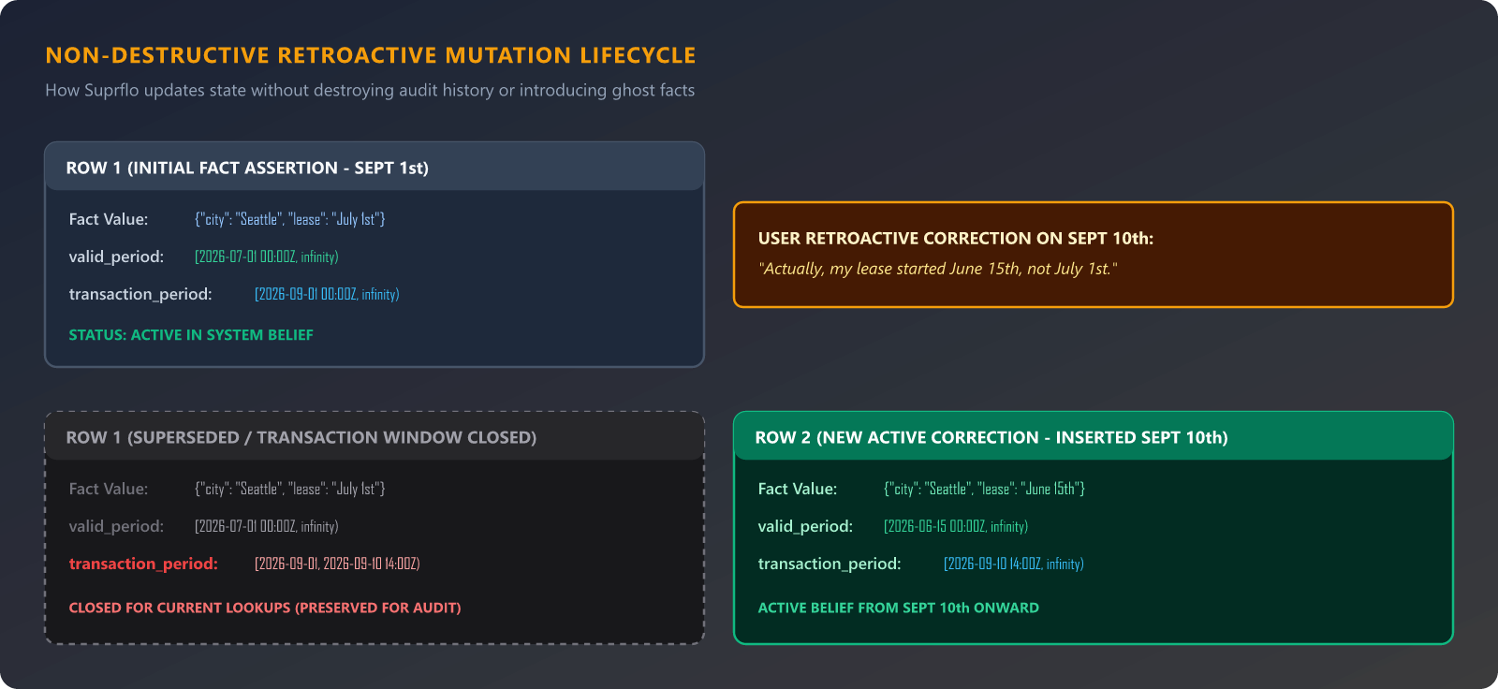
Figure 3: Non-destructive revision cycle - closing upper(transaction_period) preserves historical audit logs while routing current lookups to the updated assertion.
-- mutation_retroactive_correction.sql
-- Step 1: Close the transaction assertion window of the superseded fact
UPDATE agent_memories
SET transaction_period = tstzrange(lower(transaction_period), NOW(), '[)')
WHERE id = '9b1deb4d-3b7d-4bad-9bdd-2b0d7b3dcb6d'
AND upper_inf(transaction_period);
-- Step 2: Insert the updated fact with retroactive valid period and current transaction start
INSERT INTO agent_memories (
tenant_id, entity_id, fact_key, fact_value,
valid_period, transaction_period, embedding
) VALUES (
'e2a45012-70b1-469b-81a9-30129bc6287f',
'user_usr_94812',
'residence_address',
'{"city": "Seattle", "state": "WA", "street": "742 Evergreen Terrace"}'::jsonb,
tstzrange('2026-06-15 00:00:00+00', NULL, '[)'), -- Retroactive valid start date
tstzrange(NOW(), NULL, '[)'), -- Active assertion starting now
$1 -- Updated embedding vector
);

Performance Engineering: Hybrid Filtering & Autovacuum Tuning
Integrating range types into high-throughput vector retrieval introduces real production challenges around index selection and query execution plans. The PostgreSQL query planner can sometimes misestimate costs when combining GiST index scans with HNSW vector distance ordering.
To achieve sub-50ms p99 query latency across tables exceeding 50 million memory rows, we use CTE-based two-stage retrieval or explicit SQL pre-filtering. By constraining the search space via tenant_id and valid_period containment first, PostgreSQL reduces the working set from millions of vectors down to dozens of candidates before evaluating floating-point cosine distance.
Additionally, because superseding facts involves frequent updates to transaction_period upper bounds, table bloat can accumulate quickly. We configure aggressive autovacuum parameters specifically on agent_memories tables (autovacuum_vacuum_scale_factor = 0.02 and autovacuum_vacuum_cost_limit = 2000) to keep dead tuple overhead minimal without locking active reader threads.
Key Takeaways:
- Always pre-filter by tenant and temporal constraints to limit expensive vector distance evaluation overhead.
- Use immutable append-only transaction patterns to maintain complete regulatory auditability.
- Tune PostgreSQL autovacuum aggressively on high-churn bi-temporal tables to prevent index bloat and latency spikes.

