TTK4147 Miniproject Report
Malin Kildal and Martin Jensen

Design choices in code
We decided to run four threads instead of the recommended three. It was easier to pool all outgoing UDP messages to one thread instead of sending from both the controller and the responder. To communicate between threads we made channel object which allowed threads to send messages to each other. The channel is protected with a semaphore. Because the project was small we decided to keep the rest of the code in one file.

Task 1:
We found the smallest period possible without overshooting the running time significantly was 2 ms. From there we increased it until the results were satisfying. We ended up with a period of 4 ms.
You can see that the graph quickly converges on the reference of 1, and that the period is tightly gathered around 4 ms.

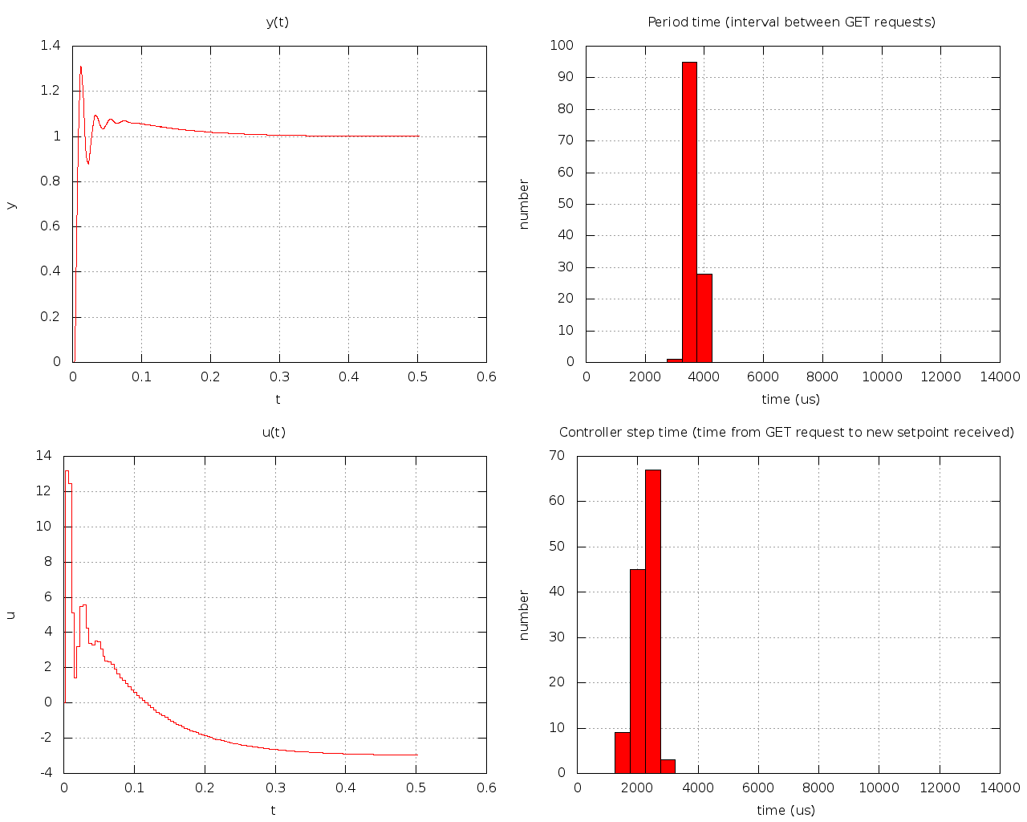

Task 2:

We made an independent thread to handle the signals. The UDP-receiver sends “SIGNAL” to it, and it immediately sends “SIGNAL_ACK” to UDP-send which forwards the message to the server. The actual response was not very affected by the addtion of the signals, but the response times had a larger variance as seen from the plots.

