RESULTS OF A FOOD SURVEY

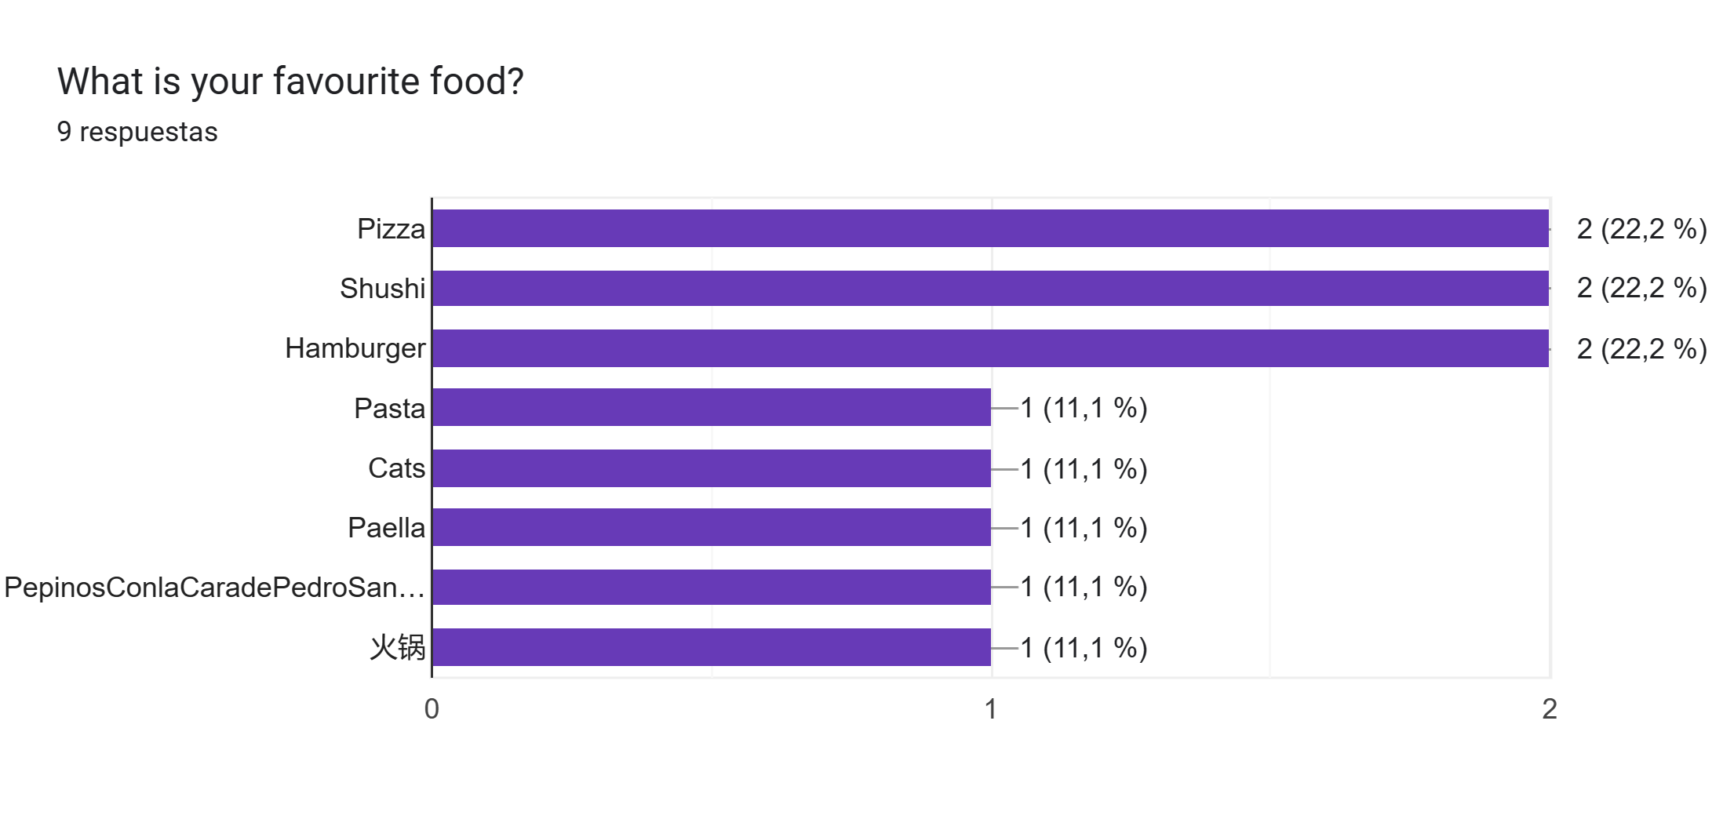

The majority of students have their favourite food the pizza, sushi or hamburger.

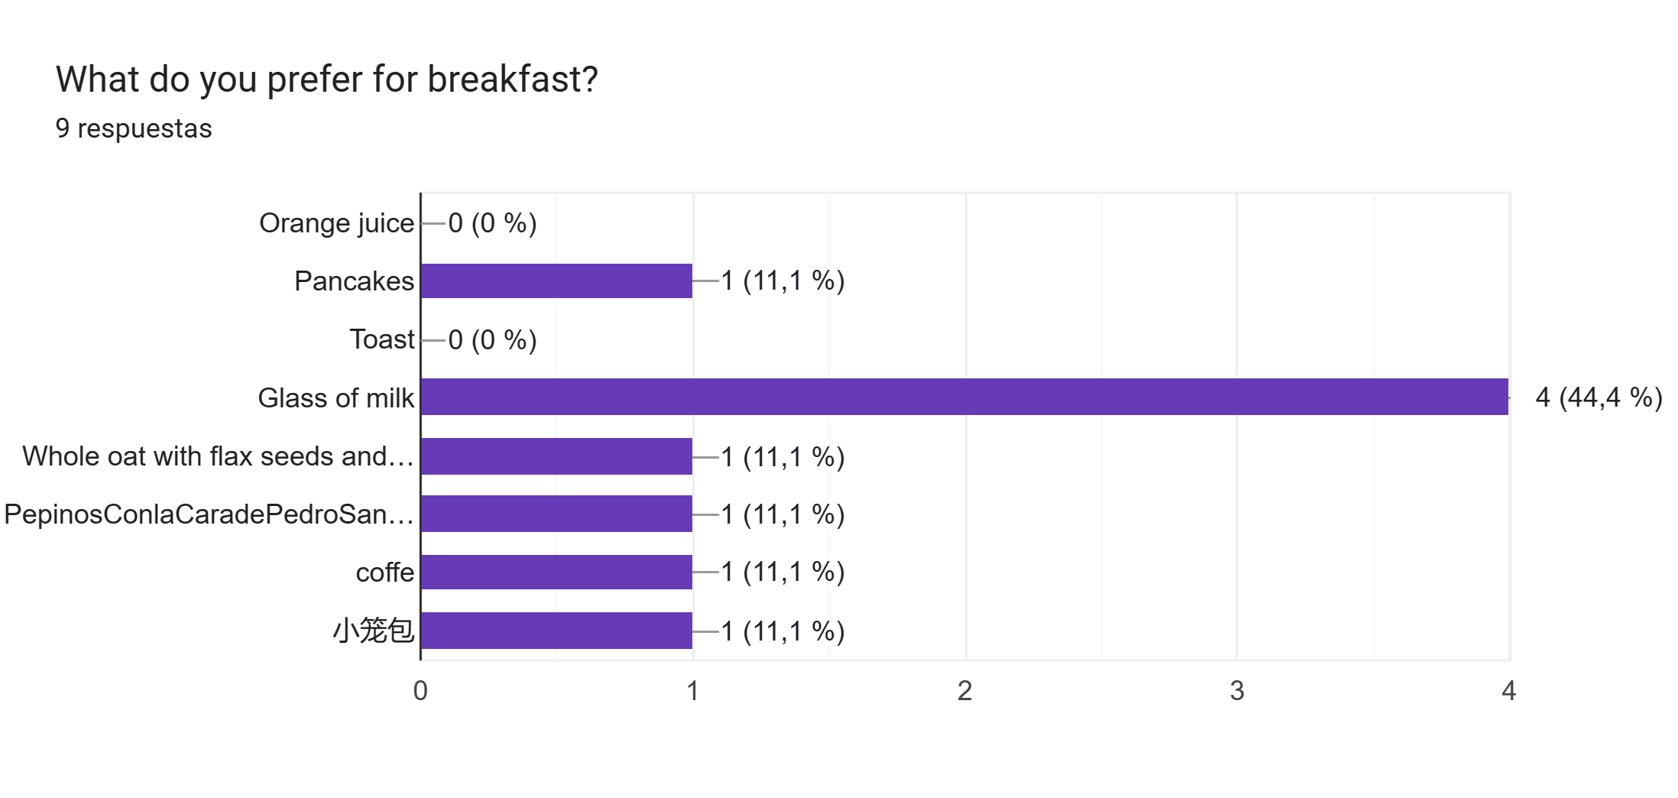
Four out of seven students prefer glass of milk for breakfast.

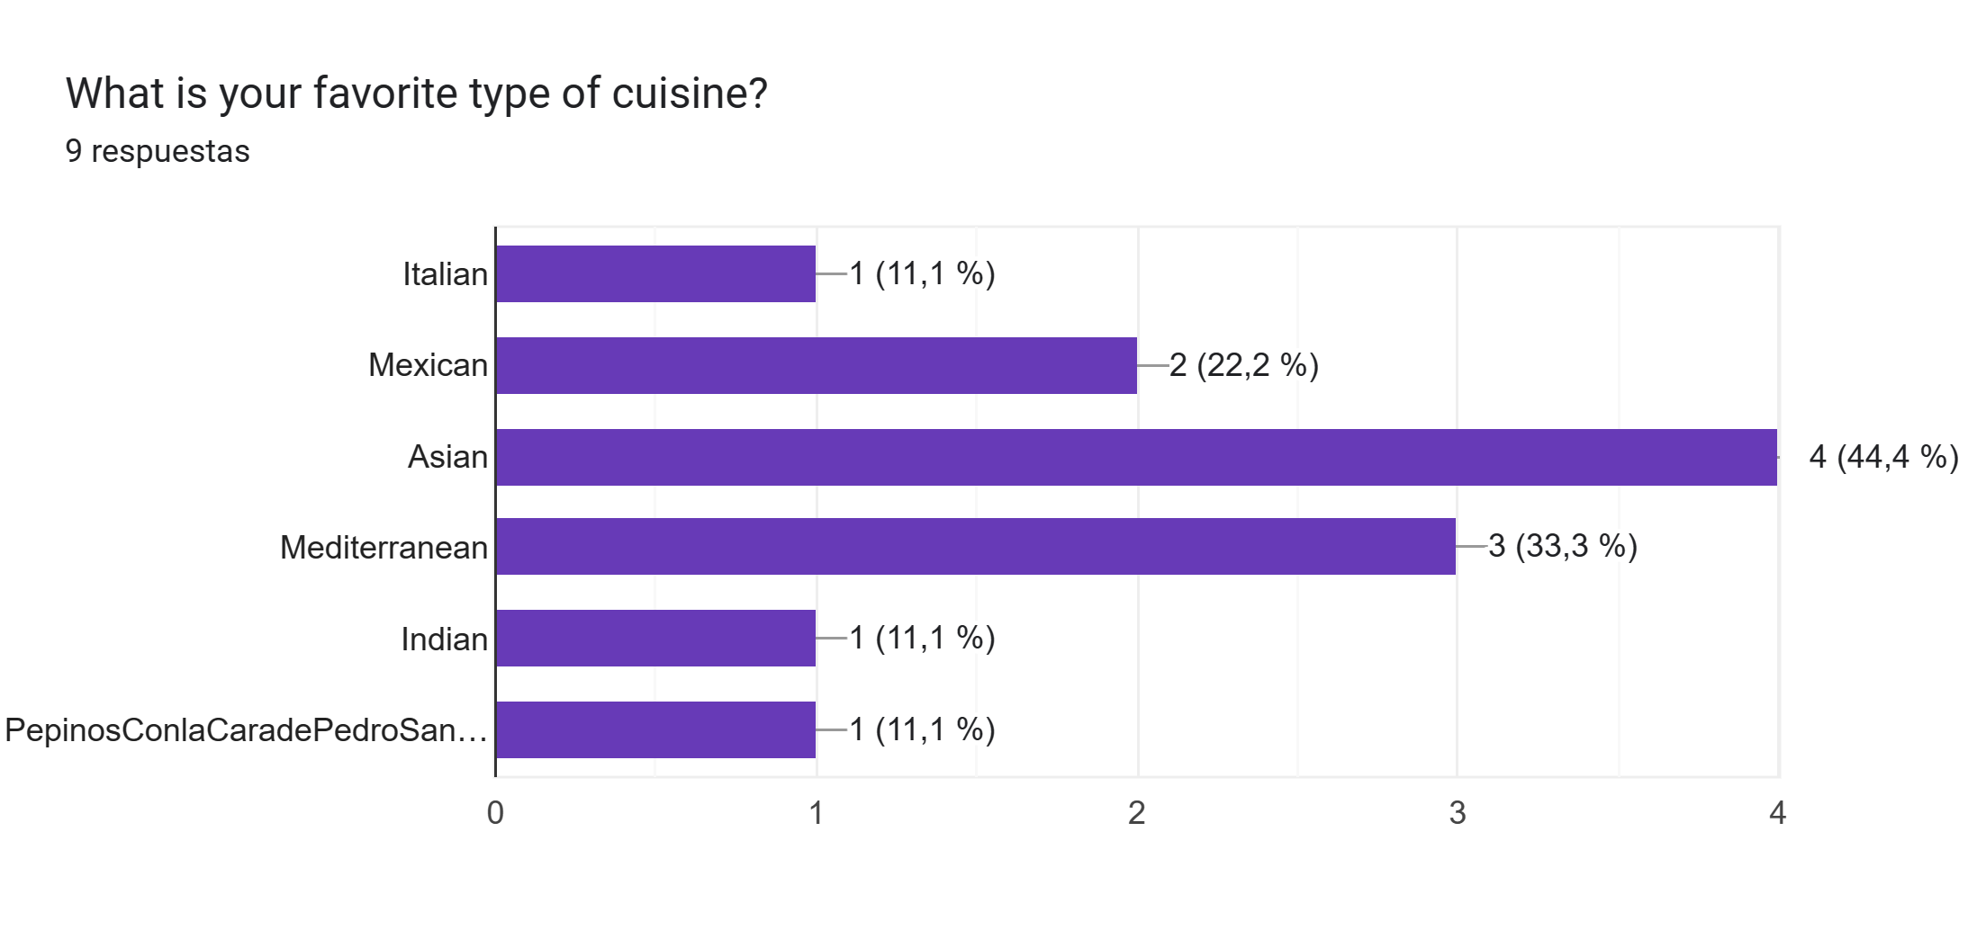

The most popular type of cuisine is Asian food.

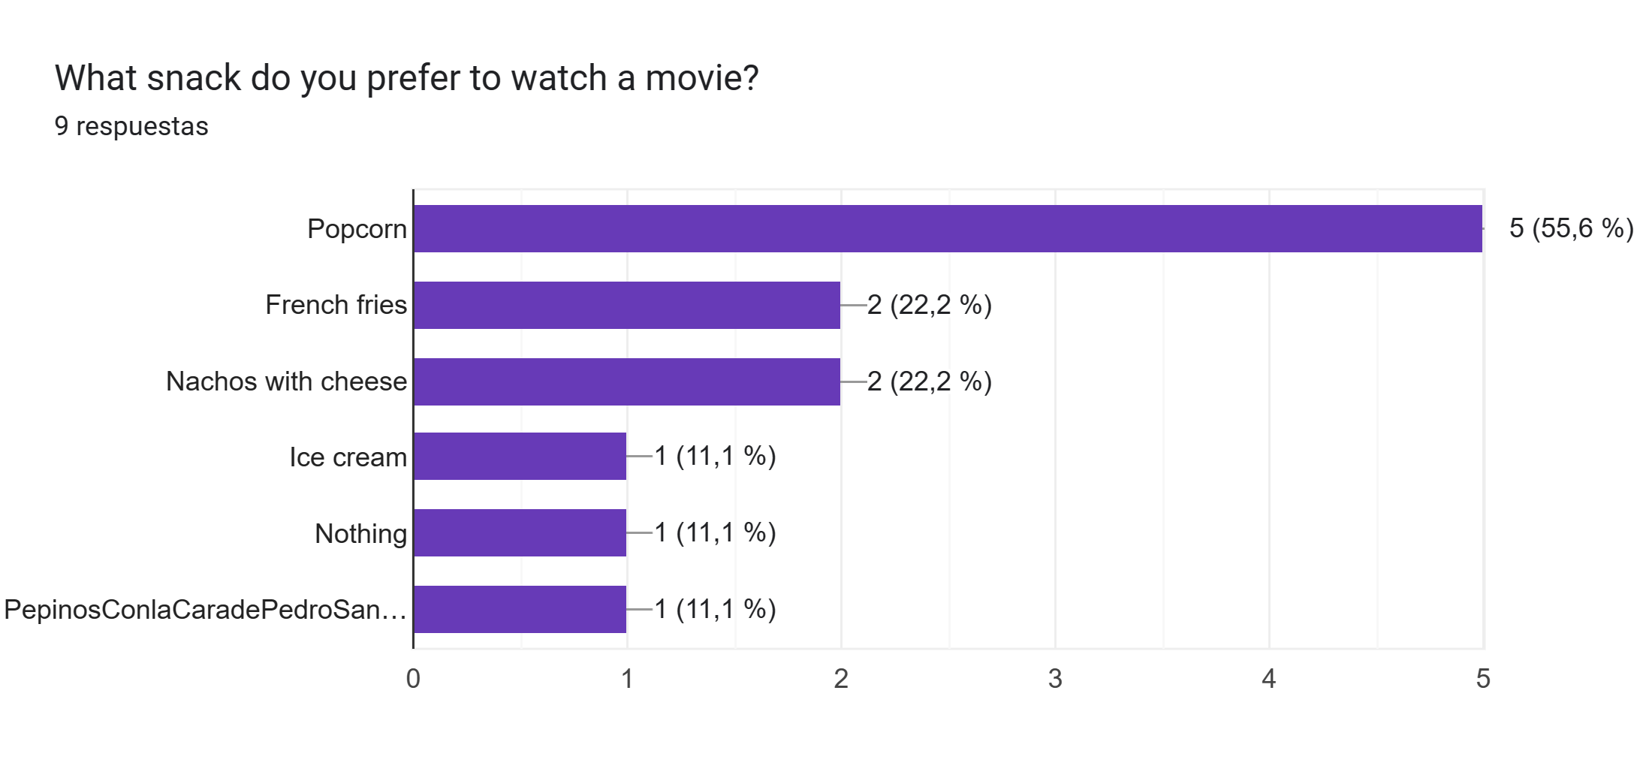

A good part of surveyed prefer popcorn snack to watch a movie.

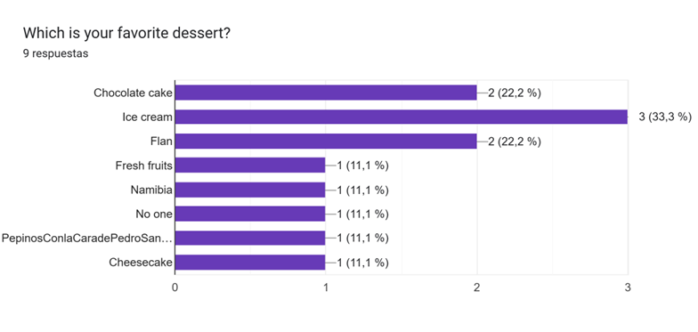

The favourite dessert of most students is Ice cream.

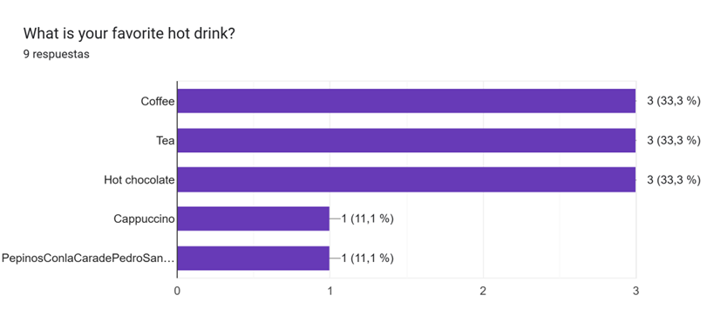

The favourite drink of a large part of the students are coffee, tea and hot chocolate

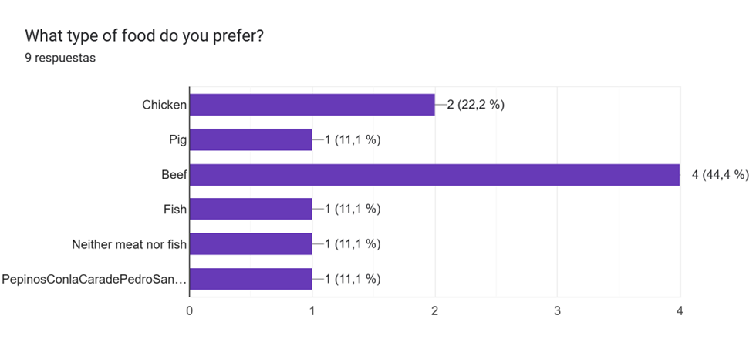
The majority of those surveyed have chosen beef as their favourite food.

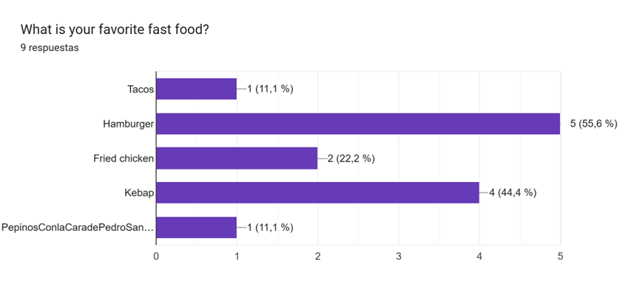

Five out of nine people prefer to order a hamburger at fast food.

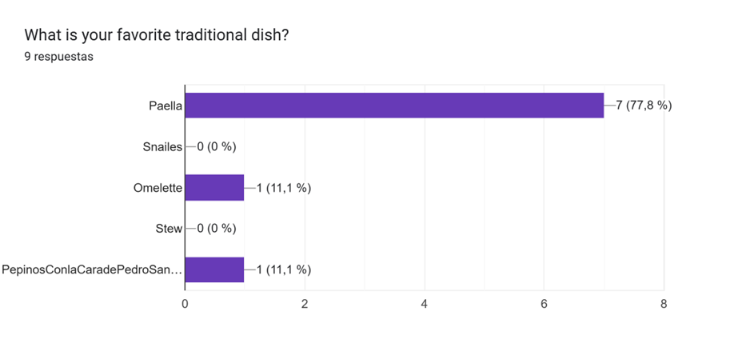
The majority of those surveyed have chosen paella as the best traditional food.

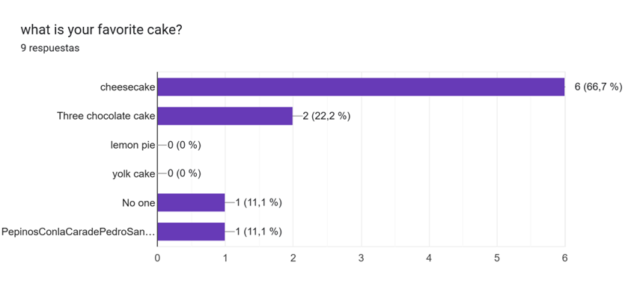
A good part of the students select cheesecake as their favourite cake.

