**Hotel_booking_project Report**

**Problem Statement:**

In recent years, City Hotel and Resort Hotel have seen high cancellation rates. Each

hotel is now dealing with a number of issues as a result, including fewer revenues and

less than ideal hotel room use. Consequently, lowering cancellation rates is both hotels'

primary goal in order to increase their efficiency in generating revenue, and for us to

offer thorough business advice to address this problem.

The analysis of hotel booking cancellations as well as other factors that have no bearing

on their business and yearly revenue generation are the main topics of this report.

**Assumptions:**

1. No unusual occurrences between 2015 and 2017 will have a substantial impact on

the data used.

2. The information is still current and can be used to analyse a hotel's possible plans in

an efficient manner.

3. There are no unanticipated negatives to the hotel employing any advised technique.

4. The hotels are not currently using any of the suggested solutions.

**Hypothesis:**

1. More cancellations occur when prices are higher.

2. When there is a longer waiting list, customers tend to cancel more frequently.

3. The majority of clients are coming from offline travel agents to make their reservations.

**Data Set:** The dataset is acquired from kaggle find the source link below l<https://www.kaggle.com/datasets/mojtaba142/hotel-booking>

The bar graph yielded from the data represents the reservations that have been cancelled it can be seen that nearly 40% of the customers had cancelled their reservations which can be the main reason that is affecting the earnings of the hotel 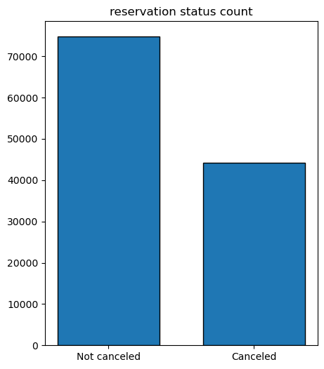

up on deeper investigation it Is evident that city hotel has more cancellations when compared to resort hotel i:e; resort hotel has got 28% cancellation rate while city hotel holds more cancellation rate with 42%.

But the hotel has a hood number of customers who are still not cancelling their reservation for resort hotels the customers who still hold their reservation are about 72% and for city hotel it is 58%, this can be clearly seen in the below graph.

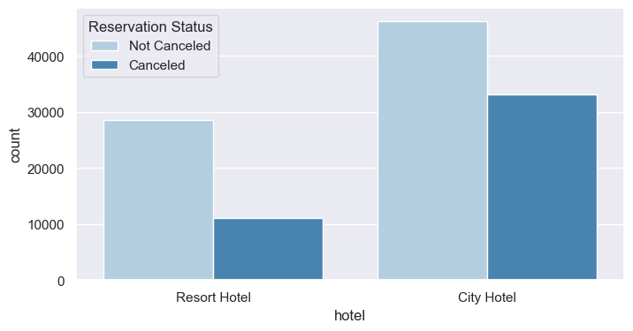

**Now let us see what factor is affecting the cancellation rate :**

From the above bar-graph we can see that the city hotel has more bookings than the resort hotels, due to this we can assume that the price of resort hotel is more when compared to city hotel

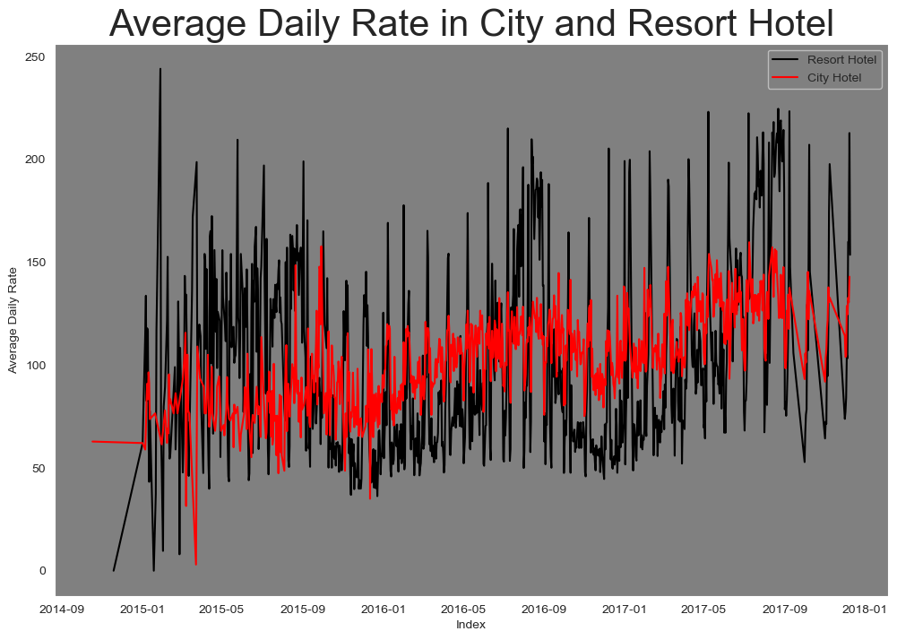

The line graph above states that ADR(Average Daily Rate ) of a city hotel is less than that of resort hotel and the spikes in the graphs represent weekends holidays and month-ends

To analyse monthly reservation status a grouped bar graph is constructed and it is evident that August ha most number of confirmed reservations and January has most number of cancelled reservations

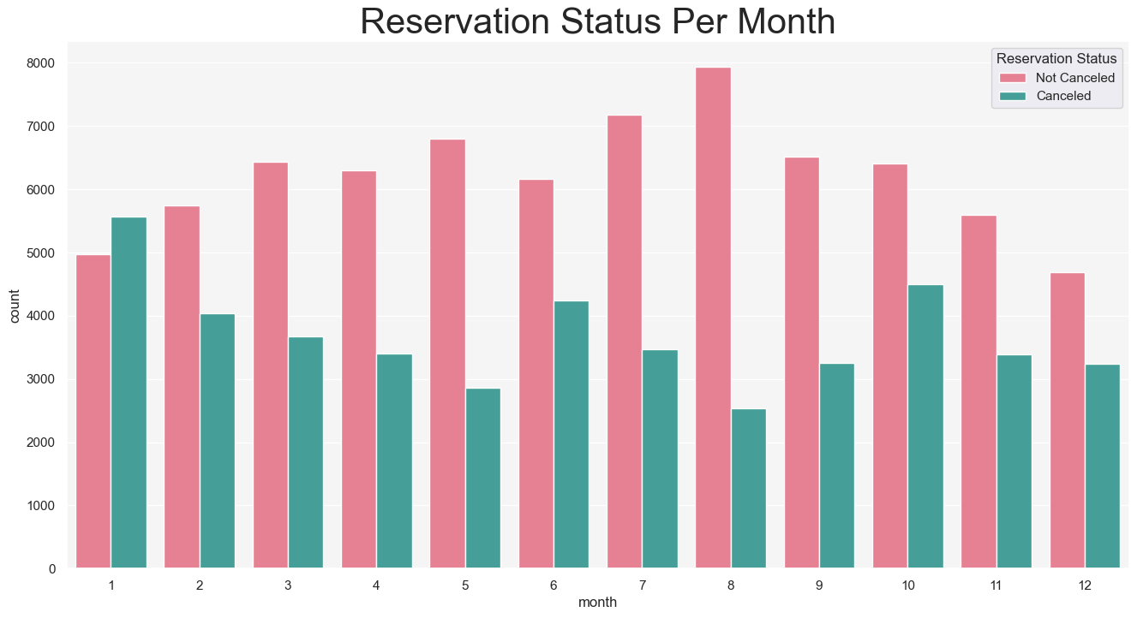

The below bar graph demonstrates that cancellations are seen more when the prices are high and cancellations are low when the prices are high. So, with this we can determine that price is the factor which is mainly affecting the cancellation rate

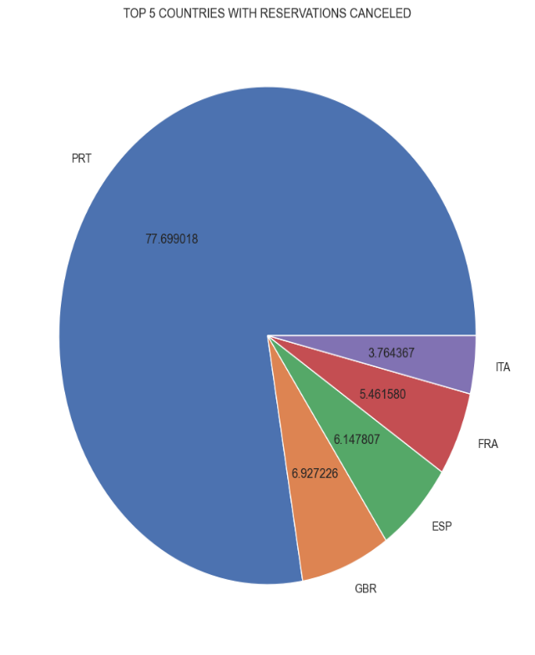 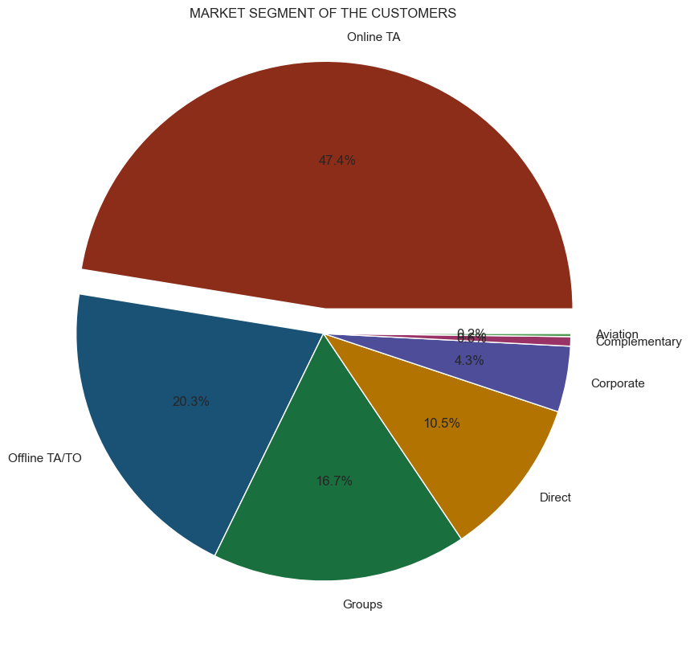

Portugal has more number of cancellations when compared to other countries and from the above pie chart it can also be seen that around 47% of bookings are coming from online travel agencies,20% from offline tour operators/offline travel agencies and only 10 % direct visitors, 4% of corporate bookings

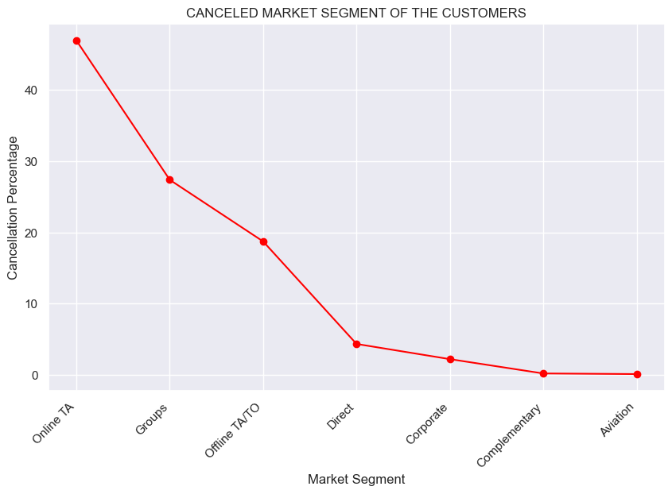

**Insights:**

1. When the price is high the cancellation rate is also significantly high. Hotels should work on their pricing strategies according to their respective locations also building a community around repeating customers and providing some sort of membership discount in resort hotels would help in stable ADR as cancellation is seen more in resort hotels than in city hotels
2. By the plot above market segment v/s cancellation percentage online travel agents are cancelling more after making a reservation
3. This need to be improved because we get around 56 thousand customers from online TA this may be due to better deals provided by competition. So, prices need to be adjusted according to the market competition and deals by rivals
4. Similarly, group travellers should be given best hospitality because they hold a market segment of 17% and their cancellation rate is also high best experience in their stay gives us future bookings and also helps in market expansion through recommendation
5. More importantly in Portugal hotels should work on their infrastructure and ambience, however the pricing strategy should also be revisited to decrease cancellation rate