
Introduction to
Web Design Using
Microsoft® Expression® Studio
Chapter 2/Module 2
Chapter 2/Module 2
Creating your First Web Site with HTML Basics

Introduction
The Internet – it’s everywhere! It is so pervasive that some students now claim that a Web site was down instead of insisting that the dog ate their homework. It has opened up a world for almost everyone to discover and explore. It has created new opportunities for education, entertainment, business, and social networking. But who creates all of the pages on the Internet? Increasingly, the answer is YOU. In this chapter, you will learn the basics of the publishing language of the Internet—HTML (Hypertext Markup Language), create pages using this language, and learn about the rules that govern the Web. Most text editors are perfect for creating Web pages with HTML. And even if you plan to use a WYSIWYG (what you see is what you get) Web design environment, a solid base of HTML knowledge is very valuable.

HTML in Transition
The content of the Web, the code that creates what you see, and the rules that govern how Web content is created, changes rapidly. The early HTML versions were very straightforward but rather static—that is, it didn’t allow for much interaction with the viewer except for hyperlinks to other pages and Web sites. Over the years HTML has evolved into the dynamic environment we know today. Modern Web pages and Expression Web are written using XHTML, which will be explored in Module 5.
To keep the Internet working smoothly and consistently, an organization was formed to establish Web standards and guidelines, including the standards and rules for the HTML coding language. The international, vendor-neutral organization called the World Wide Web Consortium is often referred to as W3C. Its goal is “Web interoperability.” The W3C was formed in 1994 by Tim Berners-Lee, who invented the World Wide Web in 1989 while working at the European Organization for Nuclear Research (CERN). Because technology is constantly changing, Web standards must be routinely updated to be assured that Web technologies, hardware, and software remain compatible. The most recent draft of proposed rules sets the standards for HTML 5.
In this most recent draft of Web standards, cascading style sheets (CSS) are recognized as the best way to create uniform designs for Web pages. Many tags from older versions of HTML and standards are not included in the most recent draft for HTML 5 or in XHTML because their effect is mostly for presentation and is more efficiently handled by CSS.
The most current changes in Web standards are also a result of the development of devices such as cell phones that are capable of accessing the Web but are limited in amount of information the screen can display. Other adaptive technologies that “read” Web content have also impacted Web standards to ensure that Web content is accessible to everyone. In Module 5 you will learn a great deal more about CSS and other features of HTML 5 and XHTML. You can learn more about W3C and HTML standards at http://www.w3.org/Consortium/.
Note: For purposes of practicing the concepts of tags and for creating a few beginner Web pages, this text includes a few elements that were commonly used in earlier versions of HTML but no longer meet the most recent HTML standards. Elements no longer supported by the current version of HTML are referred to as “deprecated.” We will note these deprecations where they appear. Other elements are no longer recommended because they are better handled with cascading style sheets. Some elements in this category are introduced separately in this text and later included in lessons on CSS after students have explored them in a simpler setting.

How the Internet Works
Browsers such as Microsoft Internet Explorer® read the HTML code from files stored on servers that form the network we call the Internet. Browsers convert the code into the graphical display you see when you open a Web page. You can view the HTML source code responsible for the page display by choosing that option from the browser menu.
Each page on the Internet is assigned a URL (Uniform Resource Locater). The first part of the URL is called the protocol identifier. The second part is called the resource name. The resource name can specify the IP address or the domain name of where the Web resource is located. The protocol identifier and the resource name are separated by a colon and two forward slashes. Sometimes there is additional information added to the URL. A URL that ends in .html or .htm or .aspx identifies a specific Web page on a site. Let’s look at a couple examples.
In this example,
http is the protocol identifier.
www.msn.com is the domain name where the resource is located.
By default, if there are no further words added to the URL, the browser opens the Web page named index.html.
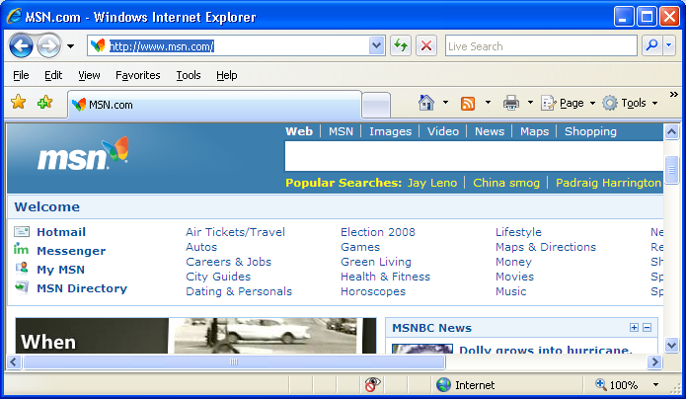
http://www.msn.com/
In this example,
http is the protocol identifier.
www.msn.com is the domain name where the resource is located.
artcenter_ is a folder on the site server, and
browse.html is the name of the Web page.
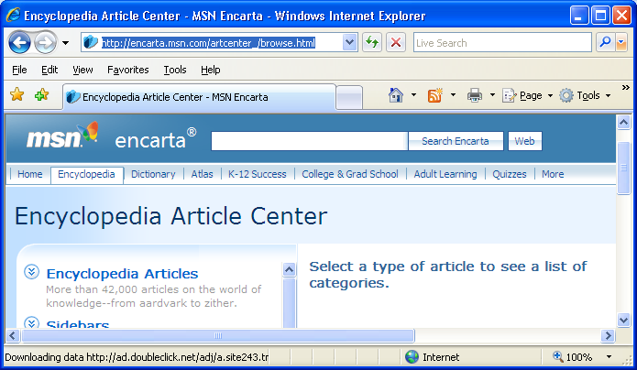
http://encarta.msn.com/artcenter_/browse.html
There are many protocols that identify the type of Web connection and the type of activity associated with a Web site. You may have seen sites with these protocol identifiers:
Protocol Identifier | Web Use
HTTP Hypertext Transfer Protocol | Common Web page displays
FTP File Transfer Protocol | Transferring (uploading or downloading) files from servers
POP3 Post Office Protocol version 3 | Commonly associated with incoming e-mail transfer
SMTP Simple Mail Transfer Protocol | Commonly associated with outgoing e-mail transfer

For more information on how the Internet works, try viewing the video How the Internet Works from the Microsoft “Kid’s Corner: Beginner Developer Learning Center.”

Web Page Structure
HTML is easy to learn and you can use many different editors to write the code. The most basic pages can be written in Notepad, and more graphic or interactive pages can be easily designed with a program such as Expression Web. Regardless of what tool is used to create the pages, all pages must be written following the syntax or language rules of HTML code. A summary of the HTML tags used in the lessons of Module 2 are included at the end of this chapter.
It is important to create a folder to hold all the page and image files that are part of the Web page being created. Within the classroom environment, the instructor will provide instructions for creating this folder.
The commands in HTML consist of elements that include one or two tags, which are text enclosed in angle brackets (greater-than and less-than symbols). These tags are the heart of the HTML language. Most elements include an opening and closing tag (indicated by the forward slash before the text word), surrounding text, or other information:
<tag> information </tag>
However, some elements include only a single tag (with no closing tag) such as the <p>, which is a paragraph tag. It creates the effect of hitting the enter key twice. It does not require a </p> tag.
Attributes are commands that can alter the look of a tag. These attributes are included with the opening tag and create some type of effect on the information included between the opening and closing tags.
<tag attribute=xx> information </tag>
HTML elements may be nested within other elements, but elements may not overlap.
<tag1><tag2> information </tag2></tag1>
In the preceding example, notice that the TAG2 element is nested completely inside of the TAG1 element. Elements are used to identify, format, and place the components on a Web page, such as paragraphs, images, and lines.

Block and Inline Formatting
The layout of the content elements of a Web page can be described as “block” or “inline.” The inline elements can consist of text and other items such as images. Inline elements appear within the flow of the page. This image is an “inline” element of this paragraph. The words lead up to and extend directly beyond it. When viewed through a browser, the inline elements do not usually begin on a new line.
However, block-level elements are separated from the flow of the content. You can identify many block elements because they stand alone on the page and are separated from the flow of the content.
These elements usually begin on a new line when viewed in the browser. Headings and tables are two examples of block elements you will learn about in this chapter. A heading would appear as a block element in the browser. Notice the white space above and below the text as well as above and below the image.

Learning about Tags and Attributes
When you first look at the code of a Web page, it may be very confusing. In this section, we will break the code into manageable portions and explain the lines of code, starting right at the top.
The first element you will see at the top of most Web pages tells the browser what set of “rules” to use. Here is an example.
<!DOCTYPE html PUBLIC "-//W3C//DTD XHTML 1.0 Transitional//EN" "http://www.w3.org/TR/xhtml1/DTD/xhtml1-transitional.dtd">
This looks very complex but is really quite straightforward. You will learn more about this later in this chapter. For right now, just think of this as the line that tells the browser by which set of HTML (or in this case, XHTML) rules this page was created.
HTML files usually are saved using the .html or .htm extension. Commonly, the first page is named index.html. The index file will be shown when a Web site is opened using just the protocol and domain identifiers. If the URL http://mysite.org is entered into the address field of a browser, the browser will try to open a page named index.html.
The HTML code of a page consists primarily of two parts, the head and the body. Just as a letter’s head contains information pertinent to the reader, an HTML document's head contains information pertinent to the browser rendering the code.
In a letter, the writing is usually indented, capitalized, and spaced to make it easier to read. But you probably still could read it if it were
crunchedtogetheror
str ang ely spaced.
Of course, the human reader would not be too happy with your style! Similarly, HTML code has a style. The style you use should make the page easy to read. Keep in mind that the browser ignores extra spaces and blank lines within the code. The best style rule is to space and arrange the HTML code of a page in such a way that a reader of the code can easily understand what has been written.
HTML code is not case sensitive, but it is best to always use lowercase for the tags. Future XHTML standards will actually require lower case, so using lowercase is a good habit to get into.
The following three examples show different styles of the same HTML code, producing exactly the same page. You will learn what each tag means later in this chapter. Which code sample is easiest to read?

Style sample 1
<html>
<head><title>My first web page</title></head>
<body>all the important details</body>
</html>

Style sample 2
<html>
<head>
<title>My first web page </title>
</head>
<body>
all the important details
</body>
</html>

Style sample 3
<html><head><title>My first web page</title></head><body>all the important details</body> </html>
Look at the following graphic. Notice where the words enclosed in the title tag are displayed on the Web page. Notice where the words enclosed in the body tags are displayed on the Web page.
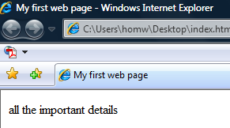

Using Tags and Attributes to Create a Web Page
It’s time to learn how HTML tags are used to create Web pages. Considering the huge amount of information on the Internet, Web pages are created from a surprisingly small number of tags, and you will find that they are easy to learn and use.
The code of all HTML pages begins with the <html> tag and ends with the </html> tag. This tag defines the beginning and the end of the page and all of the other HTML tags must be contained between these beginning and ending tags.
The HEAD element (delineated by the <head> and </head> tags) comes next and serves as a box or container that can hold a variety of other elements, including the TITLE element. The TITLE element contains the words that appear on the title bar and page tab in the browser window—the title of the page. In the following example, “My first web page” is the title.
The title – “My first web page” – that appears on the browser tab in the preceding image, is produced with these lines of code:
<html>
<head>
<title>My first web page</title>
</head>
.
.
</html>
The <body> tag follows the </head> tag. Most of the elements that produce what you see on a Web page are located within the BODY element.
Here is the complete code for the Web page in the preceding image illustrating the HTML, HEAD, and BODY tags.
<html>
<head>
<title>My first web page</title>
</head>
<body>
all the important details
</body>
</html>

Increasing Understanding with Comments
Sometimes, the HTML author will want to make a comment that explains the code to the viewer of the source code. This comment will not show up on the actual Web page but is very useful to anyone viewing the code such as a Web development team member or a curious Web site viewer. Comments might include details about the HTML version, the plans for updating, or details about the development process. Here is an example:
<!-- This is a comment to tell the reader of the code something -->
This tag includes an exclamation mark at the beginning, but not at the end.

Enhancing the Appearance of Web Page Content
Heading elements are used to emphasize text on a page by changing the size of the font and making the text bold. There are six sizes of text created with heading elements ranging from H1 (the largest) to H6 (the smallest). The following example demonstrates the use of all six heading elements:
<body>
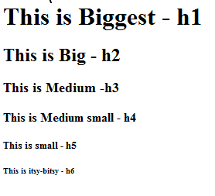
<h1>This is Biggest - h1</h1>
<h2>This is Big - h2</h2>
<h3>This is Medium - h3</h3>
<h4>This is Medium small - h4</h4>
<h5>This is small - h5</h5>
<h6>This is itsy-bitsy - h6</h6>
</body>
To position headings or other elements on the page, use the attribute align = position, where position can be right, center, or left. Each BR element (consisting of a single <br> tag) in the samples below indicates a “break” in the flow of the text across the page and create the equivalent of an “enter” in the rendering of the page.
<h1 align=left>Hickory</h1><br>
<h1 align=center>Dickory</h1><br>
<h1 align=right>Dock</h1><br>

The following chart lists some common HTML tags. You will find a more complete list at the end of this chapter of text.
Element | Meaning | Used For
<p>text</p> | paragraph | Paragraph or paragraph break. (A blank line is automatically inserted between paragraphs.)  Note: Most browsers accept <p> as a paragraph break, without an associated end tag, but the end tag is recommended by W3C.
<b>text</b> | bold (deprecated) | Formats text between tags as bold
<strong>text</strong> | strong or bold | represents importance
<u>text</u> | underline | Underlines text between beginning and end tag
<i>text</i> | Italics (deprecated) | Formats text between tags as italic.
<em>text<em> | emphasis or italics
<br>  <br/> | break | Line break. (By default, no blank line is inserted after a <br> tag, unlike with a paragraph break.)  Note: <br/> is an alternative form of <br>; it is not a closing tag.
<hr>  <hr width = x%  size = n  color = #0000FF> | horizontal rule | Creates a horizontal line to separate sections.  Optional attributes include width (as a percent), size (thickness as an integer), and color.
<sub>text</sub> | subscript | Formats text between tags as subscript
<sup>text</sup> | superscript | Formats text between tags as superscript

Special Characters
There are many symbols and letters that are used on Web pages that are not normally on the keyboard. Two examples of these symbols are ñ and é. To create these characters in HTML, use the ampersand (&), followed by the pound sign #, followed by the number of the special character, and then a semicolon. For example, &#169 will produce ‘©’. This technique must be used to display a ‘<’ or a ‘>’ character on a Web page because simply adding a ‘<’ or a ‘>’ into a string of characters causes the browser to expect the rest of the syntax of a tag. The following is a list of the values used in the code for some of the more common characters as well as those that might confuse the browser or interpreter.

Unicode Number | Character
34 | "
38 | &
60 | <
62 | >
169 | ©
174 | ®
162 | ¢
177 | ±
191 | ¿
232 | è
233 | é
241 | ñ
For a complete list of special characters, visit http://www.utexas.edu/learn/html/spchar.html.

Enhancing Tags with Attributes
Certain HTML tags require details to complete the instructions to the browser for rendering a page. To enhance or complete the elements of the page, many tags have attributes. Attributes simply add more flexibility and greater details to tags; attributes can define such things as color and placement. They become part of the start tag and take the form attribute = value.
In this BODY element example, the background color is set to black and the text is set to yellow.
<body bgcolor="#000000" text="yellow">
Any subsequent content will be printed in yellow on a black background.

Creating Color in HTML
There are several ways to set the color of various elements of a Web page. The preceding example uses one hexadecimal number for black and one color name for yellow to set the color attributes of the body tag. You can also use an RGB (Red Green Blue) values to define colors.
Colors on the computer screen are made up of combinations of red, green, and blue. Each of these colors can vary in intensity from 0 to 255. By mixing these colors, 16,777,216 unique colors can be created. Of course, your eyes usually can’t discern colors that are close in number. Black is expressed as a hexadecimal value of #000000, or an RGB value of (00,00,00), and pure red is hexidecimal #FF0000, or RGB (255,0,0).
There are several color names that can be used in HTML code. You can try a few color names to see which ones work (single color names work best) or you can use the following Web sites to discover the hexadecimal or RGB values or the useable color names:
www.html-color-codes.com
www.computerhope.com/htmcolor.htm
www.htmlcolorcodes.info/
The following is an example of a color chart that you might find on the Internet.
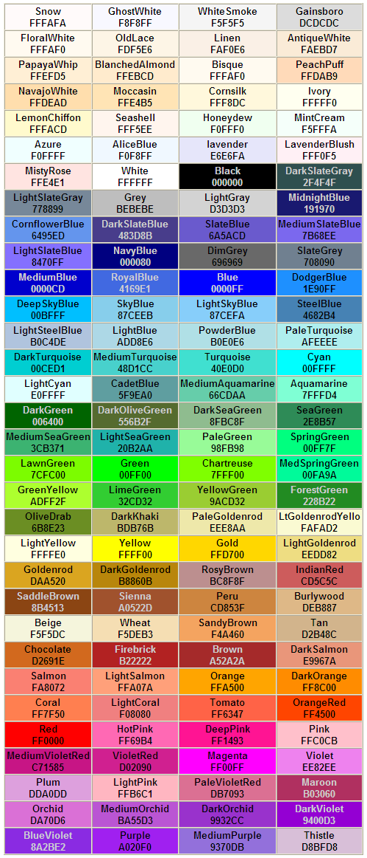

Organizing with Lists
Everyone uses lists to help organize information or prioritize tasks. Lists help us think more clearly. Perhaps you have made an ordered or numbered list of the homework you must complete this week. The numbers indicate the priority or importance of the tasks or perhaps the order in which you plan to complete them.
Homework assignments
- Study spelling list
- Make term paper outline
- Finish book report
- Study for math test
Other lists might be unordered—that is to say they are not prioritized in any way. The contents of such lists are included because they share common traits. A list of gift ideas for a sibling could be this type of unordered list. Unordered lists often have a graphic bullet in front of each list item.
- Kim’s birthday
- Tennis racket
- MP3 player
- Movie tickets
- Diary
Lists can organize information on a Web page and make it more readable. There are several types of lists with very specific uses. Unordered lists usually have bullets to emphasize the items in the list. Ordered lists have numbered or lettered items. Definition lists use special indentations to create a hierarchy of elements. Each element in a list is called a “list item.”
Here is a summary of the tags used for various lists.
Tag | Meaning | Used For
<ul> | unordered list | heading for bulleted list
<ol> | ordered list | heading for numbered list
<li> | list item | bulleted / numbered item (indented)
<dl> | definition list | beginning list
<dt> | definition term | word to be defined
<dd> | definition description | definition (indented)
Analyze the code in the following side-by-side samples. Predict what each will produce on a Web page. Were you correct?

An unordered “To-do” list
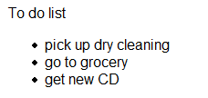
To do list
<ul>
<li>pick up dry cleaning</li>
<li>go to grocery</li>
<li>get new CD</li>
</ul>

An ordered “Desserts” list
Favorite desserts
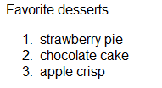
<ol>
<li>strawberry pie</li>
<li>chocolate cake</li>
<li>apple crisp</li>
</ol>

A definition list of "Things to Know"
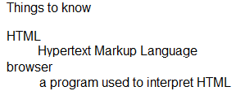
Things to know
<dl>
<dt>HTML</dt>
<dd>Hypertext Markup Language</dd>
<dt>browser</dt>
<dd>a program used to interpret HTML</dd>
</dl>

Adding Interest with Images
Images add interest and value to Web pages. They are used to illustrate information, add emphasis, and in general, make Web pages more appealing. Image files are saved in many formats; you have likely heard of, and maybe worked with .bmp, .jpg, and .tif files. The .jpg extension is the most popular choice for Web pages. The .bmp image format cannot be used. In Chapter 4 you will learn more about image files types and experiment with creating images for Web pages.
Images are included in the HTML source with an IMG element, which does not include a closing tag. The letters "src" stand for source. The information between quotation marks is the location of the image on the server.
<img src="where it is found on your computer">
Sometimes users turn off their browser’s ability to view images because this speeds up the loading time of the page. Occasionally a picture does not load properly, which can be the result of a missing or misplaced file on the server.
This is what would appear on the Web page if the image file was unavailable to be displayed.
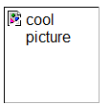
Use the alt = “description” attribute to tell the user what is missing if the picture cannot be displayed. Blind individuals have computers and browsers that “speak” the words on Web pages. The alt attribute contents are read aloud by such browsers and are necessary for those individuals to fully understand the contents of the page.
Height and width attributes can be added to assure accurate placement of images on the page.
Here is a sample of an image tag with both dimension and alt description attributes.
<img src="pic1.jpg" height="100" width="100" alt="cool picture">
When images are not located in the same folder as the HTML file that is intended to display the image, a “path” to the image must be defined. The following path indicates that the image is in a folder named “pictures” that is in the same file location as the HTML file.
<img src="pictures/pic1.jpg" alt="cool picture">
Occasionally, a path indicates that the file location of the image is outside of or “above” the location of the HTML file. The following path refers to an image that is one level above the HTML file. The two dots (..) tells the computer to “back out” one folder level of the HTML file and to look in the “picture” folder at that level in order to locate the pic1.jpg image.
<img src="../pictures/pic1.jpg" alt="cool picture">
The paths to images and other files can become very complex. It is critical for the designer to carefully plan the file and folder structure for Web sites to ensure a straightforward and convenient design process.

Hyperlinks
An exciting aspect of the Internet is the ability to link to other Web pages within the site or to other Web sites. This is the very essence of the concept of the Internet—linking from one site to another. The code used to create links is very simple. Hyperlinks can consist of text or images and are defined by an ANCHOR ("a") element with a href attribute.
This is the general syntax for an ANCHOR element for a hyperlink:
<a href = "url and/or file name"> words or picture the user clicks on </a>
Here are some examples:
Linking to another page in the same site using the text “My Favorite Movies” as the link:
<a href= "myfavoritemovies.html">My Favorite Movies</a>
Linking to a distant site using text as the link:
<a href= "http://myfavoritemoviestarsite.com">My Favorite Movie Star</a>
Linking to a distant site using an image in the “pictures” folder on this site:
<a href="http://anothersite.com"><img src="pictures/me.jpg"></a>
Sometimes it is desirable to open a page or site in a new window. A target attribute—blank—can be added to the anchor tag to tell the browser to open the page being linked to in this new window.
The following code segment produces the following hyperlink and opens the site in a new browser window, rather than replacing the contents of the open window.
<a href="http://www.microsoft.com" target="_blank">Microsoft</a>

Adding color to hyperlinks
It’s useful for Web site visitors to have a visual cue to keep track of whether or not they have visited a hyperlink. The colors can be set as part of the BODY element for unvisited links, visited links, and active links. The active link tag affects the color of a link as you click on it. This is another HTML feature that is best handled in CSS, and you will learn those techniques a bit later.
<body link = "#FF0000> sets the color of unvisited links to red
<body vlink = "#00FF00> sets the color of visited links to green
<body alink = "#0000FF> sets the color of active links to blue

Cascading Style Sheets
Now that you have explored the basics, you will be excited to learn how many of the HTML elements and attributes can be incorporated into cascading style sheets (CSS). CSS gives amazing flexibility in creating the “look” you want for a Web page and makes creating that “special look” easier.
The original goal of HTML was to define the content of a Web document. The <body> tag defined the contents of the body of the page, <list> defined the contents of a list, and <p> defined the contents of a paragraph.
As major browsers added new tags, many of which described style, it became very difficult to separate content from the design elements of the page. Style tags such as <font> and <color> became entangled within the content paragraph <p> tag. Changing the attributes of every element in a large Web site became very time consuming!
Styles were created by the World Wide Web Consortium (W3C) that became part of HTML 4.0. This enabled designers to separate content from style by using cascading style sheets. An entire site could take on a whole new look within a few minutes and a few changes to the style sheet document.
A style sheet goes hand in hand with the HTML page. It is simply a listing that tells the HTML page how to handle the formatting of the visual aspects of the pages. The CSS file is created separately and is saved with a .css extension. Inside of the HTML page, there will be a link to the CSS page.
In addition to style uniformity and ease, cascading style sheets improve page load time for the site because there is less data to transfer from the server to the viewer’s computer. As the Web browser downloads the first page, it caches (stores in memory) the style sheet to use on any
additional pages from the same site. This causes all subsequent pages to load faster. An added benefit is that CSS gives sites a more cohesive look because the style is consistent from page to page.
Style sheets can specify style elements in several ways. Styles can be defined within individual HTML elements, within the HEAD <head> element, or in one or more external CSS files—all at the same time! While this can become rather confusing for the beginning designer, it is important to understand how multiple styles interact within a single Web page or site. But don’t worry; this module will go slowly in building your skills and knowledge in using CSS.
The term “cascading” is the basis of the power that CSS offers to designers. Because styles can be defined in various places (the browser, tags, and external documents), an order of priority rules has been established. The actual style applied to content follows these rules where rule number four has the highest priority:
- Browser default
- External style sheet
- Internal style sheet (inside the <head> tag)
- Inline style (inside an HTML element)
An inline style has the highest priority, which means it takes precedence over any style defined at any other level. This “cascading” allows designers both the convenience and ease of setting styles in an external CSS document or within the <head> tag, AND the power to override those styles within the tag of an HTML element as desired.
Syntax:
CSS syntax has three parts: a selector, a property, and a value.
Selector {property: value}
The selector is the HTML element to define, the property is the attribute of that element to change, and the value is the specific quality of that element.
Here are a couple examples:
body {color: red}
The following example has the effect of indenting every paragraph three times the width of the upper-case “M” character (see “em” entry in Vocabulary). To add more properties to the paragraph, just append them on the next line. Make sure that the ending brace (}) is included to close the selector.
p {text-indent: 3em}
The same selector can have multiple styles. They are included within the braces and separated by semicolons. Here is a style definition for the HEADER element. The properties have been placed on separate lines to improve readability, but that is not necessary.
h1
{
text-align: center;
color: red;
font-family: arial
}
The same style can be defined for multiple elements by grouping selectors. In this example, all of the HEADER elements (separated by commas) have been defined in a single style definition:
h1,h2,h3,h4,h5,h6
{
text-align: center;
color: red;
font-family: arial
}

Selector Categories
Recall that the first word in the CSS syntax (selector {property: value}) is “selector.” The selector is the HTML element to define. Selectors fall into 3 categories:
1. HTML tag selector—changes the style of existing HTML tags.
Syntax:
HTMLtagSelector
{
property:value;
property:value;
}
Note semicolons!
All of the examples thus far in this module have been HTML tag selectors—the HTML tags <body>, <p>, and <h1>. In addition to setting the value of various properties of HTML tags, you can actually change how the browser interprets standard tags such as bold. In the following sample, the effect of the bold HTML tag has been changed for the whole page.
Example:
CSS File | HTML File Segment (with reference to associated .css file)
b  {  font-family:arial;  font-size:24px;  color:red  } | <body>  <b><i>This is the redefined bold HTML</i></b>  </body>
Result:
2. Class selector—defines styles to use without affecting existing HTML tags. That is, it will not redefine an HTML tag entirely, as in the preceding example using bold, but will take effect only when invoked inside of a particular tag.
Syntax:
Note the dot before the class selector.
tag.classSelector
{
property: value
}
Class selectors enable the designer to create various unique styles for HTML elements without overriding the existing styles. A class selector allows the freedom to define different styles for a given HTML element.
Sometimes it would be helpful to have a paragraph that is centered, and sometimes a right-aligned paragraph would be useful. Below are two examples of class selectors that create unique alignment styles for the paragraph tag.
CSS File | HTML File Segment (with reference to associated .css file)
p.right  {  text-align:right  }  p.center  {  text-align:center  } | <body>…  <p class="right">  It is always a challenge to get paragraphs right  </p>  <p class="center">  Where there is a will,<br>  There is a way.<br>  To get done,<br>  All that we need to do today!  </p>  </body>

Result:
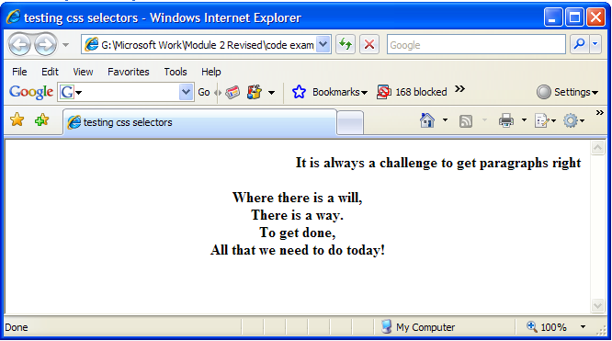
Here’s another example:
Even though it is highly desirable for the fonts to be consistent on a Web site, there are occasions when it is appropriate to have a unique appearance. By using class selectors, CSS allows the use of different formats for the same tag. For a colorful page, the author may want some paragraphs with red letters, some with blue fonts, and others with white lettering.
Three class selectors would be needed; each with a different color definition.
CSS File | HTML File Segment (with reference to associated .css file)
p.blue_text {color:blue}  p.red_text {color:red}  p.white_text color:white} | <p class="blue_text">blue font</p>  <p class="red_text">red font!</p>  <p class="white_text">white font</p>
Result:
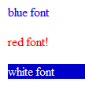
Some styles can be used with more than one HTML element or tag. In the following example, a class selector is defined without reference to a specific HTML tag, and then it is used in conjunction with a <b> element in a specific place in a Web page. The same style could be applied to a paragraph or heading tag.
Note that there is no tag name before the dot in the first line of code.
Syntax:
.classSelector
{
property: value
}
CSS File | HTML File (with reference to associated .css file)
.headline {  font-family:arial;  font-size:25px;  color:blue  } | <body>  <b class="headline">This is the headline class with the bold tag</b>  </body>
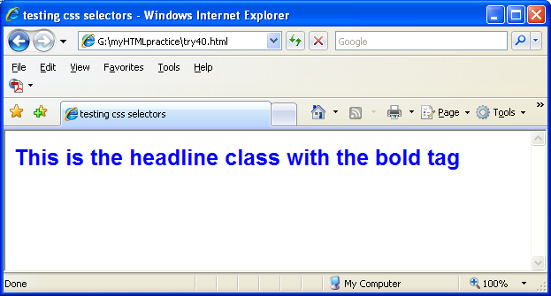
3. ID selector—defines style relating to objects having a unique user-assigned ID.
Syntax:
Note the # before the ID selector name.
#IDSelector{
property: value;
property: value;
}
The style rule matches an element that has an ID attribute with the value defined in the style. In the following example, the styles defined in the ID selector “top” will be applied to the <div> tag in the HTML code. Note how the style is referenced in the HTML code— id=“top”.

CSS File | HTML File (with reference to associated .css file)
#top  {  background-color:  #000099;  color: #FFFFFF  } | <body> …  <div id="top">  <h2>  One for the money,<br>  Two for the show<br>  Three to get ready,<br>  And four to GO!  </h2>  </div>  </body>
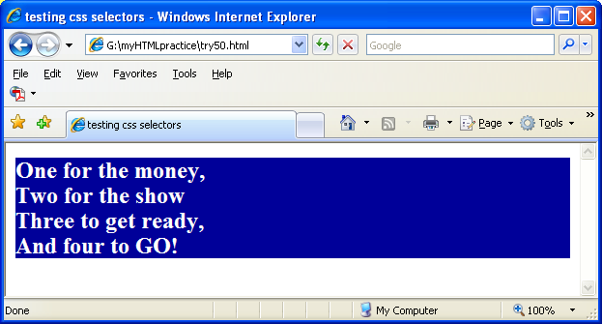

Inserting Style Sheets
When a page is rendered in a browser window, the browser reads any associated style sheet and formats the display accordingly. There are three ways to apply a style sheet to an HTML document.

External Style Sheets
When a designer creates a site with multiple pages, an external style sheet is the perfect solution. All of the style definitions are saved in a separate text file and “linked” to each page in the Web site. Styles can be easily changed for all of the pages by simply changing the style definitions in the one external style sheet document.
The link tag that applies the external style sheet to the Web page goes inside the head section of the HTML code.
<link rel="stylesheet" type="text/css" href="myStyle.css">
The browser reads the style definitions from the file mystyle.css and creates the Web page accordingly.
Create the following Web page display in two easy steps.
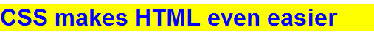
1. Define the style in the HTML h1 tag selector in the .css file. Enter the following code into a text document. Save as myStyle.css.
h1 {
color: blue;
font-family: Arial, Helvetica, sans-serif;
background-color: yellow;
}
2. Create another text document and enter the following HTML code.
<html>
<head>
<link rel="stylesheet" type="text/css" href="myStyle.css">
</head>
<body>
<h1>CSS makes HTML even easier</h1>
</body>
</html>
The font family of sans serif was chosen because it is usually the easiest to read. Fonts are either serif or sans (without) serif. Serif fonts have small lines in characters at the end of each stroke.
Many new Web designers often use the fancy fonts found on their own computer. But unless viewers also have the specified fonts on their computers, the text will not appear as intended.
There are many properties and values that can be used to modify a font style; font-size, font-style, font-weight, and font-variant are just a few of them. Fortunately, most have been designed to be easily interpreted and remembered.

Internal Style Sheets
Internal Style sheets are used to create a unique style on a single document. Internal styles are defined within the <head> section of the HTML file using the <style> tag.
Syntax:
<style type="text/css">give all declarations here</style>
Create the same Web page as in the previous exercise using the following instructions.
1. Create another text document and enter the following HTML code.
<html>
<head>
<style type="text/css">
h1 {
color: blue;
font-family: Arial, Helvetica, sans-serif;
background-color: yellow;
}
</style>
</head>
<body>
<h1>CSS makes HTML even easier</h1>
</body>
</html>

Inline Styles
Inline styles sacrifice many of the advantages of external and internal style sheets. They should be used sparingly and only when it is important to override a style defined within other style sheets. You will recall from the earlier discussion of cascading that inline styles have the highest priority and will override styles defined by other style sheets.
Create the same Web page as in the previous exercise using the following instructions.
1. Create another text document and enter the following HTML code.
<html>
<body>
<h1 style="color: blue;font-family: Arial, Helvetica, sans-serif; background-color: yellow">
CSS makes HTML even easier
</h1>
</body>
</html>
You can learn more about CSS at http://www.w3schools.com/css/.

Standards and Accessibility
The World Wide Web Consortium’s stated purpose is “To lead the World Wide Web to its full potential by developing protocols and guidelines that ensure long-term growth for the Web.” The W3C has the responsibility to set standards to ensure uniformity and accessibility across the Web. Many organizations from around the world have contributed to the work of the W3C.
HTML standards are established by the W3C and, like most computer software releases, HTML is numbered sequentially as new versions and sets of standards are accepted. HTML 4.0 is the current set of standards, but HTML 5.0 is in development.
The W3C also establishes accessibility standards to ensure that everyone has opportunities to participate in the Web. The accessibility standards are based upon the notion of providing clear, complete, and simple language and design in such a way that people who have communication disabilities such as blindness or those who have cognitive disabilities, or for whom the Web site language is not the user’s first language, can fully participate. You can learn more about the W3C accessibility standards at http://www.sitepoint.com/article/w3c-accessibility-guidelines.
The W3C Web page at http://www.w3.org/ contains information about this organization and many resources for Web designers.

Chapter Summary
Now that the simplest HTML code has been presented, the reader should be ready to begin creating Web pages. Tags and attributes form the basis of Web pages. Special characters allow the designer to include symbols that are not on the keyboard or that may cause unpredictable results when rendered in the browser. Color can make a page attractive and help organize the information. Hyperlinks give pages the power that is the very essence of the Web. Tables and lists organize information. CSS is a powerful tool for creating attractive and consistently-styled Web sites.

Review Questions
1. How do computers connected to the Internet locate a Web page?
2. T/F: If additional comments are added to the HTML code, the browser will render the page more slowly.
3. How are HTML tags used and what is their basic form?
4. Name the three colors used to create the display on a computer monitor.
5. Write a line of code that would display the words “Hello Dolly” in italics and underlined.
6. Use heading tags to create an approximation of the following:
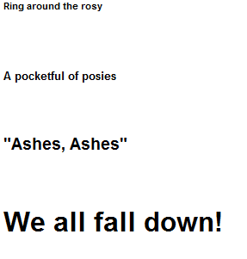
7. Explain the difference between an unordered and ordered list.
8. List three purposes for hyperlinks.
9. Assume you have a picture 100 x 100 called me.gif. Create a hyperlink to http://www.myspace.com/zzzzme when the user clicks on the picture. Include an ALT attribute.
10. How are selectors used in creating styles?
11. List the three types of CSS selectors.
12. List three locations where styles can be defined.
13. List several functions of the W3C organization.

Essential Vocabulary
Attributes – Additional information about an HTML tag. For example: In the body tag, the bgcolor is an attribute: <body bgcolor = "#ff0000">.
(To) code – To create an HTML file or other computer program by entering specific syntax into a file.
CSS – Cascading style sheets contain the selectors needed for formatting the style of a Web page.
Deprecated – Refers to a Web design technique that is obsolescent or has been replaced by another technique often due to accessibility reasons.
Element – One component of an HTML document (such as paragraph, image, or link), including one or two tags, as well as attributes and content, if any.
Em – In typography, was equal to the size of a capital M. Its use has become more common as it is a relative measurement and the W3C best practices recommendations dictates that Web pages be based on scalable designs.
Format – The design and layout of a page.
Hexadecimal – A numbering system based upon having 16 different symbols to represent numbers 0 … 9, A, B, C, D, E, F.
HTML – HyperText Markup Language—one publishing language of the World Wide Web.
RGB – An acronym for red, green, and blue, representing the three colors of light that make up all the other colors. An RGB representation of a color is a collection of three numbers (each in the range 0–255) representing how much red, green, and blue are present in the color.
Render – The process of reading tags and attributes from an HTML file, interpreting them, and displaying the resulting Web page.
Source code – The HTML code that creates a Web page.
Tags – Codes in HTML provide details to the browser on how to display a Web page, such as begin the body, start a paragraph, or modify the appearance of text and other elements.
W3C – World Wide Web Consortium, the organization responsible for Web standards, including HTML and accessibility.
Web page – A file written in HTML, or other Web publishing language, that can be rendered by a browser and posted on the Internet.
Web site – A collection of Web pages linked together on a server that creates a unified presence.
White space – Extra spaces, tabs, or blank lines placed in an HTML file, which the browser ignores, but make the source code more readable. White space can also refer to the empty space around elements on a Web page or other document that makes it more readable.

A Summary of HTML Tags and Attributes
Lesson | Element Tags | Description and Notes
 | <!Doctype…> | First thing in the document, tells what version of HTML or other language is being adhered to
1 | <!-- Comment --> | Example of a comment
1 | <html>…</html> | Indicates the page is written in HTML(first and last tags on a page, other than comments)
1 | <head>…</head> | Contains information about the page
1 | <title>…</title> | Displays the title at the top of the window. Always goes inside the HEAD element
1 | <body>…</body> | Indicates the body section
1 | <b>…</b> | Bold (deprecated)
1 | <strong>…</strong> | Strong or bold; represents importance
1 | <u>…</u> | Underline
1 | <i>…</i> | Italic (deprecated)
1 | <em>…</em> | Emphasis or italics
 | <sub>…</sub> | Subscript
 | <sup>…</sup> | Superscript
1 | <p>…</p> | Paragraph or paragraph break (A blank line is automatically inserted between paragraphs.)  Note: Most browsers accept <p> as a paragraph break, without an associated end tag, but the end tag is recommended by W3C.
1 | <br> | Line break (By default, no blank line is inserted after a <br> tag, unlike with a paragraph break.)
1 | <br/> | Note: <br/> is an alternative form of <br>; it is not a closing tag.
2 | <hr> | Creates a horizontal rule
2 | hr width=X% size=N color=#YYYYYY | Creates a horizontal rule with a width of X%, a size of some integer. and the color of the line is defined by a hexadecimal code.

2 & 3 | <body background ="img.jpg" | Uses a picture as the background (requires location of the picture)
2 & 3 | bgcolor=#xxxxxx | Background color of the page
2 & 3 | Text=#xxxxxx | Color of the text
2 & 3 | Link=#xxxxxx | Color of the hyperlinks that have not yet been followed
2 & 3 | Vlink=#xxxxxx | Color of the hyperlinks that have been followed
2 & 3 | Alink=#xxxxxx> | Color of the links while you are clicking on them
3 | <img src="pic1.jpg" height=xx | Inserts the image at the location pic1.jpg
3 | Width=xx | Defines the size of the image as xx pixels high and xx pixels wide
3 | alt="My Picture"> | Creates a alt tag of My Picture
3 | <a href="URL of a Web page">text</a> | Hyperlink using text as a link
3 | <a href="URL of a Web page"><img scr=pic.jpg></a> | Hyperlink using an image as a link
3 | <a href="URL of a Web page" target="_blank">text</a> | Hyperlink using text as a link and opens the Web page in a new window
3 | <embed name="Heirloom" | Plays a music file named Heirloom
3 | src="C:\Documents and Settings\Owner.FAMILYROOM\My Documents\My Music\Heirloom.mp3" | Defines the place where the music file can be found on the computer
3 | width=xx  height=xx | Places a player with a size of xx pixels wide and xx pixels high on the screen
3 | loop=false | Plays the file once
3 | autostart=true>  </embed> | Requires the viewer to press play to start the music
8 | <ul>…</ul> | unordered list – heading for bulleted list
8 | <ol>…</ol> | ordered list – heading for numbered list
8 | <li>…</li> | list item – bulleted/numbered item (indented)
8 | <dl>…</dl> | definition list – definition list
8 | <dt>…</dt> | definition term – word to be defined
8 | <dd>…</dd> | definition description – definition (indented)

Ext | <table border=3 | Table with border of 3
Ext | width=50% | Extends the table to 50% of the Web page
Ext | align=center>… | Centers the table on the Web page
Ext | </table> | Ends the table
Ext | <tr>…</tr> | Defines a table row
Ext | <td align=right | Defines table data, right alignment in the cell
Ext | rowspan=2 | Creates a cell 2 rows wide
Ext | colspan=3>… | Creates a cell 3 columns high
Ext | </td> | Ends the table data

For Instructors
File name T.2.Text
The goals in this module are to introduce basic HTML tags and CSS through projects designed to experiment with page design and to introduce the concepts of Web standards.

Topics
1. Web page structure
a. Block and inline formatting
2. Tags and attributes
a. Headline Styles
b. Color
c. Images
d. Lists and tables
e. Hyperlinks
f. Troubleshooting and debugging
3. Introduction of cascading style sheets (CSS)
4. Standards and accessibility
a. W3C - World Wide Web Consortium

Learning Objectives
1. Explore the code that creates Web pages.
2. Create pages with images, links, and other controls.
3. Investigate the development of Web standards.
4. Apply standards to simply projects.
5. Explore CSS and other Web design/development concepts.

NETS-S
1. | Creativity and Innovation
 | Students demonstrate creative thinking, construct knowledge, and develop innovative products and processes using technology. Students:
  a. | apply existing knowledge to generate new ideas, products, or processes.
4. | Critical Thinking, Problem Solving, and Decision Making
 | Students use critical thinking skills to plan and conduct research, manage projects, solve problems, and make informed decisions using appropriate digital tools and resources. Students:
  c. | collect and analyze data to identify solutions and/or make informed decisions.
6. | Technology Operations and Concepts
 | Students demonstrate a sound understanding of technology concepts, systems, and operations. Students:
a. | understand and use technology systems.
b. | select and use applications effectively and productively.
c. | troubleshoot systems and applications.
d. | transfer current knowledge to learning of new technologies.

21st Century Skills

Learning and Innovation Skills
Critical Thinking and Problem Solving Skills
- Understanding the interconnections among systems
- Identifying and asking significant questions that clarify various points of view and lead to better solutions
- Framing, analyzing and synthesizing information in order to solve problems and answer questions
Communication and Collaboration Skills
- Articulating thoughts and ideas clearly and effectively through speaking and writing

Information, Media and Technology Skills
Information Literacy
- Accessing information efficiently and effectively, evaluating information critically and competently and using information accurately and creatively for the issue or problem at hand
Media Literacy
- Understanding how media messages are constructed, for what purposes and using which tools, characteristics and conventions.
ICT Literacy
- Using digital technology, communication tools and/or networks appropriately to access, manage, integrate, evaluate, and create information in order to function in a knowledge economy
- Using technology as a tool to research, organize, evaluate and communicate information, and the possession of a fundamental understanding of the ethical/legal issues surrounding the access and use of information

Review Questions with Answers
1. What enables other computers on the Internet to locate a Web page?
Answer
URL – the Uniform Resource Locator ensures each page has a unique ID.
2. T/F: If more comments are added to the HTML code, the browser will render the page more slowly.
Answer
False, the browser ignores comments. They are only there to explain the code to the viewer of the source code.
3. How are HTML tags used and what do they look like?
Answer
A tag is used in the HTML document to tell the Web browser how to display the page. Tags are displayed in angle brackets and usually have a beginning and ending tag.
4. What are the primary colors displayed on the computer screen?
Answer
The primary colors are red, green, and blue. There are 256 different combinations of each.
5. Write a line of code that would display the words “Hello Dolly” in italics and underlined.
Answer
<u><i> Hello Dolly</i></u>
6. Using heading tags, create the following:
Answer
<h6>Ring around the rosy</h6><br>
<h5>A pocketful of posies</h5><br>
<h3>"Ashes, Ashes"</h3><br>
<h1>We all fall down!</h1><br>
Other answers may be acceptable.
7. Explain the difference between an unordered and ordered list.
Answer
Although both use <li> for the items, an unordered list <ul> is preceded by bullets. An ordered list <ol> is automatically numbered beginning with 1. The values at the beginning of each item in an ordered list can be styled for numbers or letters.
8. List three purposes for hyperlinks.
Answer
A hyperlink allows the user to open another page within the same Web page or another Web site, or move to another point within the same page. An example would be:
<a href= "zzzStuff.com">Go to Stuff page</a>.
9. Assume you have a picture 100 x 100 called my.gif. Create a hyperlink to http://www.myspace.com/zzzzme when the user clicks on the picture. Include an ALT tag.
Answer
<a href=http://www.myspace.com/zzzzme><img src="my.gif" height =100 width =100 alt ="picture of me">
10. How are selectors used in creating styles?
Answer
CSS uses selectors to "select" elements on an HTML page so that they can be given a style.
11. List the three types of CSS selectors.
Answer
HTML tag selectors, class selectors, and ID selectors

