First copy The GreenWich Folder from CD to
C:\Inetpub\wwwroot folder…
→Right click on Greenwich folder in wwwroot and select properties..
→Deselect the Readonly Check box …

→ open U R Folder and DblClick on GreenWich file to open the project..
→ Now open SolutionExplorer and Open the Class1.cs file
Find out where is
Provider=Sqloledb.1;user id=sa;password=;database=Greenwich;Dta source=localhost

→Change user id= and password is need as per u r system.Change the Above Data source=U r servername..
→Save the project. And close project.

→ How to Restore SqlServer Database Backup ..?

Start with Sqlserver → Enterprise Manager…
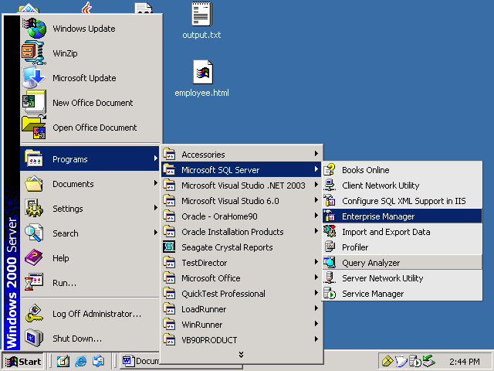

Expand all options Till found DataBases…option

Then Right click on DataBase and select All Tasks -> Restore DataBase...

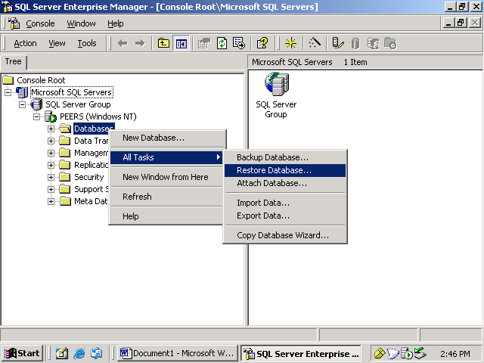

→ Enter Restore as database : GreenWich
→ Select the From Device radio button.
→Now click on Select Devices Button .. Bellow see the screen
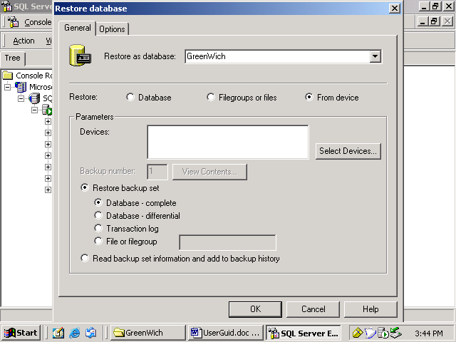

U will find the Bellow screen..
Click on the Add Button..
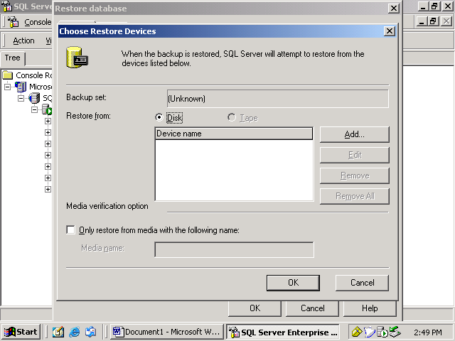

U find File name option..

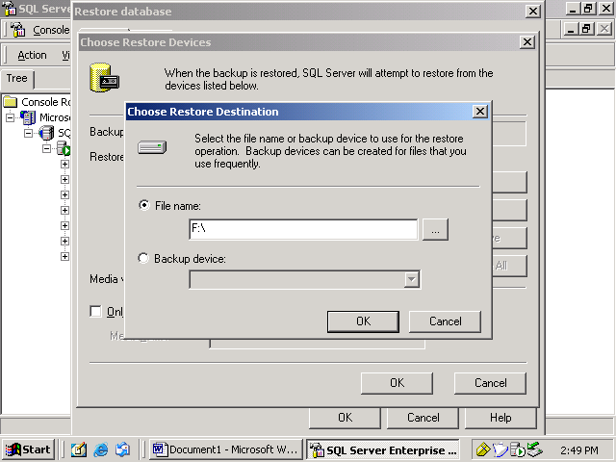
Click on that Dotted button.. and browse GreenWichDb_Back file…
GreenWich\SQLDB\Backup\GreenWichDb_backup
After Browse press Ok button ok button..
→ Now U came back to first location ..find above u have Options button click it..
on this bellow screen …
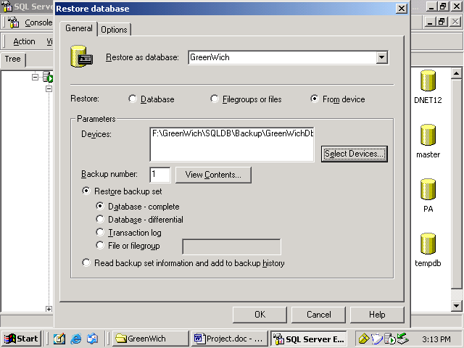
→ U can see now this bellow screen..
→ Change the database names.. on Move to physical column as bellow
1)Greenwich.ldb
2)Greenwich.mdf
See this bellow
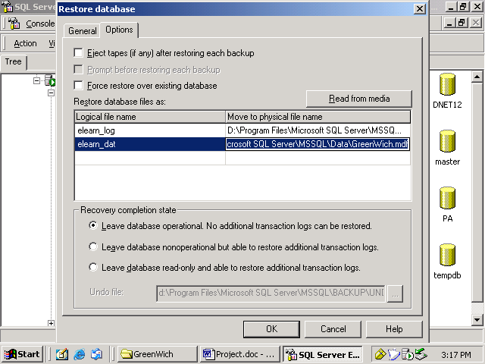
Now press ok.. U can see now
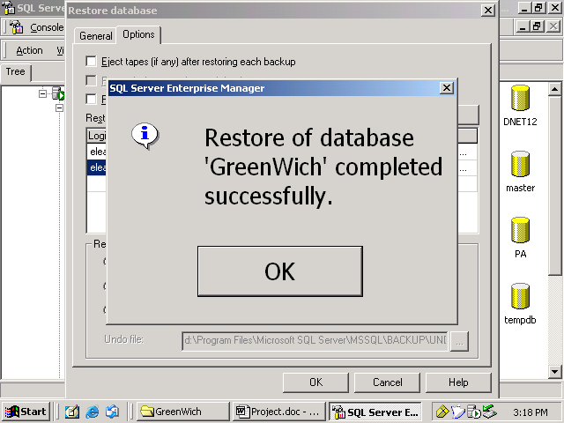
press ok..

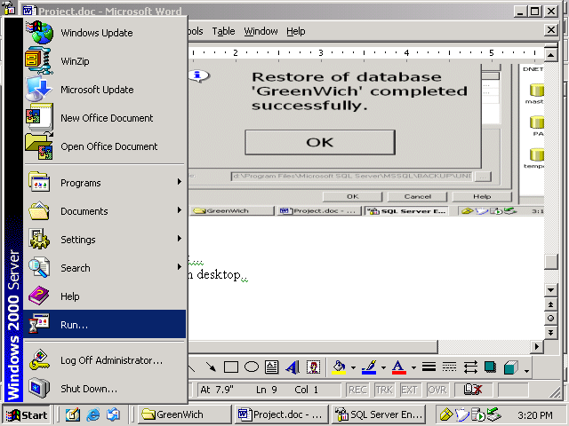

→ To Run the project ...
Select Start → Run on desktop..
Type on Open – inetmgr
Press ok..
Look this :
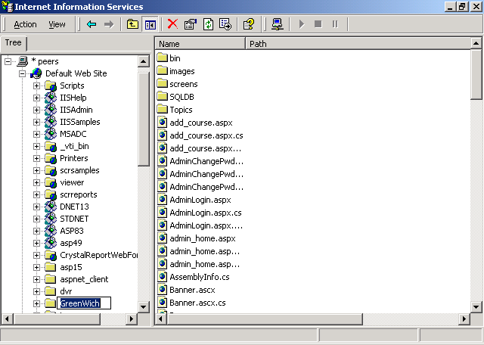
Select Greenwich..on rightside window u can see all files..
Right click on GreenWich folder in left side window..
And select properis…
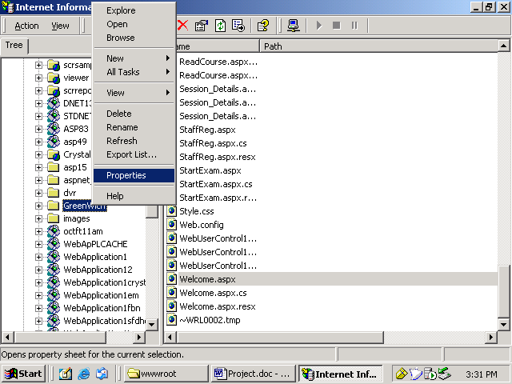
U will find this window..
→ click on create button and press ok at last…
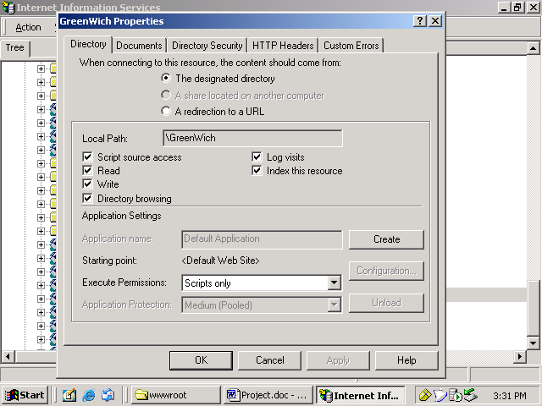

→ Now on right side window find the welcome.aspx file in the ending. Right click on it and select Browse….
