**NAME:RUBIANA JOSEPHINE PAUL**

**USN:1BM19CS208**

**USP LAB 5D**

**1)PROGRAM TO FIND IF A GIVEN YEAR IS LEAP OR NOT**

echo "Check whether the year is leap year or not"

read year

if test `expr $year % 4` -eq 0;

then

echo "Leap year"

else

echo "Not a leap year"

fi

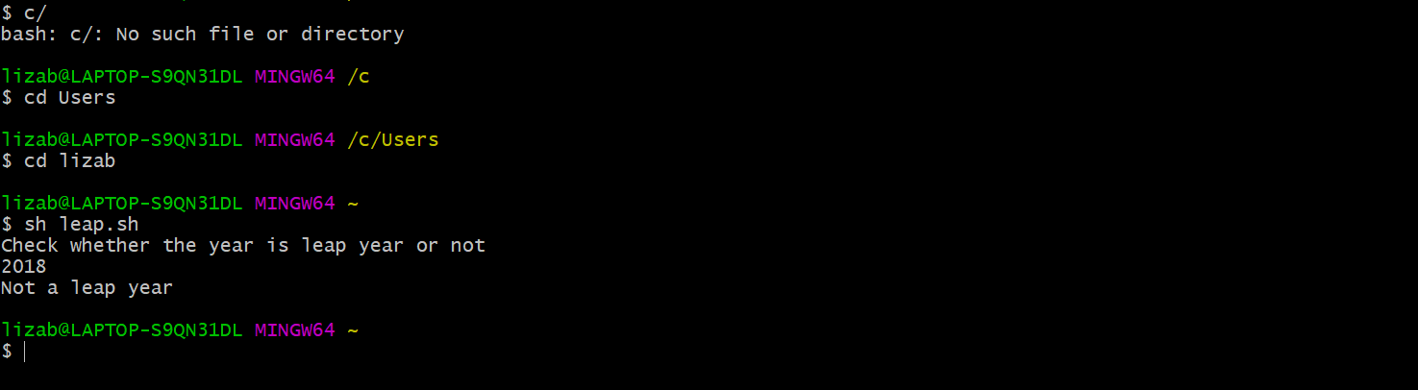

**2)PROGRAM TO FIND THE AREA OF A CIRCLE**

echo "Find the area of circle"

echo "Enter the radius"

read r

area=$(echo"scale=2; 3.14* $r* $r "| bc)

echo $area

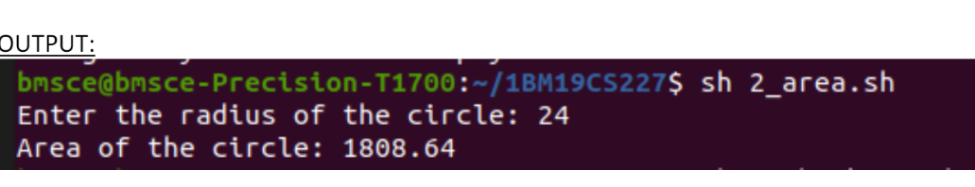

3)PROGRAM TO FIND IF THE NUMBER IS POSITIVE OR NEGATIVE

#!/bin/sh

read -p "Enter a number: " no

if [ $no -gt 0 ] ; then

echo "Given number is positive"

elif [ $no -lt 0 ] ; then

echo " Given number is negative"

else

echo "Given number is equal to zero"

fi



4)PROGRAM TO FIND THE LARGEST OF 3 NUMBERS

echo "enter n1"

read n1

echo "enter n2"

read n2

echo "enter n3"

read n3

if [$n1 -gt $n2] && [$n1 -gt $n3]

then

echo "n1 is the largest"

elif [$n2 -gt $n1] && [$n2 -gt $n3]

then

echo "n2 is the largest"

else

echo "n3 is largest"

fi



5)PROGRAM TO FIND THE FACTORAL OF A NUMBER

read -p "Enter a number: " n

fact=1

i=1

while [ $i -le $n ]

do

fact=$(($i*$fact))

i=$(($i+1))

done

echo "Factorial of $n is : $fact"

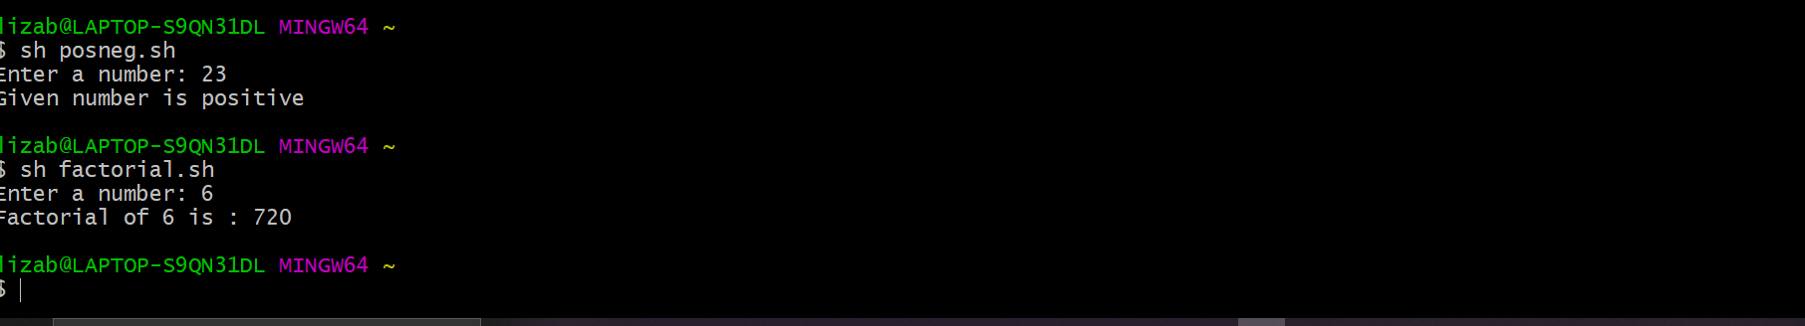

6)PROGRAM TO FIND THE CELSIUS TEMPERATURE OF A GIVEN FAHRENHEIT TEMPERATURE

#!/bin/sh

echo "Read the temperature in Fahrenheit: "

read f

v1=$( echo "$f - 32" | bc )

c=$( echo "$v1 * 0.55555" | bc )

echo "Temp in Celsius: = $c"

7)PROGRAM TO PERFORM ARITHMETIC OPERATIONS

#!/bin/sh

echo "enter 2 nos"

read a b

echo "1.Add

2.Subtract

3.Multiply

4.Divide

5.Remainder"

echo "Enter your choice"

read ch

case $ch in

1) echo "Addition-->" `expr $a "+" $b`;;

2) echo "Subtaction-->" `expr $a "-" $b`;;

3) echo "Multiplication-->" `expr $a "*" $b`;;

4) echo "Divide-->" `expr $a "/" $b`;;

5) echo "Remainder-->" `expr $a "%" $b`;;

*) echo "Invalid option"

esac

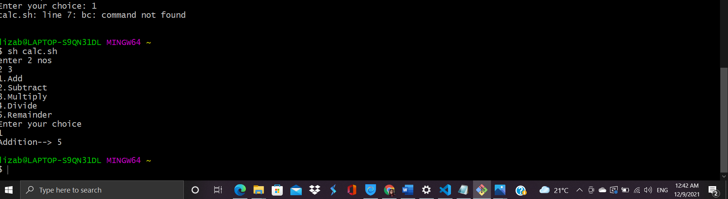

8) PROGRAM TO FIND THE BASIC SALARY

read -p "Enter the basic salary: " basic

da=$(echo "0.1*$basic"|bc)

hra=$(echo "0.2*$basic"|bc)

gross=$(echo "$basic+$da+$hra"|bc)

echo "Gross Salary of the employee is: $gross"

9.1)PROGRAM TO FIND THE SUM OF EVEN NUMBERS USING WHILE LOOP

read -p "Enter the value of n: " n

i=2

sum=0

while [ $i -lt $n ]

do

sum=$(($sum+$i))

i=$(($i+2))

done

echo "The sum of even numbers upto $n is : $sum"

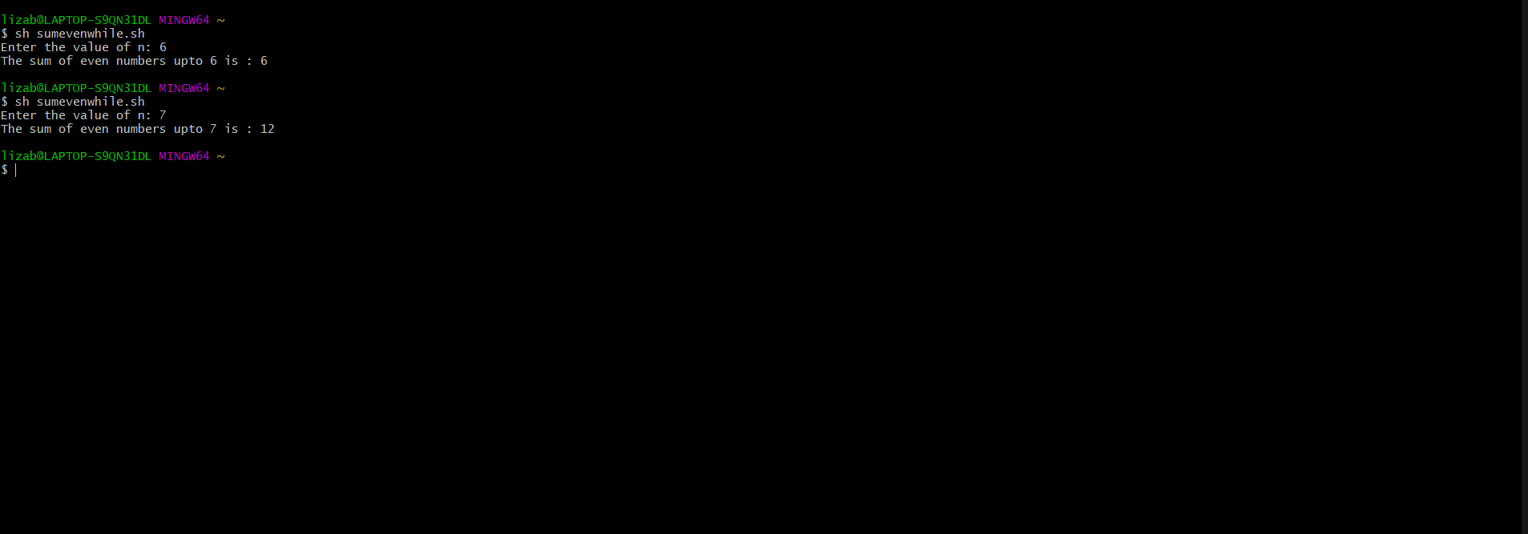

9.2)PROGRAM TO FIND THE SUM OF EVEN NUMBERS USING FOR LOOP

read -p "Enter a number: " n

sum=0

for (( i=2; i<$n; i=i+2 ))

do

sum=$((sum+i))

done

echo "The sum of even numbers upto $n is: $sum"

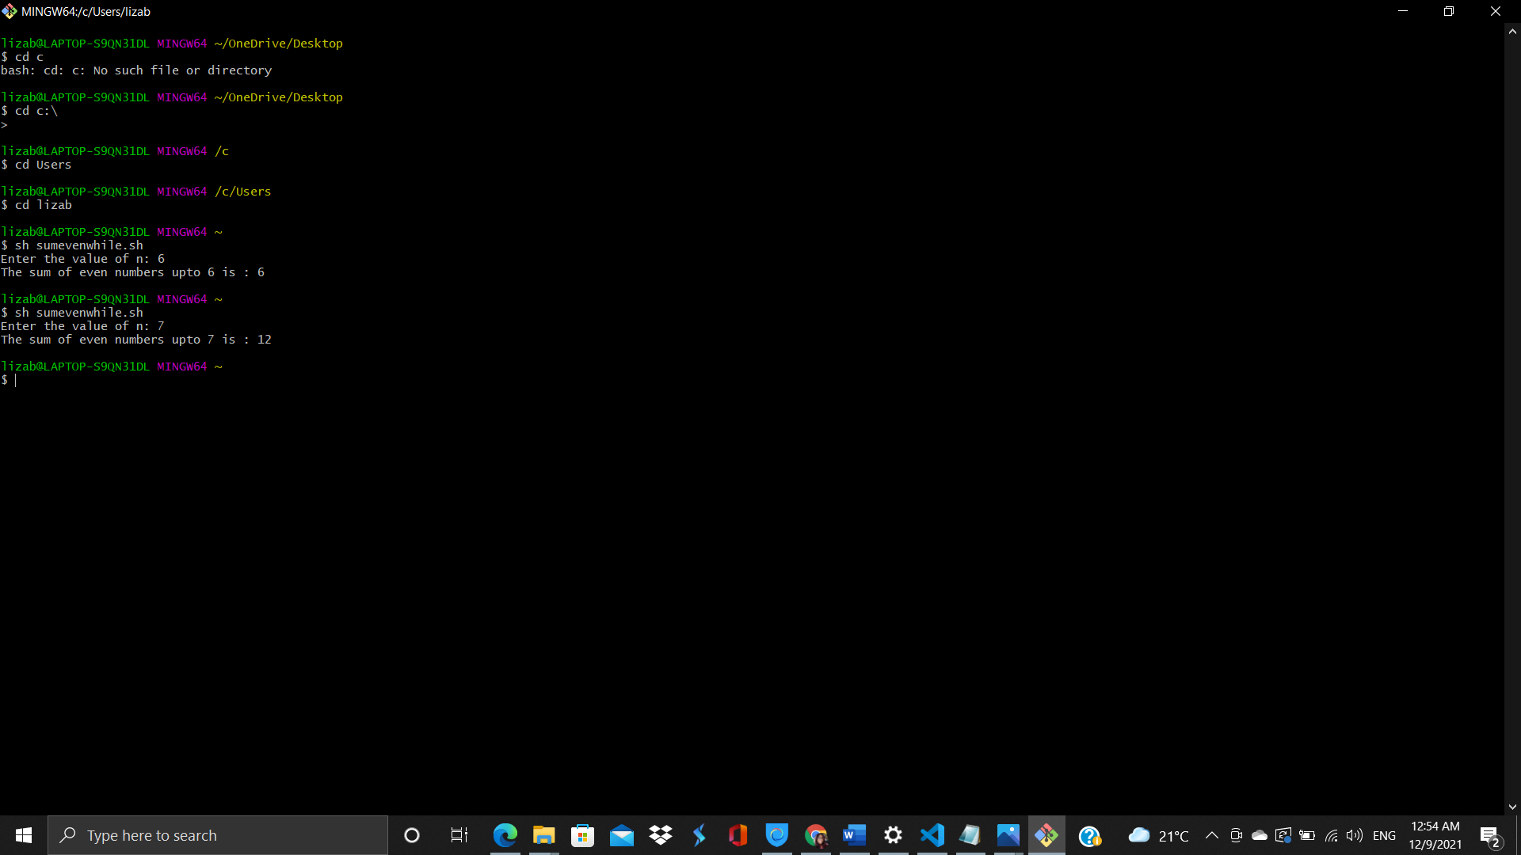

10)PROGRAM TO FIND THE COMBNATIONS

for i in 1 2 3

do

for j in 1 2 3

do

for k in 1 2 3

do

echo $i $j $k

done

done

done

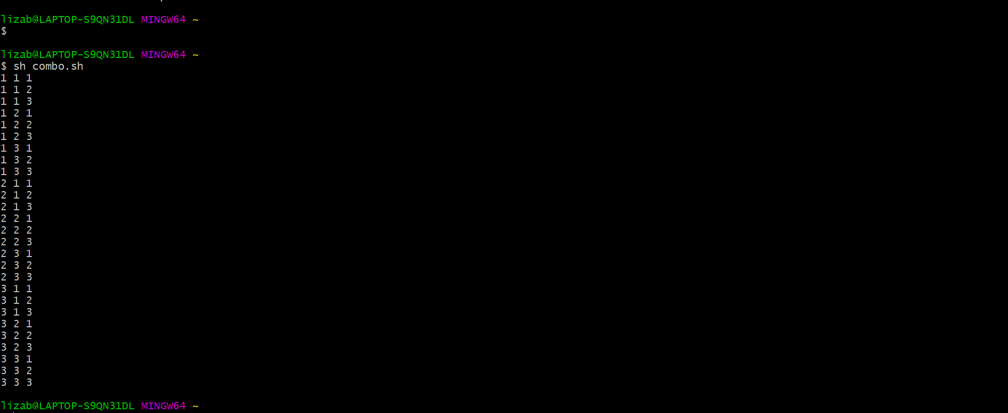

11)PROGRAM TO FIND THE POWER OF A NUMBER

#!/bin/sh

read -p "Enter a number: " n

read -p "Enter a power: " pow

count=0

res=1

while [ $pow -ne $count ]

do

res=$((res * $n))

count=$((count+1))

done

echo "$n raised to the power $pow is : $res"

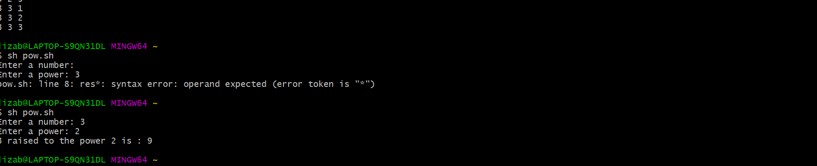

12.1) Shell script to find the sum of n natural numbers (using while loop)

read -p "Enter a number: " n

sum=0

for (( i=1; i<=$n; i++ ))

do

sum=$((sum+i))

done

echo "The sum of $n natural numbers is: $sum"

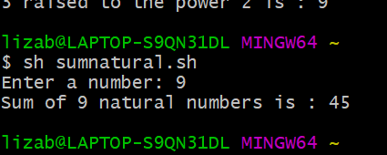

12.2)PROGRAM TO PRINT THE SUM OF N NATURAL NUMBERS(FOR LOOP)

read -p "Enter a number: " n

sum=0

for (( i=1; i<=$n; i++ ))

do

sum=$((sum+i))

done

echo "The sum of $n natural numbers is: $sum"

