Royston Centre Layout

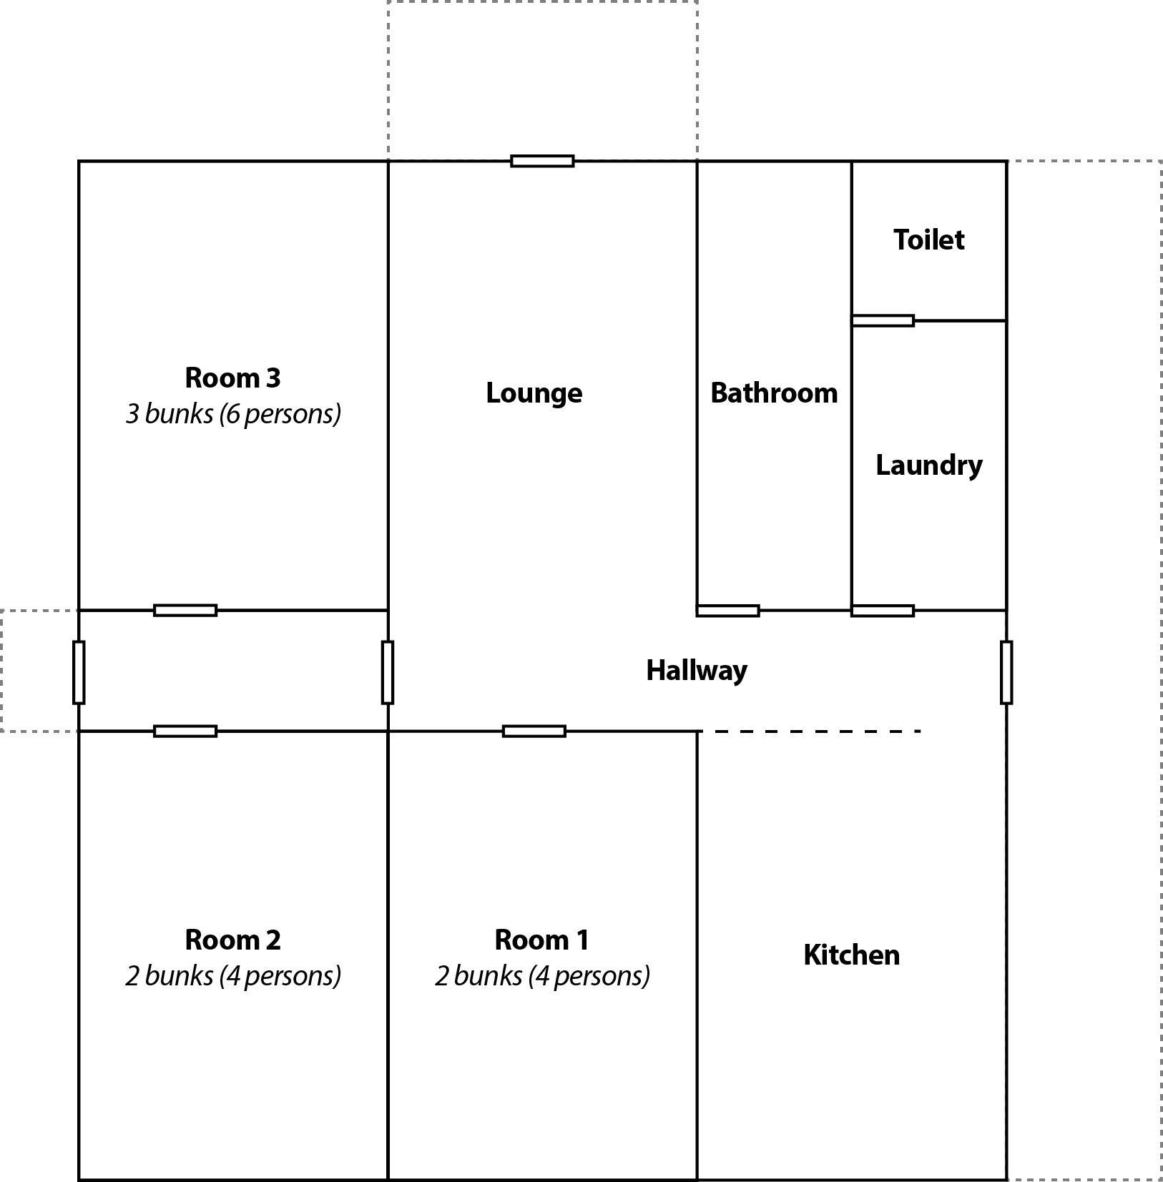

Total beds: 14
BYO food and linen

