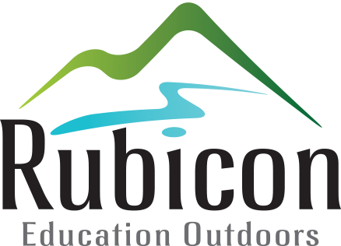

PRIVATE BOOKINGS

BOOKING INFORMATION

Group Name: |  | Contact Person:
Phone Number: |  | Email:
Address:
Arrival Date: |  | Departure Date:
Arrival Time: |  | Departure Time:

SERVICES REQUESTED

Accommodation (including dining room and kitchen)
Number of Adults ($28 each): |  | Number of Children ($20 each):

Facility Only

Dining Room/Kitchen ($300): | Yes / No | Conference Room ($40 per hour): | hours

Catering can be negotiated (minimum of 20 persons).

Activities (three hour sessions)
Canoeing ($60 per person): |  | (12 years and over—minimum of $420)
Rock Climbing ($60 per person): |  | (8 years and over—minimum of $420)
Mountain Bikes ($60 per person): |  | (12 years and over—minimum of $420)
High Ropes ($60 per person): |  | (8 years and over—minimum of $420)
Rafting ($100 per person): |  | (12 years and over—minimum of $600)

Note:
- Activities must be pre-arranged.
- Participants must be competent swimmers to take part in Canoeing or Rafting.
- All activities provided will be led by a Rubicon trained activity leader.
- Rubicon reserves the right to cancel or vary activities for any reason whatsoever.

DISCLAIMER: All activities involve some degree of risk. Participants will be required to sign a waiver before participating.

PUBLIC LIABILITY INSURANCE
Commercial or for-profit groups and unincorporated sporting groups must hold current Public Liability Insurance for the duration of the booking. A current Certificate of Insurance must be provided prior to your arrival.

Your booking is not confirmed until this form together with a deposit of $250 is received at least four weeks prior to your arrival (unless otherwise arranged).

Balance due and payable on invoice.

