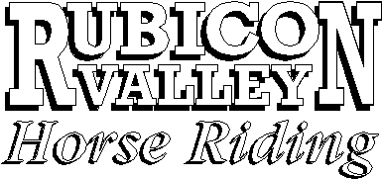
90 Rubicon Rd Thornton, Vic 3712

Release and Waiver of Liability

HORSE RIDING IS A DANGEROUS ACTIVITY

I understand and acknowledge that horse riding is a dangerous activity and that horses can act in a sudden and unpredictable (changeable) way, especially if frightened or hurt.

I understand and acknowledge that serious INJURY or DEATH may result from horse riding activities and in particular this ride/lesson. I agree that I RIDE at my OWN RISK.

I agree not to drink alcohol or take drugs prohibited by law before or during this ride.

Conduct
I agree to follow the directions of the ride leader/instructor and that any misconduct or refusal by me to follow any direction of the ride leader/instructor will result in the CANCELLATION of my riding fee and my immediate removal from my horse NO MATTER where that may occur.

I agree to wear a helmet during the lesson/ride.

Health
I am in good health and I have no physical disabilities )
OR ) Strike out whichever one is inappropriate
I have the following physical disabilities )

Name of rider and guardian (if under 18 years):
Address:
Phone: Date of birth: Occupation:

Riding experience (tick where appropriate)

Very experienced Less than 50 hours riding experience
Never ridden Less than 20 hours riding experience

Details of riding experience:

Effect of this Document
I understand that my signature to this document constitutes a complete and unconditional release of all liability of the proprietors of Rubicon Valley Horse Riding
To the greatest extent allowed by law in the event of me and/or the children under my care, suffering injury or death.

Dated: / / Signature of rider/guardian

Duty of Proprietors of
The proprietors of will exercise due care and skill in providing each rider with a suitable horse and will conduct the ride keeping in mind the welfare and safety of the rider (Section 74 Trade Practices Act).

