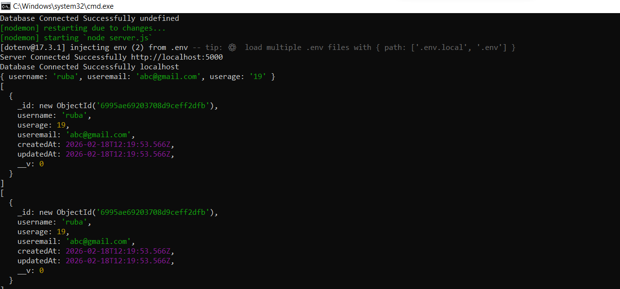
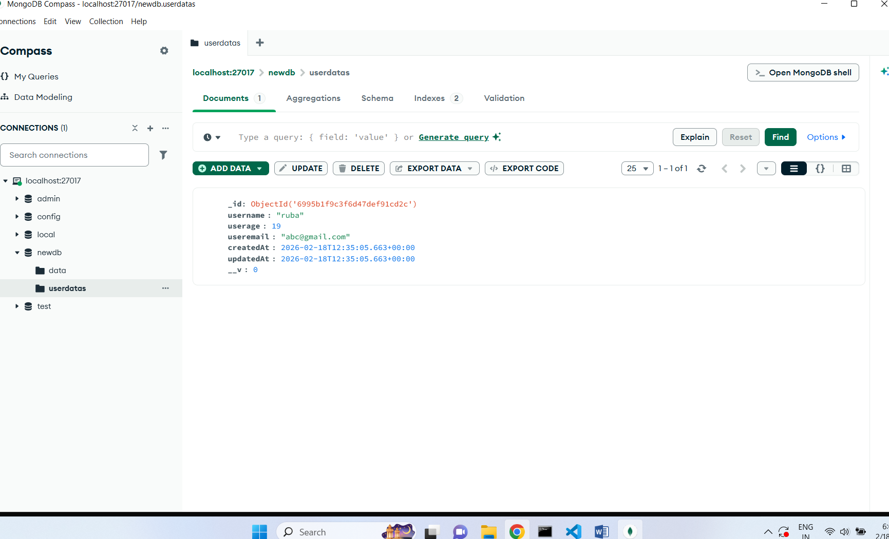

1️. Explain DB Connection Process

1.How MongoDB connects locally
MONGO_URL=mongodb://localhost:27017/myDatabase
It means:
- mongodb:// → protocol
- localhost → your computer
- 27017 → default MongoDB port
- myDatabase → database name
- When MongoDB server is running (mongod), it listens on port 27017.
Your Node app connects to that running MongoDB service.

2. What mongoose.connect() does?
await mongoose.connect(process.env.MONGO_URL)
Internally it:
- Parses the connection string
- Creates a connection pool
- Authenticates (if credentials exist)
- Connects to the database
- Returns a connection object
Without this → your app cannot talk to MongoDB.
3. Why we use async/await with try-catch
We use async await because DB connection takes time.
We use try catch because connection can fail:
- MongoDB not running
- Wrong URL
- Wrong password
- Network issue
Without try-catch → app crashes.
4. What happens if DB connection fails
If connection fails:
- mongoose.connect() throws error
- catch block runs
- If not handled → app crashes
- Models won’t work
- Queries will fail

2. ORM Methods Understanding
create() - Inserts new document.
find() - Gets all documents.
findById() - Finds document using _id.
findByIdAndUpdate() - Finds and updates document.
findByIdAndDelete() - Deletes document by ID.
Mongoose is an ODM (Object Document Mapper).

3️ SQL vs MongoDB Mapping
Create a table comparison explaining:
- Database
- Table
- Row
- Column
- Primary Key
And write the MongoDB equivalent terms.
SQL Term | MongoDB Term
Database | Database
Table | Collection
Row | Document
Column | Field
Primary Key | _id (ObjectId)

4. Schema Reading Task
Given this schema:

{
name: { type: String, required: true },
role: { type: String, enum: ["admin", "manager"] },
age: { type: Number, default: 18 }
}

Explain:
1.What validations are applied?
- name
  - Must be String
  - Required (cannot be empty)
- role
  - Must be String
  - Must be either:
    - "admin"
    - "manager"
- age
  - Must be Number
  - If not provided → default = 18
2. What happens if role is "user"?
- Mongoose throws ValidationError:
- Because "user" is not inside enum list.
3.What happens if age is not provided?
Mongoose automatically sets age=18 because of default value.

5️. Model Understanding Task
1.What is the difference between Schema and Model?
Schema defines:
- Structure
- Data types
- Validations
- Default values
It is just a blueprint.
Model is a wrapper around schema.
Model allows you to:
- create()
- find()
- update()
- delete()
Schema = Design
Model = Working Tool
2.Why do we need model after defining schema?
schema is just a definition, not something that interacts with the database directly.
A Model is created from a schema and allows you to:
- Create documents
- Read documents
- Update documents
- Delete documents
3.What happens internally when we run mongoose.model()?
Mongoose:
- Creates a collection name (pluralized → users)
- Attaches schema to that collection
- Creates constructor function
- Enables query methods
- Registers model globally in Mongoose

