- Make the 4 route - req object using. body, params, query and headers

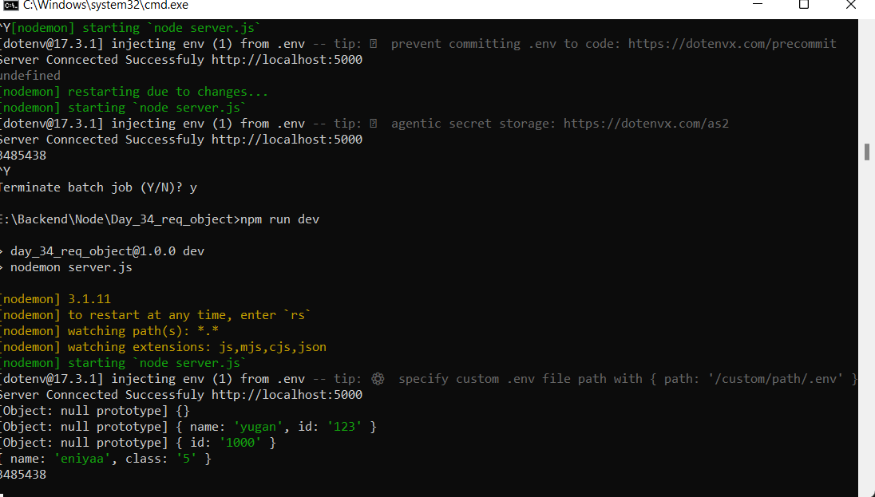

2.What is request object ?
In Express, the request object is written as req. It represents the HTTP request sent by the client and contains all information about that request. We use req when we need to get form data, get JSON data, read URL parameters, read query parameters, access headers, check authentication tokens, get request method or URL.
3. what is the use of body data's when we use?
Body data is used to receive data sent from the client (mostly in POST, PUT requests). It Used When we creating a new user, logging in, updating records and submitting forms.
4. what is the use of headers data's when we use?
Headers contain extra information about the request. It is used when we get authentication token, checking content type and reading custom headers.
5. what is the use of params data's when we use?
Params are route parameters (dynamic values in URL). It is used when we get user by ID, updating product by ID and deleting specific record.
6. what is the use of query data's when we use?
Query parameters come after ? in the URL. It is used when we searching, filtering, sorting and pagination.
7. what is request object when we use?
We use req when we need to get form data, get JSON data, read URL parameters, read query parameters, access headers, check authentication tokens, get request method or URL.

