- 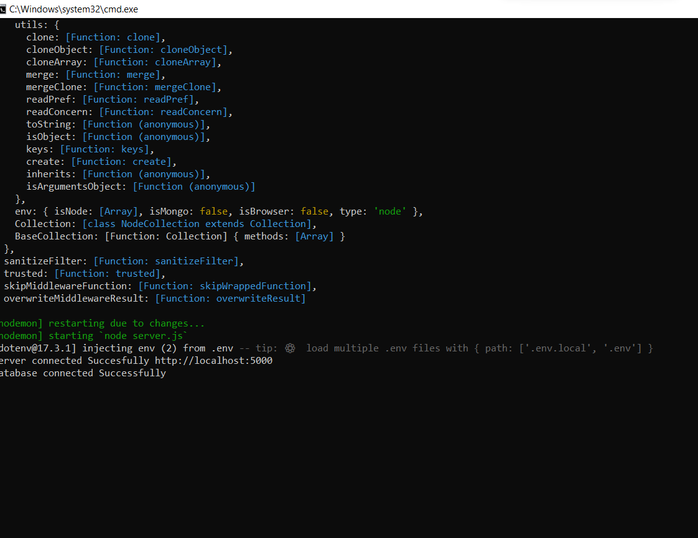

- What is Mongo Db? and what is mongo dB cluster?
MongoDB is a NoSQL database that stores data in a JSON-like format (BSON documents) instead of tables like traditional SQL databases.
- It is document-based
- It is schema-flexible
- It stores data in collections and documents
- what is ORM methods?
ORM = Object Relational Mapping. It is mainly used for SQL databases, not MongoDB. Since MongoDB is NoSQL (document-based), we use ODM instead of ORM. So in MongoDB projects, ORM is generally not used.
- what is ODM? why we use?
ODM stands for Object Document Mapping. ODM is a technique used to interact with MongoDB documents using objects in programming languages like JavaScript.
We use ODM because:
- It lets us define schemas
- It provides data validation
- It makes code cleaner and structured
- It simplifies database operations
- what is mongoose? why we use?
Mongoose is an ODM library for MongoDB in Node.js.
We use Mongoose to:
- Connect MongoDB with Node.js
- Create schemas
- Validate data
- Use built-in database methods
- Manage relationships
- what is DB?
DB stands for Database. A database is a system that stores and manages data. In MongoDB, a database contains collections and collections contain documents.

- What is the different between Sql and no sql ?

SQL | NoSQL (MongoDB)
Table-based | Document-based
Fixed schema | Flexible schema
Uses SQL queries | Uses JSON-like documents
Vertical scaling | Horizontal scaling
Example: MySQL | Example : MongoDB

- what is collections?
In MongoDB, a collection is a group of documents. It is similar to a table in SQL, but:
- It does not require a fixed structure
- Documents inside can have different fields
- what is document in mongodb?

A document is a single record in MongoDB. It is stored in JSON-like format (BSON).

10.what is compass? why we use?
MongoDB Compass is the official GUI tool for MongoDB.
We use it to:
- View databases and collections
- Insert, update, delete documents
- Run queries
- Analyze data visually

