1️. What is Response Object in Express?
In Express.js, the Response object represents the HTTP response that an Express app sends when it receives a request. It allows you to:
- Send data back to the client
- Set HTTP headers
- Set status codes
- Redirect to another route
2️. What are the different types/methods available in the Response Object?
res.send() | Sends a response (string, JSON, Buffer, HTML).
res.json() | Sends a JSON response.
res.status() | Sets the HTTP status code for the response.
res.sendFile() | Sends a file as the response.
res.redirect() | Redirects the client to a different URL.
res.set() | Sets HTTP headers.
res.end() | Ends the response without sending any data.

3️. How is the res object made available inside route handlers? Do we import it manually?
No, we do not import it manually. Express automatically passes it as the second parameter to route handler functions.
4️. What kind of data can be sent using the response object?
Respose object can sent data like text, html, json, files and buffers.
5️. What is the use of status codes in HTTP responses?
HTTP status codes indicate the result of the request.
They help the client understand what happened:
- Success
- Failure
- Redirect
6️. What is a status code? Explain with examples.
A status code is a 3-digit number sent by the server in the HTTP response.
- 200 OK → Request succeeded.
- 201 Created → Resource successfully created.
- 400 Bad Request → Client sent invalid data.
- 401 Unauthorized → Authentication required.
- 404 Not Found → Resource not found.
- 500 Internal Server Error → Server encountered an error.

7️. Create an API that runs on port 5000 and sends a response message “Success Done” when accessed.



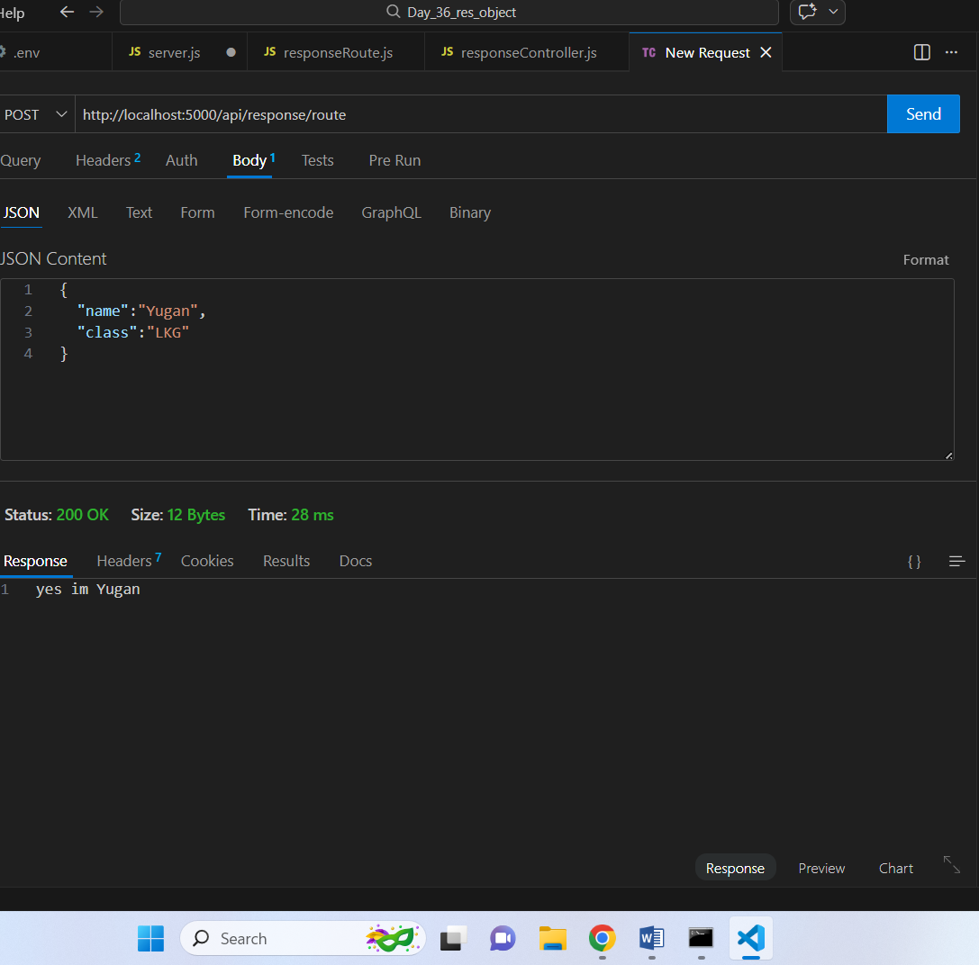

8️. Create an API that sends status code 201 and returns a message to the client.
