- Gender Clash

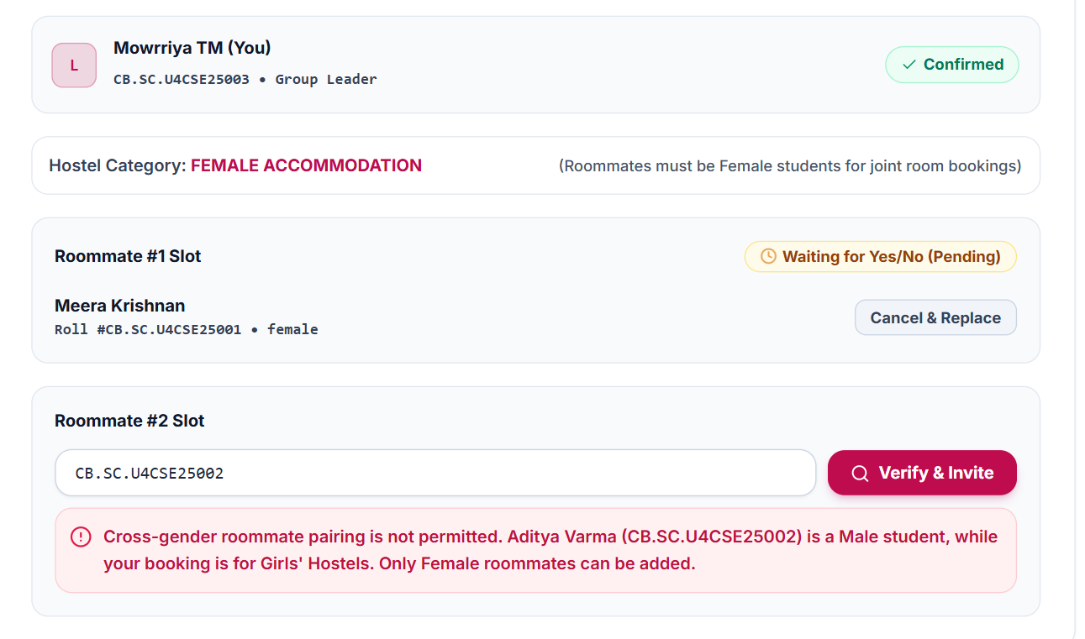
- Trying to book room while being part of a group
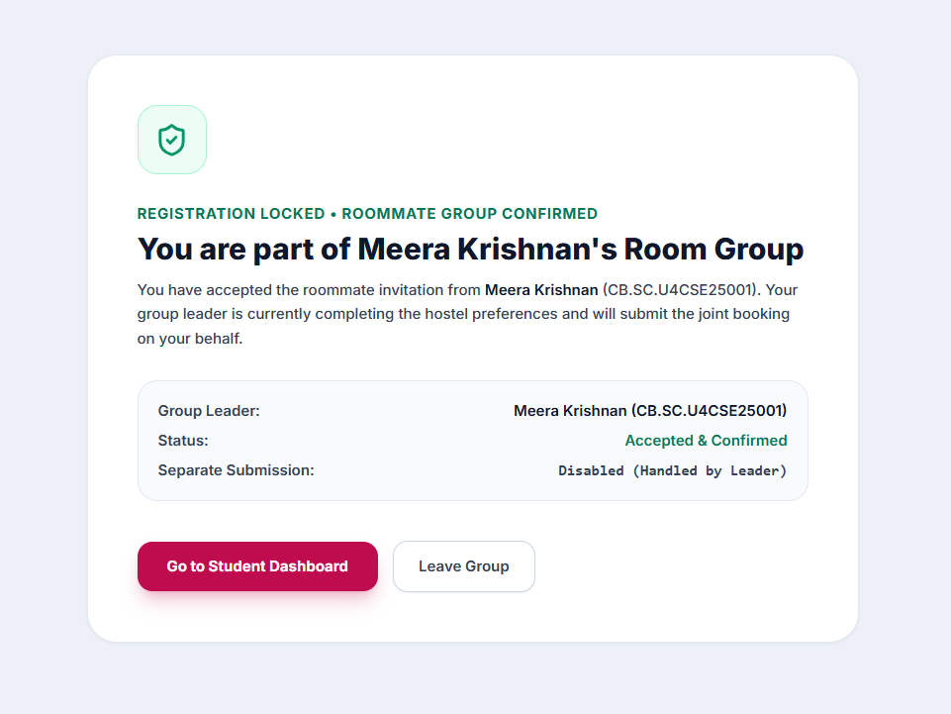
- Testing Priority Queue
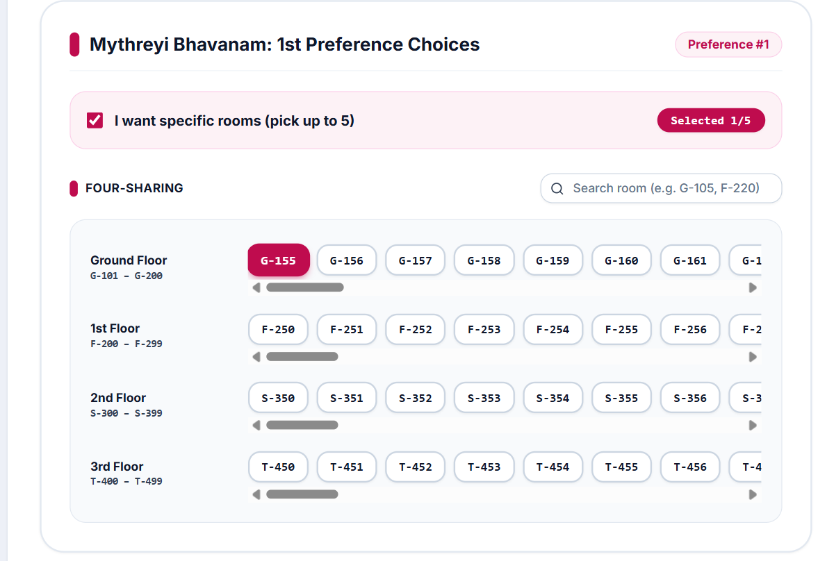
A 3 friend group chooses a specific 4 sharing room: G-155
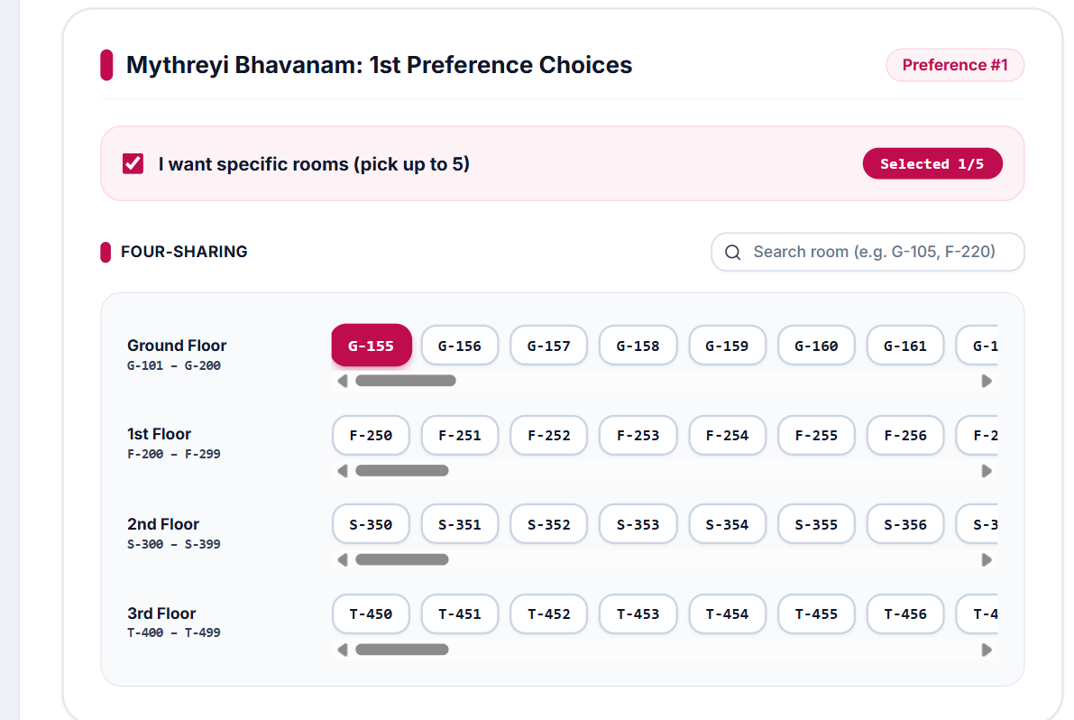
A 4 friend group now choose the same room as their first preference
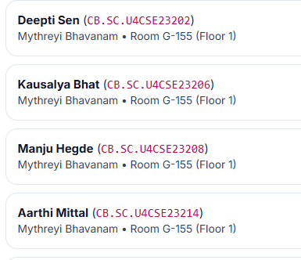
Priority is given to the 4 friend group(although they booked later) because that’s the most efficient way to allocate resource
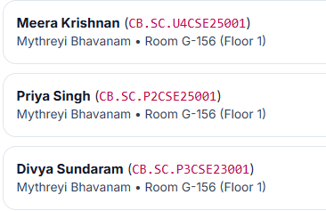
- Sharing between two clans
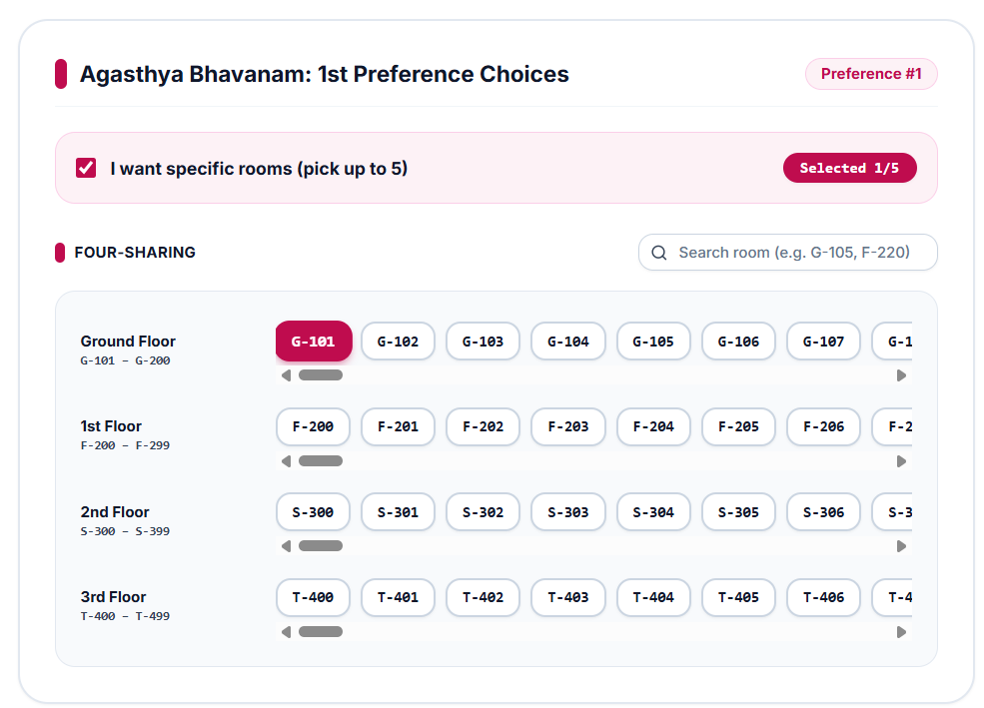
A single student who would like to occupy 4 sharing
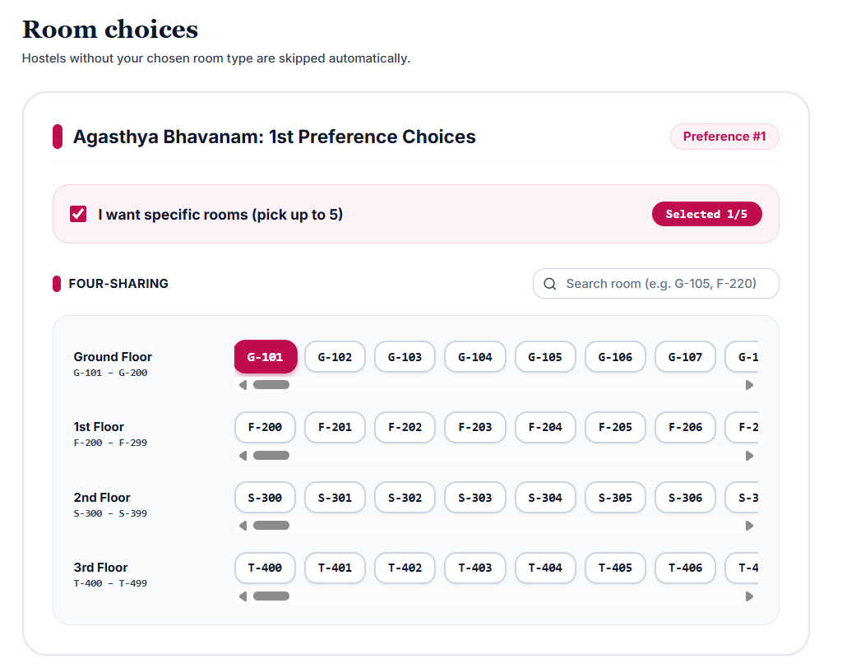
A 3 friend group willing to occupy same room
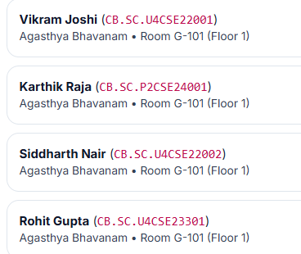
Result: Assigned to same room
- PG Scholars Restriction
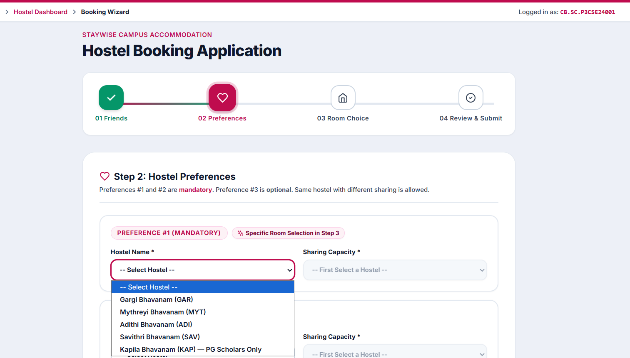
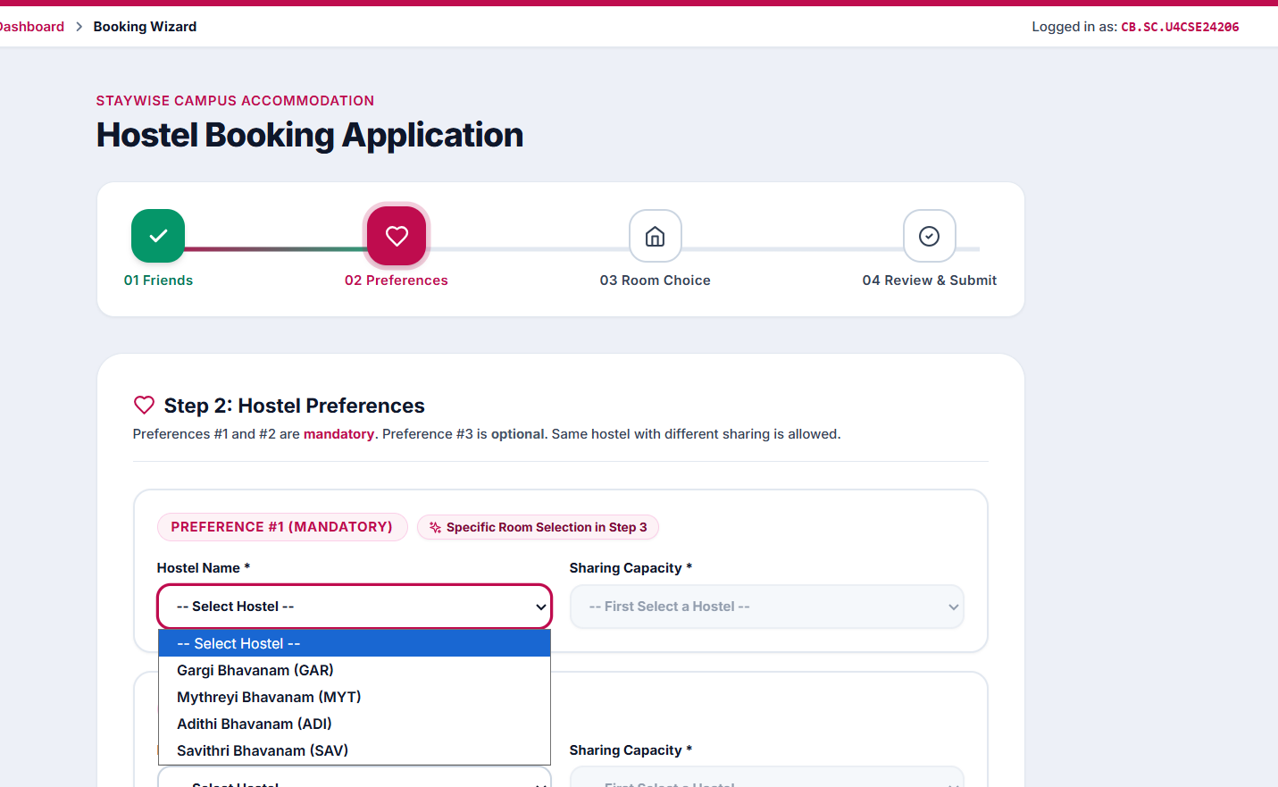
Done through allocation_engine.py

