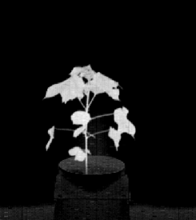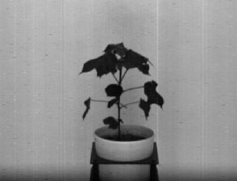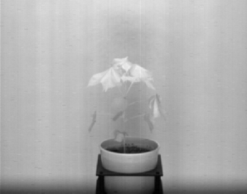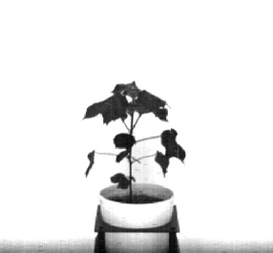

(e) Binarization (Subtraction)

(d) (2\*VIS) {Brightness}

(c) (2\*NIR) {Brightness}

(d) Subtraction ((2\*NIR) {Brightness} – (2\*VIS) {Brightness})

(b) VIS image

(a) NIR image