**README**

1. **Requirements**
   * 1. **Python Version** : 2.7.10
     2. **Pandas Version** : 0.24.1 (install command : **pip install pandas**)
2. **File Description**
   * 1. can_parser.py : making scripts
     2. confg.py : User input (See Below)

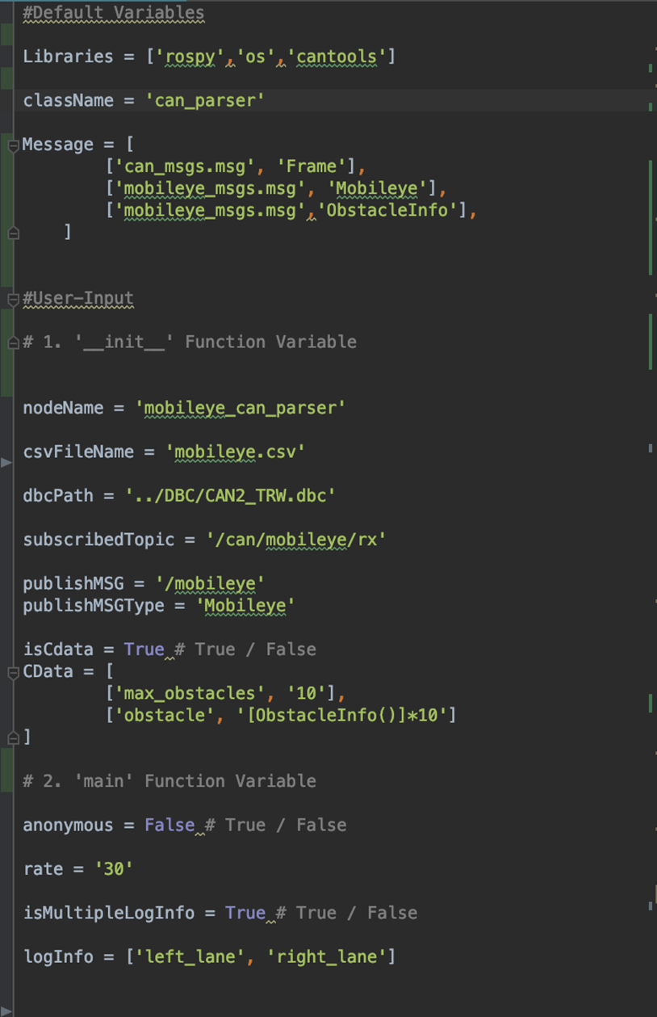 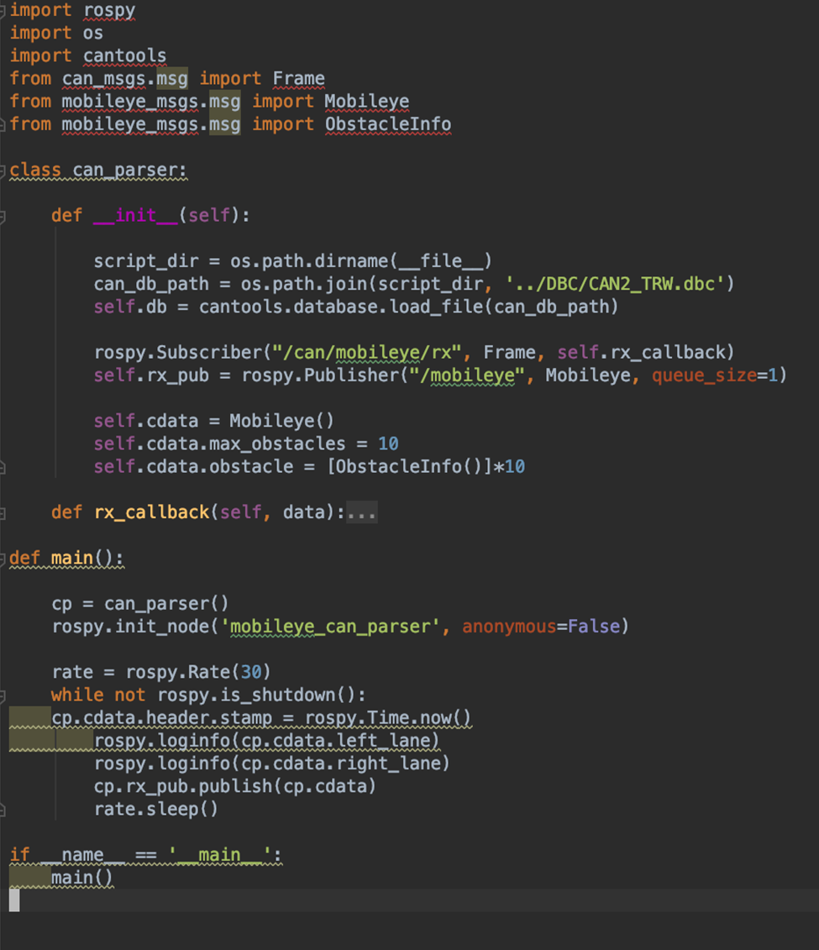

**< confg.py > <Generated Script>**

**( ※ True / False Variables : isCdata, anonymous, isMultipleLogInfo )**

**- True ->** generates certain data variable based on given information

**- False ->** generated default data variable

1. **Rx / Tx Mode** 
   * 1. Set Rx/Tx Mode Trigger in **‘confg.py’**

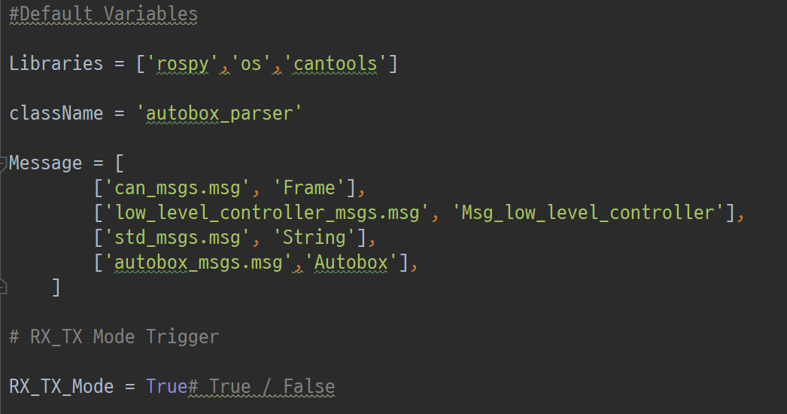

**< confg.py >**

**- True ->** generates Rx/Tx based scripts

**- False ->** generated only Rx based scripts

* + 1. Make a **Rx_Tx Configuration File**

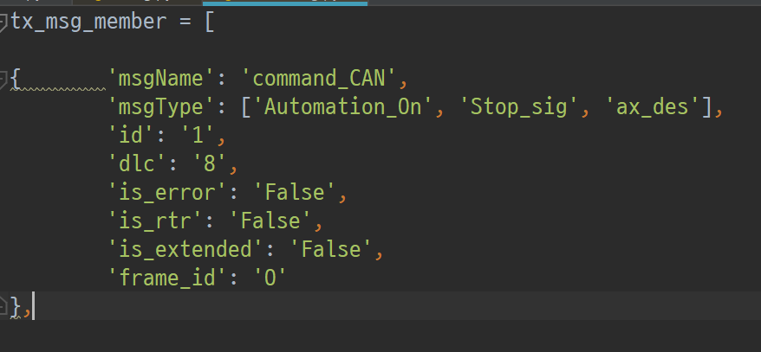 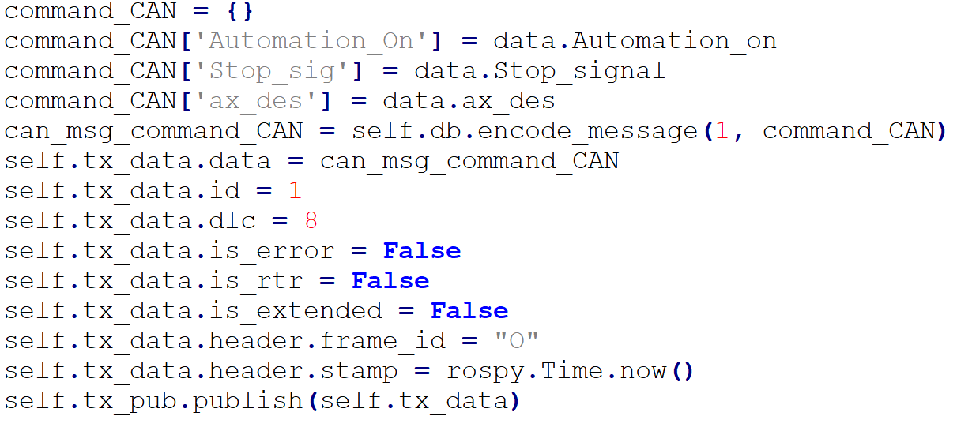

**- Rule 1.** All information must be written in ‘{ }’

**- Rule 2.**  Each information must followed by the name of variables

1. **Run Command**

**> python can_parser.py**