

**Analysis and Implementation**

**MSc in Advance Software Engineering**

**Enterprise Application Development**

**Course Work 1**

Student Name : Anet Rubisha Roshan Norbertsan

Student ID : w1850887

Email : [rubisha.20210061@iit.ac.lk](mailto:rubisha.20210061@iit.ac.lk)

Task 1

1. Functional Requirements

* User able to login to the system
* User able to Create/Read/Update/Delete transaction in the system
* The values should be updated based on the user operations
* User able to view weekly income and expenses for each day
* System predicts the future financial status

1. Non Functional Requirements
   * Accessibility
   * Memory optimization
   * Performance
   * Privacy
   * Reliability
   * Response Time
   * Usability
   * Testability
2. Domain model

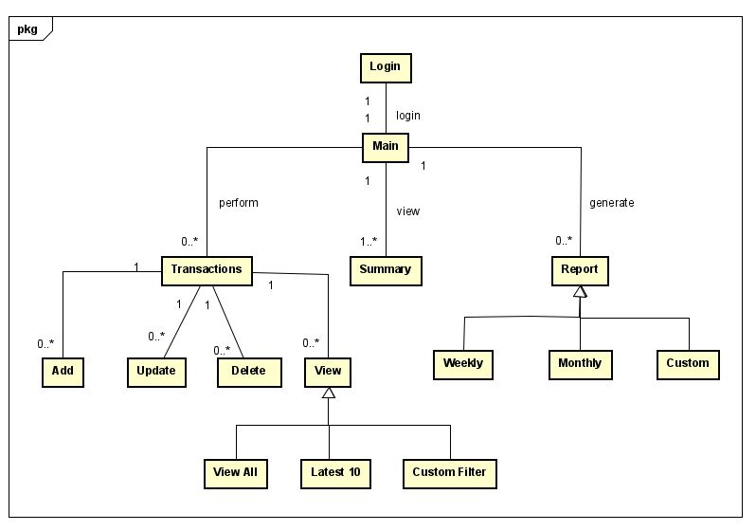

1. Use case diagram

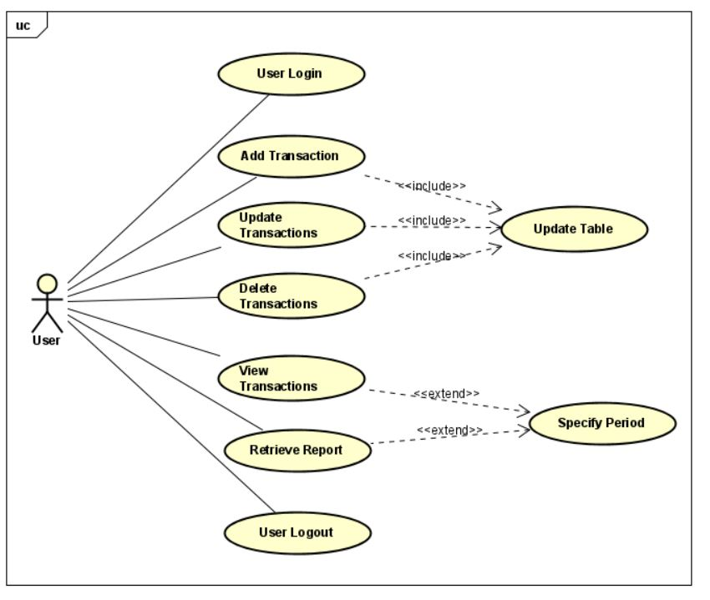

1. Use case description

|  |  |
| --- | --- |
| ID | BT1 |
| Name | Add Transaction |
| Description | User enter new transactions to the system |
| Actors | Individual User |
| Preconditions | User successfully logged in to the system |
| Post conditions | All relevant data get updated |
| Main  Success Scenarios | 1. User log in to the system 2. User go to the Transaction page 3. User click on add 4. User enter the new data on Add page and submit 5. System validate and save the data 6. User see the success message |
| Alternate flows | If the system validation fails for the entry, system will reject and shows validation error message |

|  |  |
| --- | --- |
| ID | BT2 |
| Name | Retrieve Report |
| Description | User able to get a report for the selected period |
| Actors | Individual User |
| Preconditions | User successfully logged in to the system |
| Post conditions | Report saved in the system |
| Main  Success Scenarios | 1. User log in to the system 2. User go to the Report page 3. User select the report period 4. User click on generate report 5. System filter the relevant data and save as xlsx file. 6. User see the success message |
| Alternate flows | If the report generation or save failed system will show an error message. |