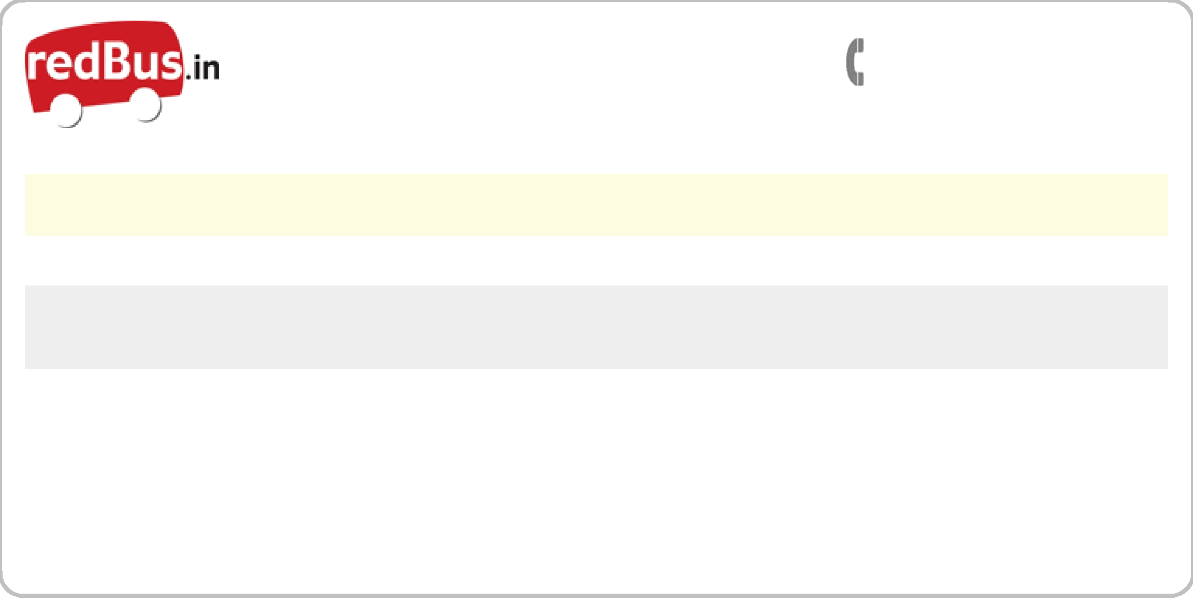 |  |  | Travel related queries
 |  |  | 09025124777/ 9176255999
Itinerary
Nellore to Hyderabad | Sunday, November 13, 2011 |  | Kaveri Kamakshi Travels HYD
Passenger name | redBus ticket # | Seat Numbers | PNR #
Miss.Kasi Visalakshi | TDBZ85657643 | 1L | KAVERI408865-KNH-11A

Bus Type Reporting Time

A/C Sleeper (2+2) 08:45 PM

Total Fare Departure Time

Rs. 850 09:00 PM

Terms and conditions

1.redBus* is ONLY a bus ticket agent. It does not operate bus services of its own. In order to provide a comprehensive choice of bus operators, departure times and prices to customers, it has tied up with many bus operators.

redBus’ advice to customers is to choose bus operators they are aware of and whose service they are comfortable with.
redBus’ responsibilities include:

- Issuing a valid ticket (a ticket that will be accepted by the bus operator) for its’ network of bus operators
- Providing refund and support in the event of cancellation

- Providing customer support and information in case of any delays / inconvenience
redBus’ responsibilities do NOT include:

- The bus operator’s bus not departing / reaching on time

- The bus operator’s employees being rude

- The bus operator’s bus seats etc not being up to the customer’s expectation
- The bus operator canceling the trip due to unavoidable reasons

- The baggage of the customer getting lost / stolen / damaged

- The bus operator changing a customer’s seat at the last minute to accommodate a lady / child
- The customer waiting at the wrong boarding point (please call the bus operator to find out the exact boarding point if you are not a regular traveler on that particular bus)

- The bus operator changing the boarding point and/or using a pick-up vehicle at the boarding point to take customers to the bus departure point

Boarding point address

Location: Bypass

Landmark: Opp.Milinium Sub Station

Address: Near Mini Bye Pass, Opp.Milinium Sub

Station

- The departure time mentioned on the ticket are only tentative timings . However the bus will not leave the source before the time that is mentioned on the ticket.

- Passengers are required to furnish the following at the time of boarding the bus:

  - A copy of the ticket (A print out of the ticket or the print out of the ticket e-mail).

  - A valid identity proof

Failing to do so, they may not be allowed to board the bus.

- Change of bus: In case the bus operator changes the type of bus due to some reason, redBus will refund the differential amount to the customer upon being intimated by the customers in 24 hours of the journey.

- Cancellation Policy: For Kaveri Kamakshi Travels HYD:Between 0 hours to 6 hours before journey, the cancellation charge is 100.0%.And, above cancellation charge is 10.0%.
- In case one needs the refund to be credited back to his/her bank account, please write your cash coupon details to support@redbus.in
* The home delivery charges (if any), will not be refunded in the event of ticket cancellation

- In case a booking confirmation e-mail and sms gets delayed or fails because of technical reasons or as a result of incorrect e-mail ID / phone number provided by the user etc, a ticket will be considered 'booked' as long as the ticket shows up on the confirmation page of www.redBus.in.

redBus Contact Details |  |  |  |  | Whom should I call?
Ahmedabad | (079) |  | 39412345 | Hyderabad | | (040) 39412345 | Boarding point related | | Bus operator (# on the top of the ticket)
Bangalore | | (080) | 39412345 | Mumbai | | (022) 39412345 | Time related queries | | Bus operator (# on the top of the ticket)
Chennai | | (044) | 39412345 | Pune | | (020) 39412345 | Cancellation | | | redBus
Coimbatore | | (0422) 3941234 |  | Vijayawada | | (0866) 3941234 | Refund | | | redBus
Delhi | | (011) | 39412345 | Vizag | | (0891) 3941234

