

IT342-G5
System Integration and Architecture

System Design Document (SDD)

Project Title: Campus Event Tracker
Prepared By: Polancos, Mizzie C.

Version: 0.2
Date: February 27, 2026
Status: Draft

REVISION HISTORY TABLE
Version | Date | Author | Changes Made | Status
0.1 | 02/20/2026 | Polancos, Mizzie C. | Initial draft | Draft
0.2 |  |  |  | Draft
0.3 | [Date] | [Your Name] | Updated database design | Review
0.4 | [Date] | [Your Name] | Added UI/UX designs | Review
0.5 | [Date] | [Your Name] | Incorporated feedback | Revised
0.6 | [Date] | [Your Name] | Final review and corrections | Final
1 | [Date] | [Your Name] | Baseline version for development | Approved

TABLE OF CONTENTS
Contents
EXECUTIVE SUMMARY 4
1.0 INTRODUCTION 5
2.0 FUNCTIONAL REQUIREMENTS SPECIFICATION 5
3.0 NON-FUNCTIONAL REQUIREMENTS 8
4.0 SYSTEM ARCHITECTURE 9
5.0 API CONTRACT & COMMUNICATION 10
Authentication Endpoints 11
User Registration 11
User Login 11
6.0 DATABASE DESIGN 13
7.0 UI/UX DESIGN 14
8.0 PLAN 17

EXECUTIVE SUMMARY
1.1 Project Overview
Campus Event Tracker is a simple, focused web-based platform that enables students to discover upcoming school events, register for events, and track which events they have registered for. Event organizers can create and manage events, as well as view the list of students registered for their events.
The system uses a straightforward three-tier architecture: Spring Boot backend API, React web frontend, and MySQL database, providing a clean and efficient event management solution.

1.2 Objectives
- Develop a fully functional event management MVP with authentication, event listing, ad student registration.
- Implement a three-tier architecture using Spring Boot (backend), React (web), and Android (mobile)
- Create RESTful APIs for communication between all system components
- Design a responsive and intuitive user interface and event organizers.
- Deploy all components to production-ready environments
1.3 Scope
Included Features:
- User registration and authentication (email/password)
- Event listing with details (name, date, location, organizer)
- Student event registration and withdrawal
- Student dashboard showing upcoming events and registered events
- Organizer of view registered students per event
- User profile management
- Responsive web interface
- Native Android mobile application
- PostgreSQL database with relational schema
Excluded Features:
- Payment or ticketing
- Event creation by organizers (admin-only initial scope)
- Social media login integration
- Push notifications
- Advanced analytics or reporting

1.0 INTRODUCTION
1.1 Purpose
This document serves as the comprehensive design specification for the Campus Event Tracker system. It provides detailed requirements, architectural decisions, API contracts, database design, and an implementation roadmap to guide development and ensure all components integrate seamlessly.

2.0 FUNCTIONAL REQUIREMENTS SPECIFICATION
2.1 Project Overview
Project Name: Campus Event Tracker
Domain: Education/Campus Management
Primary Users: Students and Event Organizers
Problem Statement: Students lack a centralized platform to discover and register for campus events, leading to low attendance and missed opportunities.
Solution: A focused event tracker allowing students to view and join events, and organizers to monitor registrations.
2.2 Core User Journeys
Journey 1: Student Event Registration
- Student visits the web application
- Clicks "Sign Up" and creates an account with their school email
- Logs in and views the dashboard showing upcoming events
- Clicks on an event to view its full details
- Clicks ‘Register for Event’ and confirms attendance
- Dashboard updates to show the event under ‘My Registered Events’

Journey 2: Returning Student
- Student logs in
- Views new upcoming events
- Clicks "Register for Event" on a new event
- System saves → Confirmation shown
Journey 3: Event Organizer
- Organizer logs in
- Navigates to "My Events"
- Views list of students who registered
2.3 Feature List (MoSCoW)
MUST HAVE
- User authentication (register, login, logout)
- Event listing (view all upcoming events with details)
- Register for Event (student confirms attendance - transactional)
- Student dashboard (upcoming registered students per event)
SHOULD HAVE
- User profile management (view and update personal info)
- Event withdrawal (student cancels their registration)
- Responsive UI for desktop and mobile
COULD HAVE
- Event search and filtering by date, category, or college/department
- Registration confirmation display
WON'T HAVE
- Real payment notifications
- Payment/ticketing
- Social login
- Advanced analytics
- Multi-language support
- Push notifications
2.4 Detailed Feature Specifications
Feature: User Authentication
- Screens: Registration, Login
- Fields: Full Name, Email, Password, Confirm Password, Role (Student/Organizer)
- Validation: Email format, password strength, email uniqueness
- API Endpoints: POST /auth/register, POST /auth/login, POST /auth/logout
- Security: JWT tokens, password hashing with bcrypt
Feature: Event Listing & Dashboard
- Screens: Dashboard (Student), Event Detail Page
- Display: Event name, date, time, location, organizer, category, college/department, event image, available slots
- API Endpoints: GET /events, GET /events/{id},
Feature: Register for Event (Transactional)
- Screens: Event Detail Page, Confirmation Prompt, Success Message
- Process: View event-> Click Register->Confirm->Record saved->Dashboard updated
- Validation: Prevent duplicate registration; check event capacity if applicable
- API Endpoints: POST /registration, DELETE /registrations/{id}
- Database Effect: Creates a new EventRegistration record with studentID, eventId, and timestamp
2.5 Acceptance Criteria
AC-1: Successful User Registration
- Given I am a logged-in student
- When I navigate to an event and click 'Register for Event'
- And I confirm the registration in the prompt
- Then my registration should be saved in the database
- And the event should appear in 'My Registered Events' on my dashboard
- And I should see a success confirmation message
AC-2: Organizer View of Registrations
- Given I am logged in as an Event Organizer
- When I navigate to my event's page
- Then I should see a list of all students who registered for that event

3.0 NON-FUNCTIONAL REQUIREMENTS
3.1 Performance Requirements
- API response time: ≤ 2 seconds for 95% of requests
- Web page load time: ≤ 3 seconds on broadband
- Support 100 concurrent users without performance degradation
- Database queries complete within 500ms
3.2 Security Requirements
- HTTPS for all communications
- JWT token authentication with expiry
- Password hashing with bcrypt (salt rounds = 12)
- SQL injection prevention via parameterized queries
- XSS protection
- Role-based access control (Student vs Organizer)
3.3 Compatibility Requirements
- Web Browsers: Edge (latest 2 versions)
- Android: API Level 24+ (Android 7.0+)
- Screen Sizes: Mobile (360px+), Tablet (768px+), Desktop (1024px+)
- Operating Systems: Windows 10+
3.4 Usability Requirements
- Students should be able to complete event registration within 3 minutes
- WCAG 2.1 Level AA compliance for web
- Consistent navigation across all pages
- Clear error messages with recovery options

4.0 SYSTEM ARCHITECTURE - draft
4.1 Component Diagram
Note: Insert your component/architecture diagram image here (draw.io, Lucidchart, or hand-drawn photo)
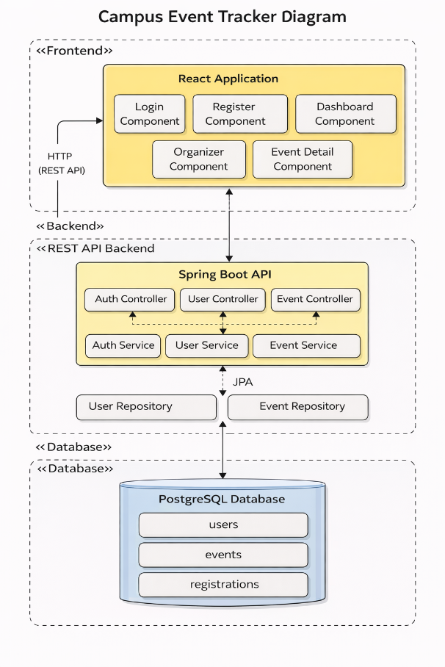

Technology Stack:
- Backend: Java 17, Spring Boot 3.x, Spring Security, Spring Data JPA
- Database: PostgreSQL 14+
- Web Frontend: React 18, TypeScript, CSS3 / Custom CSS, Axios, React Router DOM, Context API, npm
- Mobile: Kotlin, Jetpack Compose, Retrofit, Room, Material Design Components, Glide for images
- Build Tools: Maven (Backend), npm/yarn (Web), Gradle (Android)
- Deployment: Railway/Heroku (Backend), Vercel/Netlify (Web), APK (Mobile)

5.0 API CONTRACT & COMMUNICATION
5.1 API Standards
Base URL | http://localhost:8080/api
Format | JSON (application/json) for all requests and responses
Authentication | Session-based — after login, user object stored in localStorage (web) or SharedPreferences (Android). No JWT token used.
CORS Policy | Allowed origins: http://localhost:3000, http://localhost:5173. Configured in Spring Security.
Success Response: | {  "message": "Success message",  "fullName": "John Doe",  "email": "john@example.com",  "role": "STUDENT",  "userId": 123  }
Error Response: | {  "timestamp": "2026-03-01T10:30:00",  "status": 400,  "error": "Bad Request",  "message": "Email already exists",  "path": "/api/auth/register"  }

5.2 Endpoint Specifications

Authentication Endpoints

User Registration
Description | Creates a new user account (Student or Organizer)
Method & URL | None (Public endpoint)
Request Body | {  "fullName": "Mizzie C. Polancos",  "email": "mizzie.polancos@example.edu",  "password": "SecurePass123",  "role": "STUDENT"  }
Success Response | 200 OK — {  "message": "Registration successful",  "fullName": "Mizzie C. Polancos",  "email": "mizzie.polancos@example.edu",  "role": "STUDENT",  "userId": 1  }
Error Response | 400 Bad Request — "Email already exists" or validation error message string
Validation | fullName: min 2 chars; email: valid format and unique in DB; password: min 6 chars

User Login
Description | Verifies credentials and returns the user’s profile data
Method & URL | None (Public endpoint)
Request Body | {  "email": "mizzie.polancos@example.edu",  "password": "SecurePass123"  }
Success Response | 200 OK — {  "message": "Login successful",  "fullName": "Mizzie C. Polancos",  "email": "mizzie.polancos@example.edu",  "role": "STUDENT",  "userId": 1  }
Error Response | 401 Unauthorized — "Invalid email or password"

5.3 Error Handling
HTTP Status Codes
200 OK | Successful request
400 Bad Request | Invalid input, validation failure, or duplicate resource (e.g. email already registered, already registered for event)
401 Unauthorized | Authentication failed — wrong email or password
403 Forbidden | Insufficient role permissions
404 Not Found | Resource does not exist
500 Internal Error | Unexpected server-side error

Error Code Examples
Example | {  "success": false,  "data": null,  "error": {  "code": "AUTH-001",  "message": "Invalid credentials",  "details": "Email or password is incorrect"  },  "timestamp": "2026-03-01T10:30:00Z"  }

Common Error Codes
AUTH-001 | Invalid credentials (wrong email or password)
AUTH-002 | Email already exists
AUTH-003 | Insufficient permissions
VALID-001 | Validation failed (missing or invalid field)
DB-001 | Resource not found (event or user ID does not exist)
DB-002 | Duplicate entry (email already taken, already registered for event)
SYSTEM-001 | Internal server error

6.0 DATABASE DESIGN
6.1 Entity Relationship Diagram
Note: This should be an ERD (Database Schema)
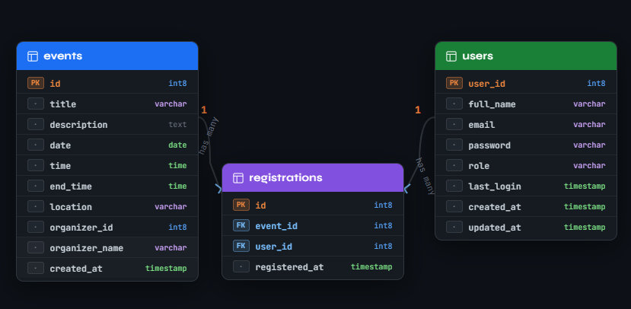
Detailed Relationships:
- One-to-One: Events ↔ Registrations (one event has many registrations)
- One-to-Many: User → Registrations (one user can register for many events)
Key Tables:x`
- users - User accounts and authentication
- events - Campus event information
- registrations - Student event registration records

Table Structure Summary:
- events: id, title, description, date, time, end_time, location, organizer_id, organizer_name, created_at
- registrations: id, event_id (FK), user_id (FK), registered_at
- users: user_id, full_name, email, password, role, last_login, created_at, updated_at

7.0 UI/UX DESIGN
7.1 Web Application Wireframes
Note: This should be wireframes from Figma
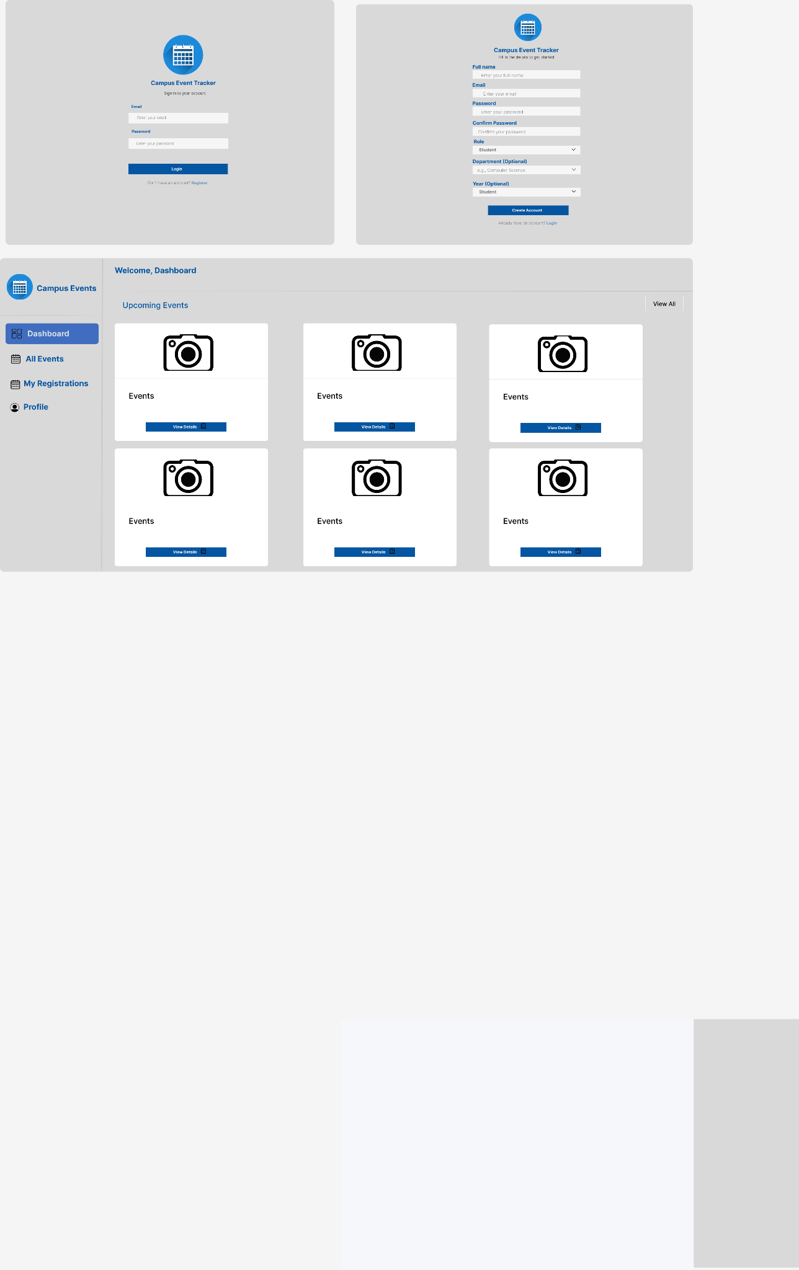

LoginPage

- Centered card layout
- Logo icon (calendar)
- Title and subtitle
- Email input field
- Password input field
- Login button (primary)
- Register link (secondary text)
- Error message area (conditionally displayed)

RegisterPage

- Full name input
- Email input (with validation)
- Password input (min 6 chars)
- Confirm password input
- Role dropdown (Student/Organizer)
- Create Account button
- Login link
- Error/success message area

DashboardPage

- Top navigation bar
- "Upcoming Events" section (card grid)
- Event cards with:
- Placeholder image
- Event title
- Category badge
- Date, time, location icons
- "View Details" button
- "My Registered Events" section (table)
- Registered events table with columns:
- Event name and location
- Date
- Registration status badge
- View button

EventDetailPage

- Back button
- Event banner image
- Event title with category badge
- Event details (icon + text):
- Date
- Time (start and end)
- Location
- Organizer name
- Description section
- Register button (primary)
- Changes to success message if registered
- Shows error message if registration fails

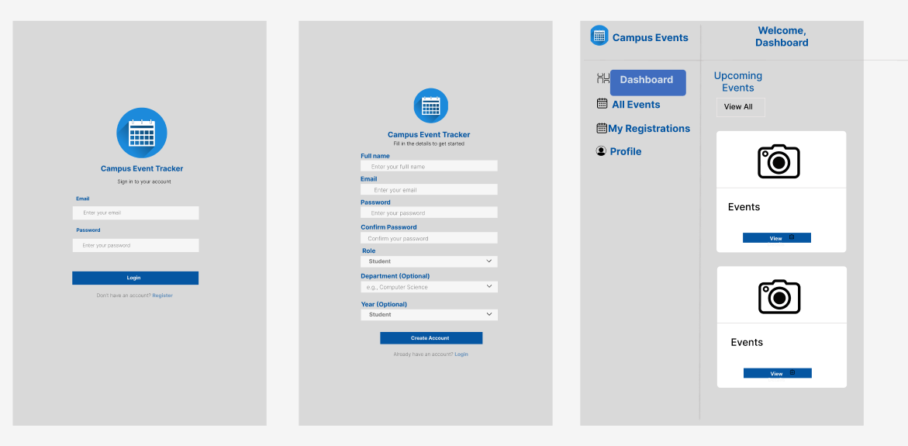
7.2 Mobile Application Wireframes

Login Screen
Calendar icon
Email & Password fields
Login button
Register link

Register Screen
All registration fields
Role dropdown
Optional fields (Department, Year Level)
Java Activity structure

Dashboard Screen
Welcome header
Sidebar navigation (Dashboard, All Events, My Registrations, Profile)
Event cards with camera placeholders
Blue "View Details" buttons

Student Registration Flow
Login Page
↓ (click Register link)
Register Page
↓ (fill form & submit)
Success Message
↓ (auto-redirect)
Login Page
↓ (login with credentials)
Dashboard
Event Registration Flow
Dashboard
↓ (click event card)
Event Detail Page
↓ (click Register button)
API Call (POST /registrations)
↓ (success)
Success Message Displayed
↓ (back to dashboard)
Dashboard Updates (My Events)
Mobile-Specific Features:
Touch-optimized buttons (min 44x44px)
Gesture support (swipe, pull-to-refresh)
Offline caching
Bottom navigation
Simplified forms
Design System:
- Colors: Primary (#2563EB), Secondary (#7C3AED), Success (#10B981), Error (#EF4444)
- Typography: Inter font family, responsive sizing
- Spacing: 8px grid system
- Components: Material Design
- Responsive: Mobile-first approach, breakpoints at 640px, 768px, 1024px

8.0 PLAN
8.1 Project Timeline
Phase 1: Planning & Design (Weeks 1-2)
Week 1: Requirements & Documentation
Day 1-2: Project Setup
Day 3-5: Requirements Gathering
Day 6-7: System Design

Week 2: Detailed Design
Day 1-2: Database Design
Day 3-4: API Specification
Day 5-6: UI/UX Design
Day 7: Sprint Planning

Phase 2: Backend Development (Weeks 3-4)
Week 3: Core Backend
Day 1: Database & Models
Day 2: Security Setup
Day 3: Authentication Service
Day 4-5: Authentication API
Day 6-7: Repository Layer

Week 4: Event Management Backend
Day 1-2: Event Service
Day 3-4: Event Controller
Day 5-6: Registration Service
Day 7: Registration Endpoints

Phase 3: Web Frontend Development (Weeks 5-6)
Week 5: Core Web Pages
Day 1: Project Setup
Day 2: Authentication Pages
Day 3: Services Layer
Day 4: Navigation & Layout
Day 5: Dashboard Page
Day 6-7: Event Detail

Week 6: Advanced Web Features
Day 1-2: Profile Page
Day 3-4: Organizer Dashboard
Day 5: UI Polish
Day 6-7: Integration Testing

Phase 4: Mobile Application (Weeks 7-8)
Week 7: Android Foundation
Day 1: Android Setup
Day 2: Models & API
Day 3: Authentication
Day 4-5: Dashboard
Day 6-7: Event Details

Week 8: Complete Mobile App
Day 1-2: Profile Activity
Day 3-4: Organizer Features
Day 5: UI Polish
Day 6-7: Testing & APK

Phase 5: Integration & Deployment (Weeks 9-10)
Week 9: Testing & Refinement
Day 1-2: End-to-End Testing
Day 3: Bug Fixes
Day 4: Security Review
Day 5: Documentation
Day 6-7: Preparation for Deployment

Week 10: Deployment & Handover
Day 1: Backend Deployment
Day 2: Frontend Deployment
Day 3: Mobile Distribution
Day 4: Final Testing
Day 5: Project Handover

Milestones:

CRITICAL PATH:
1. Authentication System - Foundation for all features
2. Event Registration API - Core transaction
3. Database Schema - 3 tables with relationships
4. Web Frontend Integration - Complete user flow
5. Cross-Platform Testing - Final validation
Risk Mitigation:
• Start with simplest working version of each feature
• Test integration points early
• Prioritize MUST HAVE features over COULD HAVE

