A Internship Project Report
On
Sales Data Analysis And Reporting
For Retail Chain
Submitted in Partial Fulfilment of the Requirements for
Successful Completion of Internship
By
Ruby Kumari
Bachelor of Technology
Computer Science & Engineering
(Dev Bhoomi Uttarakhand University,
Dehradun, Uttarakhand )

Internship Domain :
Data Analytics
Tools & Technologies Used
SQL Server | Python | Pandas | Excel
Submitted To
INTERNSHIP STUDIO


JUNE 2026

ACKNOWLEDGEMENT

I would like to express my sincere gratitude to Internship Studio for providing me with the opportunity to work on the project titled “Sales Data Analysis and Reporting for Retail Chain”. This project has been a valuable learning experience that enhanced my understanding of data analytics and business intelligence.
I am thankful to my internship mentor and the entire Internship Studio team for their guidance, support, and valuable suggestions throughout the project. Their encouragement helped me successfully complete this work.
I would also like to thank the faculty members of the Department of Computer Science & Engineering, Dev Bhoomi Uttarakhand University, for providing the knowledge and foundation required to undertake this project.
Finally, I express my heartfelt gratitude to my family and friends for their constant motivation and support during the completion of this project.

- Ruby Kumari

ABSTRACT
The project “Sales Data Analysis and Reporting for Retail Chain” was undertaken to analyse retail transaction data and generate meaningful business insights. The analysis was performed using SQL Server, Python, Pandas, Matplotlib, and Microsoft Excel.
The project involved data collection, database creation, data cleaning, exploratory analysis, and visualization. Key performance indicators such as total revenue, total transactions, unique customers, average transaction value, and campaign response rate were calculated to evaluate business performance.
The analysis revealed that the retail chain generated total revenue of approximately 8.12 million through 125,000 transactions from 6,889 unique customers. The average transaction value was 64.99. The study also identified high-value customers and showed that customers who responded to marketing campaigns spent more on average than non-responding customers, indicating the effectiveness of targeted marketing efforts.
The project demonstrates how data analytics can transform raw sales data into actionable insights that support business decision-making, customer engagement, and revenue growth.
Keywords: Data Analytics, Retail Sales Analysis, SQL Server, Python, Pandas, Data Visualization, Business Intelligence.

TABLE OF CONTENTS
ACKNOWLEDGEMENT ................................................................................................... ii
ABSTRACT ........................................................................................................................ iii
TABLE OF CONTENTS .................................................................................................... iv
- INTRODUCTION ................................................................................................... 1
- PROJECT OBJECTIVES ........................................................................................ 2
- DATASET DESCRIPTION
3.1 Retail_Data_Transactions ................................................................................... 3
3.2 Retail_Data_Response ........................................................................................ 4
- TOOLS AND TECHNOLOGIES USED ................................................................. 5
- DATABASE SETUP AND DATA IMPORT .......................................................... 6
- DATA CLEANING AND PREPARATION ............................................................ 7
- SQL-BASED DATA ANALYSIS
7.1 Revenue Analysis ................................................................................................ 8
7.2 Customer Analysis ............................................................................................... 9
7.3 Campaign Response Analysis ............................................................................ 10
- PYTHON-BASED DATA ANALYSIS .................................................................. 11
- DATA VISUALIZATION
9.1 Monthly Sales Trend .......................................................................................... 12
9.2 Top Customers Analysis .................................................................................... 13
9.3 Customer Response Distribution ........................................................................ 14
- BUSINESS INSIGHTS AND FINDINGS ............................................................... 15
- RECOMMENDATIONS ......................................................................................... 16
- CONCLUSION ........................................................................................................ 17
- FUTURE SCOPE ..................................................................................................... 18
- REFERENCES ......................................................................................................... 19

1. INTRODUCTION
In today's competitive business environment, retail organizations generate a significant amount of transactional data through customer purchases and marketing activities. This data contains valuable information that can help businesses understand customer behaviour, identify sales patterns, improve marketing strategies, and make informed business decisions. However, raw data alone has limited value unless it is properly analysed and transformed into meaningful insights.
Data analytics plays a crucial role in helping organizations convert large volumes of data into actionable information. By analysing sales transactions, businesses can monitor performance, identify high-value customers, evaluate the effectiveness of promotional campaigns, and uncover opportunities for growth. Such insights support strategic decision-making and contribute to improved customer satisfaction and business profitability.
The project titled “Sales Data Analysis and Reporting for Retail Chain” focuses on analysing retail transaction data and customer campaign response data using modern data analytics tools and techniques. The project utilizes SQL Server for database management, Python and Pandas for data processing and analysis, Matplotlib for data visualization, and Microsoft Excel for dashboard creation and reporting.
The primary goal of this project is to examine sales performance, customer purchasing behaviour, and campaign effectiveness through a structured analytical approach. Various key performance indicators (KPIs) such as total revenue, total transactions, unique customers, average transaction value, and customer response rates have been analysed to derive meaningful business insights.
The outcomes of this project demonstrate how data analytics can assist retail organizations in understanding customer trends, improving marketing efforts, and making data-driven decisions that support long-term business success.

2. PROJECT OBJECTIVES
The primary objective of this project is to analyse retail sales data and generate meaningful business insights that can support data-driven decision-making. The project focuses on understanding customer purchasing behaviour, evaluating sales performance, and assessing the effectiveness of marketing campaigns through analytical techniques.
The specific objectives of this project are as follows:
• To collect, organize, and manage retail transaction data efficiently.
• To create and maintain a structured database using SQL Server.
• To perform data cleaning and validation to ensure data accuracy and reliability.
• To analyse customer transaction patterns and spending behaviour.
• To identify high-value customers based on purchase frequency and transaction amount.
• To calculate key business performance indicators such as total revenue, total transactions, average transaction value, and customer response rate.
• To evaluate the effectiveness of marketing campaigns by comparing the spending behaviour of responding and non-responding customers.
• To create visual representations of sales trends and customer insights using Python and data visualization techniques.
• To develop a dashboard that presents important business metrics in a clear and understandable format.
• To transform raw transactional data into actionable insights that can assist businesses in improving customer engagement, marketing strategies, and overall performance.
Expected Outcomes
Upon completion of the project, the analysis is expected to provide a comprehensive understanding of sales performance, customer behaviour, and campaign effectiveness. The findings can help businesses identify growth opportunities, improve customer retention strategies, and make informed decisions based on data rather than assumptions.

3. DATASET DESCRIPTION
This project uses two datasets: Retail_Data_Transactions and Retail_Data_Response.
These datasets were imported into SQL Server and analysed to understand customer purchasing behaviour and campaign effectiveness.

Retail_Data_Transactions
This dataset contains customer transaction records with the following fields:
- customer_id
- trans_date
- tran_amount
The dataset consists of approximately 125,000 transaction records and was used to analyse sales performance, customer spending patterns, and revenue generation.

Retail_Data_Response
This dataset contains customer campaign response information with the following fields:
- customer_id
- response
Where:
- 0 = No Response
- 1 = Response
The dataset contains approximately 6,884 customer records and was used to evaluate marketing campaign effectiveness.
Important: Combining both datasets helped identify customer spending behaviour and compare responders with non-responders, providing valuable business insights.

4. TOOLS AND TECHNOLOGIES USED
Various tools and technologies were used throughout the project to perform data storage, analysis, visualization, and reporting.
Tool / Technology | Purpose
SQL Server | Database creation and data storage
SQL Server Management Studio (SSMS) | Query execution and database management
Python | Data analysis and processing
Pandas | Data manipulation and aggregation
Matplotlib | Data visualization and chart creation
Jupyter Notebook | Python development environment
Microsoft Excel | Dashboard creation and reporting

Important: The combination of SQL Server and Python enabled efficient handling of large datasets, while visualization tools helped transform analytical results into meaningful business insights

5. DATABASE SETUP AND DATA IMPORT
A database named RetailSalesDB was created in SQL Server to store and manage the project datasets. The transaction dataset and customer response dataset were imported into separate tables within the database using SQL Server Management Studio (SSMS).
After importing the data, validation checks were performed to ensure that all records were loaded correctly and that there were no missing or inconsistent values affecting the analysis. Basic verification queries were executed to confirm row counts, data types, and overall data integrity.
SQL Server provided a structured and efficient environment for storing, querying, and managing large volumes of retail transaction records. It also enabled faster data retrieval and supported complex analytical queries required for customer and sales analysis.
Important: Proper database setup and data verification ensured reliable analysis results and served as the foundation for all subsequent SQL and Python-based analytical tasks performed in the project.

6. DATA CLEANING AND PREPARATION
Data cleaning and preparation were performed to ensure the accuracy, consistency, and reliability of the datasets before analysis.
The following preprocessing activities were carried out:
- Verification of imported records.
- Validation of customer identifiers and transaction dates.
- Inspection of missing or null values.
- Verification of transaction amounts and data types.
- Removal of duplicate records where applicable.
- Conversion of date fields into a suitable format for time-based analysis.
These steps helped improve data quality and ensured that the analysis was based on accurate and reliable information.
Important: Data cleaning is a critical stage in any analytics project because the quality of insights directly depends on the quality of the underlying data.

7. SQL-BASED DATA ANALYSIS
SQL Server was used to analyse the retail datasets and extract meaningful business insights. Various SQL queries were executed to calculate key performance indicators (KPIs), identify customer trends, and evaluate campaign effectiveness.

7.1 Revenue Analysis
The total revenue generated from all customer transactions was calculated using aggregate SQL functions.
Metric | Value
Total Revenue | 8,123,989
Total Transactions | 125,000
Average Transaction Value | 64.99
The results indicate strong business activity with over 8.12 million in total sales revenue generated through 125,000 transactions.

7.2 Customer Analysis
Customer-level analysis was performed to identify high-value and highly active customers.
Metric | Value
Unique Customers | 6,889
Top Customer | CS4424
Total Spending | 2,933
Total Transactions | 39
Customer CS4424 was identified as the most valuable customer based on both spending amount and transaction frequency.

7.3 Campaign Response Analysis
The customer response dataset was analysed to evaluate marketing campaign performance.
Response Status | Customer Count
No Response (0) | 6,237
Response (1) | 647
The campaign achieved a response rate of approximately 9.4%.
Further analysis compared spending behaviour between responding and non-responding customers.
Customer Group | Average Spend
Non-Responders | 64.49
Responders | 69.03
Important Finding: Customers who responded to the campaign spent more on average than customers who did not respond. This suggests that the marketing campaign successfully attracted customers with higher purchasing potential.

7.4 Sales Trend Analysis
Monthly sales analysis was conducted to understand revenue patterns over time. The analysis showed relatively stable sales performance throughout the observed period, with monthly revenue generally ranging between 160,000 and 185,000.
The highest monthly sales were recorded during May 2013, generating revenue of approximately 185,826.
Important: SQL analysis provided the foundation for identifying customer behaviour patterns, measuring campaign effectiveness, and generating actionable business insights.

8. PYTHON-BASED DATA ANALYSIS
Python was used to perform advanced data analysis and visualization on the retail sales dataset. After importing the data from SQL Server, the Pandas library was used to organize, process, and analyse the transaction records efficiently.
The datasets were loaded into Pandas Data Frames using the pyodbc library, which enabled seamless integration between SQL Server and Python. Various analytical operations such as data aggregation, customer spending analysis, transaction frequency analysis, and monthly sales trend analysis were performed using Python.
The Matplotlib library was used to create visual representations of the data, including sales trend charts, top customer analysis, and campaign response distribution. These visualizations helped in identifying patterns and presenting analytical findings in a clear and understandable manner.
Python significantly improved the efficiency of data processing and enabled deeper exploration of customer behaviour and sales performance beyond traditional SQL queries.
Important: The integration of SQL Server, Python, and Pandas allowed efficient analysis of 125,000 transaction records and helped transform raw data into meaningful business insights through visualization and statistical analysis.
9. DATA VISUALIZATION
Data visualization was performed using Python and Matplotlib to present analytical findings in a clear and understandable manner. Visual representations helped identify trends, customer behaviour patterns, and campaign performance more effectively than raw numerical data.

9.1 Monthly Sales Trend
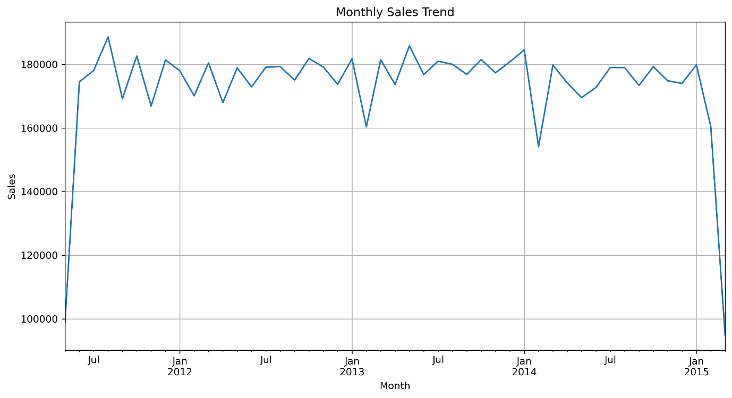

The monthly sales trend chart illustrates the variation in sales revenue over time. The analysis shows that sales remained relatively stable throughout the observed period, with monthly revenue generally ranging between 160,000 and 185,000.
Important: The highest monthly sales were recorded in May 2013, generating revenue of approximately 185,826.

9.2 Top 10 Customers by Spending
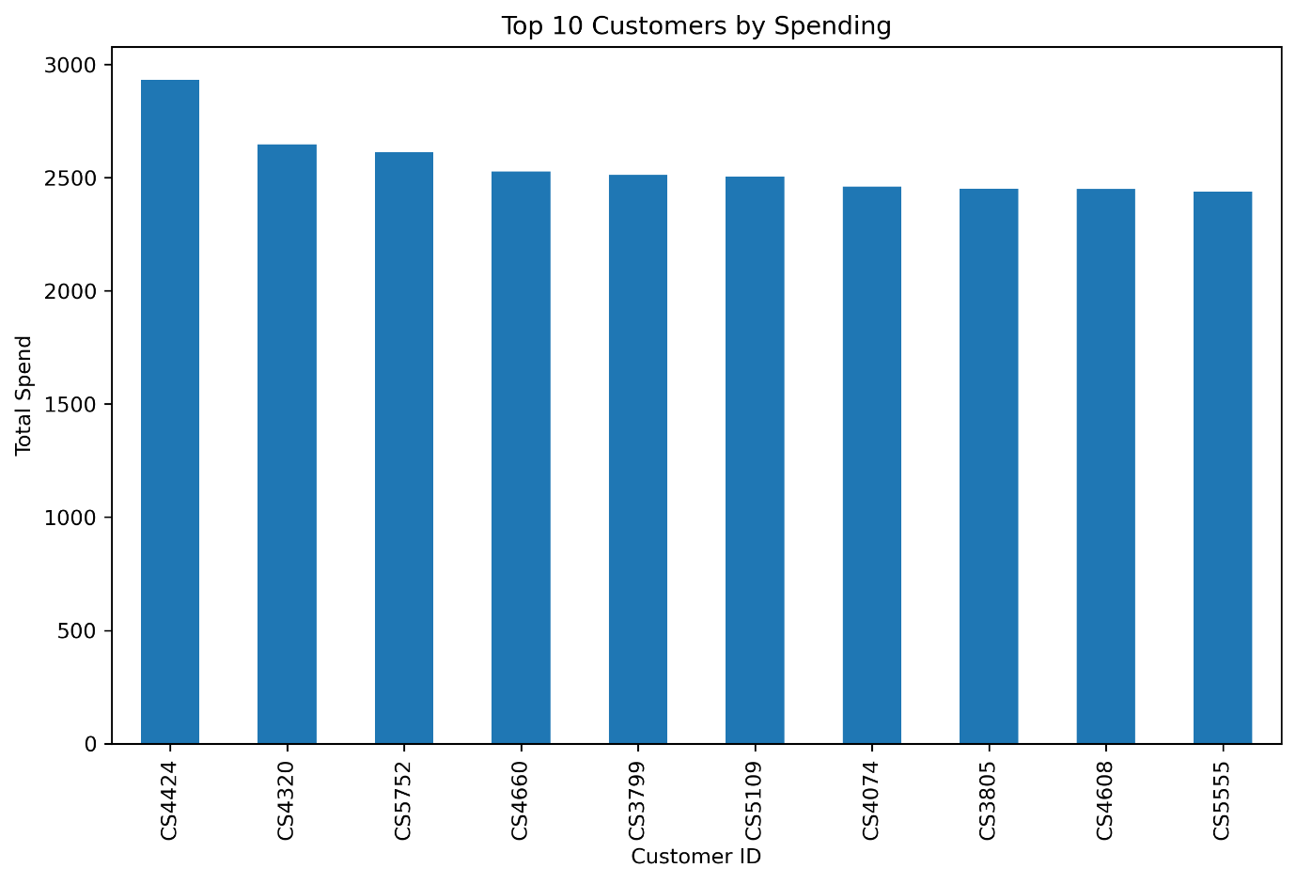
This chart highlights the top-performing customers based on their total spending. The analysis identified Customer CS4424 as the highest-value customer, followed by several other customers with significant contributions to total revenue.
Important: High-value customers represent an important customer segment and should be targeted through loyalty and retention programs.

9.3 Customer Response Distribution
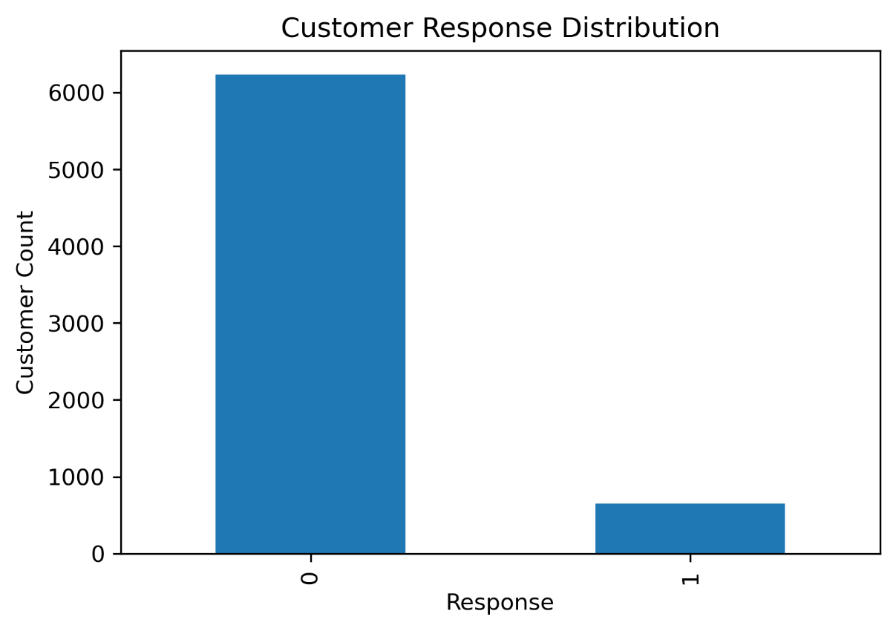
The customer response distribution chart compares customers who responded to the marketing campaign with those who did not respond. The majority of customers did not respond to the campaign, while approximately 9.4% of customers participated.
Important: Customers who responded to the campaign demonstrated higher average spending than non-responders, indicating the effectiveness of targeted marketing efforts.
Overall, the visualizations provided valuable insights into sales performance, customer behaviour, and campaign outcomes, supporting data-driven business decision-making.

10. BUSINESS INSIGHTS AND FINDINGS
The analysis of retail sales and customer response data provided several valuable insights into customer behaviour, sales performance, and marketing effectiveness.

Key Business Insights
• The retail business generated a total revenue of 8.12 million through 125,000 transactions, demonstrating a strong and consistent sales performance across the observed period.
• A customer base of 6,889 unique customers contributed to overall revenue, indicating a broad and active customer network.
• The average transaction value was 64.99, reflecting stable customer spending patterns and consistent purchasing behaviour.
• Customer CS4424 emerged as the highest-value customer, recording the highest spending and transaction frequency among all customers. This highlights the importance of identifying and retaining high-value customers through targeted engagement strategies.
• The marketing campaign achieved a response rate of approximately 9.4%, with 647 customers responding out of 6,884 customers.
• Customers who responded to the campaign recorded an average transaction value of 69.03 compared to 64.49 for non-responding customers. This indicates that campaign-engaged customers represent a more valuable customer segment with stronger purchasing behaviour.

Business Outcomes
The findings suggest that marketing campaigns can play an important role in identifying and engaging customers with higher spending potential. Although only a small percentage of customers responded to the campaign, the responding group generated higher average spending, making them a strategically important segment for future promotional activities.
The analysis also revealed the presence of high-value customers who contribute significantly to business revenue. Developing loyalty programs, personalized offers, and customer retention initiatives for such customers can improve long-term profitability and customer lifetime value.
Monthly sales trends remained relatively stable throughout the analysis period, indicating consistent customer demand and a healthy sales environment. This stability provides a strong foundation for future growth initiatives and marketing investments.

Strategic Recommendations
• Prioritize retention of high-value customers through loyalty and reward programs.
• Develop targeted marketing campaigns aimed at customer segments that demonstrate higher engagement and spending behaviour.
• Use customer transaction history to create personalized promotional strategies.
• Continuously monitor campaign performance and customer response metrics to improve marketing return on investment (ROI).
• Adopt data-driven decision-making practices to support future business planning and customer relationship management.
Overall, the analysis demonstrates that customer-focused marketing strategies, supported by data analytics, can help improve customer engagement, increase revenue opportunities, and support sustainable business growth.

11. RECOMMENDATIONS
Based on the findings of the analysis, the following recommendations are proposed to improve customer engagement, sales performance, and overall business growth:
• Implement customer loyalty programs to retain high-value customers and encourage repeat purchases.
• Focus future marketing campaigns on customer segments that demonstrate higher spending behaviour and engagement levels.
• Utilize customer transaction history to deliver personalized offers and promotions.
• Continuously monitor customer response rates and campaign performance to improve marketing effectiveness.
• Develop targeted retention strategies for customers with high purchase frequency and spending potential.
• Regularly analyse sales and customer data to identify emerging trends and support informed business decisions.
• Strengthen data-driven decision-making practices to optimize resource allocation and improve business performance.
By implementing these recommendations, the retail business can enhance customer satisfaction, improve marketing return on investment, and create opportunities for sustainable revenue growth.

12. CONCLUSION
The "Sales Data Analysis and Reporting for Retail Chain" project successfully transformed raw retail transaction data into meaningful business insights through the use of SQL Server, Python, and data visualization techniques. The project provided a practical understanding of how data analytics can be used to evaluate business performance, understand customer behaviour, and support informed decision-making.
Through the analysis of 125,000 transactions from 6,889 unique customers, key performance indicators such as total revenue, average transaction value, customer response rate, and customer spending patterns were identified and evaluated. The study revealed that the retail business generated total revenue of approximately 8.12 million, reflecting strong sales performance over the observed period.
One of the most significant findings of the project was that customers who responded to marketing campaigns demonstrated higher average spending compared to non-responding customers. This insight highlights the importance of customer engagement and the potential value of targeted marketing strategies. The analysis also identified high-value customers whose contribution to overall revenue emphasizes the need for effective customer retention and loyalty initiatives.
The project demonstrated how combining SQL-based analysis with Python-powered data processing and visualization can help organizations uncover actionable insights from large datasets. The dashboards and visual reports created during the project further improved the interpretation and communication of analytical findings.
Overall, this project reinforced the importance of data-driven decision-making in the retail sector and provided valuable practical experience in database management, data analysis, business intelligence, and reporting. The insights generated through this analysis can assist businesses in enhancing customer engagement, improving marketing effectiveness, and supporting sustainable business growth.

