MARCH 16, 2026

RUBY GRACE
CLIENT

This Agreement sets forth the terms and conditions under which the Developer(s) agree to provide development services to the Client.

Project Description

The Developer(s) will design and develop COLLEGE EVALUATION SYSTEM with the following feature(s):
- Log in Page: (QA)
- - Student Signup and Faculty SignUp buttons are working and connected to the database already pero pwede pa check nalang rin po test nyo.
- - Forgot Password must not be able to use direct lang po sila sa admin if they want to acess their account again.

- Student Portal:
- - Sychonized ng lahat ng data sa dashboard including the dates, courses they enrolled will also display, pending evaluation, days left for the evaluation,
- - for the evaluation modules must display po yung mga evaluations forms na created by the admin for the teacher and can comment privately direct to the dashboard of the teacher anonymously.
- - History modules must be synchronized rin.
- - Profile, removed avatar photo

- Teacher Portal:
- Synchronized rin lahat dapat dito and meron ring Peer to Peer evaluation and can see the comments anonymously from the students and peer(faculty members and dean)

- student to teacher
- teacher to teacher
- dean to teacher (Optional anonymous to all)

- Admin:
- Can create user friendly evaluation system because yung target po na admin is dean and 50 years old na po so avoid complexity in the entire admin po talaga.
- Yung iba hindi ko nasya ma mention pero makita nyo rin po yun sa video.

- /dean/evaluation-setup
- - Academic Year Dropdown 2025-2026, 2026-2027
- - Evaluation Name: Midterms, and Finals
- - Larger calendar for WCAG (Elderly use)
- - Save Setup and Start Evaluation not working (should be wired to Evaluation Forms; tables, )
- - Create One button on Dashboard should be wired to Evaluation Setup

- PRIORITY FUNCTION:
- - Evaluation Flow: Create Evaluation > Show Eval (Eval Form) > Update on Teacher, student side > makapag eval ang stud to teacher etc..

- teacher/dashboard
- - no role change

- User
- - dropdown/make profile and settings work

As discussed on gmeet, the priority function are the ones evaluated with the price, most of the functions that are minor are not required to be completed but can be if there are available time

API Checklist

Item/Service | Cost (₱)
Item/Service | 0
Item/Service | 0
Item/Service | 0
Item/Service | 0

The Client acknowledges that the pricing and final selection of third-party APIs shall be provided and confirmed at a later stage, as the Developer will initially focus on implementing the core functions of the system to ensure project progress. During this phase, the Client may collaborate with the Developer and suggest relevant APIs based on their own research, subject to compatibility and technical feasibility.

Deliverables Included:
- Source code
- Progress updates

Optional
- Deployment guide and support
- System Documentation (README’s)
- Code Comments and Snippets
- APK

All frameworks, tools, components, or any related technologies present in this contract are subject to change upon mutual agreement.

Payment Terms

Total Project Cost: ₱10,000.00

Payment Schedule:

- First Payment: 80% ₱ 8000 – to be paid before source code delivery.
- Final Payment: Remaining balance (pahabol)

Payments already made are non-refundable once services or knowledges have been delivered for that period.

Timeline

- Start Date: ASAP when the client presents their ID and attached to the contract
- Target Completion: On or before MARCH 21, 2026 (may be adjusted by mutual agreement)

“or before” should not be treated as a direct deadline for the project but instead a timeline of possible project delivery. “On” will still be the default and final deadline for the project.

Bug Fixes & Revisions

- Bug Fix Period: Client is responsible to check/test the app after (every) delivery to report bugs. Developers will fix reported issues free of charge if and only if the report does not exceed (5) calendar days after the delivery
- Additional Revisions: Requests beyond the agreed scope or outside the bug fix period will be billed separately.

Responsibilities

Developers’ Responsibilities:
- Build the project according to agreed specifications.
- Provide updates and consultations during development.
- Deliver source code, documentation, and deployment instructions (depends on specific agreements).
Client’s Responsibilities:
- Provide downpayment and timely payments as agreed.
- Supply necessary content, references, or requirements.
- Test and review the project during the bug fix period.

Applicable for projects with Firebase:
- Firebase Storage Usage and Charges - The Client shall be responsible for monitoring and maintaining their allocated Firebase storage within the agreed limits. Only if the Firebase account is billed to the Developer’s debit card, any additional charges incurred as a result of exceeding the storage quota shall be reimbursed by the Client upon notification.
Applicable for projects with APIs:
- API Usage and Billing Policy – The Client shall be responsible for monitoring and managing the usage of any third-party APIs integrated into the system within the agreed usage limits. In cases where an API subscription or usage-based service is billed to the Developer’s debit or credit card, any additional charges incurred due to exceeding the allocated quota or usage limits shall be reimbursed by the Client upon notification. The Client agrees not to exceed the defined API limits without prior written approval from the Developer.

Termination & Refund Policy

- By Client:
  - Payments already made are non-refundable.
- By Developers:
  - Payments already made for completed services are non-refundable. Any unused advance payment for services not yet delivered will be refunded.
  - The Developer reserves the right to temporarily suspend access or request payment prior to reactivation in cases of excessive or unpaid storage fees.

Miscellaneous
- Mutual Agreement, Revisions, and Evidence Integrity: Any revisions, modifications, or breaches to the project scope or terms of this contract shall be considered valid if made upon mutual agreement between both parties, whether through written, verbal, or digital communication (including but not limited to chat messages, video meetings, or face-to-face discussions), provided that such communication is supported by verifiable evidence. Both parties acknowledge that adjustments to project tools, frameworks, components, or implementation methods may occur as necessary to meet development deadlines, ensure system compatibility, or improve performance consistent with the clause stating that “All frameworks, tools, components, or any related technologies used are subject to change upon mutual agreement.”
- Evidence Integrity: Any form of evidence used to support a mutual agreement (such as chat logs, meeting records, screenshots, or emails) must be kept intact and not deliberately deleted, unsent, or altered. Any act of evidence destruction, falsification, or deliberate misrepresentation shall be considered a violation of good faith and may nullify claims that contradict the preserved records. Such revisions or mutual agreements shall not be considered a breach of contract but rather an authorized modification, made in good faith and in the best interest of the project’s success.
- Governing Law: This Agreement is governed by the laws of the Philippines.
- Entire Agreement: This document contains the complete agreement between all parties.

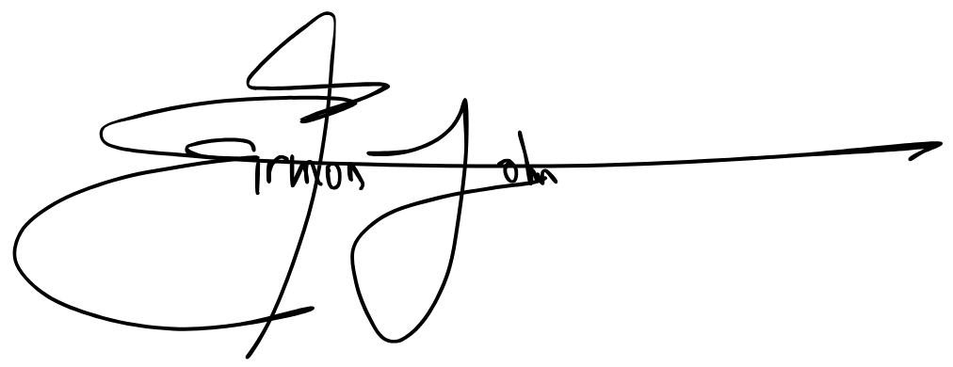
Checked and Confirmed by
EIRMON JOHN P. PACULAN  Service Provider |  |  | RUBY GRACE  Client

Contract can be valid with either an e-signature, or a well-defined message that states the client acknowledges the contract and wishes to proceed with the commission:
Optional Message Evidence:

ID Attached:


