NodeJS Technical Test: TODO List
Create a TODO list application with NodeJS

Requirements
Design and develop an application that allows me to:
- Create a new task
- Mark a task as done (They go in an archive list or they disappear, it’s up to you)
- See the list of pending tasks
- It’s ok if tasks are not persisted (in-memory)
- Persistent data: refreshing the browser or restarting the browser should not affect tasks. Use a database (MySQL, MongoDB or other..)

What we really want
We would like to see how you develop and to what you’re able to do. Essentially we want a working application. If you’re stuck early, contact us early.

Bonuses
- Add a ‘Due date’ to the task
- In the task list, order tasks by ‘due date’
- Highlight tasks that are past the due date
- Start your development using github and send us the link to the git-hub project
- Add the ability to modify and delete an existing task
- Add authentication (a user can only see his own tasks)
- If you’ve done all of the above, then check out Asana to get some ideas of what you can do: http://asana.com/

Wireframe
Here is what the application could look like:
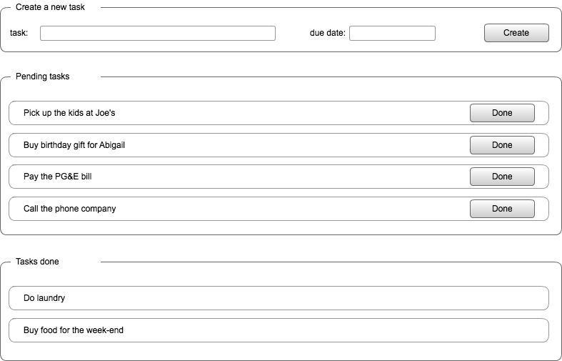
You can choose to use jQuery or another javascript front-end. It’s up to you.

Getting started
You will have to install NodeJS: http://nodejs.org/
Then npm: http://npmjs.org/
Here is a short tutorial: http://howtonode.org/getting-started-with-express
Use expressJS to make serving web pages easier and to expose your task API: http://expressjs.com/

Once you’re done
Send us your code!

