STA371G - CODEBOOK Group # 11 Aidan Medina, Yichen Pan, and Kaveh Majd

1. H4TO6 num_cigar quantitative response Table

   Description automatically generated
2. H4TO4 age_first_smoke quantitative explanatory Table

   Description automatically generated
3. H4TO30 times_quit_smoke quantitative explanatory Table

   Description automatically generated
4. H4MH2 feel_isolated categorical explanatory

1. H4MH22 feel_depressed categorical explanatory

1. H4MH23 feel_tired categorical explanatory

1. H4ID5J anxiety categorical explanatory

1. H4PE22 stress categorical explanatory

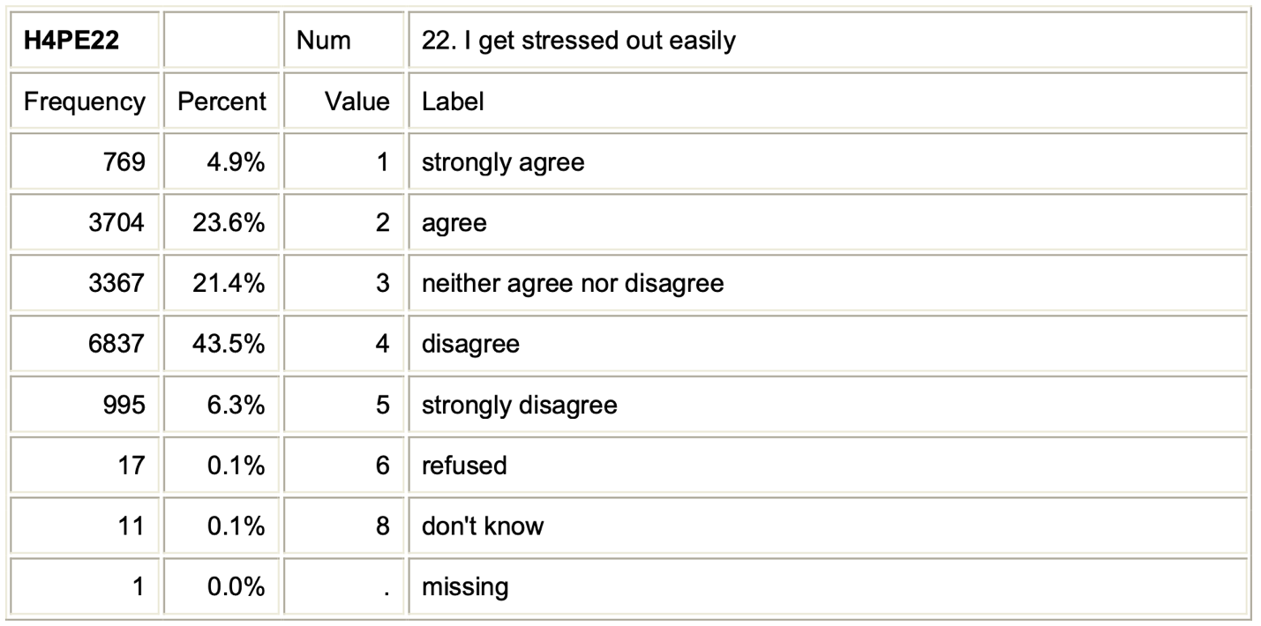

1. H4TO27 try_quit_smoke categorical explanatory

