**Group 6 - Assignment 1**

**1. Names of group members**

Faiza Quadri, Rebecca Lee, Yichen Pan, Zixi Lei, Briana Ramirez, Stephen Rhee

**2. Forum URL**

https://forums.edmunds.com/discussion/2864/general/x/entry-level-luxury-performance-sedans

**3. Top 10 brands by # of mentions**

|  |  |  |  |
| --- | --- | --- | --- |
|  | Car Brands |  |  |
| 1 | bmw | 1949 |  |
| 2 | audi | 1270 |  |
| 3 | acura | 1107 |  |
| 4 | infiniti | 571 |  |
| 5 | lexus | 517 |  |
| 6 | honda | 353 |  |
| 7 | cadillac | 335 |  |
| 8 | mercedes | 276 |  |
| 9 | volvo | 228 |  |
| 10 | porsche | 176 |  |

We chose these 10 brands because they are the top 10 most mentioned brands in the discussion forum.

**4. Car Brand Lift Values**

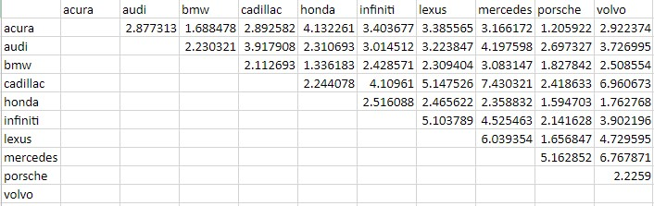

**5. MDS Map**

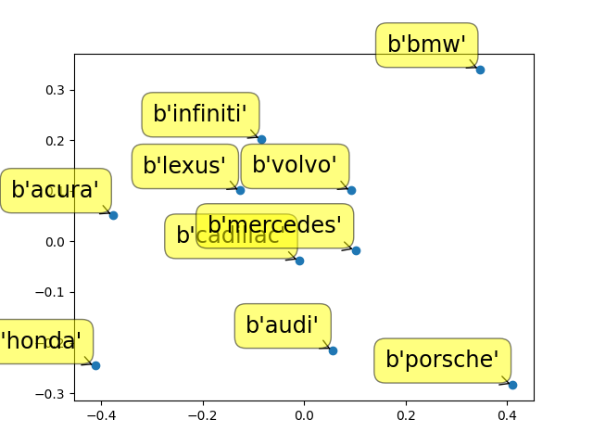

**6. Insights from Task A**

* Highest lift value: Mercedes & Cadillac, 7.43
  + Higher lift values mean that the two items are very likely to be mentioned together. So in this case, in the luxury car forum, Mercedes and Cadillac are very likely to be mentioned in the same post and have a high association with one another.
* 2nd highest lift value: Volvo & Cadillac, 6.96
* Lowest lift value: Acura & Porsche, 1.21
  + These brands are the least associated with each other among the 10 most mentioned brands.
* From the MDS map, we can observe the similarity between two specific brands by calculating the distance between them. When two brands are closer on the MDS map, they are more similar. This attribute can help the company to predict customers’ switching behavior. For example, from our analysis, current Cadillac owners are more likely to switch to Mercedes. However, current BMW owners can hardly find a rival brand to replace so BMW has relatively high competitive advantages in the entry-level luxury car market.
* Volvo and Mercedes are highly associated, with a lift value of 6.76.
* An unexpected result is that BMW, Audi, and Mercedes are not clustered together very tightly on the MDS map. Rather, Mercedes is most often mentioned with Cadillac and BMW/Audi have comparable lift values with Volvo and Cadillac. This is surprising because these 3 brands are the most popular German luxury car brands.
* Since Mercedes and Cadillac are put closely together, if they want to differentiate from each other, they should change their branding and change the marketing strategies. The branding and marketing implications from task A suggest that Mercedes and Cadillac strategies for marketing may be similar to each other, and if either brand wants to be known as a more luxury/less luxury brand, they should look at different marketing and branding strategies.

**7. State the attributes and the basis of their selection (again, a summary table with frequencies is good here).**

Top 5 attributes by # of mentions are:

|  |  |  |
| --- | --- | --- |
|  | Attributes |  |
| 1 | performance | 610 |
| 2 | power | 419 |
| 3 | interior | 410 |
| 4 | steering | 346 |
| 5 | value | 311 |

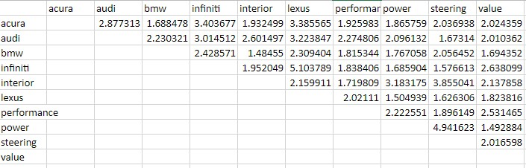

Highest associations between brands and attributes:

Infiniti with value 2.638099

Audi with interior 2.601497

Audi with performance 2.274806

Audi with power 2.096132

BMW with steering 2.05642

**8. Insights from Task B**

* Audi and interior has a strong association with approximately 2.60, which means a majority of forum commenters for Audi has a positive perception towards Audi’s interior design.
* On Audi’s main page on their website, “performance” is an attribute listed in their ads, so this could be evidence of their ads functioning well since Audi and performance also have a strong association at approximately 2.27
* The association of BMW with steering is about 2.06, and this means there is the possibility of BMW users stating they have steering issues if the sentiment is negative
* Infiniti has the high association with the attribute value (2.638099) which can imply that Infiniti buyers can get the most value for their money compared to other car purchases
* The attribute that mattered the most was value because it had the highest amount of co-mentions overall across all the brands (total of 10.19099 lift), followed by interior (total of 10.13051 lift), and performance (total of 9.875649 lift). Steering (8.969448 total lift) and power (8.919791 total lift) rounded out the top 5 attributes.
* Totals of all the attributes for each brand:

Audi has the highest association total for all of the attributes, assuming that this is positive sentiment, this implies Audi’s marketing and branding is successful 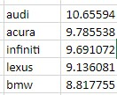

**9. Details of “aspirational brand” analysis**

We replaced the following words with “aspire”:

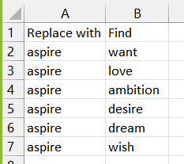

Then ran a lift analysis to compare the top 5 brands with the term “aspire”

Here are the lift values:

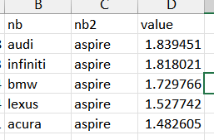

Audi is the most aspirational brand, with the highest lift value, 1.84. A majority of forum users favors Audi.

This is consistent with the attributes analysis, since Audi won the interior, performance and power categories!