Data Cleaning Report
Rubysha E | 24SBDS043| III B.Sc. Data Science| PSGR KCW| Coimbatore| Tamil Nadu| India|
rubysha0117@gmail.com

1. Executive Summary
This report documents the data cleaning and preprocessing performed on a synthetic Drug Side Effects dataset “drug_side_effects_100k_dataset” obtained from Kaggle. The objective was to improve data quality before creating interactive dashboards in Tableau and Power BI. Python and the Pandas library were used to inspect, clean, validate, and export the dataset.

Preprocessing Environment & Tools
- Development Environment: Google Colab (Hosted Python 3 runtime)
- Core Libraries: Pandas (Data manipulation), NumPy (Numerical operations)
- Hardware Allocation: Standard Cloud RAM and Disk storage for handling the 100k-row flat file.

2. Dataset Overview
Dataset contains 100,000 records and 16 columns.
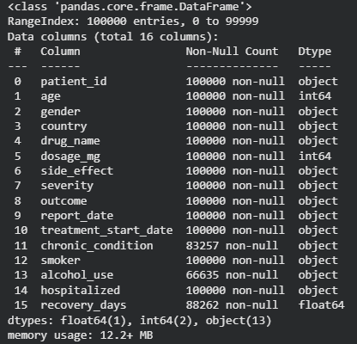

3. Data Quality Assessment
Initial inspection identified missing values in chronic_condition (16,743), alcohol_use (33,365), and recovery_days (11,738). No duplicate records were found.

4. Data Cleaning Methodology
• Imported required libraries.
----------------------------------------------------------------------------------------------------------------------
• Loaded dataset.
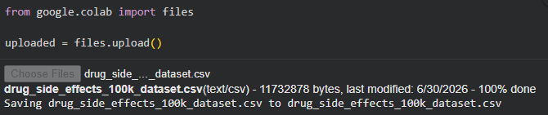
----------------------------------------------------------------------------------------------------------------------
• Checked missing values.
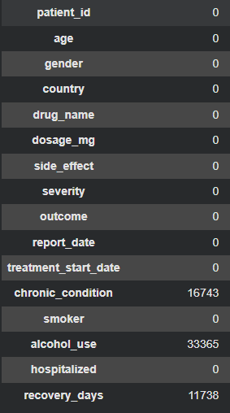
----------------------------------------------------------------------------------------------------------------------
• Verified duplicates.
----------------------------------------------------------------------------------------------------------------------
• Converted report_date and treatment_start_date to datetime
----------------------------------------------------------------------------------------------------------------------
• Filled missing categorical values with 'Unknown'.
• Filled missing recovery_days using the median.
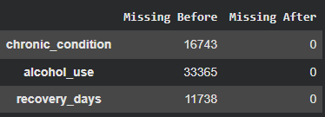
----------------------------------------------------------------------------------------------------------------------
• Exported the cleaned dataset.
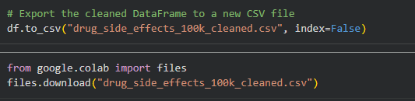
----------------------------------------------------------------------------------------------------------------------

5. Validation
After cleaning, all missing values were addressed, duplicate records remained zero, and date columns were successfully converted.

6. Conclusion
The preprocessing workflow produced a clean, analysis-ready dataset suitable for visualization in Tableau and Power BI. The cleaning process improved data consistency, completeness, and analytical reliability while preserving the integrity of the original dataset.

