**NATIONAL INFOTECH COLLEGE**



**Affiliated To :-**

**Tribhuvan University**

**Institute of Science and Technology**

**Proposal On**

**E-Commerce**

An Online E-Commerce

**Submitted to :-**

**National Infotech College**

**Shiromanitole, Birgunj**

**Submitted by :-**

**Ruby Shah**

**May, 2025**

**Table Of Contents**

1. **Introduction……………………………………………………………………………**
2. **Problem Statement…………………………………………………………………….**
3. **Objectives………………………………………………………………………………**
4. **Scope and Limitations…………………………………………………………………**
   1. Scope……………………………………………………………………………………………
   2. Limitations……………………………………………………………………………………...
5. **Methodology…………………………………………………………………………...**
   1. **Requirement Identification……………………………………………………………………….**
      1. Literature Review…………………………………………………………………………...
      2. Study of existing systems…………………………………………………………………...
      3. Requirement Analysis………………………………………………………………………
   2. **Feasibility Study…………………………………………………………………………………...**
      1. Technical Feasibility………………………………………………………………………...
      2. Economical Feasibility……………………………………………………………………...
      3. Legal Feasibility…………………………………………………………………………….
      4. Operational Feasibility……………………………………………………………………...
      5. Schedule Feasibility………………………………………………………………………...
   3. **High Level Design…………………………………………………………………………………**
      1. Class Diagram………………………………………………………………………………
      2. Activity Diagram……………………………………………………………………………
      3. Architecture Diagram……………………………………………………………………….
6. **Conclusion………………………………………………………………………………**

**1. Introduction:**

"E-commerce" (short for electronic commerce) refers to the buying and selling of goods or services using the internet, and the transfer of money and data to execute these transactions. It encompasses a wide range of business models and platforms.

**2. Problem Statement:**

Despite the rapid growth of e-commerce, many online businesses face significant challenges in delivering a seamless, personalized, and trustworthy shopping experience. These issues include like

* Low customer retention
* Inefficient logistics and fulfillment
* Security concerns
* High competition
* Cart abandonment

As a result, e-commerce businesses struggle to scale sustainably, retain customers, and maintain profitability in a highly dynamic and competitive digital marketplace.

**3. Objectives:**

Here are the **main objectives of e-commerce**, commonly pursued by businesses and platforms operating in the online commerce space:

**Primary Objectives are :-**

* Increase Sales and Revenue
* Enhance Customer Convenience
* Reduce Operational Costs.
* Expand Market Reach
* Improve Customer Experience
* Build Brand Awareness and Loyalty
* Facilitate Data Collection and Analytics
* Ensure Secure Transactions

**4. Scope and Limitations:**

**4.1 Scope:**

* Global Reach and Omnichannel Integration
* 24/7 Availability, Payment and Fulfillment Innovation
* Diverse Business Models
* Personalization & Customer Insights
* Cost Efficiency

**4.2 Limitations:**

* Lack of Physical Experience
* Security & Privacy Concerns
* Logistics Challenges
* High Competition
* Technology Dependence
* Legal and Regulatory Barriers
* Returns and Refunds
* Trust and Credibility Issues

**5. Methodology:**

**5.1 Requirement Identification:**

**5.1.1 Literature Review:**

The literature review explores academic studies, industry reports, and case studies relevant to e-commerce systems. It provides insights into how e-commerce has evolved, current trends, and the effectiveness of different technologies and strategies.

**5.1.2 Study of existing systems:**

This section evaluates popular e-commerce platforms and their features to identify best practices and gaps.

Examples :- Amazon , Shopify, WooCommerce (WordPress plugin), FlipKart (India-based)

**5.1.3 Requirement Analysis:**

This section defines the functional and non-functional requirements of the proposed or studied e-commerce system.

* **Functional Requirements :**
* User registration and login
* Product browsing and search
* Add to cart and checkout functionality
* Payment integration (e.g., credit card, UPI, PayPal)
* Order tracking, Product reviews and ratings
* Admin panel for inventory and user management
* **Non-Functional Requirements :**
* **Security**: Encrypted transactions, secure login
* **Performance**: Fast page load times, responsive design
* **Scalability**: Ability to handle increasing users and products
* **Availability**: System uptime of 99.9%
* **Usability**: User-friendly UI/UX for all demographics

**5.2 Feasibility Study:**

**5.2.1 Technical Feasibility:**

To evaluate whether the existing technology and infrastructure can support the development and operation of the e-commerce platform.

**5.2.2 Economical Feasibility:**

To assess whether the project is cost-effective and financially sustainable.

**5.2.3 Legal Feasibility:**

To ensure that the e-commerce system complies with laws and regulations.

**5.2.4 Operational Feasibility:**

To determine whether the system can be operated efficiently and meet user needs.

**5.2.5 SchedulenFeasibility:**

To evaluate whether the project can be completed in a reasonable timeframe.

**5.3 High Level Design:**

**5.3.1 Class Diagram:**

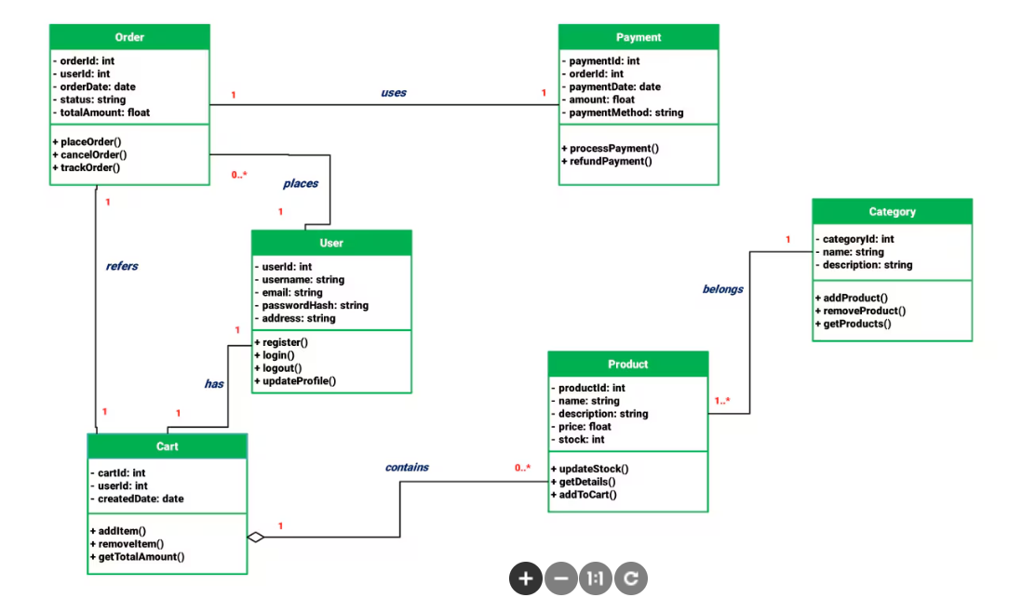

**5.3.2 Activity Diagram :**

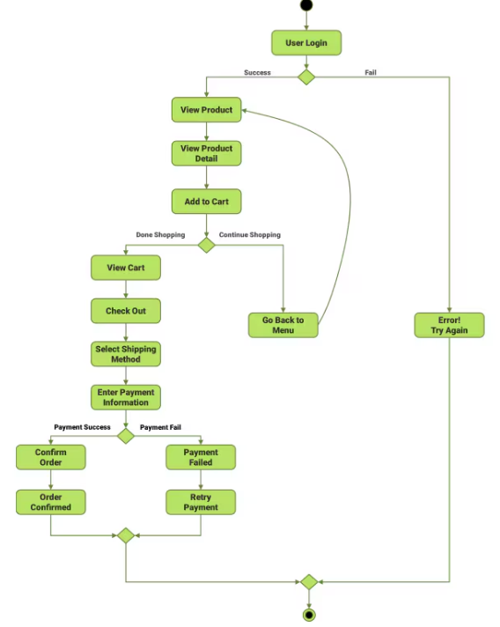

**5.3.3 Architecture Diagram :**

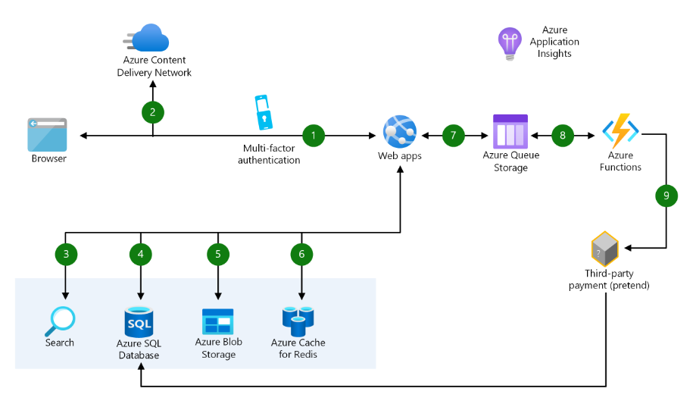

**6. Conclusion:**

In this project, to improve the accuracy, quality and scalability of movie recommendation system. Ahybrid approach by unifying content-based filtering and collaborative filtering; using SVD as a classifier. The Proposed system will recommends good movies according to user’s choice. Bring interests and make users happy.

|  |
| --- |
| Order |
| - orderId : int  - userId : int  - orderDate : date  - status : string  - totalAmount : float |
| + placeOrder()  + cancelOrder()  + trackOrder() |

|  |
| --- |
| Payment |
| - paymentId : int  - orderId : int  - paymentDate : date  - amount : float  - paymentMethod : string |
| + processPayment()  + refundPayment() |