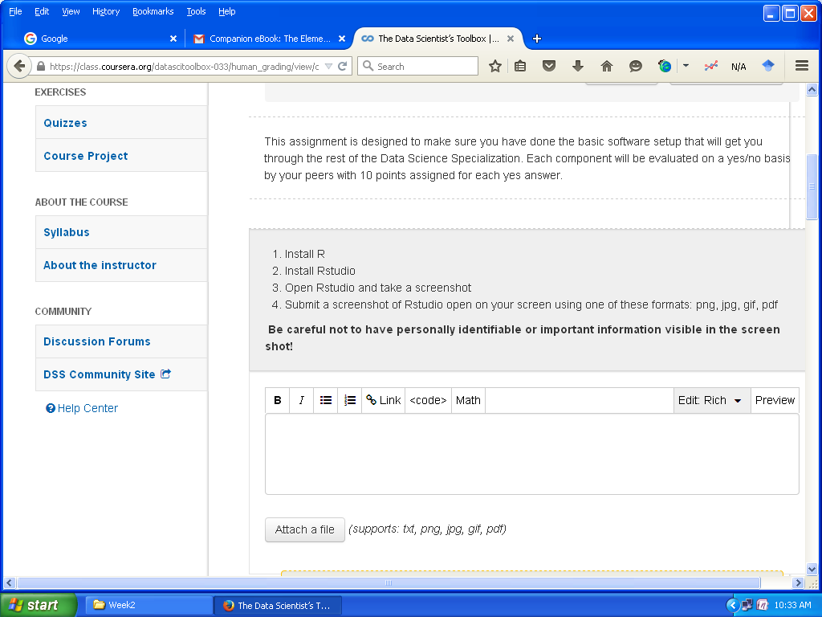

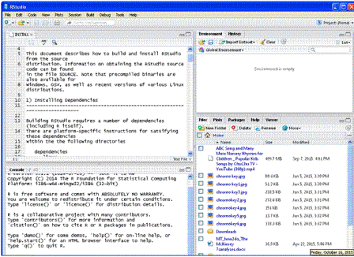

[https://github.com/rubyannette/datasciencecoursera/blob/master/HelloWorld.md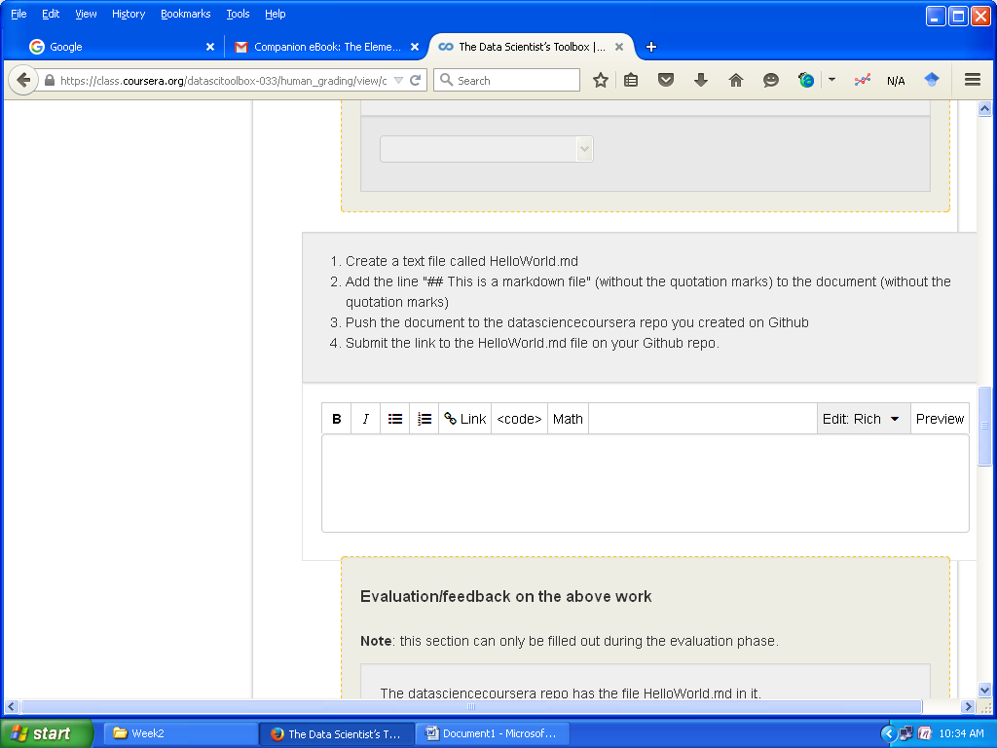](https://github.com/rubyannette/datasciencecoursera/blob/master/HelloWorld.md#)

<https://github.com/rubyannette/datasciencecoursera/blob/master/HelloWorld.md>

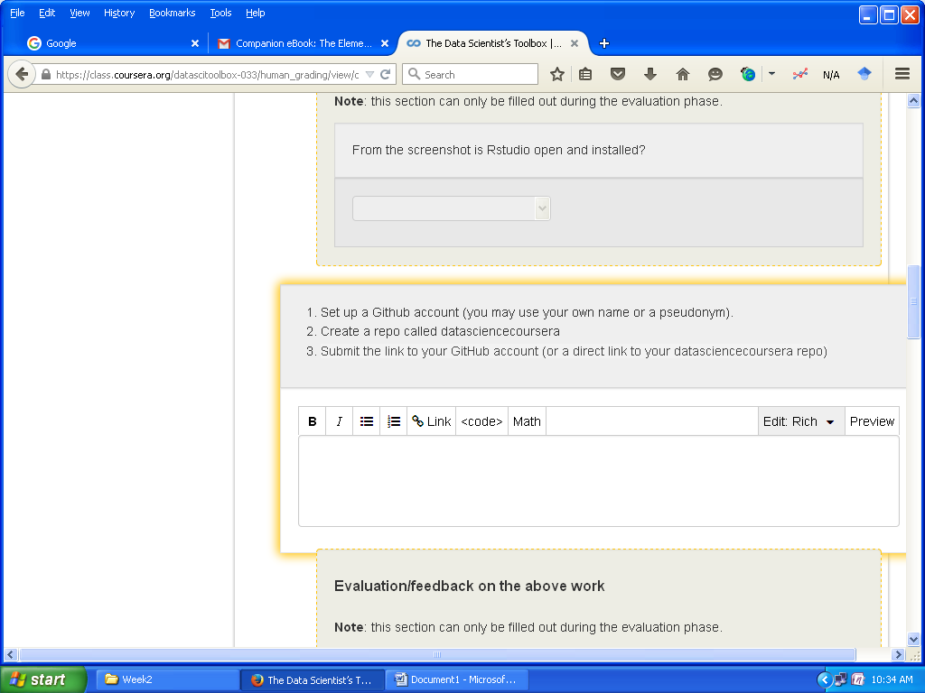

<https://github.com/rubyannette/datasciencecoursera>

https://github.com/rubyannette/datasciencecoursera.git

0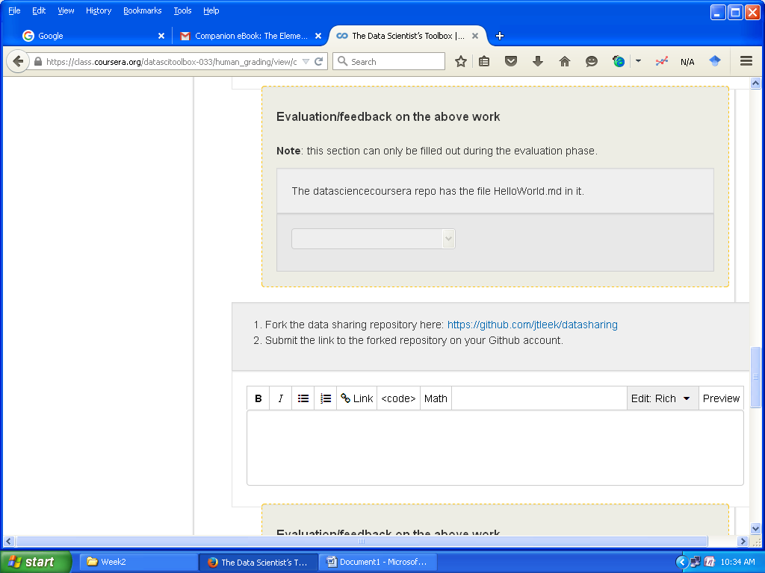

<https://github.com/rubyannette/datasharing>

https://github.com/rubyannette/datasharing.git