SCHEDULER

Administrator Guide

For Windows & Android (December 2013)

Table of Contents

1. **Introduction**  03
2. **Prerequisites** 03
   * 1. Java JRE 03
     2. Setting the Java Environment Variable 11
     3. Tomcat 12
     4. Mysql 13
     5. MySql Workbench 25
3. **Installation** 26
   * 1. Importing Database 26
     2. Deploying War 29
4. **Starting Application** 30
   * 1. Starting Server 30
     2. Changing Database Connections 31
5. **Deploying Scheduler** 32
   * 1. Open the URL 32
6. **Android Phone** 33
   * 1. Requirements 33
     2. Installation Instructions 33

**Introduction**

This system tries to overcome the existing scenario of scheduling appointments by allocating tokens to users and estimating the time of appointment. Alert will be given to the users android device, which will save time in waiting in front of the office to see the official. Admin will be user responsible for managing the application.

**Prerequisites**

Before you begin the installation of the application you must install below mentioned softwares as the application relies on them to successfully run. If you are missing any of these you might not be able to run the application successfully.

**Java JRE**

JRE or Java runtime environment allows you to run the application developed using the java runtime. This most probably would be installed on your system. To check that JRE is installed on your system, open the link below in the web browser.

<http://www.java.com/en/download/installed.jsp>

1. You will see the screen as below. Click on the verify java version button.

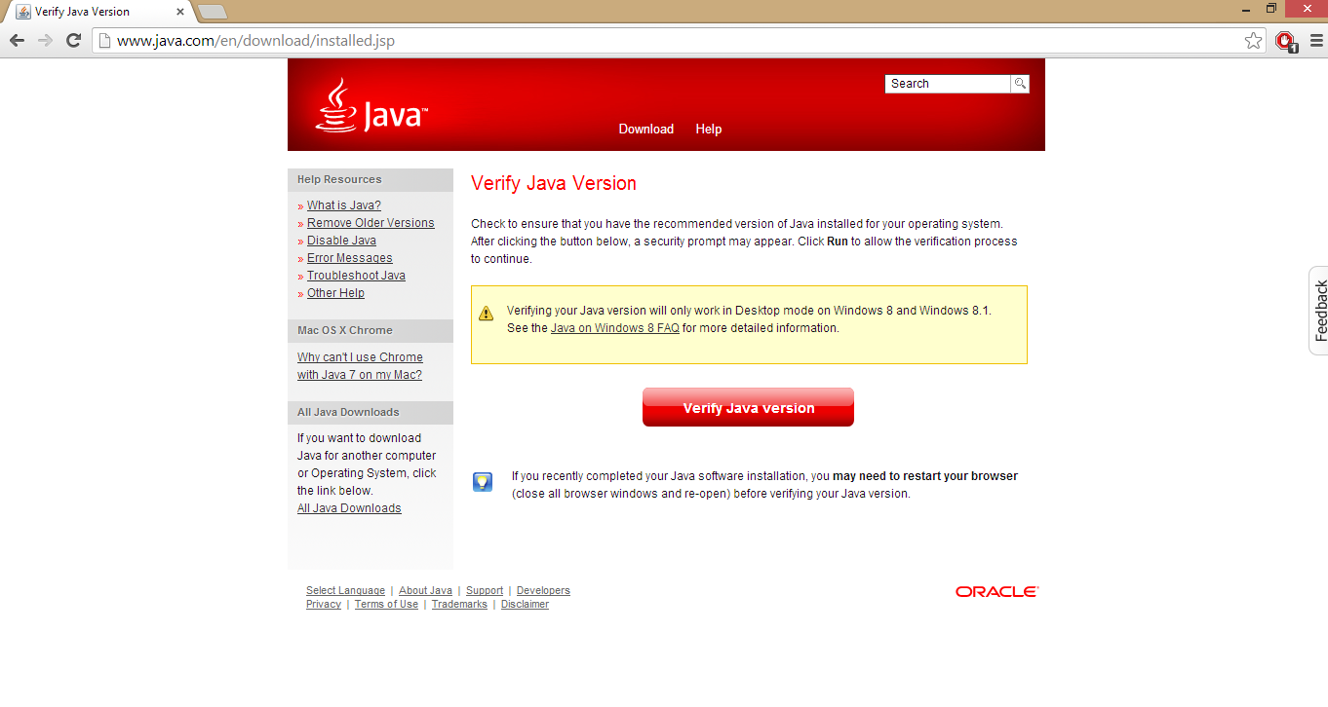

1. You will be prompted to run the java applet click on the “Run this time” button.

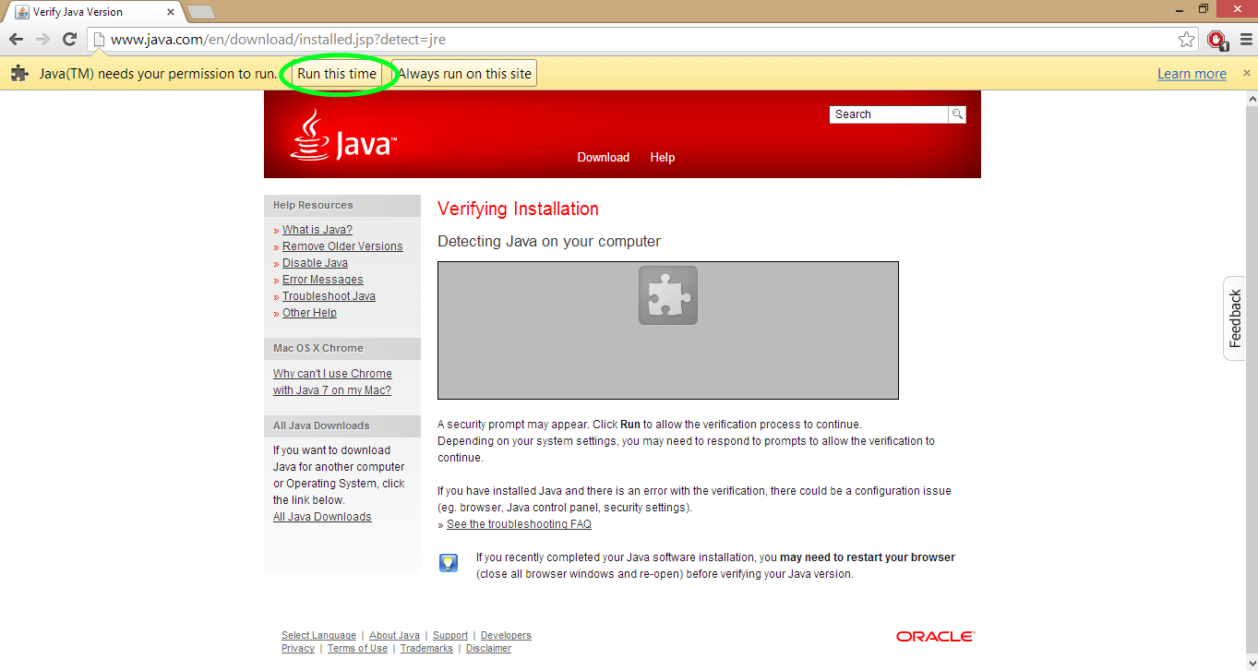

1. Click “Run” to run the actual applet.

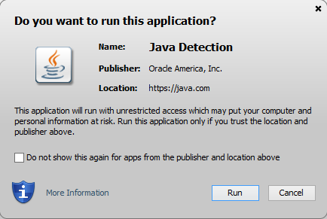

1. Following screen will appear which confirms your Java version is verified and up to date.

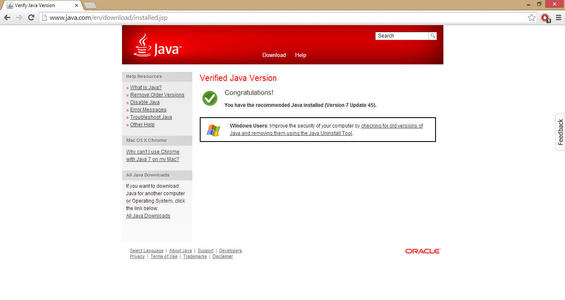

1. If you don’t find the java version installed on your system click on the link below to download the java runtime environment.

<http://www.oracle.com/technetwork/java/javase/downloads/index.html>

The page appears as below. Click on the download java and install the version specific to your operating system.

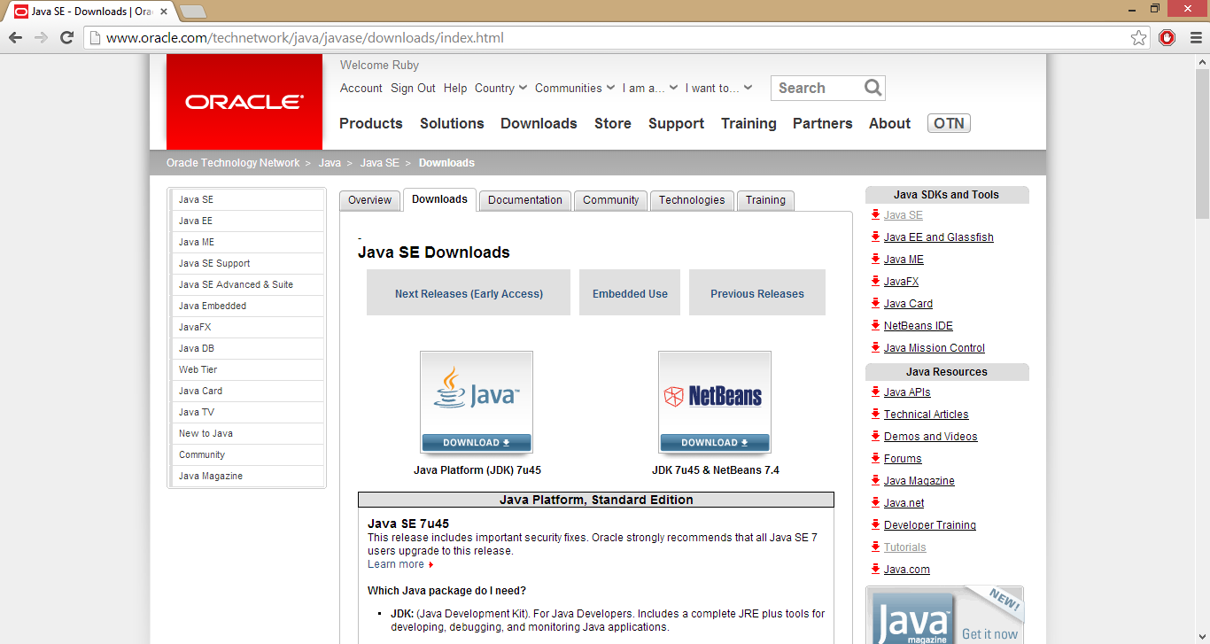

1. Scroll down, accept license terms and select the version compatible with your OS.

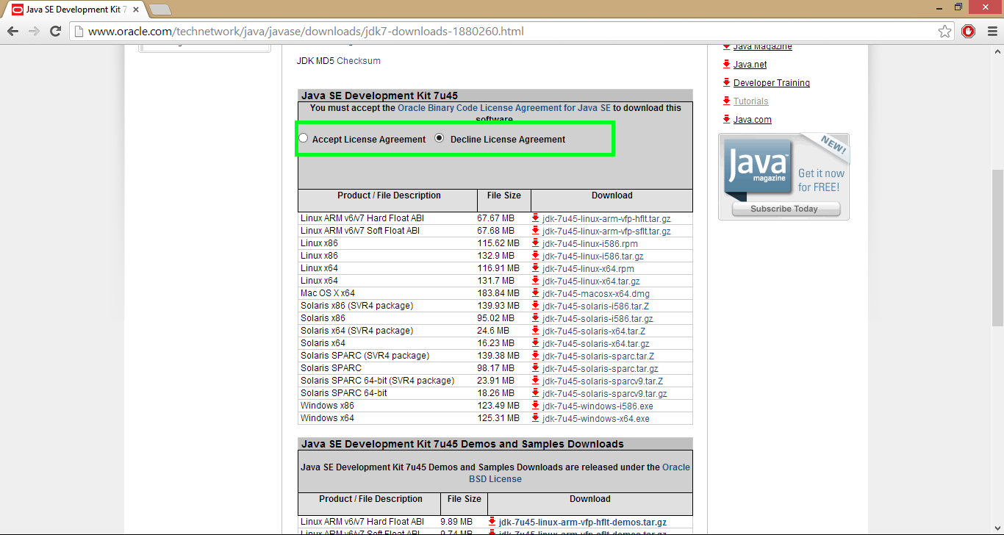

1. Click next when you see the prompt below.

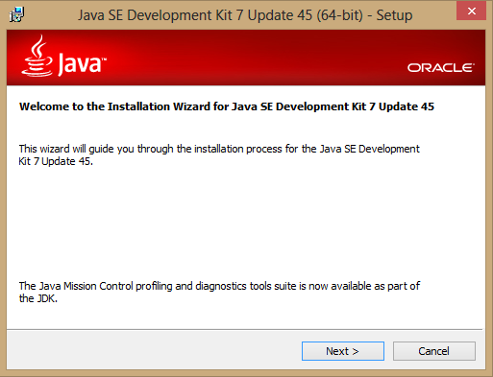

1. Development Tools is selected by default, click next.

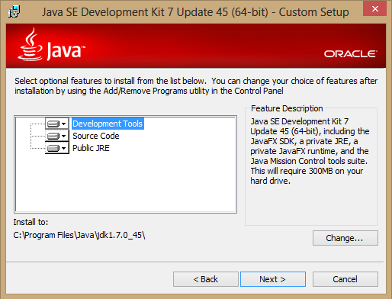

1. It will start progress and show the status.

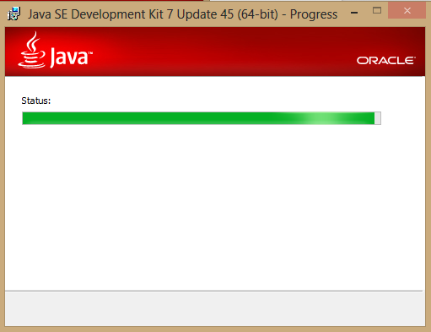

1. You can simply click next or change the destination folder if following screen appears. Otherwise, proceed with installation wizard.

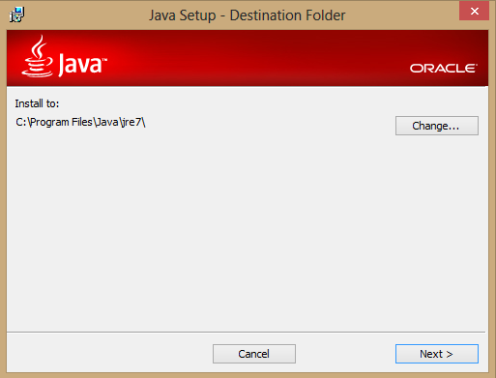

1. If you get the following screen, close any Java programs that are open, save your work, click Close Programs and Continue.

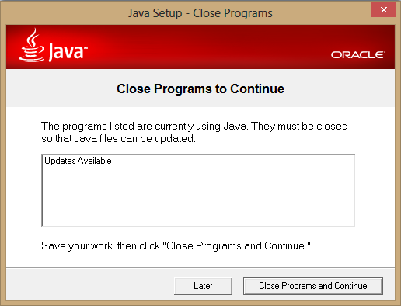

1. You will notice installation progress.

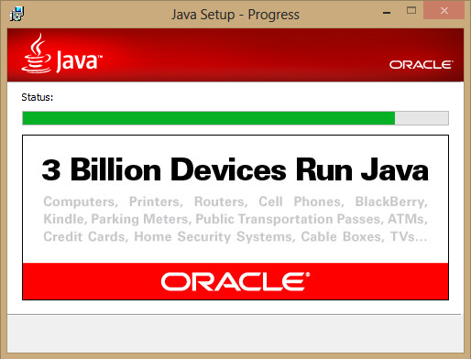

1. Click Next Steps if you wish to download tutorials, API Documentation, developer guides, or more. Otherwise click Close to close the setup.

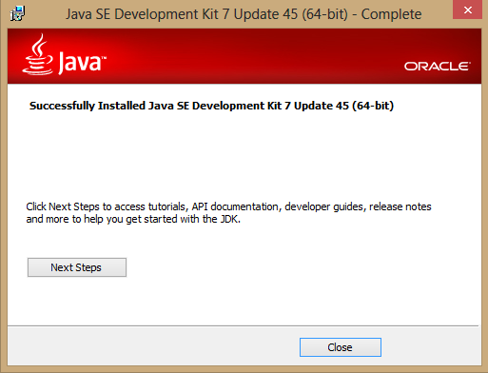

If you face any issues follow the below link to trouble shoot.

<http://docs.oracle.com/javase/7/docs/webnotes/install/>

**Setting the Java Environment Variable**

Tomcat will need to know where you have installed java. To do this, you will need to set the environment variable JAVA_HOME to home directory where you installed java.

Here are the steps for setting the environment variable on my computer (Window's Machine). The steps will probably be similar for other Windows computers.

1. Open the control panel under the start menu.
2. Double-click on System.
3. Click on the Advanced tab.
4. Click on the Environment Variables button.
5. Under System Variables, click on the New button.
6. For variable name, type: JAVA_HOME
7. For variable value, type the path of your JRE installation as shown below.

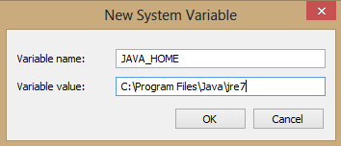

Continue to click OK to exit the dialog windows.

**Tomcat**

After setting the JAVA_HOME environment variable, you can install tomcat.

Go to the Tomcat Web page. - <http://tomcat.apache.org/>

1. In left pane under Download, select Tomcat 7.0

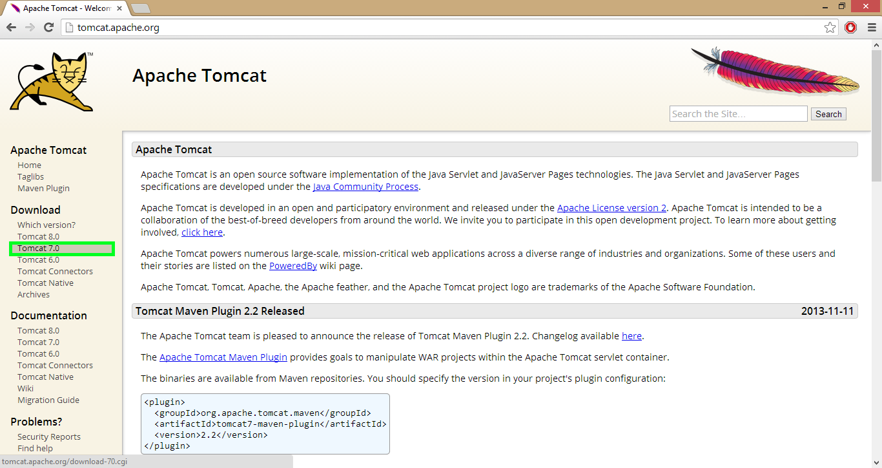

1. Scroll down to select the platform used to run tomcat.

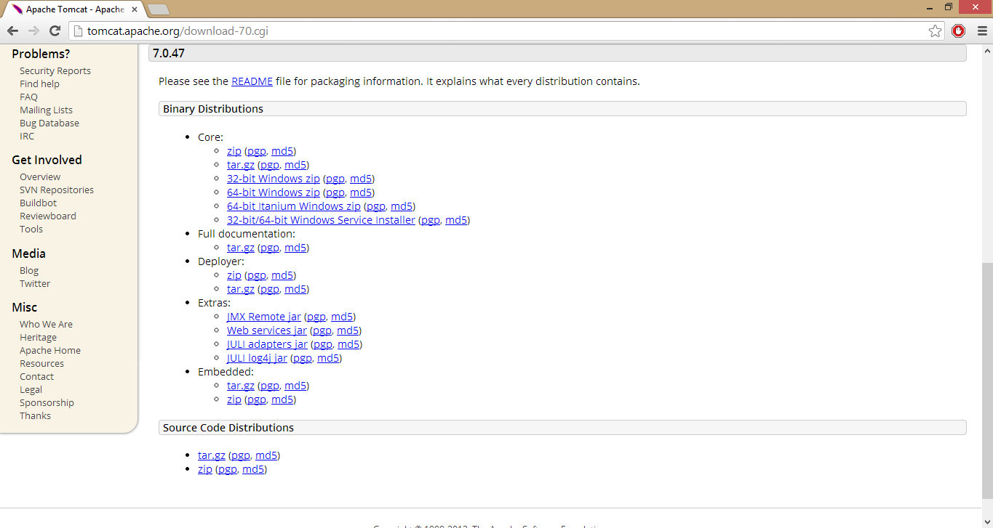

1. Once you download, extract the zipped file and go to bin folder. Double Click tomcat.exe file and run the setup.

**MySQL**

Visit the MySQL <http://www.mysql.com/> website to install the latest version of the MySQL database server. You would require this for storing the application information. Make sure you note down the database username and password. You would require them before you start your application.

1. Go to products tab.
2. Click on Download MySQL Community Edition
3. When you see next page, scroll down, select the platform on which you wish to install SQL. Download MSI Installer.
4. You might need to signup/signin before starting download.
5. Once you sign in, click Download Now button. It will start the download.
6. Now run the setup.
7. When you see the welcome screen, click on “Install MYSQL Products”.

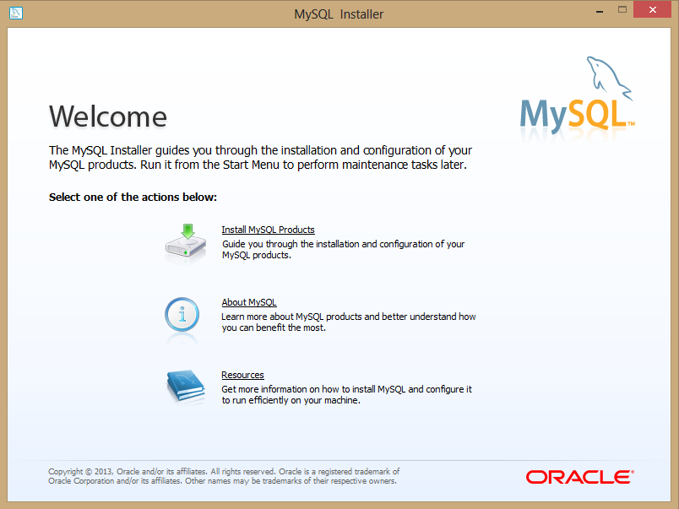

1. Accept license terms and click next.

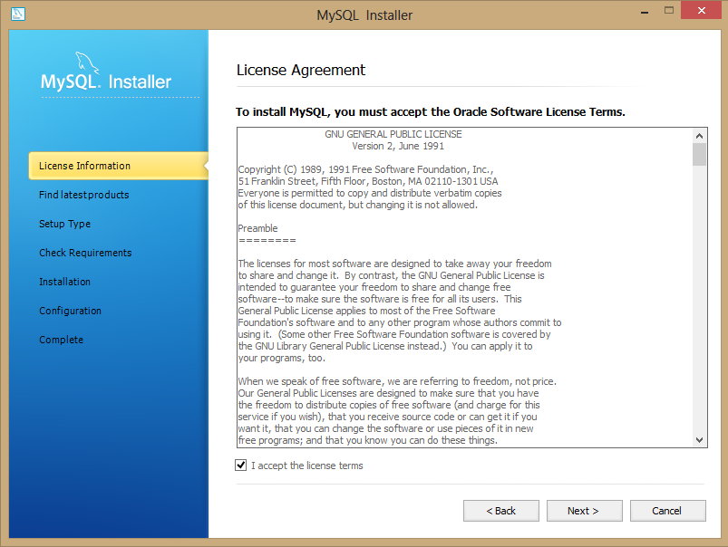

1. Check “Skip the check for updates” if you wish to skip. Or select one of the options above.

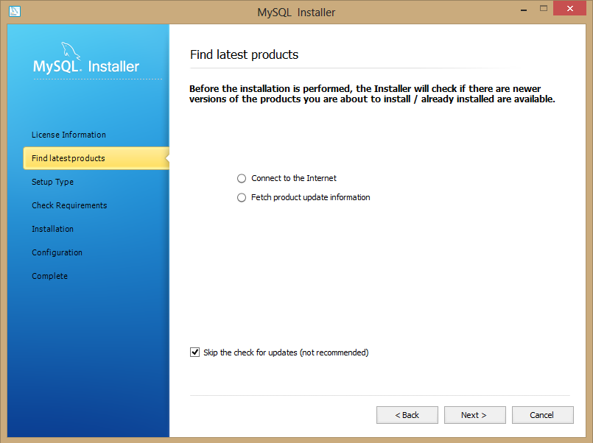

1. Click next.

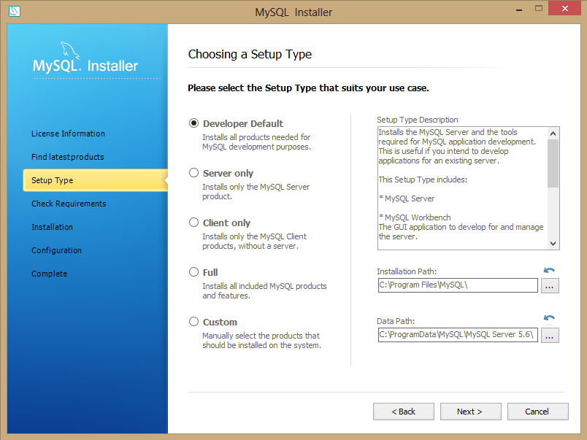

1. When all requirements are met, click next.

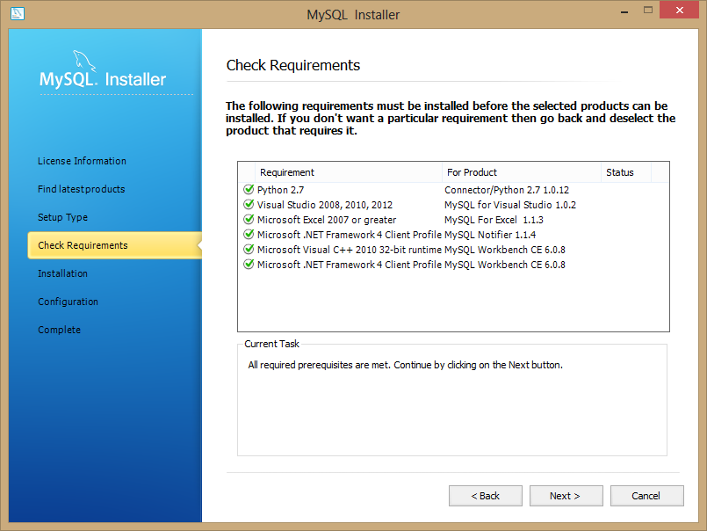

1. Click Execute.

It will take few minutes to download and install all the products.

If download stops as a result of any problem (say, internet connection is lost), run the setup again and repeat above steps until everything gets installed.

When everything is installed successfully, proceed with setup by clicking next.

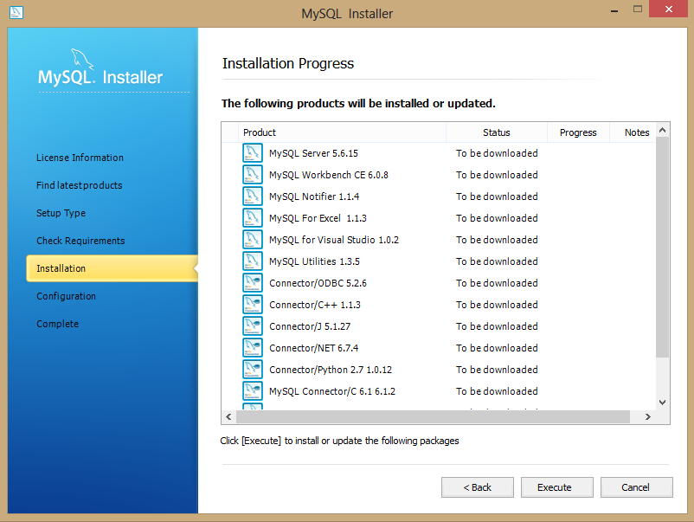

1. Click next after configurations are completed.

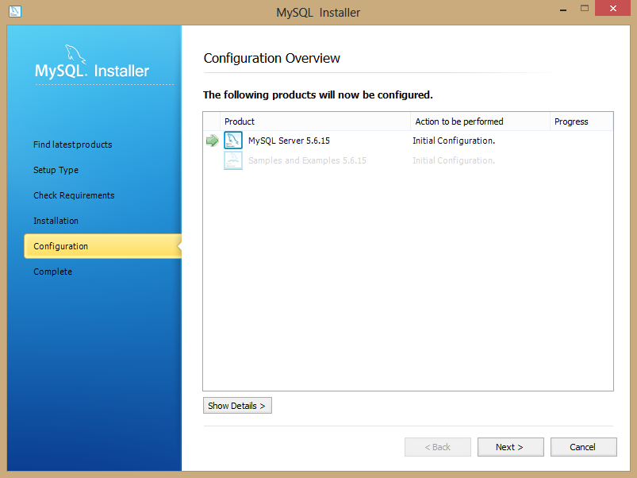

1. Keep Config Type as Development Machine and all other setting default. Click Next.

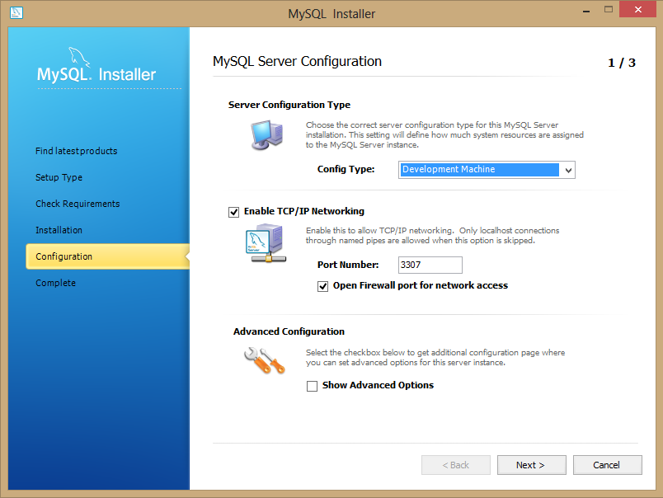

1. Provide password for default account. If you want to create new user, click on Add User and new window will appear.

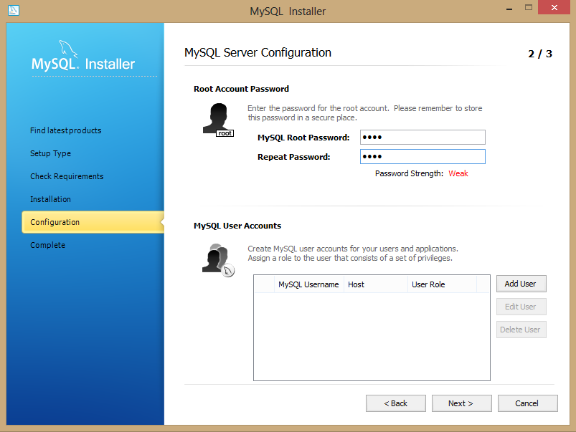

1. Provide username and password. Click OK.
2. When you create a user, it will appear in the list of user accounts. Click Next.

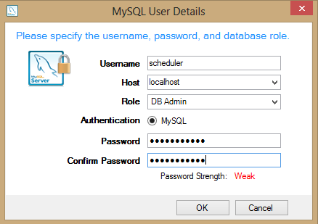

1. Click next.

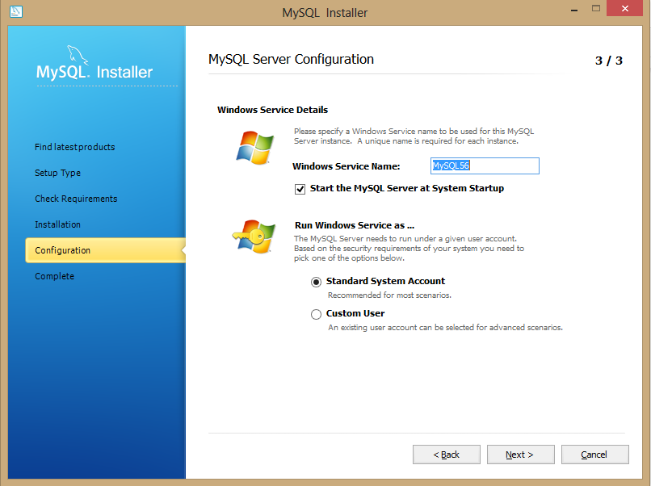

1. Click next when configurations are completed.

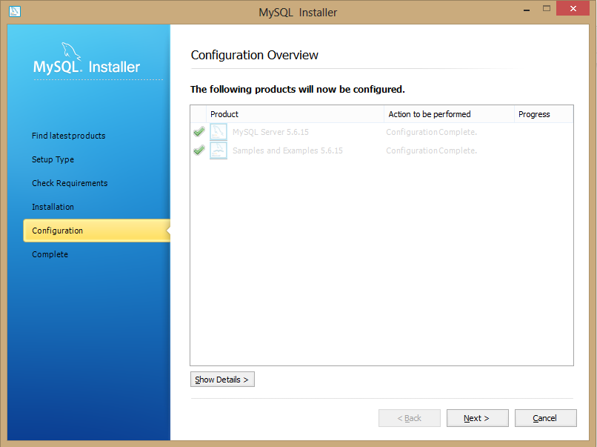

1. When installation is complete, you can check mark “Start MySQL Workbench after Setup” if you wish to start SQL Workbench. Otherwise, click Finish to exit setup.

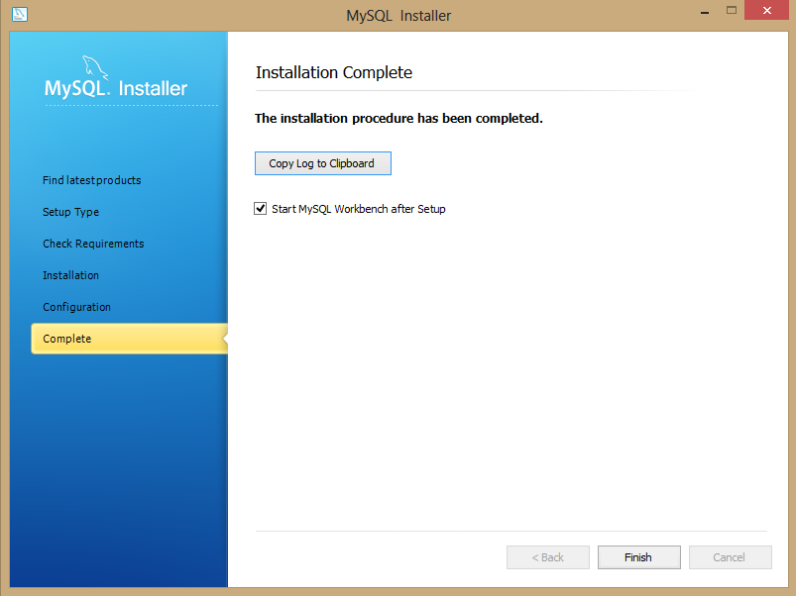

Msql Help URL: <http://dev.mysql.com/doc/refman/5.5/en/installing.html>

Follow the MySQL Workbench only if it was not installed with MySQL.

**MySQL Workbench** (if it’s not installed while MySQL installation)

We will use MySQL Workbench to communicate with the database. MySQL Workbench is the graphical user interface to connect to the database and make modifications to the data. It can also be used to troubleshoot any issues related to the database if arises. To download the software, visit the site <http://dev.mysql.com/downloads/tools/workbench/> and download the latest version. Follow the install instructions to install the application on your operating system. If you face any issues in the installation follow the below help URL.

**Installation**

Once you have all the desired softwares installed on your system we will install the database first and then the application on the system.

**Importing Database**

1. Open My SQL Workbench from start menu in windows.
2. Go to Database in menu bar and select “Connect to Database”.

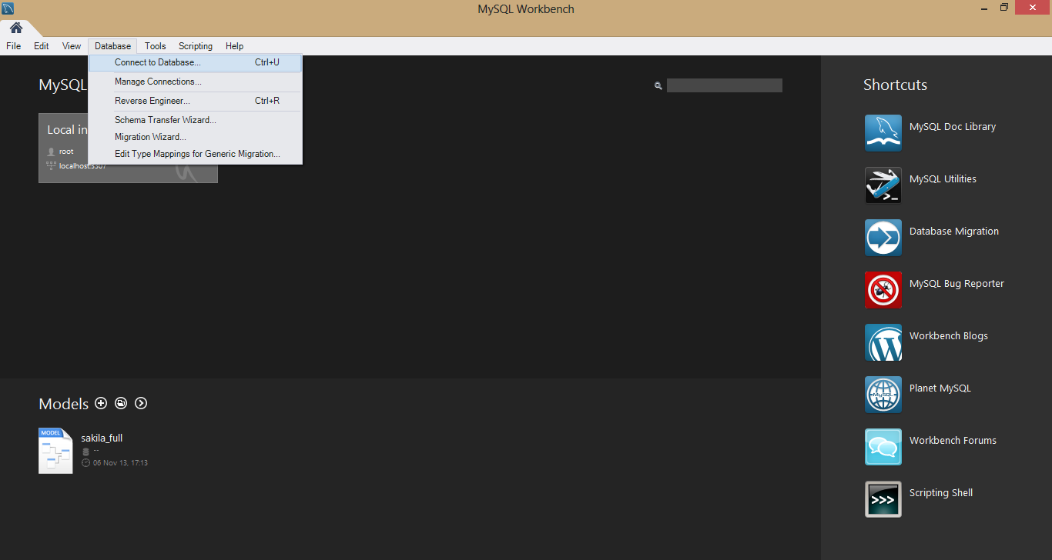

1. A Connect to Database dialog box will pop up with default username (i.e. root). You can change the username if you want. Click OK.

Another dialog box will appear that will ask for password of user. Provide the password and click OK. You will see the screen as below.

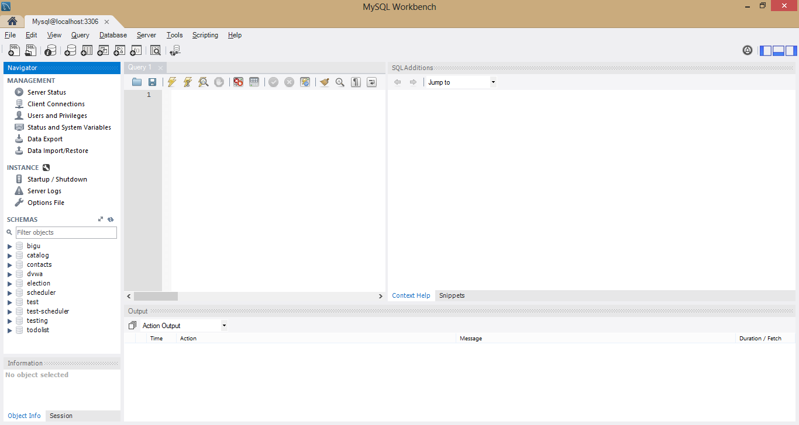

1. Copy the SQL schema given for Scheduler and paste it in query window. Select the entire text and click execute button on top of query window.

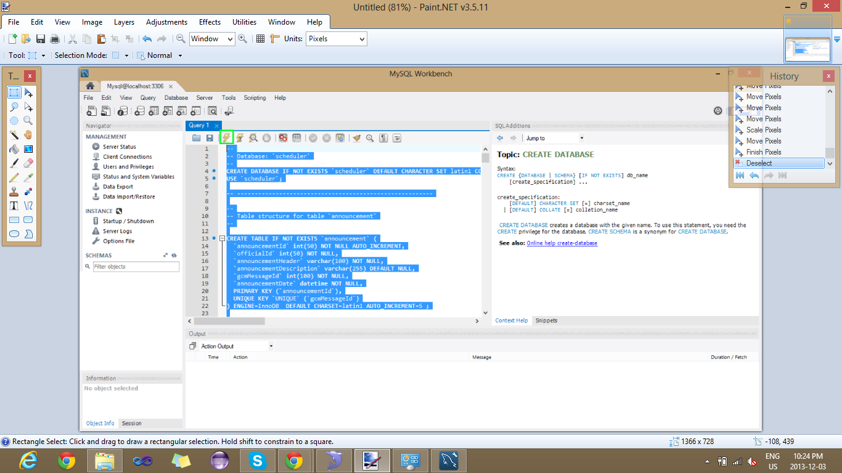

1. Once all queries are executed, a schema named “scheduler” will appear in left pane.

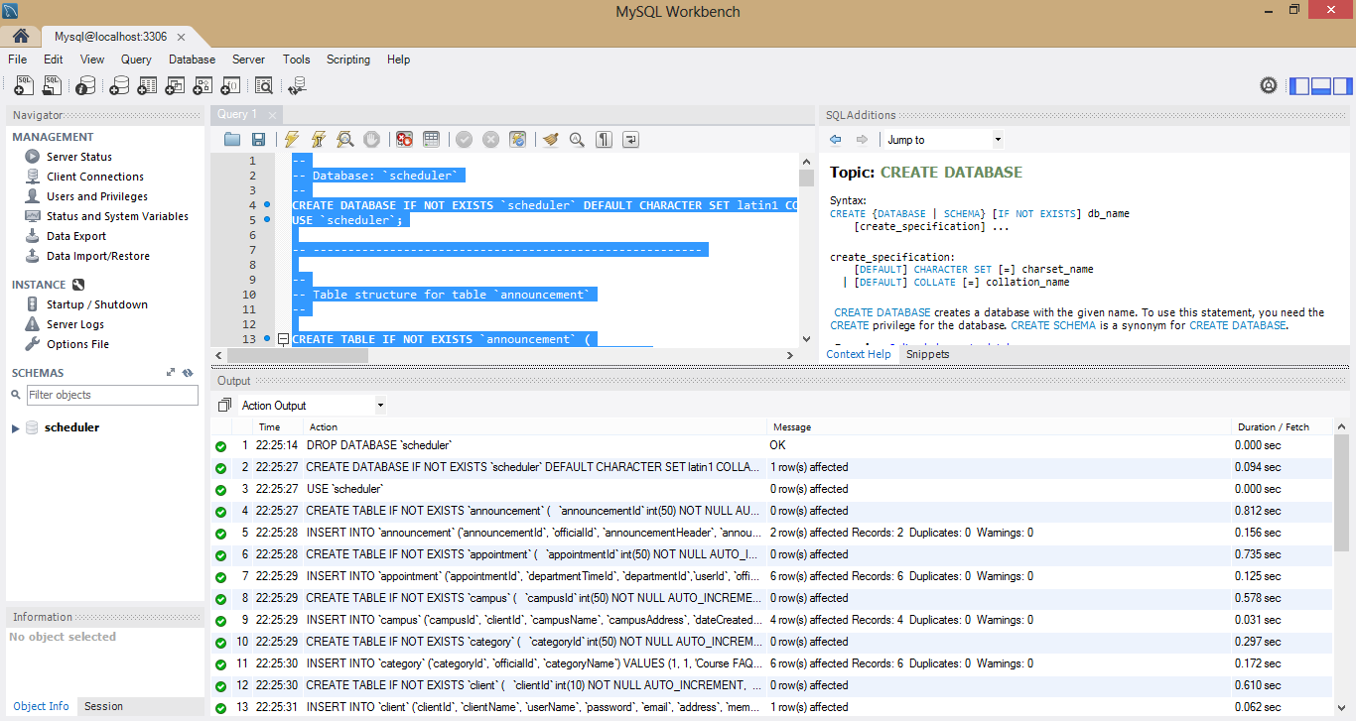

1. Expand scheduler under Schemas in left pane. You will see the following tables.

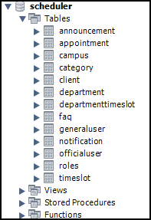

Mysql Workbench Help URL: <http://dev.mysql.com/doc/workbench/en/index.html>

**Another way to import database** is by navigating to Management tab in Navigator pane in the left. There are two tabs at the bottom of this pane. Select “Management” tab. Click “Data Import/Restore”. Select the sql file and click on Start Import.

**Deploying War**

To install application on the server, copy the war file “**Scheduler.war**” provided with the application to the tomcat webapps directory and start the server.

Follow the steps below in order to start server and deploy the application.

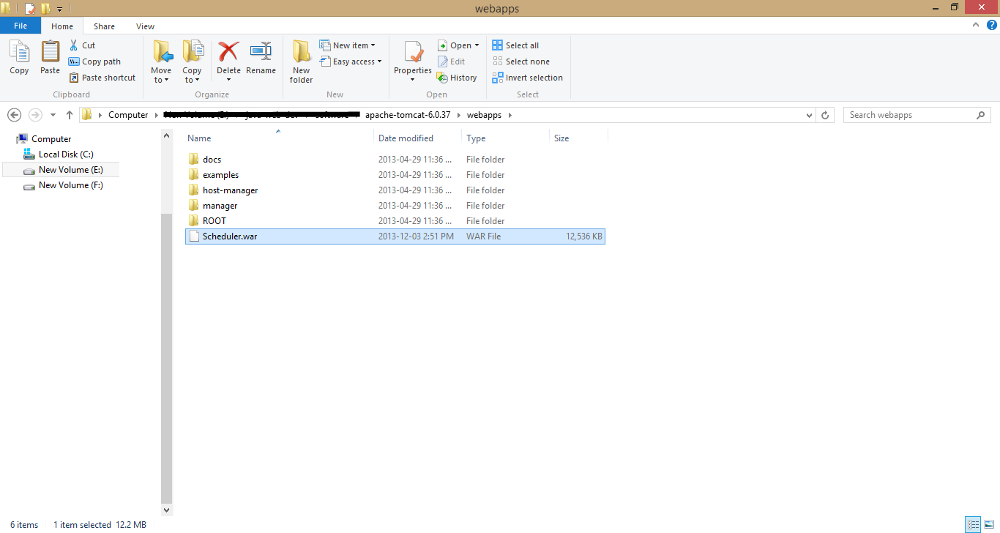

**Starting Application**

Starting the application is three step process start server, change database connections and restart server again.

**Starting Server**

To start the server, browse to tomcat root directory bin folder using the cd command in command prompt. Execute the startup script depending upon the operating system you have.

1. Type **startup** in command line. You will see something as below.

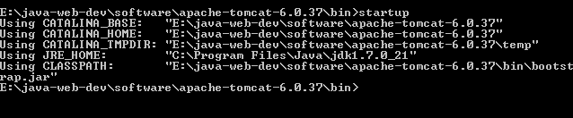

1. Within seconds, another window will open. It deploys the project.

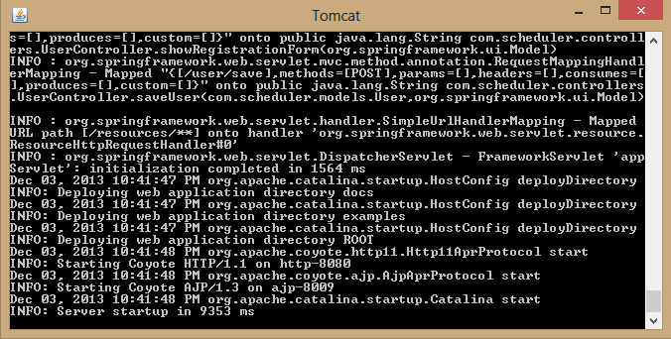

1. When you see server startup, you can test the server startup by browsing <http://localhost:8080/> in URL.

You should see the following page.

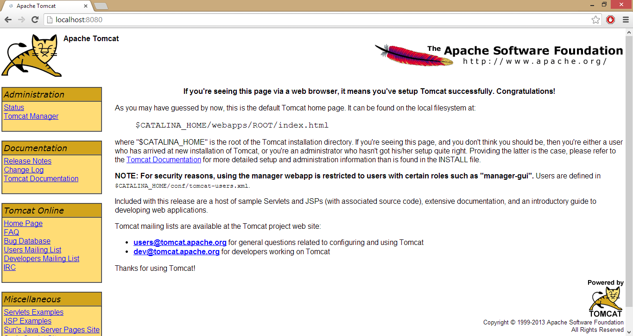

Further information about configuring and running Tomcat can be found in the documentation included here, as well as on the Tomcat web site <http://tomcat.apache.org/>

**Changing Database connections**

You can change the database connection anytime to make the application compatible for running with the server configurations.

* To do this, go to the file application.properties located in the Schduler/webapp/WEB-INF/classes/ folder in the deployed application. Change the username and password for the database according to your MySQL database configurations. Eg. If username and password is root and 123456 respectively.

**username=root**

**password=123456**

* After changing the database details you must restart your application server.

**Deploying Scheduler**

To verify that installation is successful, follow the steps below.

**Open the URL**

Open the application root URL <http://localhost:8080/Scheduler/> in any browser and check if you are able to view the application home page as shown below. If you see the home page, then proceed to the next step to check login. If not, please verify all the steps above and try to solve the issue if it still exist, contact support.

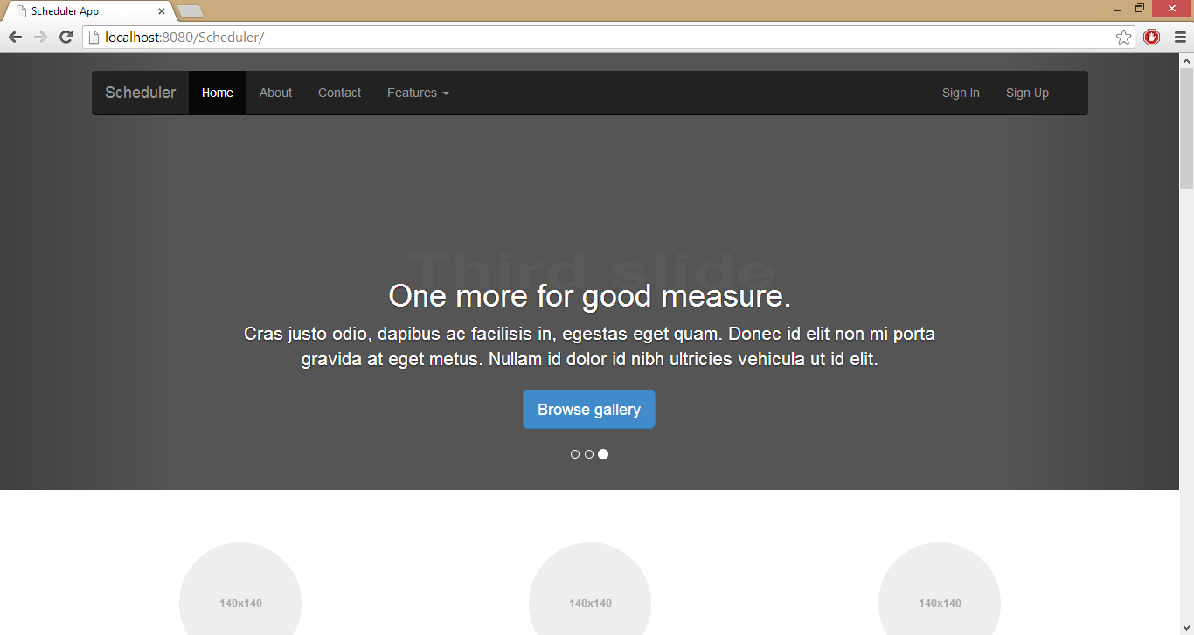

**Congratulations!** Your Scheduler application is deployed successfully.

**Android Phone**

Scheduler Android application is stored in an APK file (i.e., a file named Scheduler.apk).  You must install the APK on your Android phone in order to run it.  Normally, the Android applications are installed using the Google Play store since we don't have that ready yet, we will install the application manually with the Apk provided. We will use the Apk Installer provided by the Google Play services to install the Scheduler application. Download or copy the APK file to your computer. Mount your phone’s SD card in the computer (or connect the phone with the SD inserted in it to the computer via USB cable) and copy the APK file to the SD card, then insert the SD card in the phone. Once this is done we are ready to install the application on your phone.

**Requirements**

This method requires that you have.

1. Either cellular or internet service on your Android phone to use the browser, and

2. SD card mounted (inserted) in the phone.

**Installation Instructions**

1. Go to the google play services on your mobile and search for the Apk installer application to install the Unpublished Apk. You should be able to find the application as shown below.

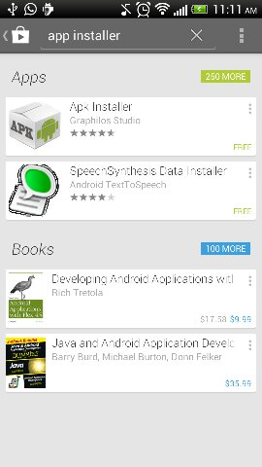

1. After you find the Apk Installer, click on the application to go to the install page to download and Install application. As shown below.

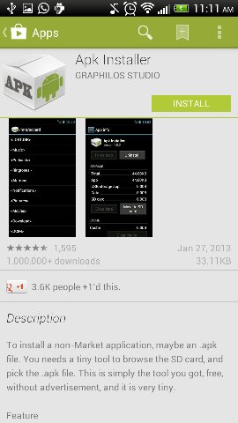

1. When application in installed, open the application and browse the phone’s storage directory and go to the folder where you copied the Apk file.

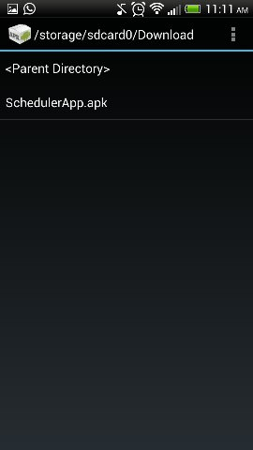

1. After that click on the Application Apk to install the Application. If you find dialogue showing multiple apps which can perform the same thing, select the Package Installer from the menu which is default Android application Installer.

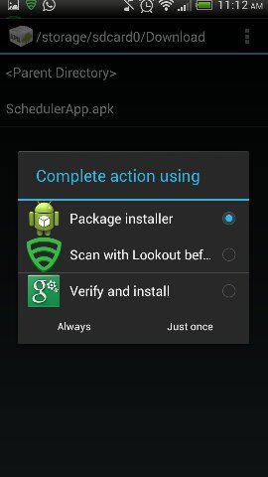

1. As the application is not signed, you might see the dialogue below if you don’t have the option to install unsigned application. Don’t worry, click on the settings button to open settings page for the phone.

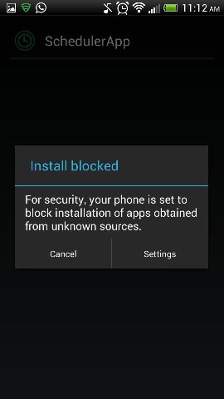

1. Once you are on the Settings page, check the option to install application from Unknown Source as shown below. Once selected, click on the save button and go to step 3 and repeat the process again this time you should not get the dialogue to change settings.

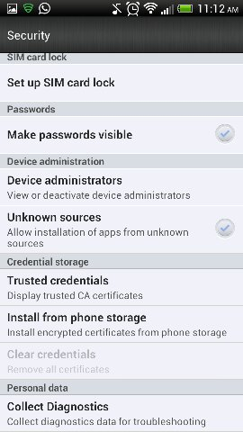

1. Click on the application’s APK file name.  A new screen showing the selected application’s name at the top is displayed.  This screen gives you more details about the application including different functionalities that it will need to access. To install the application, click on Install button.

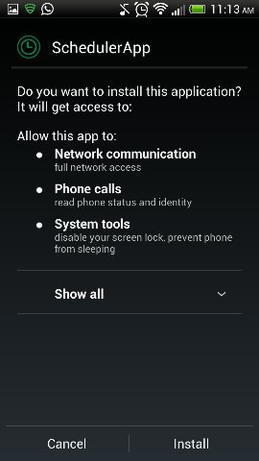

1. You will see the progress screen which indicates about the installation progress.

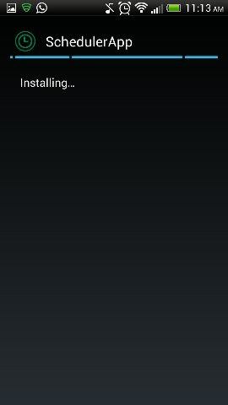

1. A new screen is displayed once the installation is complete and you can choose to immediately run the application by clicking the Open button at the bottom of the screen.

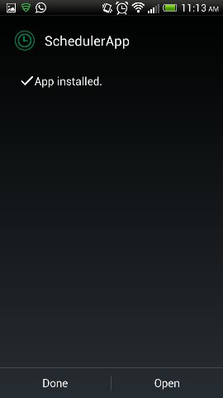

1. After installing the application when you run the application, you would see the login page. Please login to the application using the credentials provided. (You can also sign up as a new user in web and use those credentials).

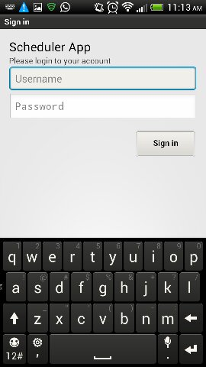

1. After login you would see the below Menu screen. Click on the specific button to perform the operation you want.

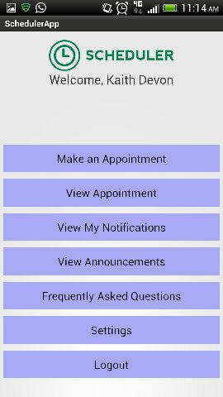

**Congratulations!** Now you can book your appointments from Scheduler Mobile App and receive notifications about any updates for appointments.