**Street Medical Delivery Service Proposal**

Group Members: Nick Cao, XingCheng Qian, Shanker Pillai, Lauren Rose

Sponsor: Street Medicine at Pitt

1. **Introduction**

This proposal describes the development of a web application that coordinates the distribution of medical supplies to individuals in need. By integrating clients, volunteers, and administrators into a single platform, we aim to simplify the submission of supply requests, update delivery statuses in real time, and provide administrators with analytics and data tracking. The overarching goal is to help Pittsburgh’s Street medical team improve resource coordination, reduce administrative overhead, and gain deeper insight into their weekly supply usage.

1. **Objective & Background**

**2.1 Objective**

The main objective of this capstone project is to build a multimodal accessible website application that allows individuals to request or order various supplies and provides a mechanism for Street Medicine volunteers to track and deliver these items efficiently. The application will also accommodate real‐time feedback and adjustments based on client needs, such as changing item preferences or updating delivery locations.

**2.2 Background**

Street Medicine at Pitt is a student‐run interdisciplinary organization affiliated with the University of Pittsburgh School of Medicine’s Center for Street Medicine. It provides healthcare, social support, and essential resources to rough‐sleeping and unhoused communities in the region. An integral part of its work involves weekly Wednesday evening “street rounds,” where volunteers offer direct assistance and supplies. Currently, Street Medicine at Pitt partners with the Second Avenue Commons Clinic, which provides shelter, medical services, and engagement centers for adults experiencing homelessness. Despite these efforts, the team faces challenges in consolidating supply requests and tracking their distribution. Requests often arrive via multiple channels (e.g., paper forms, social media, email), while volunteers use separate methods to log deliveries, leading to fragmented data. By building an integrated platform, Street Medicine at Pitt can improve its recordkeeping, strengthen volunteer coordination, and respond more effectively to emergent client needs.

1. **User Stories & Goals**

These goals will guide development and require sponsor approval. Each story is associated with the sprint or timeframe in which we expect to complete it:

1. **Hosting Pitt Server** (Sprint 1)  
   *“We need official hosting on Pitt servers so that our site is publicly accessible.”*  
   This entails working with Pitt IT to set up hosting permissions and domain configurations.
2. **Home Page UI** (Sprint 2)  
   *“As a user, I want a clear landing page that explains the service and helps me sign up or log in.”*  
   We will develop a static mockup in React, focusing on ease of navigation.
3. **Admin View** (Sprint 2)  
   *“As an administrator, I want to manage all user accounts and track requests in a unified dashboard.”*  
   This will include features to edit, delete, and view user information and requests.
4. **Client View** (Sprint 2)  
   *“As a client, I want to submit new supply requests and check the status of existing ones.”*  
   This requires both front‐end forms and back‐end endpoints for database updates.
5. **Volunteer View** (Sprint 2)  
   *“As a volunteer, I want to see pending deliveries and update the status or location in real time.”*  
   We will implement an interface for volunteers to access tasks and mark orders complete.
6. **Data Analysis and Reporting Tool** (Sprint 3-4)

*“As an admin, I want to see data dashboards showing weekly delivery counts, item usage trends, and user engagement.”*

1. **Guest Request Feature (No Login Required)** (Sprint 2-3)

*“As a guest user, I want to submit a supply request without creating an account, in case I cannot or prefer not to sign up.”*

1. **Basic Backend/Database Setup** (Sprint 1–2)  
   *“As the development team, we need Spring Boot and SQLite tables (users, items, requests) with CRUD operations.”*  
   This covers the foundation for data storage and retrieval.
2. **Google Maps API Integration** (Sprint 3)  
   *“As volunteers/admins, I want to see real‐time maps to track or update the location of deliveries.”*  
   We will integrate location data into the delivery workflow.
3. **User Authentication** (Sprint 2)  
   *“As a user, I want a secure registration/login system with different roles (admin, volunteer, client).”*  
   Role‐based restrictions will protect sensitive data and ensure proper access levels.
4. **Workflow Charts & Documentation** (Sprint1)  
   *“As a development team, we need to document process flows (e.g., supply request, volunteer updates) with UML diagrams.”*  
   This ensures consistent understanding among developers, sponsors, and future maintainers.
5. **Pitt Street Med Orientation** (Sprint 1)  
   *“As a team, we must complete the orientation program to safely distribute medicine and align with sponsor protocols.”*  
   Each member will submit proof of orientation completion.

Each goal will be presented to our sponsors for approval and feedback before implementation. While these stories outline the project’s major milestones, we anticipate refining or reprioritizing them based on sponsor feedback.

1. **Expected Outcome**

Upon completion, the Street Medical Delivery Service will offer a secure, user‐friendly interface for placing and fulfilling supply requests. Clients will have peace of mind knowing that their requests are processed systematically. Volunteers will benefit from a clear overview of their tasks and the ability to update delivery progress in real time. Administrators can run analytics to identify trends, such as weekly item requests and the number of volunteers active each day, ultimately leading to better decision‐making and resource allocation.

1. **Expected Impact**

By implementing this web application, the street medical team is expected to experience significant improvements in task efficiency and data transparency. Sponsors will gain better visibility into critical metrics like total deliveries, item usage, and volunteer participation. Access to such data may help secure additional funding or resources by providing quantitative evidence of community impact. Clients also benefit from an improved user experience that keeps them informed about the status of their requests, thereby fostering trust in the service.

**6. Project Design**

**6.1 Architecture**

We employ a client‐server model. The front end is a React web application that handles user interaction and page rendering. The back end is a Spring Boot application exposing RESTful APIs, handling business logic such as request creation, location updates, and user authentication. A SQLite database stores user profiles, requests, and related metadata.

**6.2 Technologies & Frameworks**

We selected React for its component‐based approach, which encourages modularity. The wide range of available libraries also simplifies tasks such as state management (e.g., Redux) and testing (e.g., Jest). On the back end, Spring Boot allows rapid development and scales well for future growth or additional features. SQLite meets our current storage needs, given the relatively modest volume of requests (30–50 per week), and it requires minimal setup or hosting costs.

We will additionally employ:

* GitHub: Version control, pull requests, and code reviews.
* Trello: Task management, user stories, and sprint tracking.
* Slack/Discord: Team communication and quick collaboration.
* JUnit: Testing for backend logic in Java.
* Jest/React Testing Library: Testing for frontend components.

**6.3 New Technologies**

Some team members will learn shadcn/ui to streamline React UI development, explore the Google Maps API for location tracking features, and possibly investigate Google Cloud Platform if advanced hosting or analytics become necessary. We also anticipate incorporating encryption measures for user data, ensuring privacy for sensitive records.

**6.4 Foreseen Issues**

Data security is the primary concern, given that users share confidential information such as addresses and health‐related requests. We will encrypt sensitive data in the database and adopt secure protocols (HTTPS) for data transmission. Integration bugs between the React front end and the Spring Boot back end can arise if object models are not carefully managed. Lastly, sponsor requirements may change mid‐development, so we will stay agile, adjusting project goals and timelines in response to feedback.

**7. Team Strengths and Weaknesses**

Our development team brings varied expertise:

* **Nick Cao** is adept in back‐end programming and databases (SQL, SQLite) but has limited JavaScript/Python experience.
* **Xingcheng Qian** excels at front‐end development (React, HTML, CSS, JS) and collaboration but has weaker English communication and less back‐end expertise.
* **Shanker Pillai** contributes strong research, writing, and front‐end skills yet has minimal familiarity with databases.
* **Lauren Rose** is design‐minded, an excellent communicator, and proficient in Python, HTML, and CSS but lacks knowledge of advanced system architecture and deeper back‐end tasks.

By dividing tasks according to each member’s strengths and fostering an environment of shared learning, we will efficiently address potential skill gaps and ensure continuous knowledge transfer among team members.

**8. Expected Timeline**

We plan to operate in sprints, each spanning two weeks.

* **Sprint 1 (Jan 24–Feb 7)**: Requirements finalization, initial React + Spring Boot setup, basic database schema.
* **Sprint 2 (Feb 7–Feb 21)**: Implement user authentication (client, volunteer, admin), create static UI for request submission, set up essential APIs.
* **Sprint 3 (Feb 21–Mar 14)**: Expand to volunteer scheduling, incorporate Google Maps or location features, refine data analytics for weekly deliveries.
* **Sprint 4 (Mar 14–Mar 28)**: Midterm updates, security enhancements (encrypt sensitive data), advanced analytics or reporting dashboards, continuous sponsor feedback.
* **Sprint 5 (Mar 28–Apr 18)**: Final testing, bug fixes, deployment on Pitt servers or other approved hosting, final demonstration, and submission of reports.

**9. Communication**

**9.1 Communication with Sponsor**

We will meet weekly with sponsors on Fridays from 3–4 PM, usually via Zoom. A meeting link and agenda will be shared at least 48 hours in advance. For urgent or detailed questions outside of these sessions, we will reach out through email, ensuring the entire team is copied, with responses expected within 24 hours. We also maintain a dedicated Slack channel, #streetmeddeliveryservice, for quick updates, scheduling confirmations, or immediate clarifications.

**9.2 Team Internal Communication**

* **GitHub** will serve as our primary version‐control platform. We will create pull requests for major updates so team members can review changes.
* **Trello** will track user stories, tasks, and sprint progress.
* **Discord** is used for day‐to‐day discussions and quick stand‐ups. Any significant code or architectural change will be communicated here, so the entire team remains informed.
* We plan to hold an internal meeting once a week to synchronize progress, assign tasks, and resolve any blockers.

**10. Activity and Sequence Diagrams**

In addition to written documentation, we have created activity and sequence diagrams. The activity diagram describes the flow from checking user credentials, registering a new account if needed, and directing users to role‐specific dashboards (Admin, Client, Volunteer). The sequence diagrams show interactions among the client/browser, backend (Spring Boot), and database (SQLite) for key processes such as supply requests, volunteer delivery updates, and analytics reporting. These visual aids ensure the entire team shares a consistent understanding of the system’s overall design.

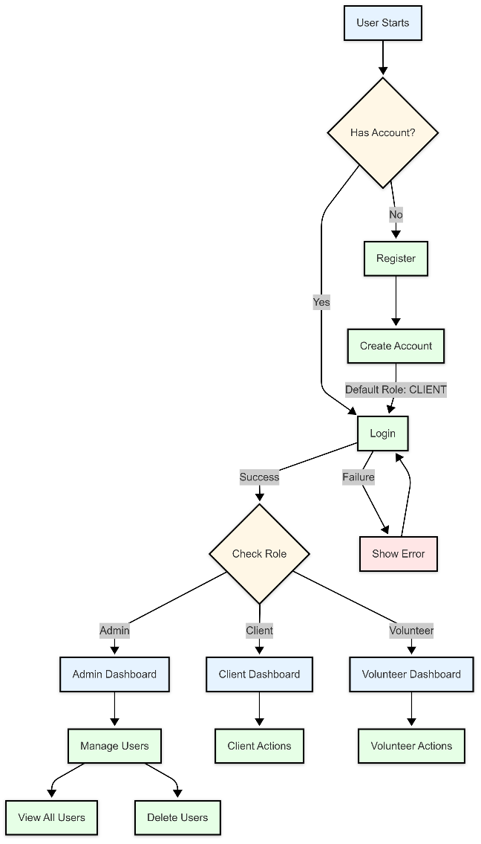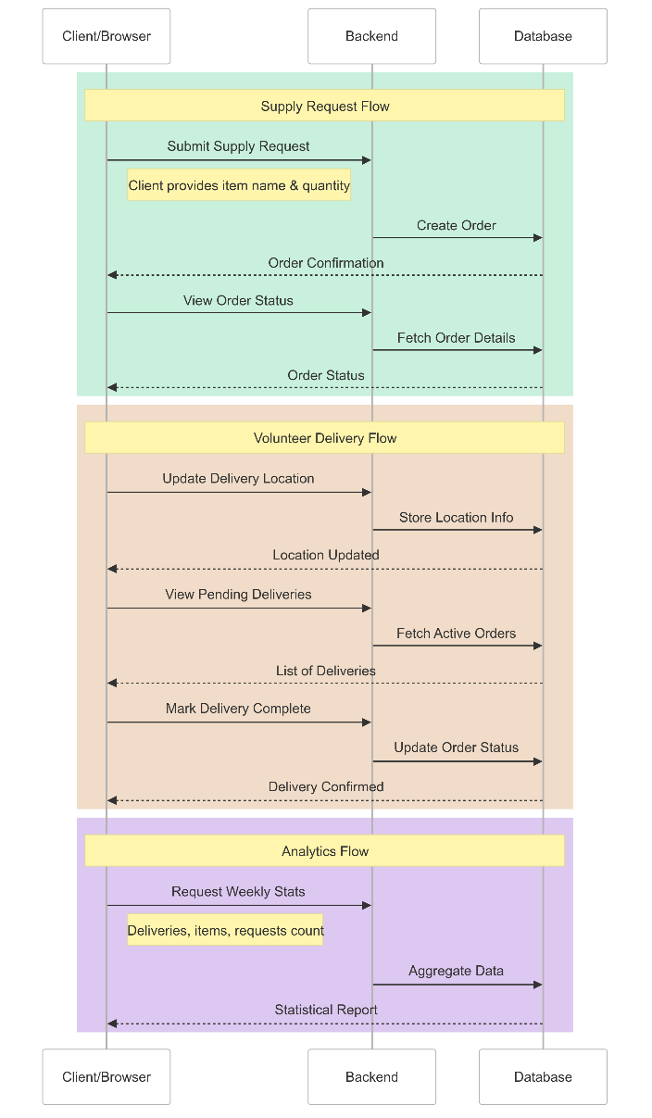

**11. Conclusion**

In summary, this proposal outlines how we will build a Street Medical Delivery Service to streamline the supply request process, monitor volunteer deliveries, and generate valuable analytics for Pittsburgh’s Street medical team. By leveraging a React front end, a Spring Boot back end, and a SQLite database, we believe we can deliver a robust solution that meets sponsor requirements and significantly improves the current process. We have identified our user stories, set a timeline for development, and established clear lines of communication. Upon receiving sponsor approval, the team will begin implementing these features in iterative sprints, ensuring that all stakeholders remain updated through regular demos and feedback sessions.