Ruchita Trivedi / STAT6610 / HW-7

1. Try all of the Activities from Week 7.

**Activity 1:**

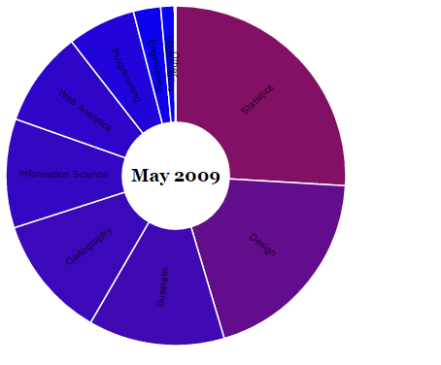

* Changed the color to blue
* var data = [200,150,100,90,80,70,50,20,10,1];
* var depthColors = pv.Scale.linear(0, 200)

**Activity 2:**

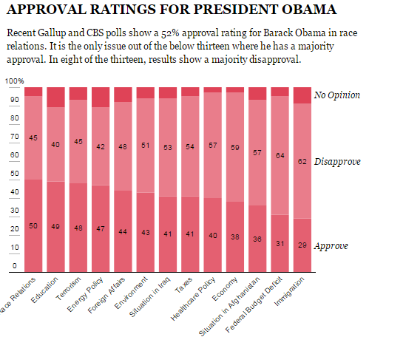

Note: There was no file scatterplot.js for **activity 3**

**Activity 4:**

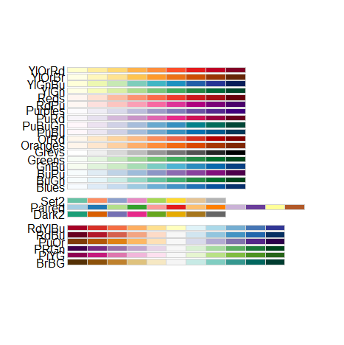

**Activity 5:**

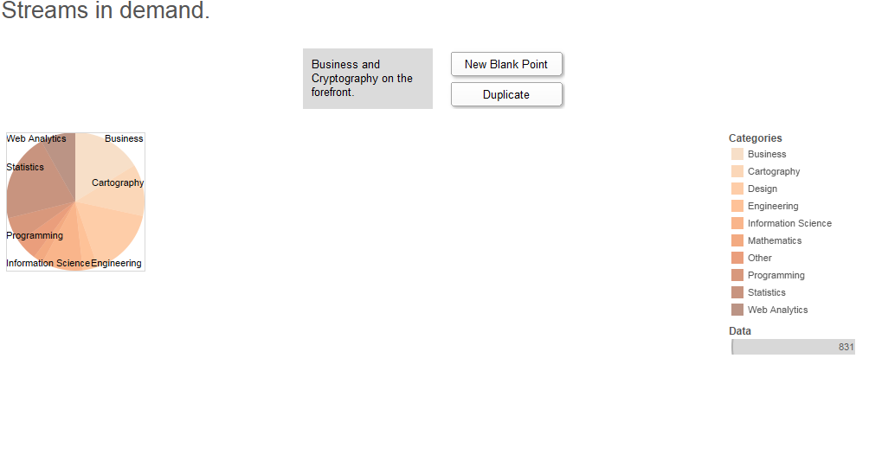**Activity 6:**

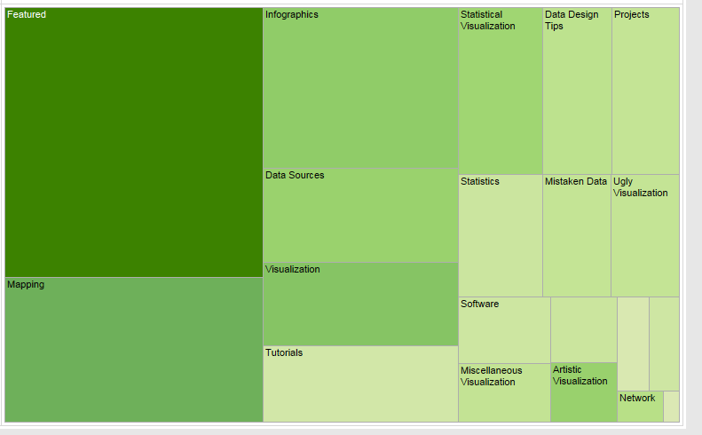

**Activity 7:**



______________________________________________________________________________

2. Using R run the example at the end of the [Proportions2](http://rpubs.com/esuess/Proportions2) presentations.

