**Ruchita Trivedi / STAT-6610/ HW-8**

* **Activity One:**
* From today's presentation [Correlation](http://www.sci.csueastbay.edu/~esuess/classes/Statistics_6610/viz/viz11/Correlation.html#/) try the code for the Simpson's Paradox.  Here is an R Markdown document with the code.  [SimpsonsParadox](http://rpubs.com/esuess/SimpsonsParadox)
* Do you see how the direction of the correlation changes with the confounding variable?

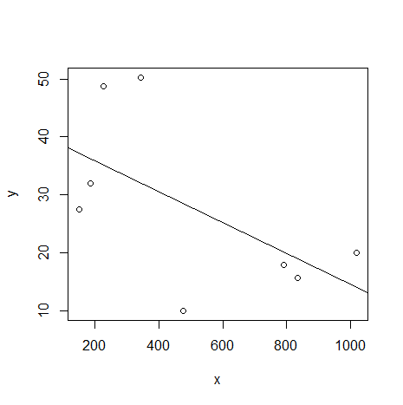

First we looked at the correlation and second at the estimated slopes in regression lines.

The plot above was ignoring the variable “type of book”.

Below is the plot including the variable type of book. We see how the fit line or the direction of correlation changes Thus, The confounding variable to consider is **type of book**, either hardcover or paperback.

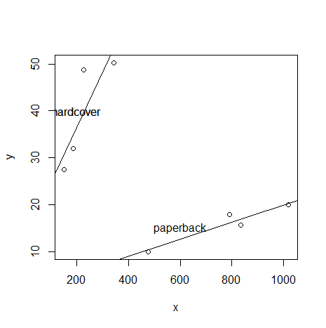

* **Activity Two**
* Download the data from the [Book](http://www.wiley.com/WileyCDA/WileyTitle/productCd-0470944889.html) website for Chapter 6.
* Using R make the scatterplot matrix for the crime data.

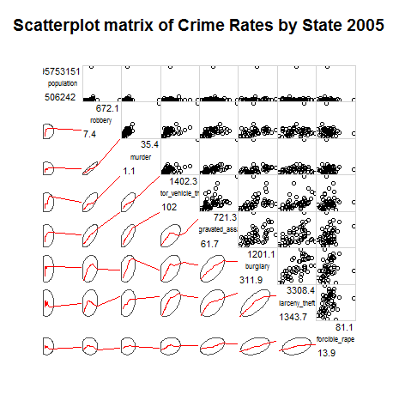

* **Activity Three:**
* Using R make the correlogram for the crime data.

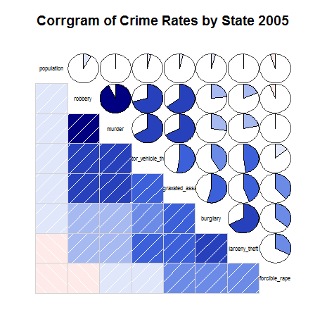

* **Activity Five:**
* Download the data from the [Book](http://www.wiley.com/WileyCDA/WileyTitle/productCd-0470944889.html) website for Chapter 6.
* Make the histogram for the birth-rate data.
* Try the option, brakes=5 and brakes=20

The first plot is for break=5

The second plot Is for break=20

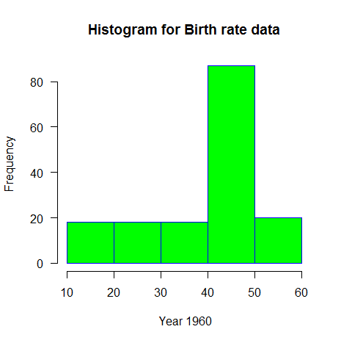

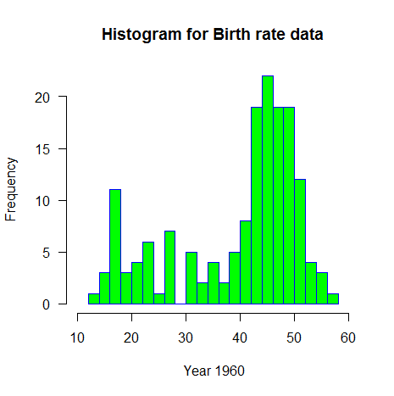

**Some Scatterplots :**

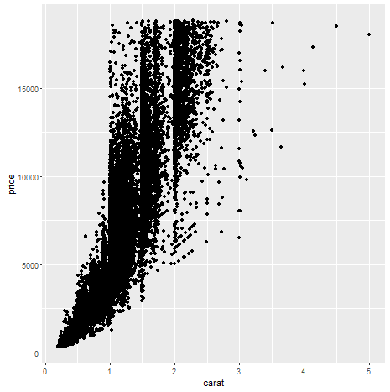

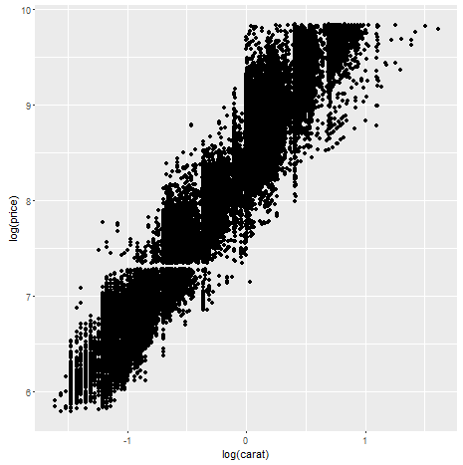

**Few Aesthetic Attributes:**

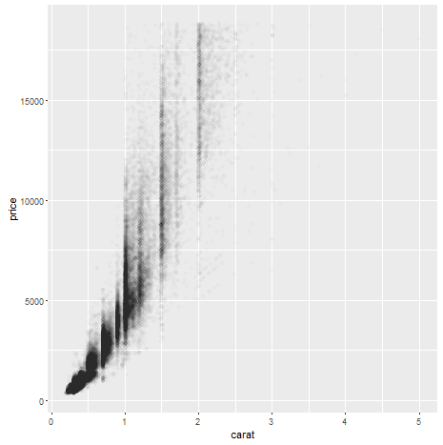

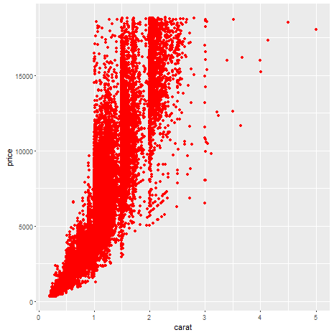

**Geometric Objects:**

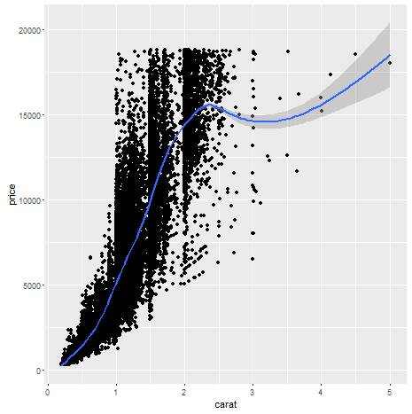

**Histograms:**

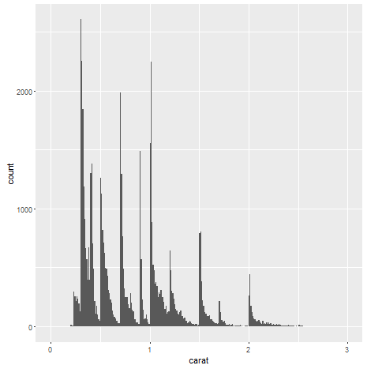

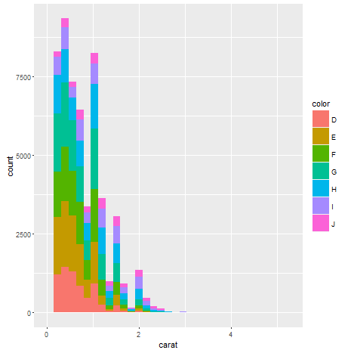

**Density Plots:**

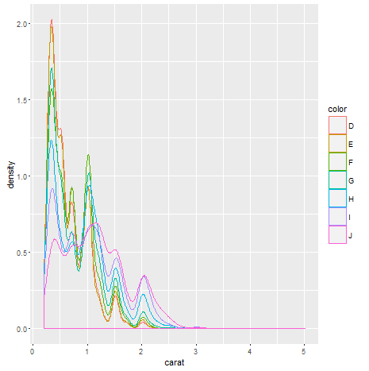

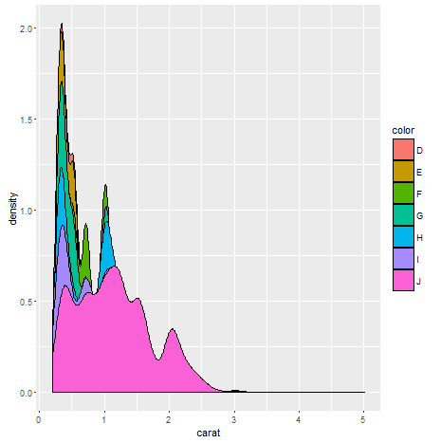

**BarCharts:**

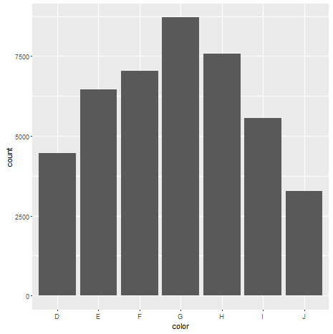

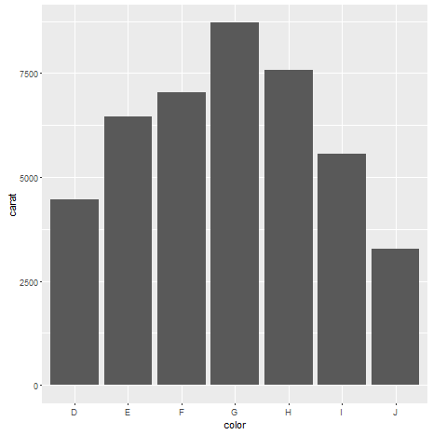

**Faceting:**

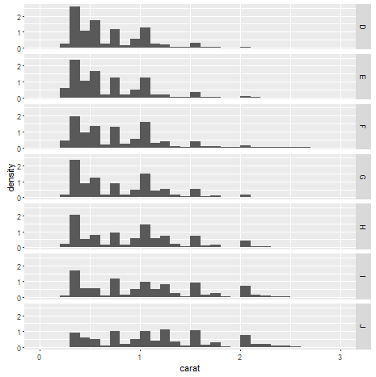

**Scatterplot:**

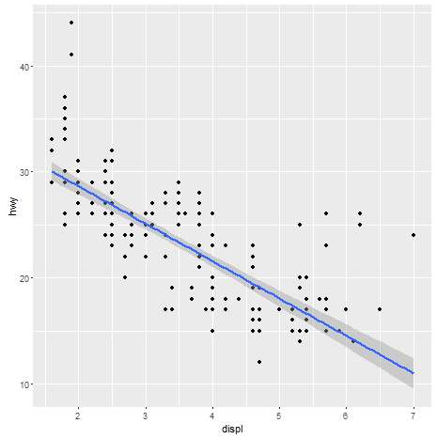

**By Year:**

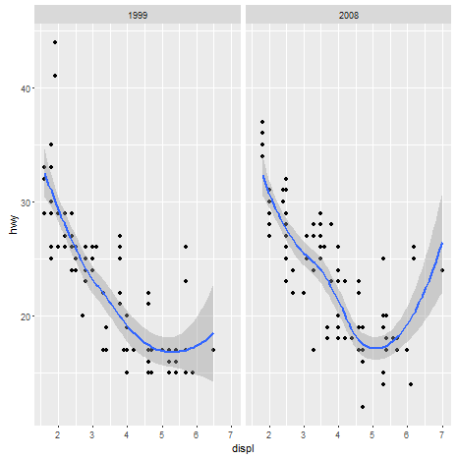

**By Cylinders:**

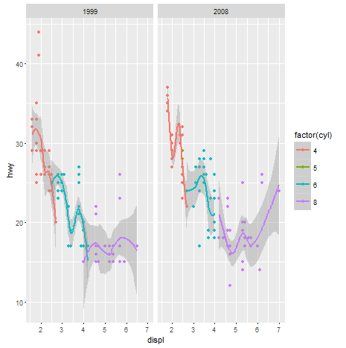

**Activity Eight:**

* Try the code in [plot-tv-sizes.R](http://www.sci.csueastbay.edu/~esuess/classes/Statistics_6610/Handouts/plot-tv-sizes.R)  Note the use of the par() function in R.

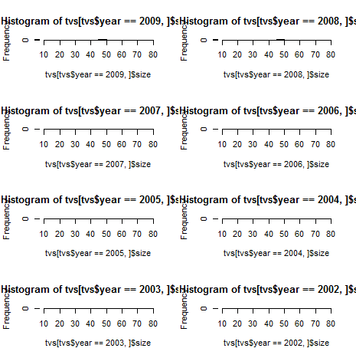

**Activity Nine:**

* Try the [hts01.R](http://www.sci.csueastbay.edu/~esuess/classes/Statistics_6610/Handouts/hts01.R) example code.

**Example 1- Etc**

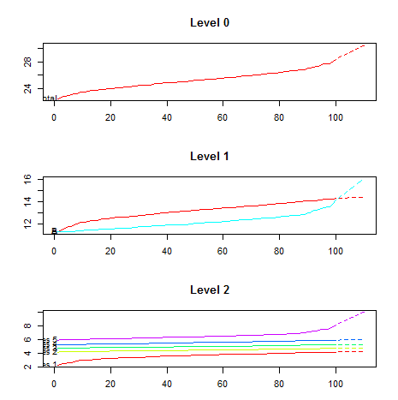

**Arima:**

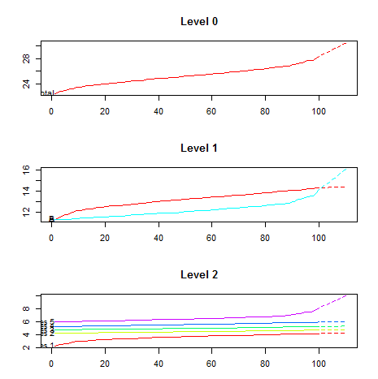

**Example 2- Etc**

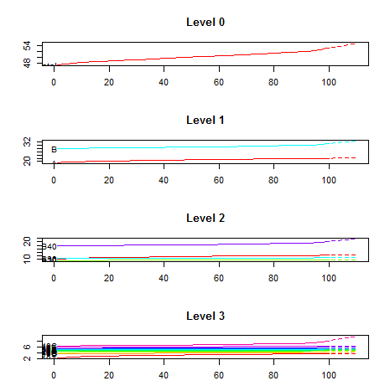

**Arima:**

