**Ruchita Trivedi /STAT-66100 /HW-9**

* **Activity One:**
* Download the data from the [Book](http://www.wiley.com/WileyCDA/WileyTitle/productCd-0470944889.html) website for Chapter 7.
* Make the heatmaps for the Basketball data, use the  ppg2008.csv  data file and the R code in  difference.R.

**Heatmap default and changed color**

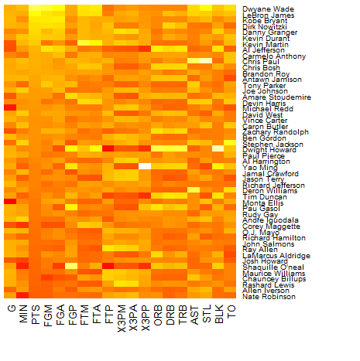

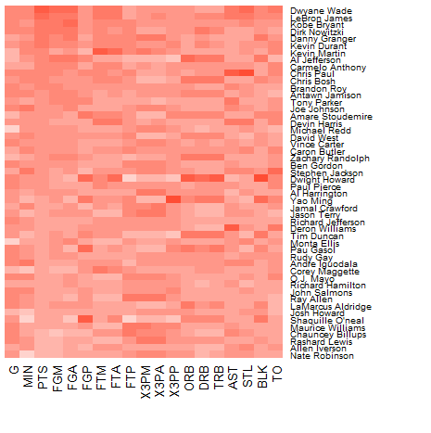

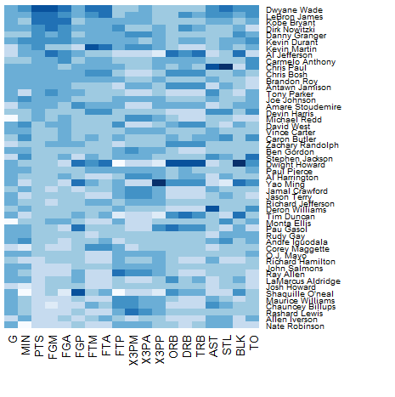

* **Activity Two:**
* Download the data from the [Book](http://www.wiley.com/WileyCDA/WileyTitle/productCd-0470944889.html) website for Chapter 7.
* Make the Chernoff Faces for the Basketball data, use the  ppg2008.csv  data file and the R code in  difference.R.

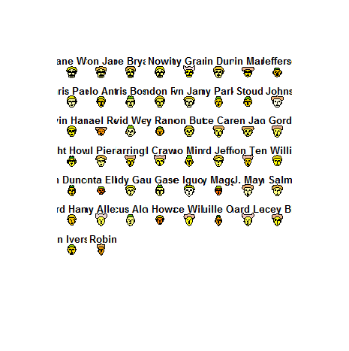

* **Activity Three:**
* Download the data from the [Book](http://www.wiley.com/WileyCDA/WileyTitle/productCd-0470944889.html) website for Chapter 7.  And the R code in  difference.R.
* Make the Star Charts and Nightingale Charts for the Crime data.

**Star Chart**

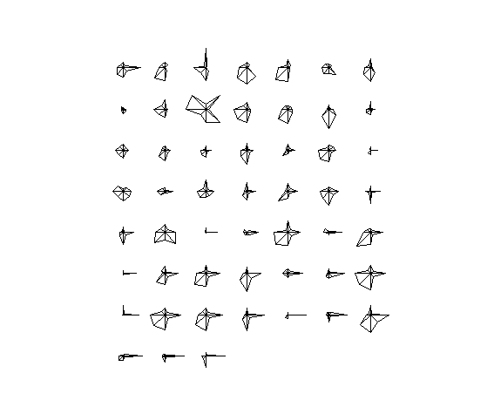

**Nightingale Chart**

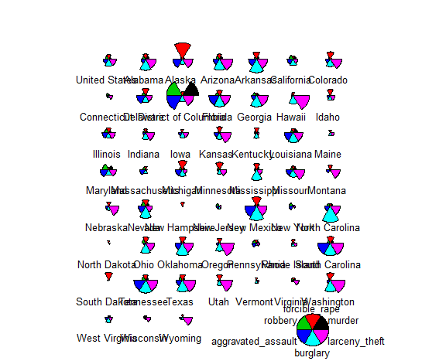

* **Activity Four:**
* Download the data from the [Book](http://www.wiley.com/WileyCDA/WileyTitle/productCd-0470944889.html) website for Chapter 7.  And the R code in  difference.R.
* Make the Parallel Coordinates Charts for the Education data.

**Parallel Coordinates Chart:**

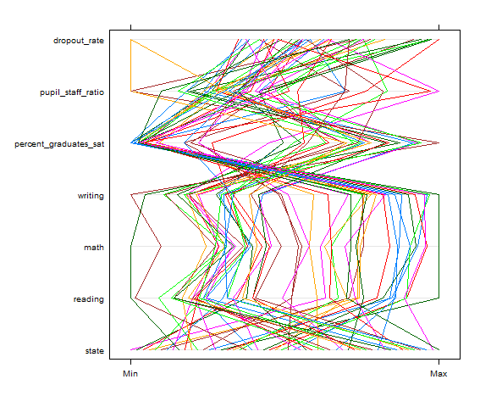

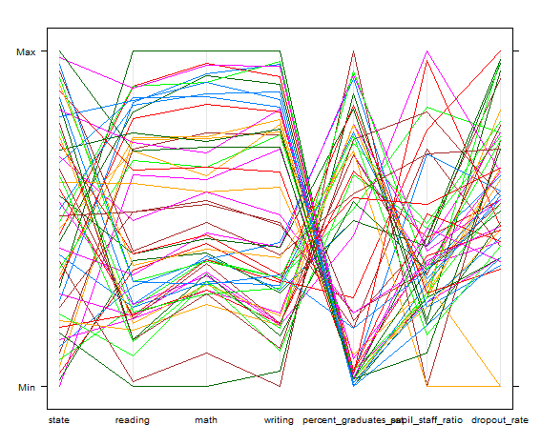

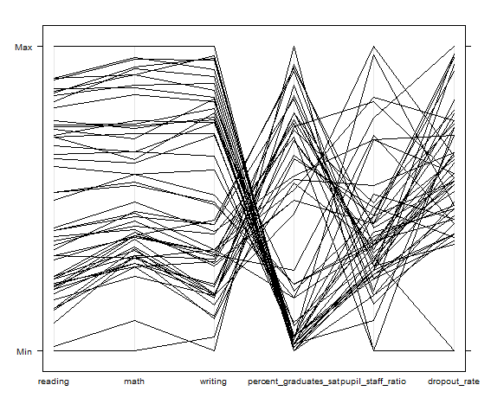

* **Activity Five:**
* Download the data from the [Book](http://www.wiley.com/WileyCDA/WileyTitle/productCd-0470944889.html) website for Chapter 7.  And the R code in  difference.R.
* Make the plots for the Education data using Multidimensional Scaling and using Clustering.

**Multidimensional Scaling**

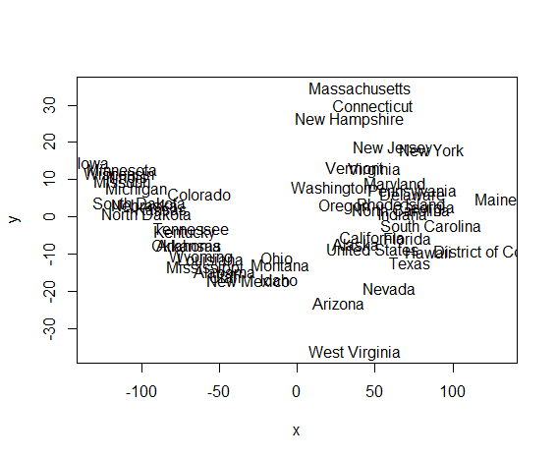

**Clustering**

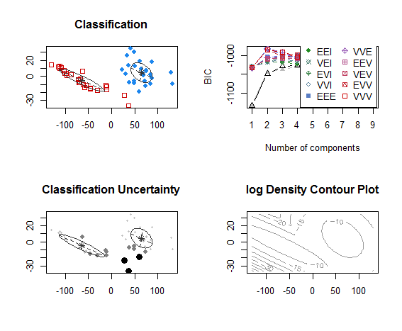

2. Try the [StockTwits Heatmap](http://stocktwits.com/signals/heatmap) website.  What kind of plot(s) are being used to present the stock market data?

Heat maps and Stalked Bar Charts