**RUCHITA TRIVEDI/ STAT-6610 / HW-5**

**1. Complete all of the Activities from Week 5.  See the**[**TimeSeries2**](http://www.sci.csueastbay.edu/~esuess/classes/Statistics_6610/viz/viz8/TimeSeries2.html#/)**presentation.  Show the plots you have created in your homework document.**

* **Activity One:** Hot Dog Eating - bar graphs

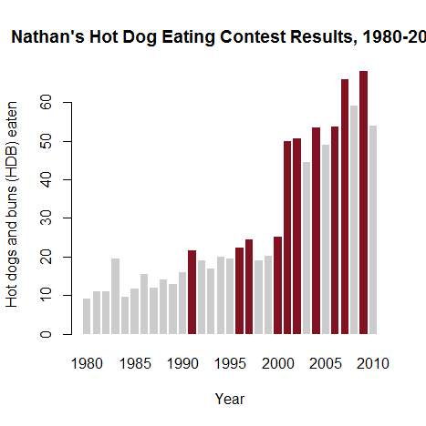

* **Activity Two:** FlowingData subscribers - time plots

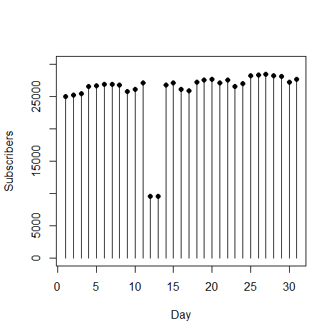

* **Activity Three:** World Population - time plots

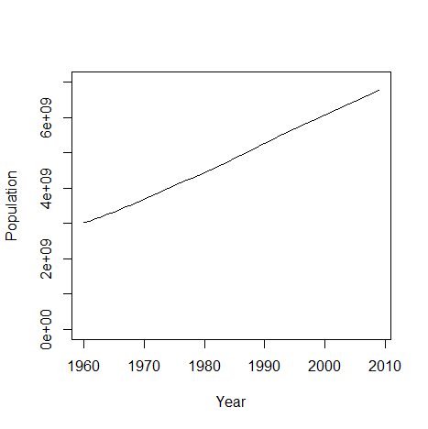

* **Activity Four:** US Postage - step plot

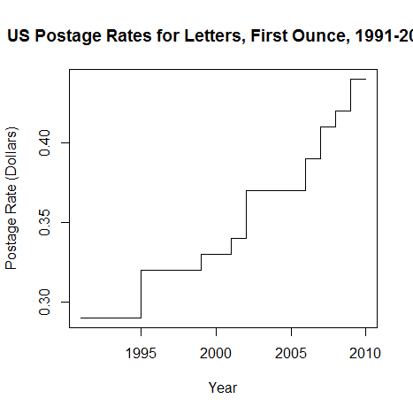

* **Activity Five:** Unemployment Data – LOESS

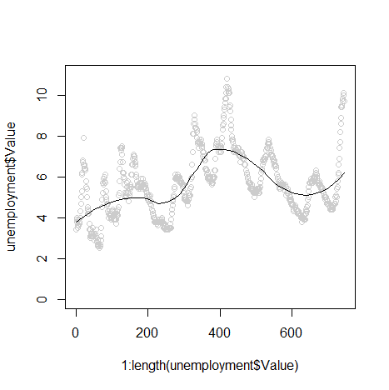

* **Activity Six:** Johnson & Johnson stock price - decompose( ) function in R, ACF, PACF

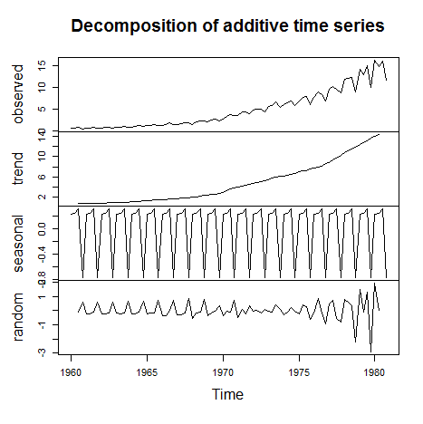

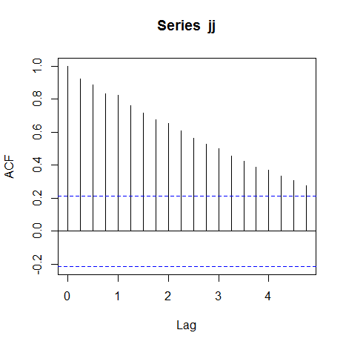

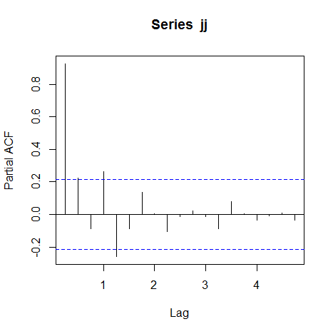

**2.Using R run the JJ examples from the end the**[**TimeSeries2**](http://www.sci.csueastbay.edu/~esuess/classes/Statistics_6610/viz/viz8/TimeSeries2.html#/)**presentation.  Show the plots you have created in your homework document.**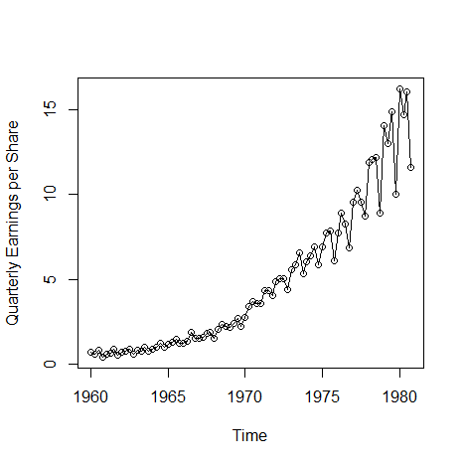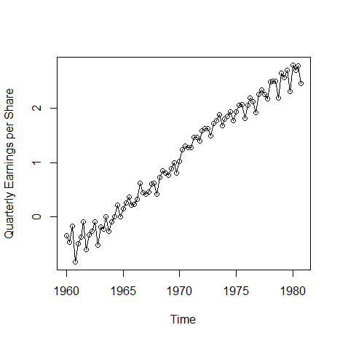

**The plots for** Johnson & Johnson stock price using decompose( ) function in R, ACF, PACF are shown in Activity 6 above