Ruchita Trivedi STAT6610 HW1-Chapter1
Friday, January 15, 2016
1:13 AM
  - Make a plot using Gapminder. Print Screen your graph.
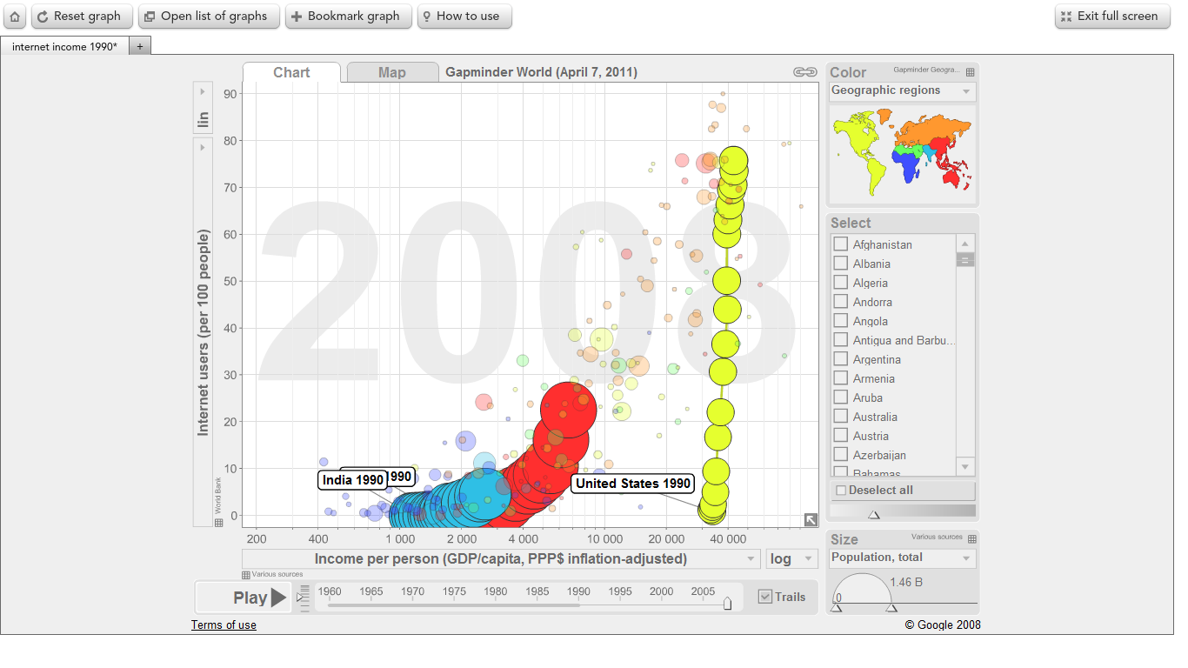
  - Use yahoo finance to plot a time series of a stock you are interested in. Print Screen the picture and turn it in. Optional: Tweet it to me @esuess
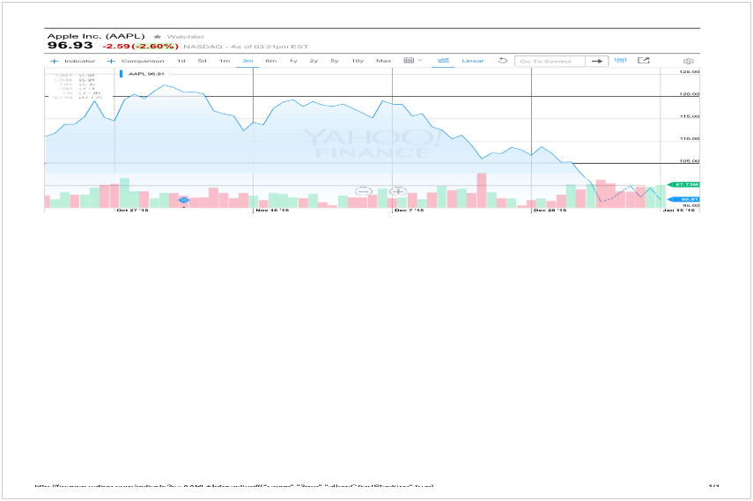

  - Download the historical data for your stock. Check the file to make sure there are no problems, such as, dividend paid. Upload the text data into tableau public. Make a time plot. Print Screen the picture and turn it in.

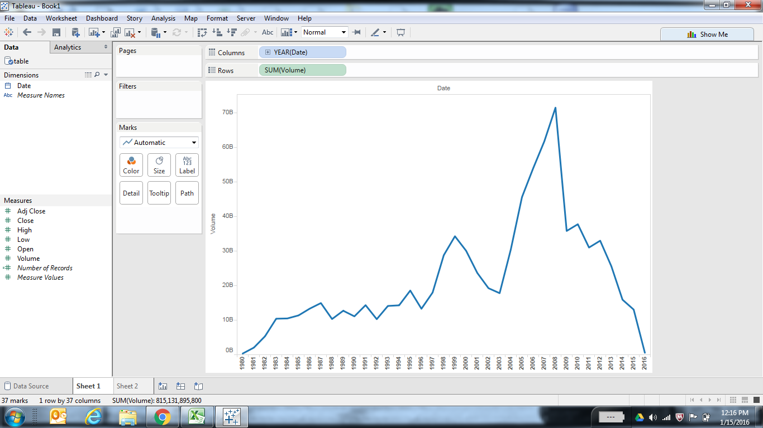

- Using R run the cars examples from the ends of the Welcome and GettingStarted presentations. Copy the pictures and turn them in.

plot(cars)

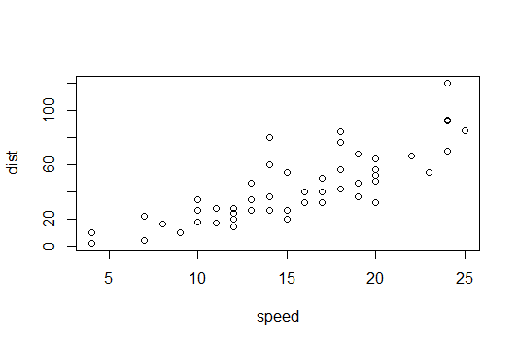
Boxplot(cars)
