Ruchita Trivedi STAT-6610 HW-2 (Chapter-2)
Sunday, January 17, 2016
12:28 PM

- Try out the Weather Underground website. Find the current temperature of a city of your choice. Try WonderMap also. Print Screen the picture and turn it in. Optional: Tweet it to me @esuess

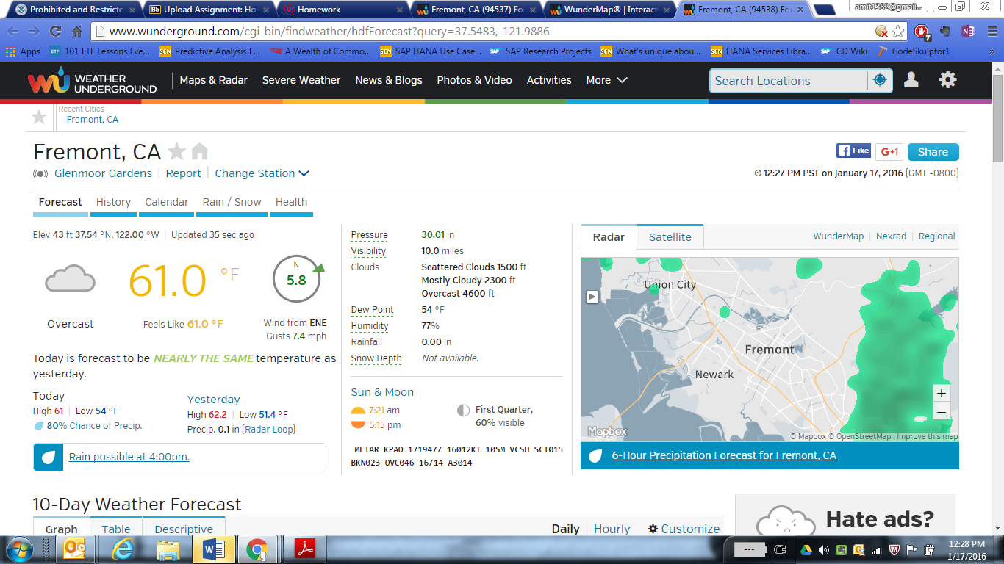

  - Use quantmod to download stock market data directly into R. Make similar plots to the ones you made using the yahoo finance webpage for Homework 1 now using the quantmod library in R. Use the example code in stocks03.R Show the plots you have created in your homework document.

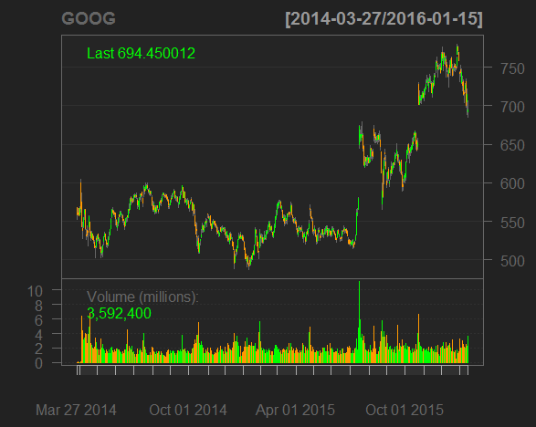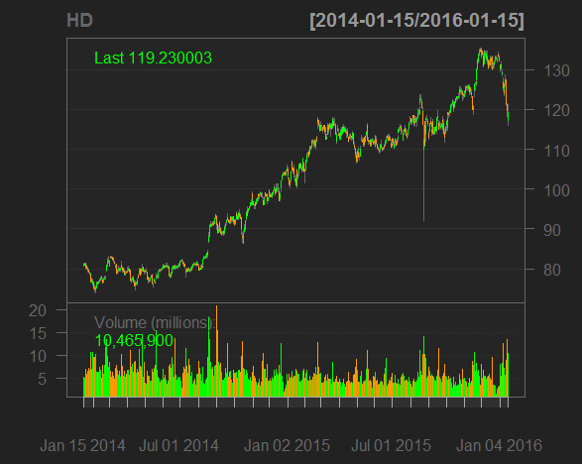

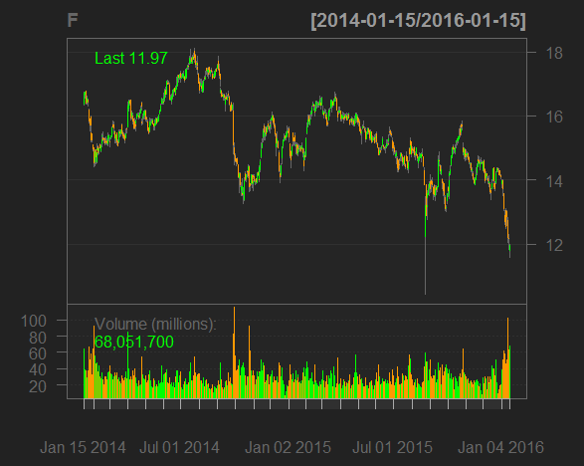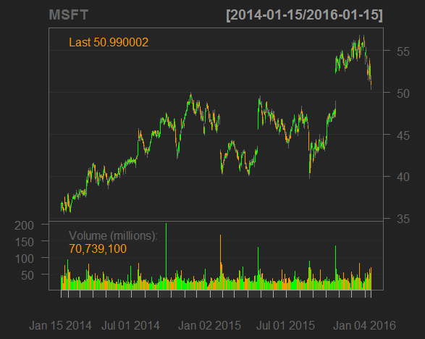

- Choose 4 more stocks and update the code in stocks03.R Save the plots for your portfolio. Comment on how the stock market is doing currently. Show the plots you have created in your homework document.

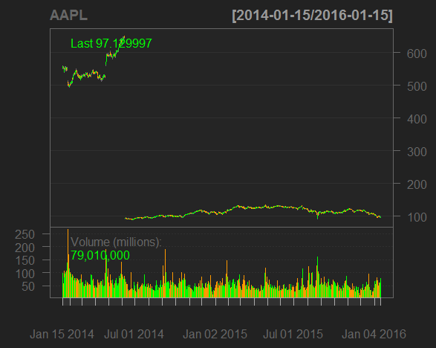
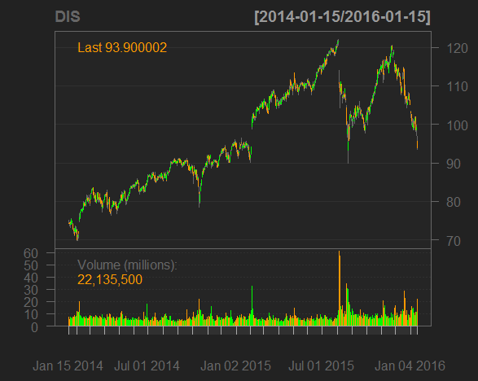

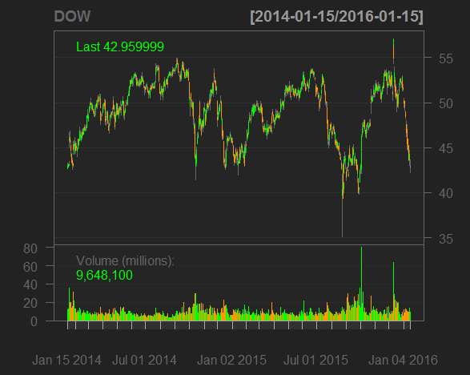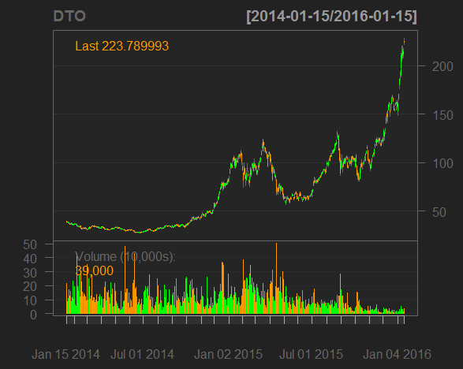

AAPL- the electronic equipment company is down primarily because the I-pad market is facing tough competition from Microsoft etc. and leading rating companies call it low return

DOW- the diversified chemical company is on a low as most of its stocks are down.

The US stock market is corrected by 8% primarily because china is seeing a low economy. Crude oil prices are low by below $30per barrel and expected to go even down.

- Using R run the mtcars examples from the end of the DataScraping and DataTypes presentations. Show the plots you have created in your homework document.

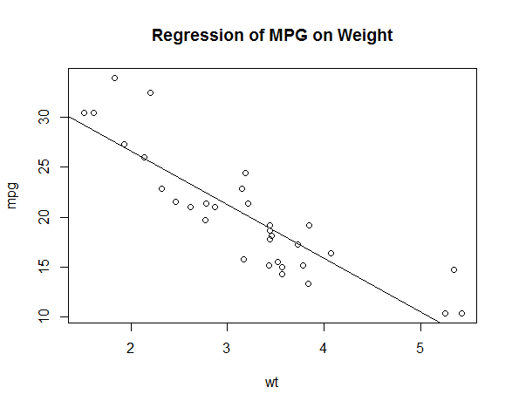
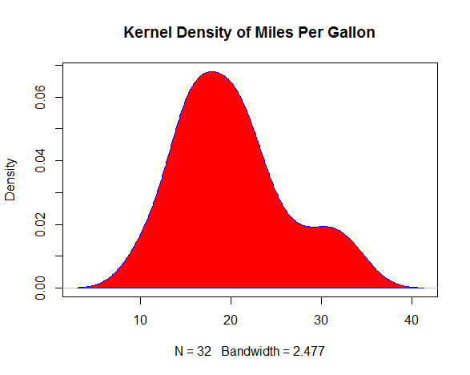

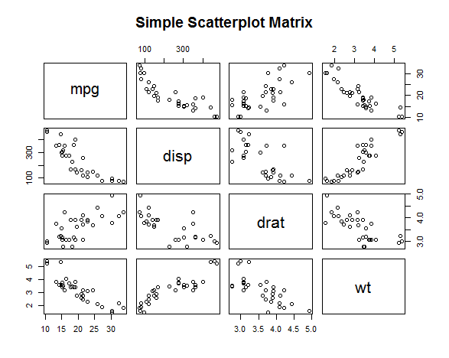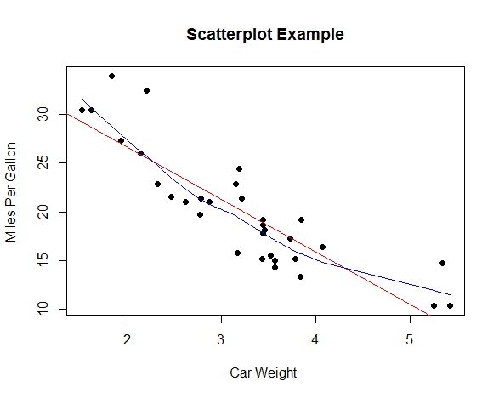

  - From the Quick-R website, run the R programs to make plots for the mtcars data. See the Basic Graphs links.
  - Density Plots
  - Dot Plots
  - Bar Plots
  - Line Charts
  - Pie Charts
  - Boxplots
  - Scatter Plots

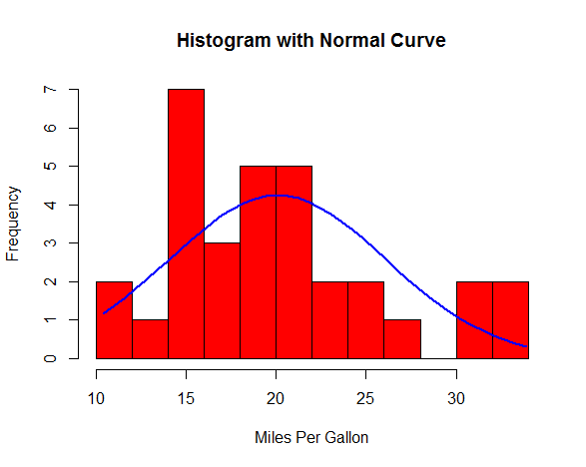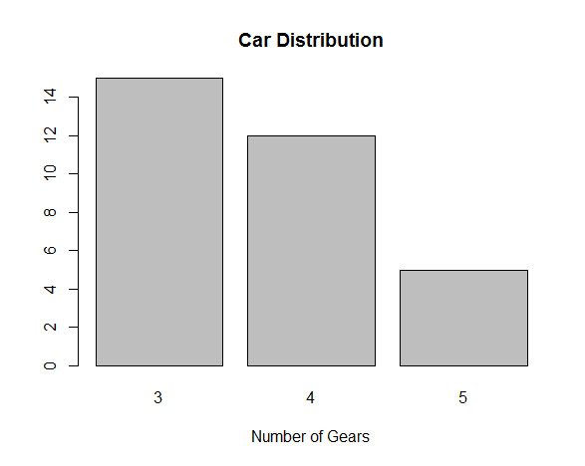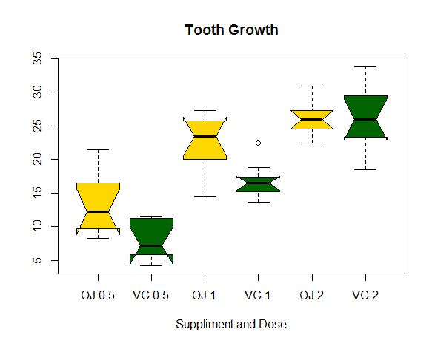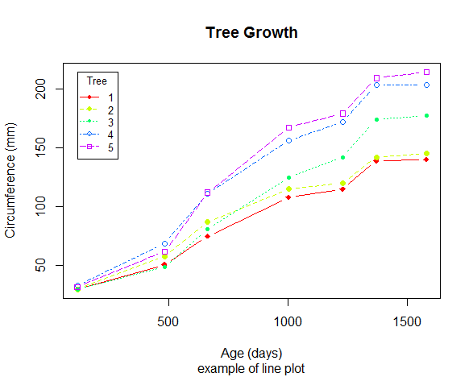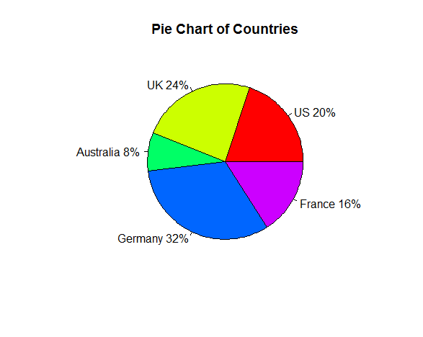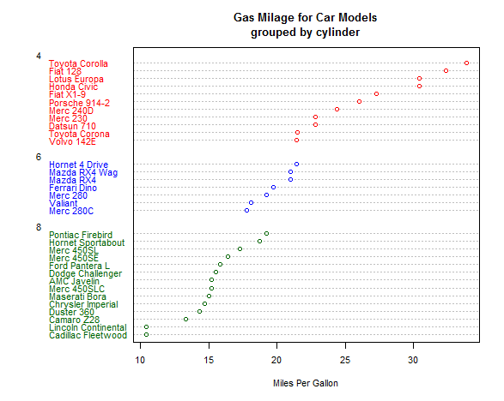
- Find the Parking meters dataset from DataSF and produce some data visualizations using the tools provided on the website, in Excel and in tableau public. Show the plots you have created in your homework document. Before you start try to think of a question to answer before you start making plots. For example, are there more or less smart meters in SF than non-smart meters?

Ques: give the count of meters from both agencys?

JURISDICTI | Count of JURISDICTI
PORT | 1255
SFMTA | 28105
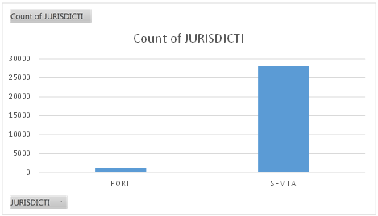

Ques: How many smart meters are there from PORT vs. SFMTA?

Count of SMART_METE | Column Labels
Row Labels | PORT | SFMTA | Grand Total
N | 737 | 20484 | 21221
Y | 518 | 7621 | 8139
Grand Total | 1255 | 28105 | 29360

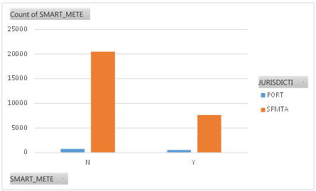

Ques: No. of meters of different colors by their location.

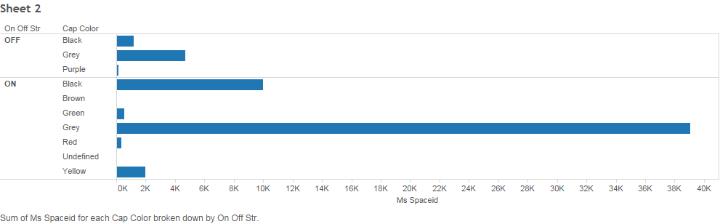

Ques: What is the ratio of non-smart meters given by PORT and SFMTA.

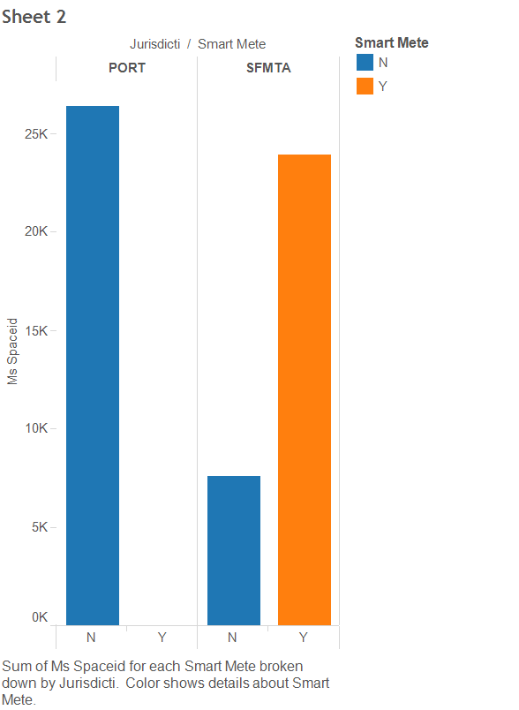

- Do you want to work as an Application User, Scripter, or Hacker?

Un-decided

