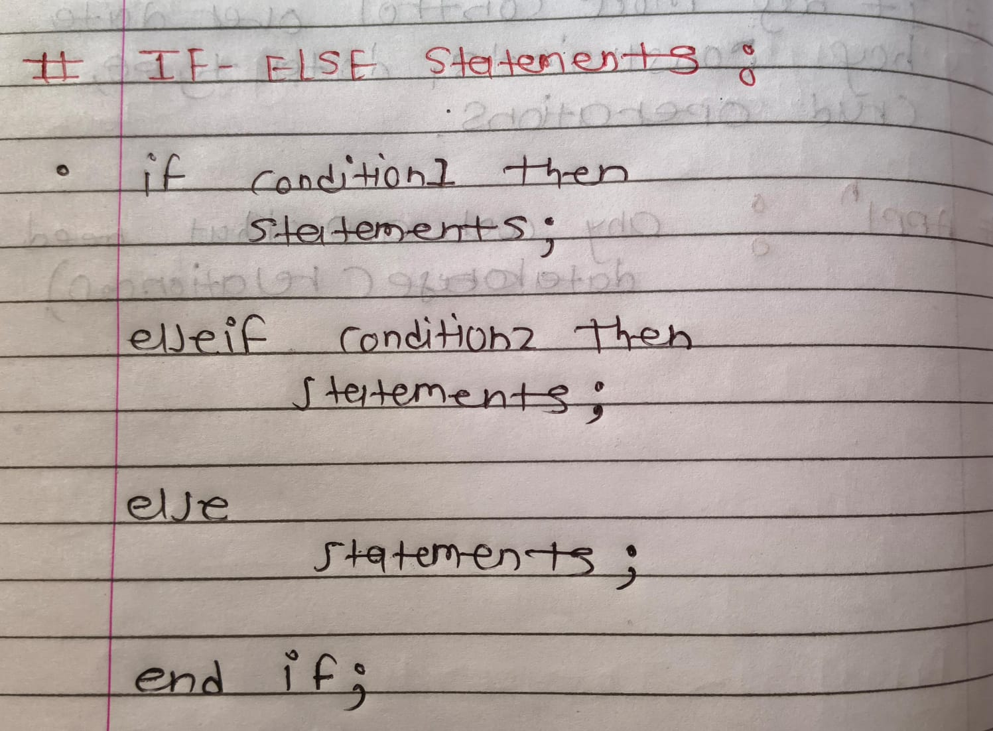
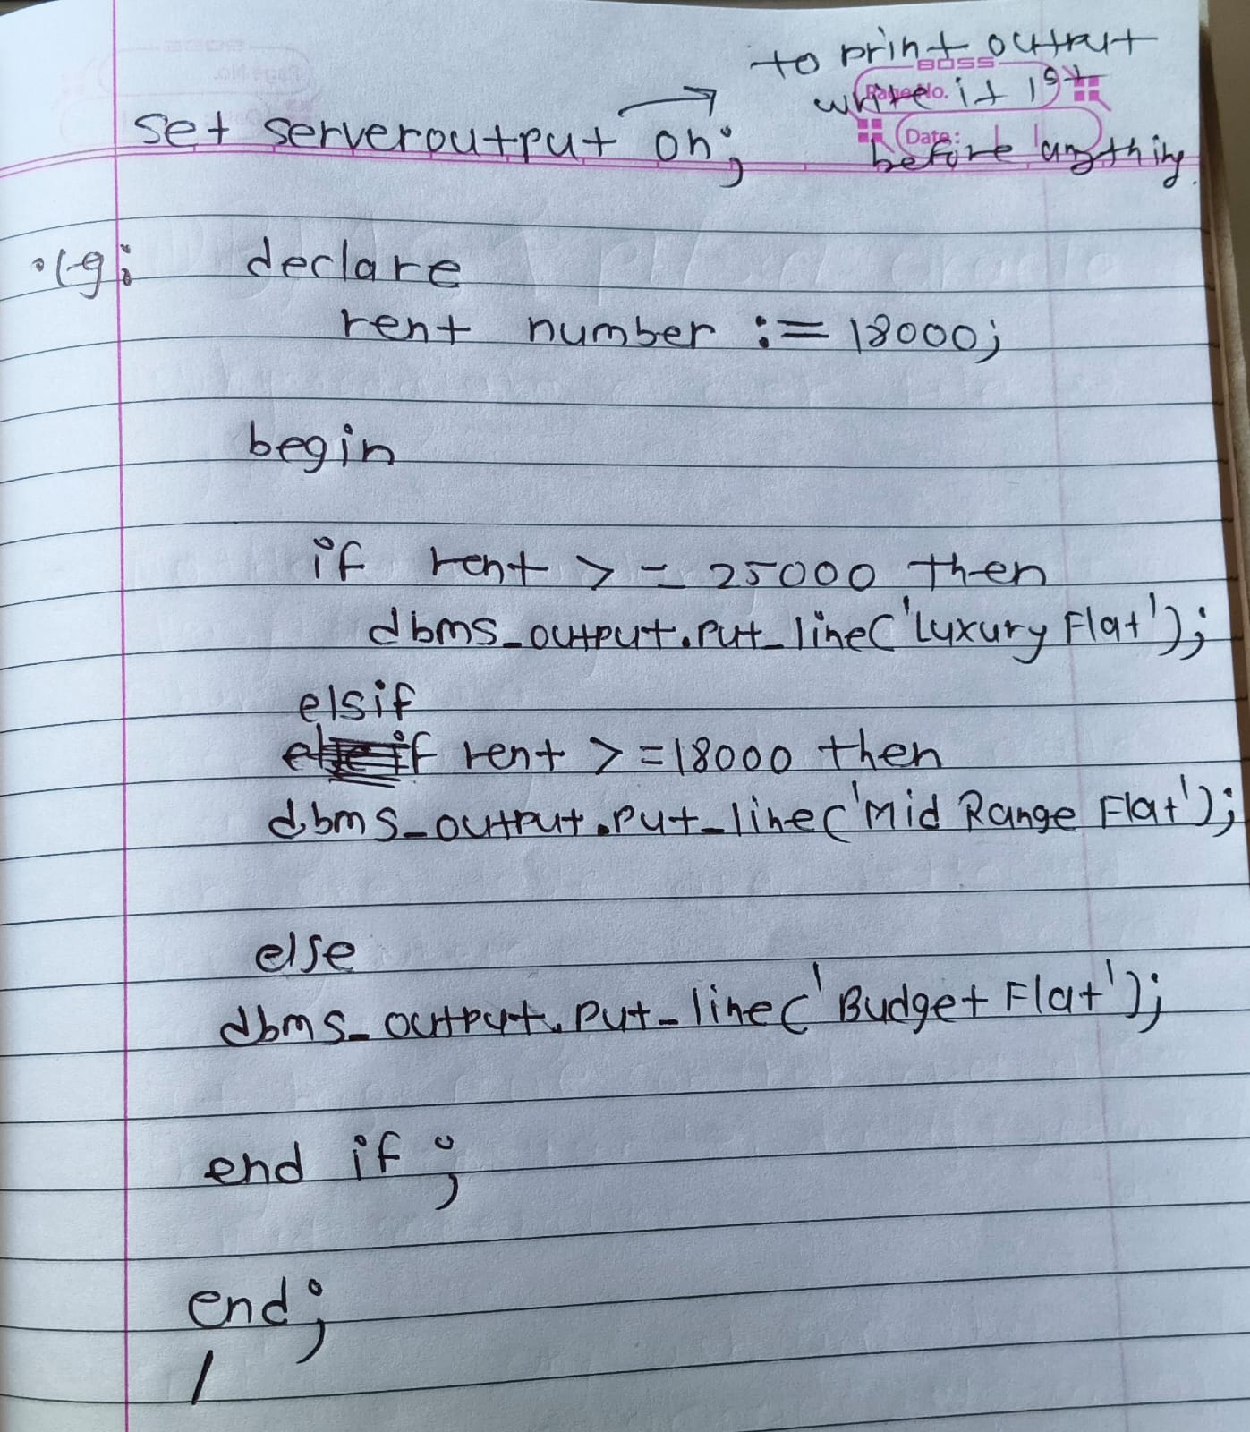

CASE
CASE is used when you want to choose output based on value.
✅ Simple CASE Example
DECLARE
property_type VARCHAR2(20) := 'COMMERCIAL';
BEGIN
CASE property_type
WHEN 'RESIDENTIAL' THEN
DBMS_OUTPUT.PUT_LINE('House Property');
WHEN 'COMMERCIAL' THEN
DBMS_OUTPUT.PUT_LINE('Office Property');
ELSE
DBMS_OUTPUT.PUT_LINE('Unknown Property');
END CASE;
END;
/
✅ Output: Office Property

✅ CASE with Condition (Searched CASE)
Used like IF-ELSIF.
DECLARE
rent NUMBER := 30000;
BEGIN
CASE
WHEN rent >= 25000 THEN
DBMS_OUTPUT.PUT_LINE('Luxury Property');
WHEN rent >= 15000 THEN
DBMS_OUTPUT.PUT_LINE('Standard Property');
ELSE
DBMS_OUTPUT.PUT_LINE('Budget Property');
END CASE;
END;
/
✅ Output: Luxury Property

⭐ IF vs CASE (Interview Point)
IF-ELSIF | CASE
Best for conditions | Best for multiple values
More flexible | More readable
Used for complex logic | Used for clean decision making

